Site Visit report of Dhrupad Sansthan for Asha for Education, Seattle Chapter
Conducted by: Vibhavaree Gargeya
Dates of visit: Dec 23-27, 2018 (arrived evening of 23rd, left early morning of 27th)

Intro to Names Mentioned/Quick Background
Dhrupad Sansthan is run by world renowned Dhrupad artists Padmashri Gundecha Brothers. They are Pt. Ramakant Gundecha, Pt. Umakant Gundecha and Pt. Akhilesh Gudecha. They are also the principle teachers/Gurus at Dhrupad Sansthan and are mentioned below.
Most of the full term students at Dhrupad Sansthan need scholarships and room and board in order to be able to attend. Asha for Education funding provides room and board to roughly 26 of these 31 students. At any given time, Dhrupad Sansthan roughly houses 50 students (short term and long term).

Activities
Dec 23rd evening – attended class by Ramakantji

Dec 24th morning – attended class by Ramakantji (all three teachers conducted class at this time)
Dec 24th evening – toured hostels

Dec 25th evening – attended student performances (students performed non-Dhrupad that day)

Dec 26th morning – attended class by Umakant-ji and Ramakant-ji (all three teachers conducted class at this time)
Dec 26th afternoon – took a look at office building under construction – will house Asha funded IMW

All days - Interacted with students during class, at meals and around the campus.

Notes, Observations
- Teachers continue to be extremely dedicated. Example – due to travels for performances and family events, class was not possible on Dec 23rd day time and on December 25th. So, one of the teachers, Ramakant-ji took class from 10 to midnight on Dec 23rd directly coming to the Gurukul straight from travels. Similarly, since the teachers were travelling for a concert in Mumbai on December 27th, all three took class for extended hours on December 26th.
- I observed several classes. The quality of teaching continues to be world class. This is also evidenced by professional, practicing musicians from all over the world coming to learn.
- I met both short term (from various countries) and long term students, and they each seemed very serious and very grateful for the opportunity they are receiving.
- Asha supports roughly 26 of the 31 students who have their boarding and lodging covered. Of the 31 students, 17 were present, 5 were away performing concerts or teaching workshops, 3 students had left the Gurukul (but others not included in the count have joined – these will be included next year, and the ones who have left will be removed), 5 were away for personal family reasons and 1 was away as he was taking his 12th standard exams.
- There is a steady influx of students. While I was there I spoke with 2-3 new students who had just come in the last 1-2 months. In fact, one came in on one of the days I was in class. He had spoken with the teachers earlier, made his decision to leave a job and go into the field of music.
- The Gurukul’s operating model in terms of admissions continues to be to welcome everyone who is interested, and if they don’t work out after an evaluation period, they will be asked to leave. They are also evaluated financially, and if they can cover their expenses, they are requested to do to.
- I toured the residential and teaching buildings - Hostel 16 is the original hostel and is about as it was described in earlier site visits. Same with the music building. The newer hostel is Hostel 20 (which has been completed and occupied since the previous site visit) and the newest one is Hostel 32, which is nearing completion. The names of the buildings are based on the number of rooms in each, as is the naming tradition in Bhopal. Hostel 20 has been recently completed, and has nice large rooms (suitable for double occupancy), with a French window on the view side, and a kitchenette equipped with a standard set of equipment (stove, kettle, vessels etc.) and attached bathroom also with a standard set of equipment. Each room has a checklist to make sure the standard set is provided. Still, however, I did not get a clean bed sheet, towel and also did not get hot water, so these areas need improvement (I stayed in Hostel 20).
Hostel 32 has smaller rooms each with a kitchenette and attached bathroom – these rooms are single rooms and are more conducive to student not to share as well as to be able to practice in their rooms. Hostel 32 is wrapping up construction.
- The office building that includes the Asha funded IMW has its foundation complete, but has not yet restarted construction. It is slated to do so very soon.
- Since my last site visit, a small Saraswati temple has been constructed. Some students like to practice by the temple, and on one of the evenings, I heard the sound of pakhawaj practice coming from the temple.
- The vegetable garden and maintained cows are flourishing, as are fruit trees
- The gray water treatment system has failed unfortunately. However, the sewerage treatment problems observed in the last site visit have been fixed.
- The long term students have assigned duties (getting rooms ready for checkin, kitchen duty, cleaning duty, grounds duty and so on). The short term students pitch in as required. Requirements for help are announced via a WhatsApp group that all hostellers belong to. WhatsApp group is also used for announcing when the teachers have arrived, and other various coordination announcements. It is also used for music questions and discussions. Students also contribute in various artistic ways by making flower rangollis, landscaping etc.
- The music get together featuring (this one was non-Dhrupad) student performances on the night of the 25th provided a flavor for the regular (Dhrupad and non-Dhrupad) get togethers and performances opportunities the students have. Students show cased singing Bhajans, old film songs, their mc-ing skills. Vocal, Violin, Guitar were amongst the intruments used, and countries represented included India, France, Germany. It was a very nice performance and sharing opportunity for students.
- On the 25th one of the short term students fell ill and was taken to a hospital (she recovered fine). The Gurujis made several trips to the hospital despite being extremely busy – this is an example of their total dedication to their students.

Impressions
This time, my impressions from the site visit formed strongly around what a unique and wonderful arts community Dhrupad Sansthan is. My previous site visits were so focused on the music schooling part of Dhrupad Sansthan, that I did not have my eyes open to the broader aspect of education that Dhrupad Sansthan imparts – which is, to provide an environment where students can imbibe what it means to be an intelligently functioning, contributing member of a community. Dhrupad Sansthan imparts this because it is run in the Gurukul style of education where students/participants become a part of an extended family and the teachers/Gurus give their all to the benefit of the students, just like they would for a family member. Students (mostly young adults) learn from the example of their highly successful teachers, learn from each other, from the many students who come from various walks of life and countries and they learn by being a part of a thriving arts community. These young adults also are given the opportunity to learn about themselves – to deeply examine their interests and modes of thinking. At a time when the only focus of most education is to learn a skill to get a job, Dhrupad Sansthan stands out in doing that but in also imparting to young adults what it means to be a part of a community. What I saw and observed of the young adults here is that they tend to be thoughtful, introspective, very serious and immensely grateful for the opportunity they are receiving. They are also eager to help out and pitch in to work for the community.
In this regard, Dhrupad Sansthan is an example of an educational institution that is providing to young adults at an impressionable age a holistic education – to be a fully functioning, thinking member of society rather than merely a skilled wage earner.
The best part is that Dhrupad Sansthan does this by following teaching methods that are a traditional part of Indian society from times immmorial, and is thus congruent/synchronous with the lives and culture of the Indian students at the Institute, and with any who want to experience traditional teaching and community building.
Regarding music skills – the skills imparted to students is of the highest quality. Dhrupad is a high art, and the teachers are astonishingly well qualified to teach it, because they are a rare combination of being world renowned artists with a deep passion for education. They have decades of teaching experience, and the students here benefit from the complementary training each teacher provides (Ramakant-ji tends to focus on voice training and using the whole body as an instrument to bring out the most musical of sounds, and Umakant-ji tends to focus on exercises that are required to perform the various elements of Dhrupad). Both teachers also impart the full range of the Dhrupad syllabus. Vocal/instrumental students have the benefit of full-fledged Pakhawaj teaching going on in parallel with an excellent Pakhawaj teacher in Akhilesh-ji, and the opportunity to practice and build performance relationships with his students. Likewise, the Pakhawaj students can readily practice with any of the vocal/instrumental students.

In Conclusion
Dhrupad Sansthan is a unique and important institution for Asha or any funding body to support. It does continue to need support because the institution is still in the growing phase (it is possible it can become self-sustaining once the requisite building construction and infrastructure investment is complete). In the interim, though it needs support, and it would be especially beneficial if there were additional personnel to take care of administrative aspects, in particular room and facilities management to lift this burden from the teachers.

Pictures
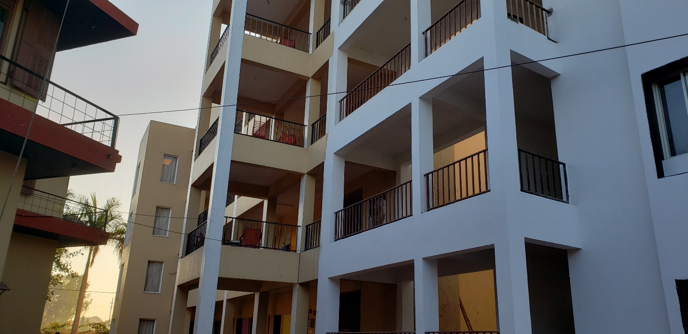
Hostel 20 in back (right) connected to Hostel 32 in front (right). On the left is Music Building
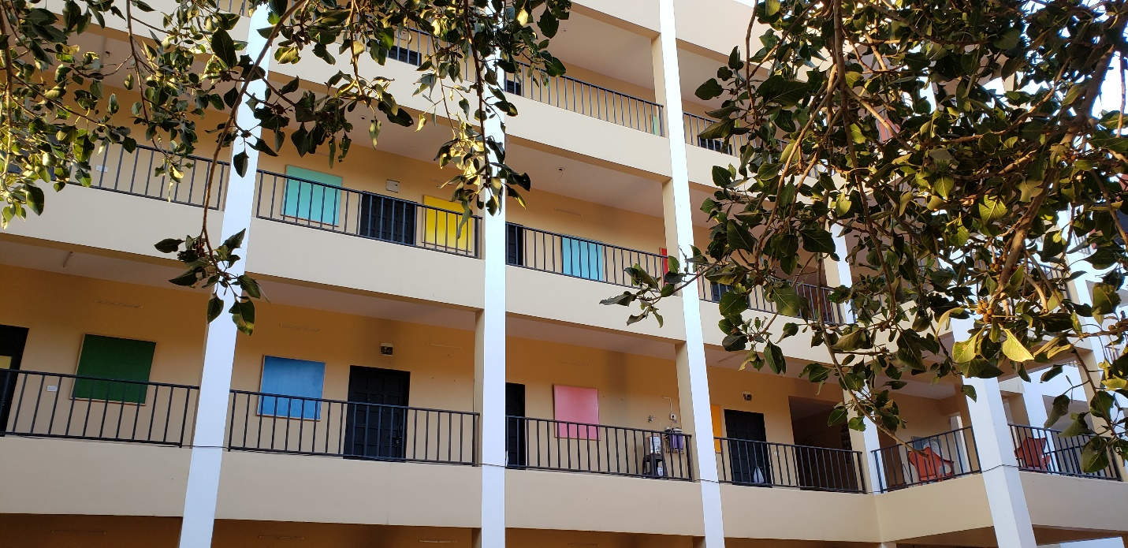
Hostel 20 front view
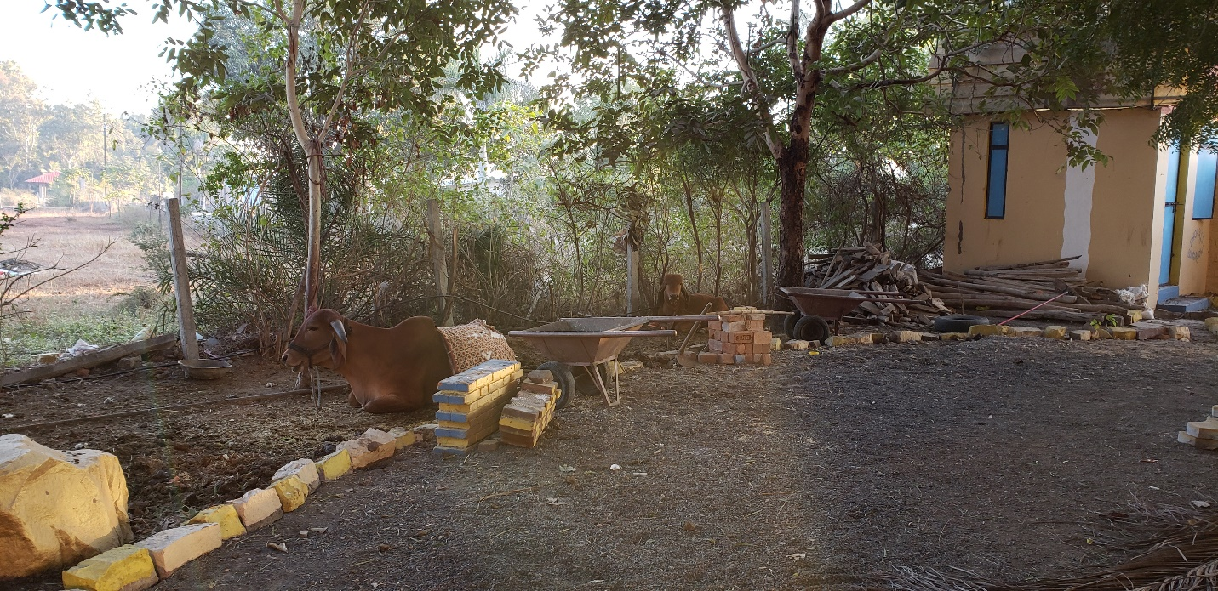
Gurukul cows peacefully lounging
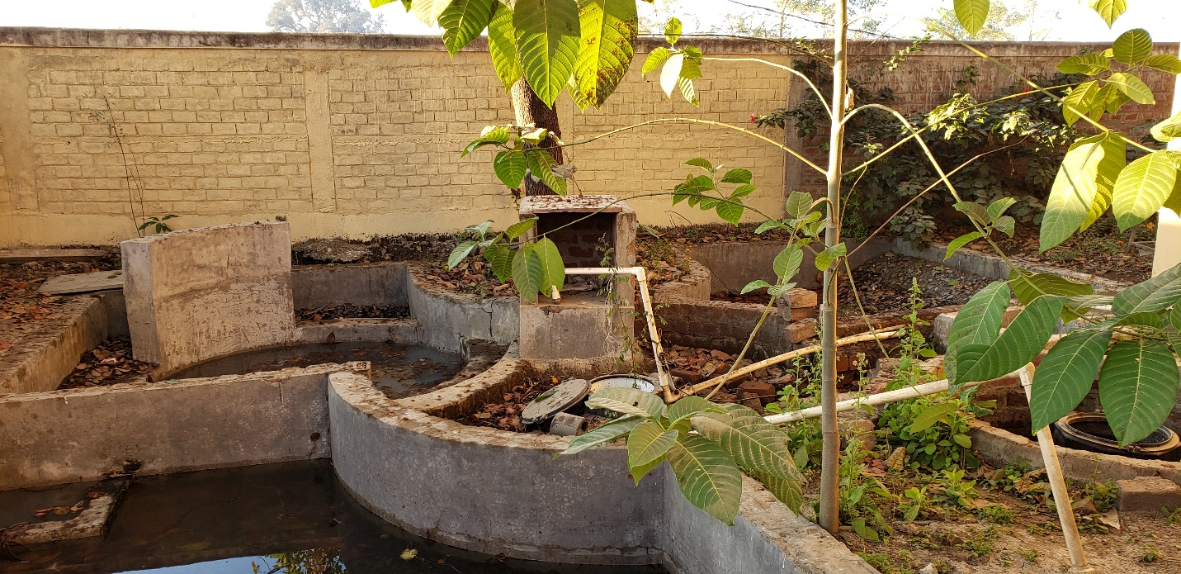
Gray water treatment plant that has failed now

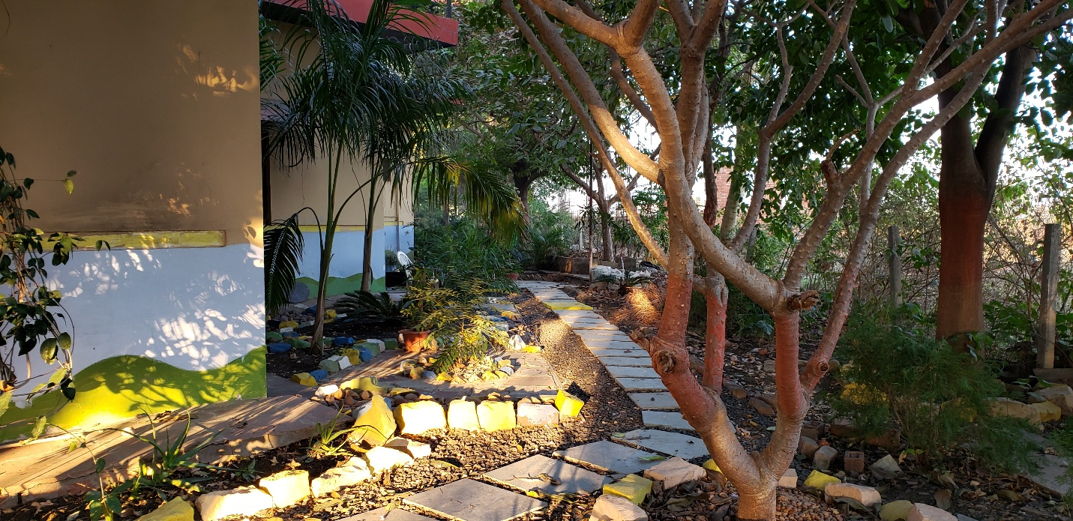Just a pretty path on campus

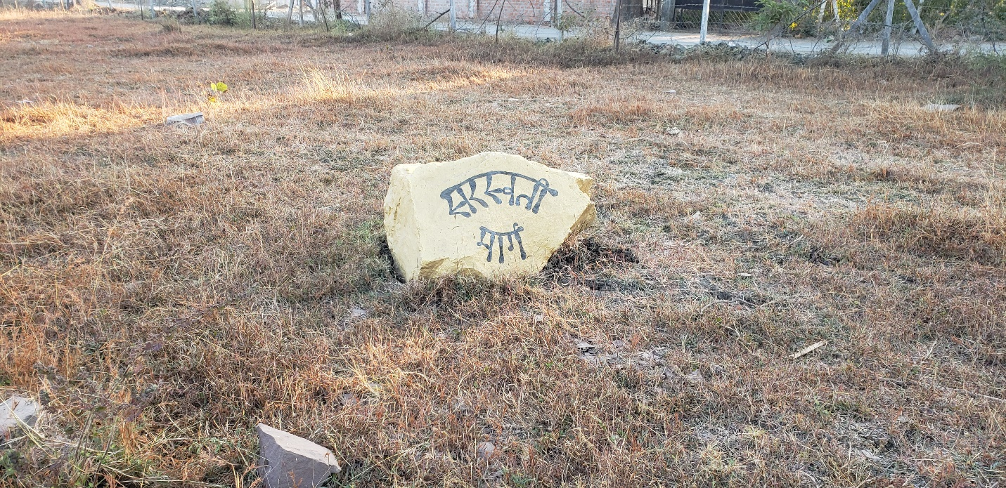On the path to the temple

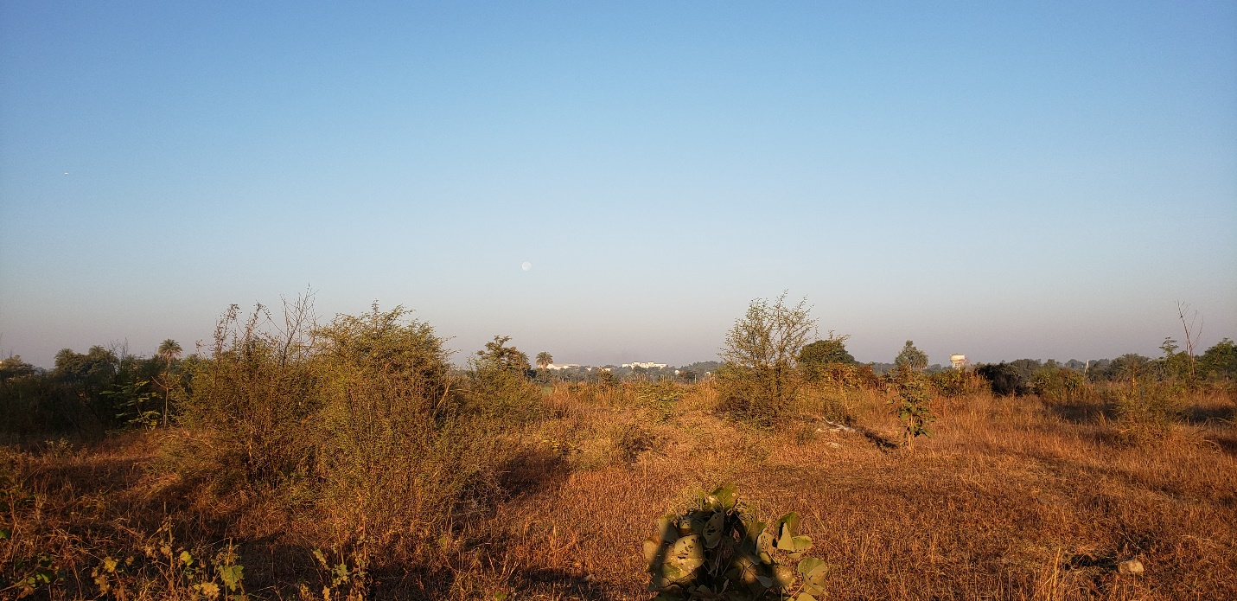A look at the land around

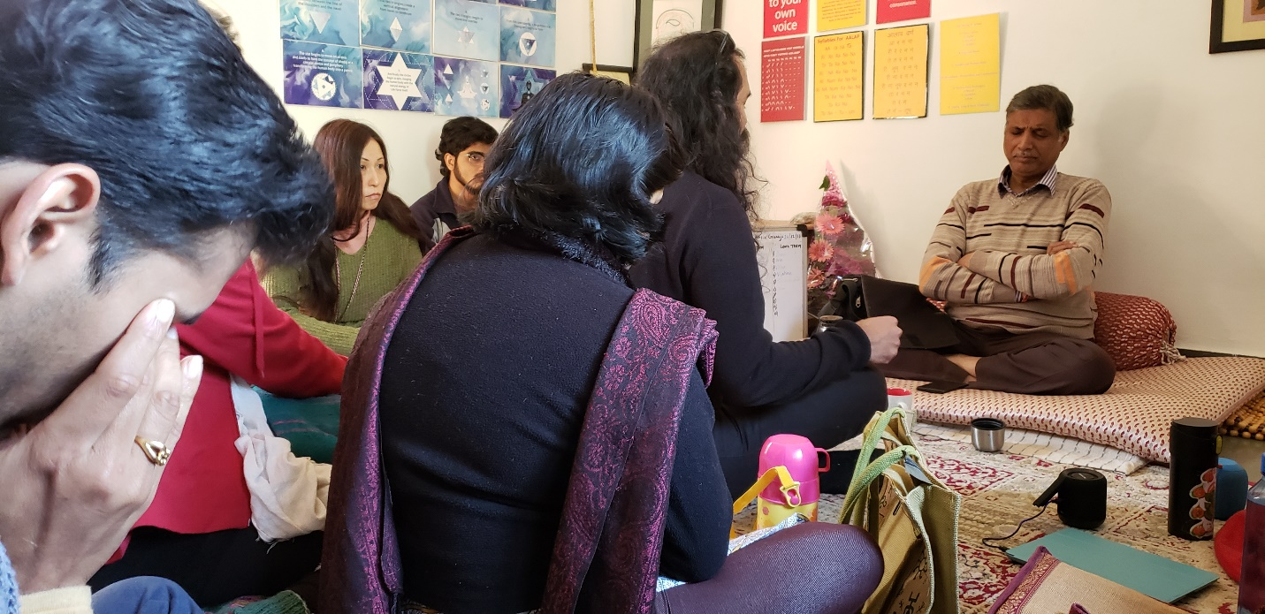
Snap from Ramakant-ji class. There was deep concentration in class. The student in front is having his individual lesson while the others are listening and learning and awaiting their turn.

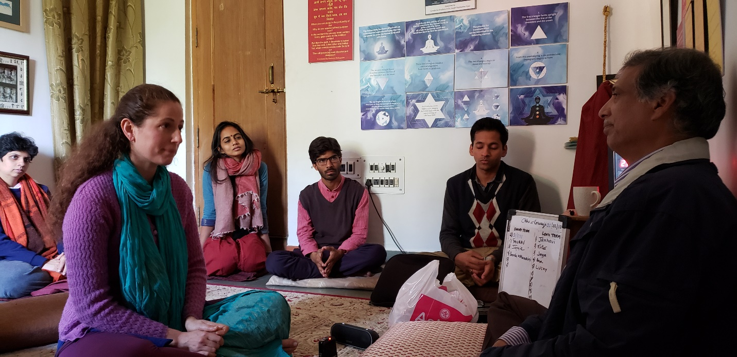
Another class snap
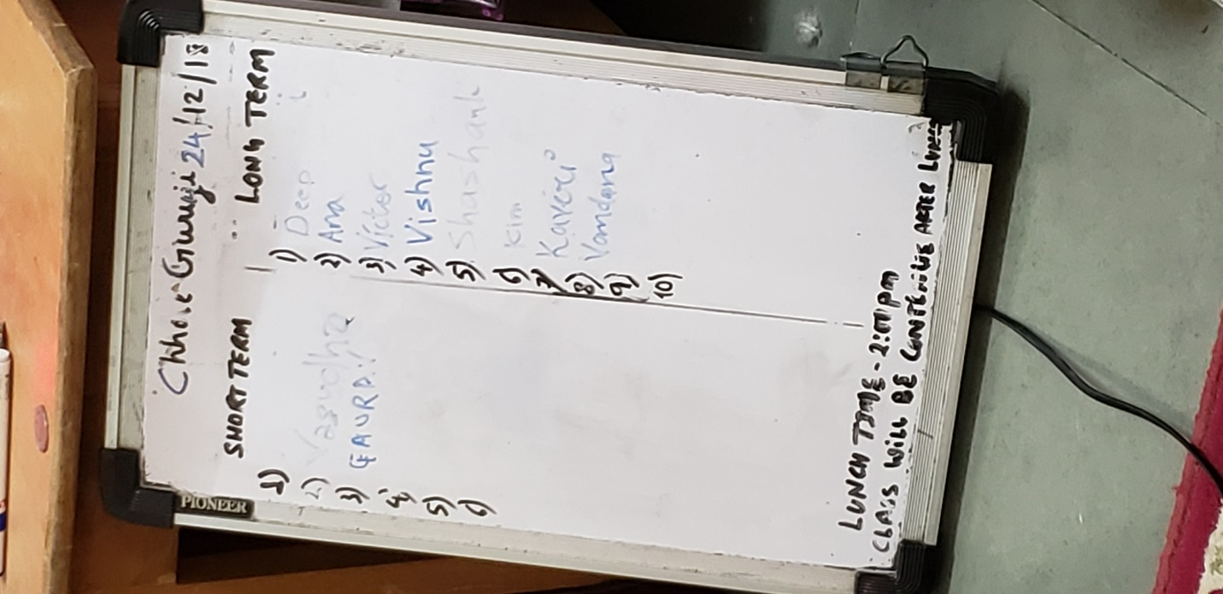

Sign up board for Ramakant-ji class (Umakant-ji class has similar board)

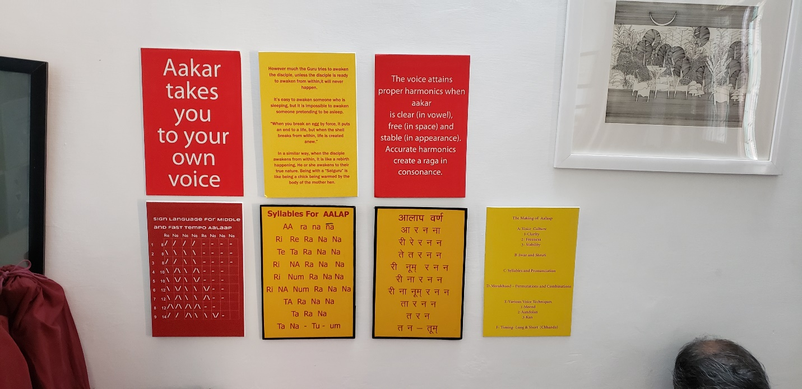
Helpful tips on the walls in the classrooms

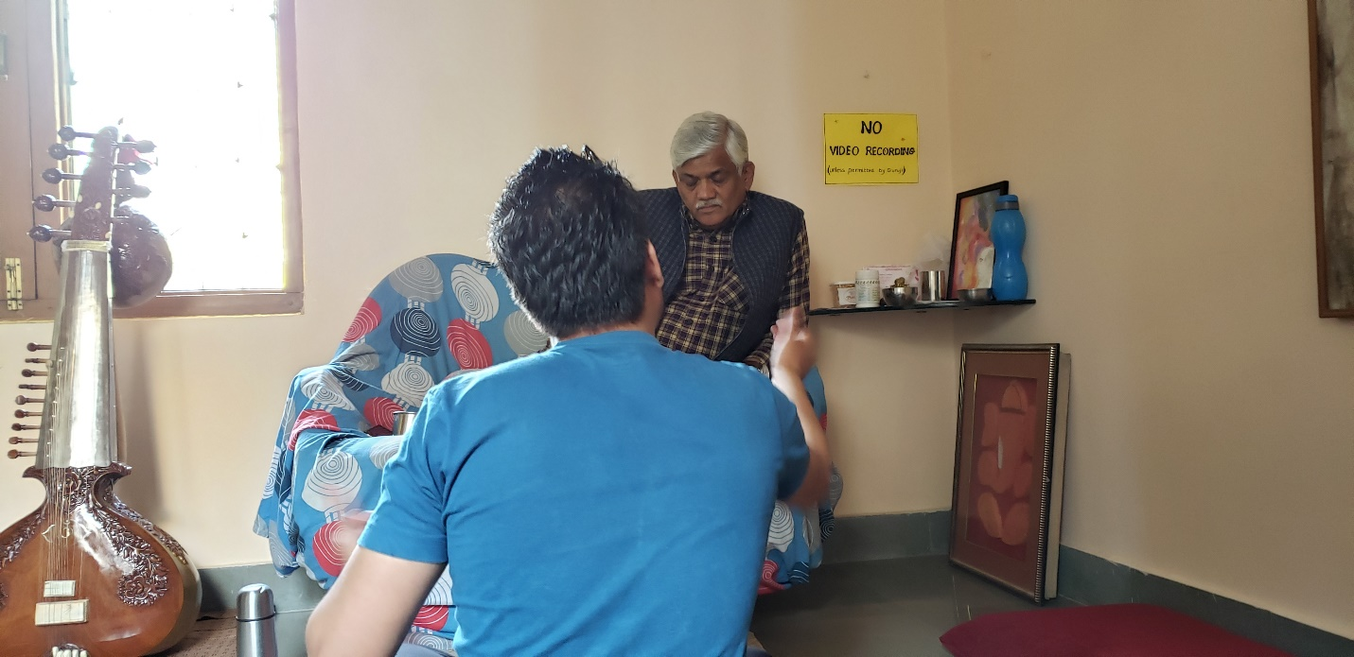
Snap from Umakant-ji class

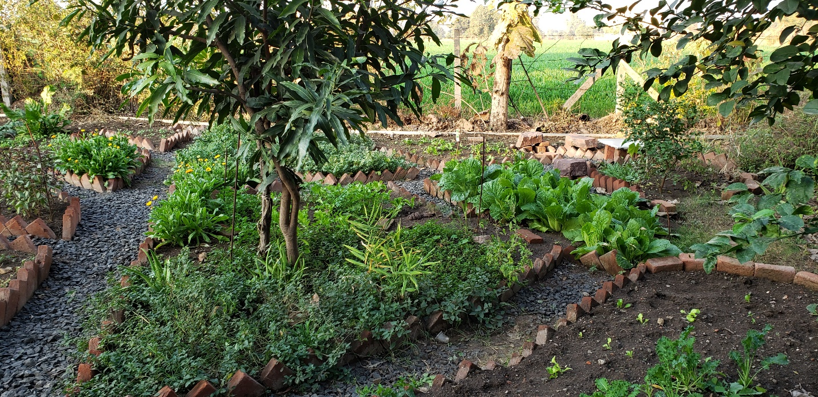
Vegetable Garden

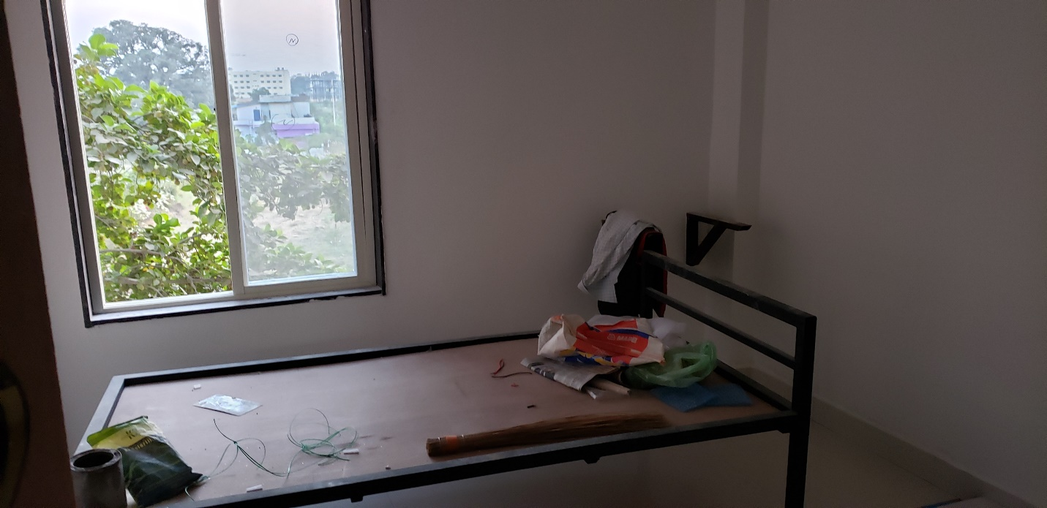
Hostel 32 interior (completing construction)

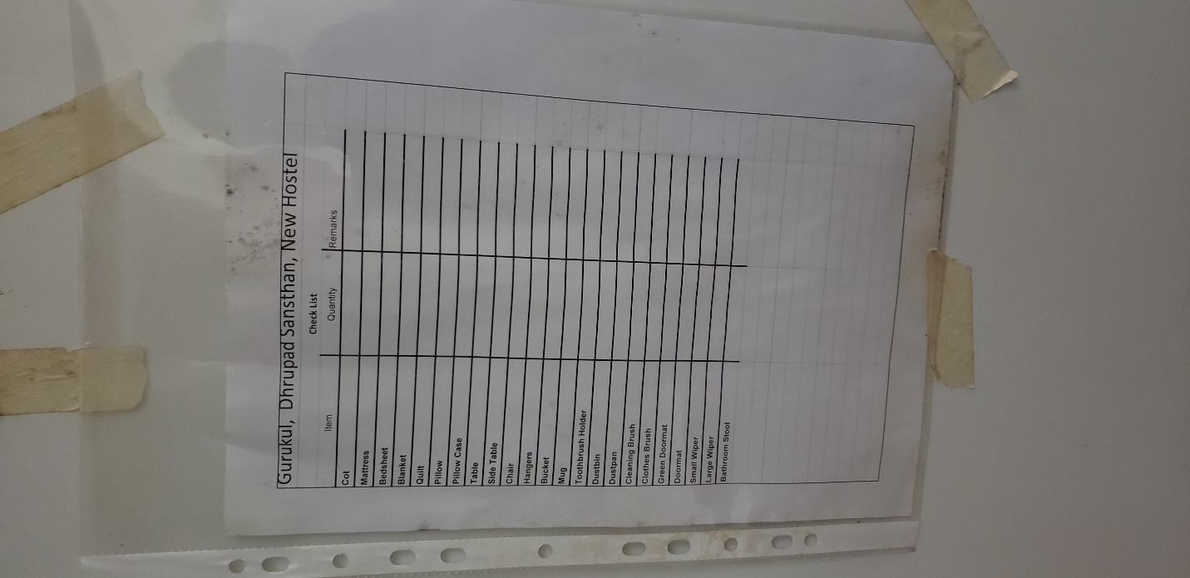
Room equipment list in Hostel 20

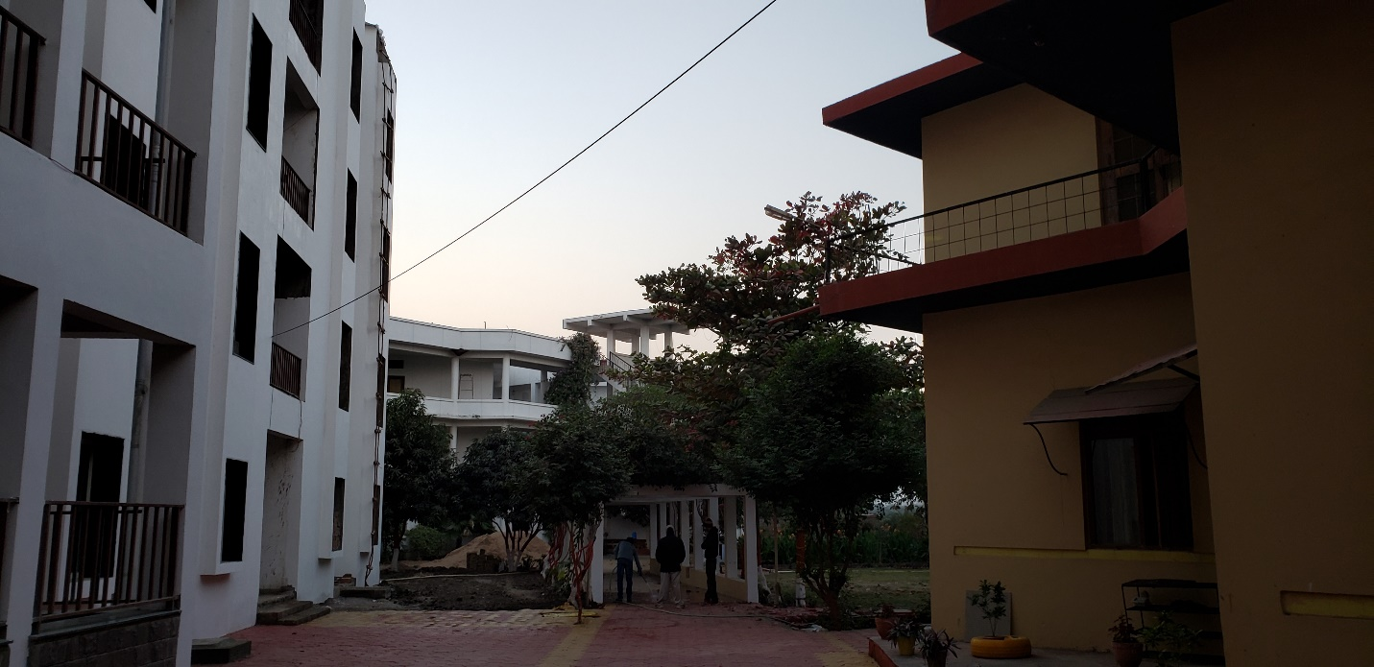
Hostel 16 in background, Hostel 20 and 32 left, music building right

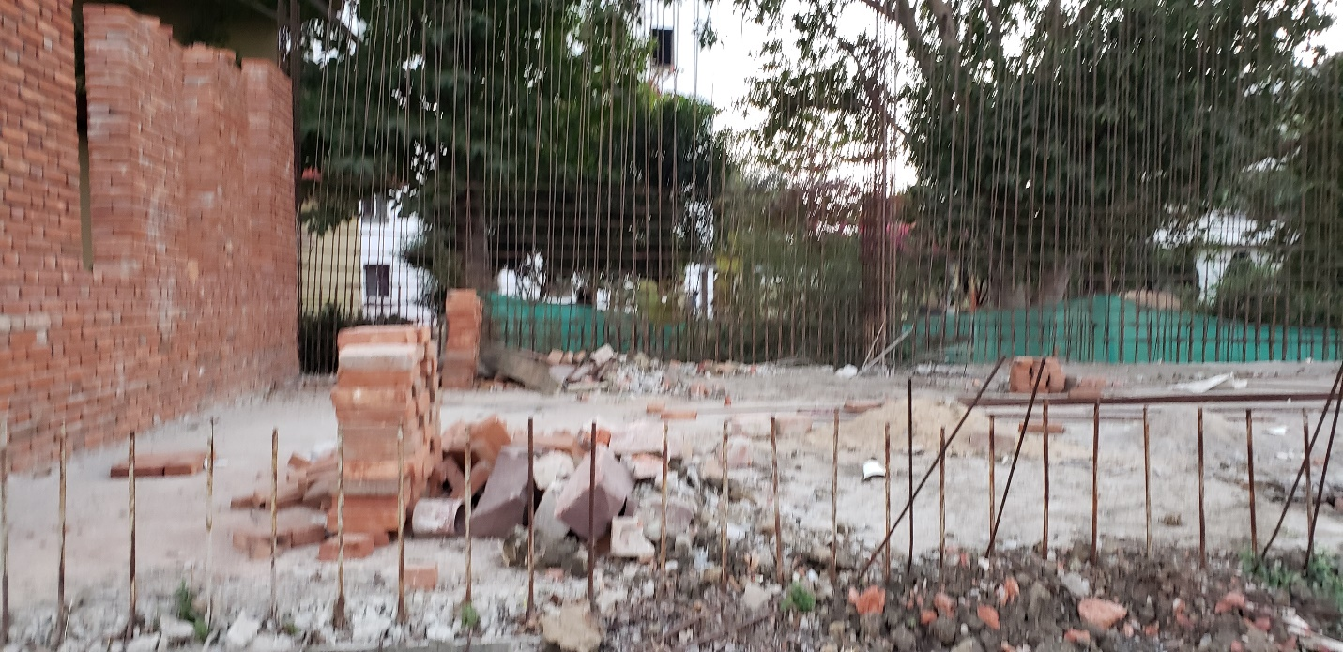
Office/IMW building which will resume construction soon

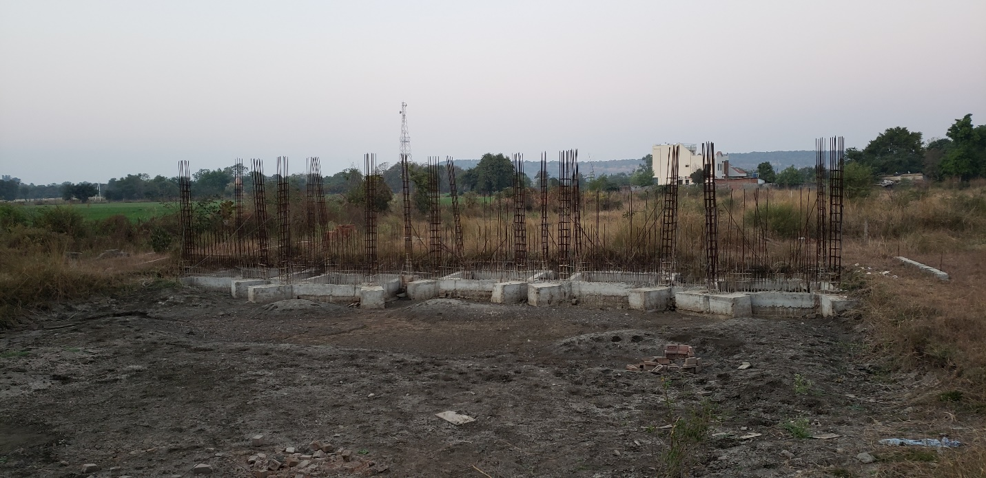
Practice rooms which will be across a pond from the Office/IMW building

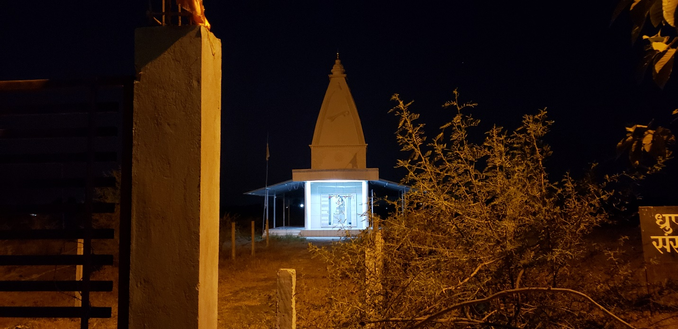
Saraswati temple in early morning

