Aarti Home& Aarti School One-Time Fund Proposal
Nov. 2019
Aarti Home and Aarti school function under Vijay Foundation Trust. Aarti Home is shelter for about 110 girls who have suffered abuse, trafficking and abandonment. Aarti school serves the children from Aarti Home as well as children from neighboring colonies. Currently it has about 430 kids. More about the organization can be found at https://www.aartiforgirls.org/
The school and Home are facing difficulties due to the lack of some basic needs and infrastructure. They requested the budget for the following items. After checking the quotes from various vendors, here is the proposal for the one-time funds.

- Purpose: RO Water filters for school (2)
Amount- INR 1,30,178 No of beneficiaries: 450
Impact: The water quality is poor in the area and currently they are purchasing drinking water for the kids every month. It is difficult for the school to continue with this.

- Purpose: Biomass Chulhas (2)
Amount- INR 46,100
No of beneficiaries: 100
Impact: The school serves the breakfast, lunch and snacks for Aarti Home kids and also other students in need. It gets tough to get the gas cylinders many times and thus serving the food. With a minimum one-time setup of Biomass chulhas, it can serve in long-term.

- Purpose: Washing Machines for home (2)
Amount- INR 90,000 No of beneficiaries: 100
Impact: Aarti Home has 100+ girls from ages 2 years to 20 years. The girls do their own household works. With increasing number of younger kids, it's getting tough for the older girls to wash their clothes and that of the toddlers and go to school. Providing these washing machines will really help these girls to focus on their studies.

- Purpose: Sanitary pad incinerators (2)
Amount- INR 33,040
No of beneficiaries: 240
Impact: With 100 girls at Home and 250+ girls at school, the safe disposal of sanitary napkins is getting challenging. it is giving raise to health issues for the girls as well as the workers. The one-time installation of these incinerators will help dispose the sanitary napkins in an environmentally safe way.
The details of the items requested and break down of the price is given below:
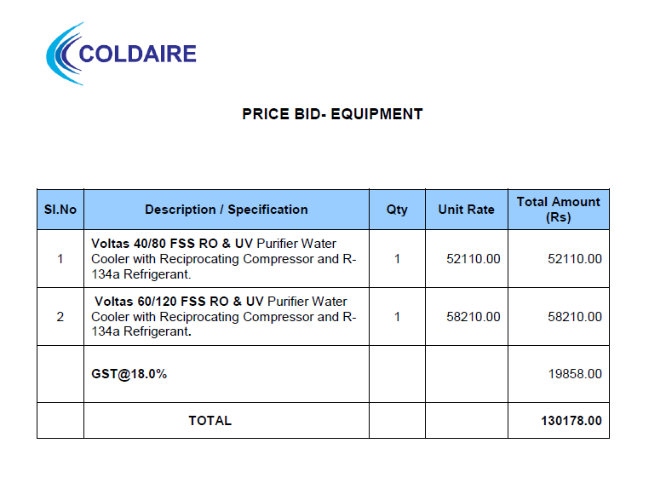
Biomass Cookers for School
Company & Brand | Model No. | Quantity | Total Cost | GST | Total Cost Invoice | Comments
Pyro | MP60 cm | 1 | 17330 | 5% | 18196.5 | Transportation charges extra
Pyro | MP80 cm | 1 | 26570 | 5% | 27898.5 | Transportation charges extra

Industrial Washing Machines
Company & Brand | Model No. | Quantity | Total Cost |  | Total Cost Invoice | Comments
Samsung | WA16N6780CV | 2 | 45000.0 |  | 90000 | It's online price including the transportation and installation charges

Sanitary Pad Incinerators
Company & Brand | Model No. | Quantity | Cost per unit | GST | Total Cost Invoice | Comments
Hi Code | 50 pads per day | 2 | 14000 | 18% | 33040 | Price Includes installation, demo and 1 year maintenance charges.

Total ask: 2,99,313 INR

