Respected sir,
Greetings from Shaaron special school
Sorry for the delay in email. By god’s grace and Asha’s support the school is functioning well. From June onwards I am focusing on raising support from local corporate companies . However, people from USA have given me a assurance to support the school from them but as I have not received any reply, that is the reason I am sending you this email late.
On 22nd march we had conducted sports day at school. On March 28th we had celebrated our 20th school annual day. All the parents of children, friends and well wishers are participated the function.
Usually we close down the school for summer vacation on April 22nd, however this year we are closing on 12th April due the extreme weather conditions and the construction of dining hall. Last year we were planning to construct the dining hall due to lack of fund we were unable to do it. But this year we feel it is highly required for the students.
Last year from Asha we had a person called Karthick coming and visiting the school. This year no one has come to visit the school, so we are in a confusion if we would be receiving support from Asha. As you promised to support for one year, however you supported us for three years. Till the time we did not get a permanent sponsor for the school, if you could help we would be grateful to you.

Waiting for a positive reply from you.
Kindly find the attachment of the Annual day & sports day programme.
Thank you.

Annual day

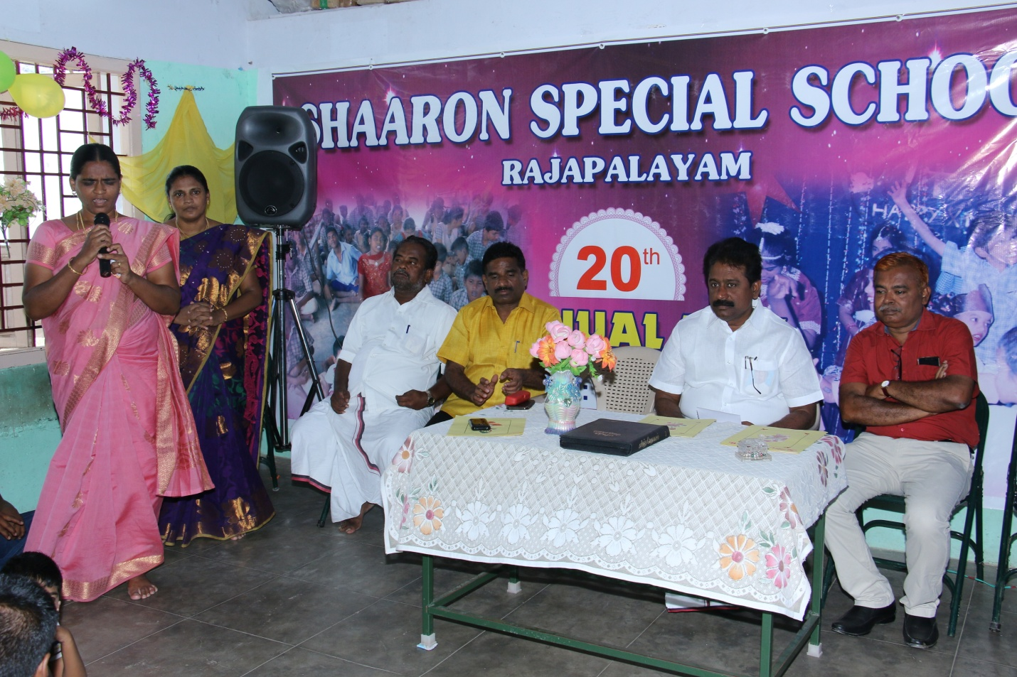

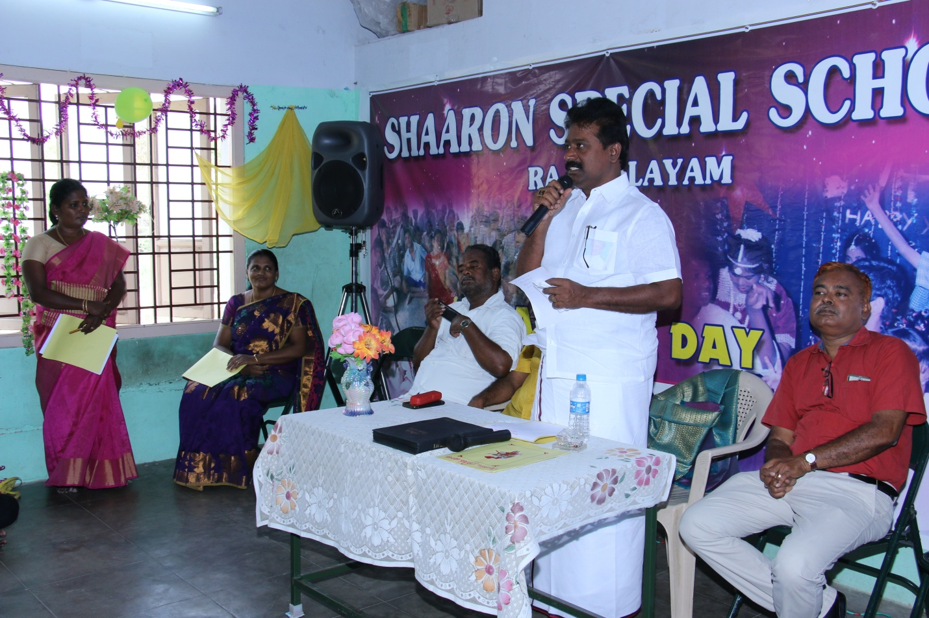

Our MLA Mr. Thangapandian was felicitating in the function.

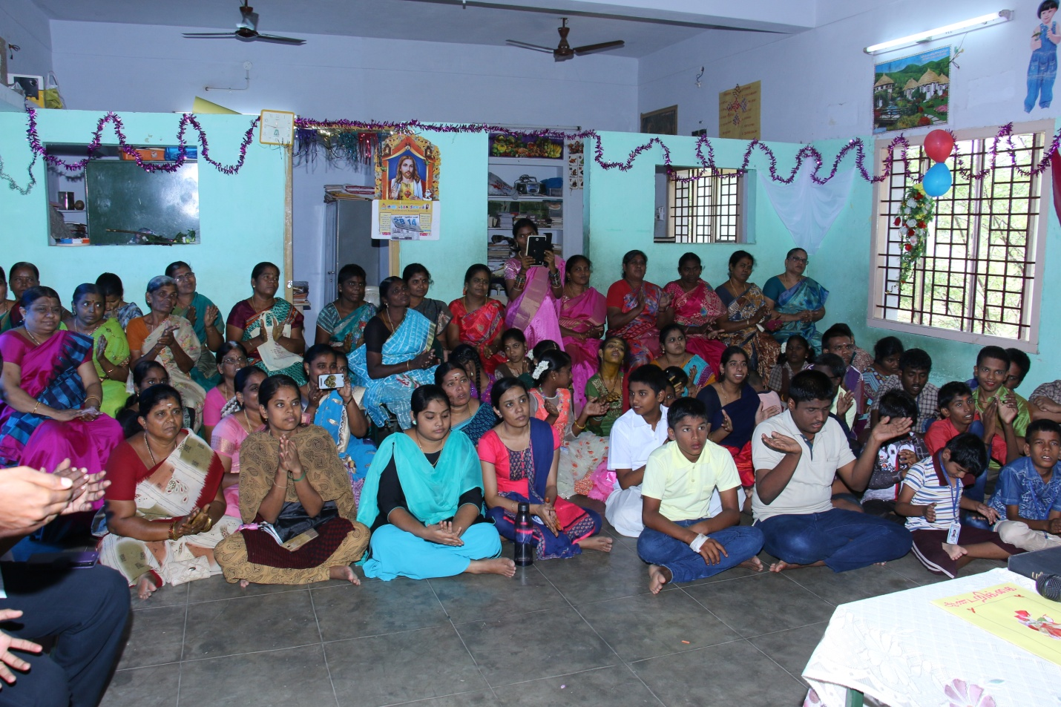

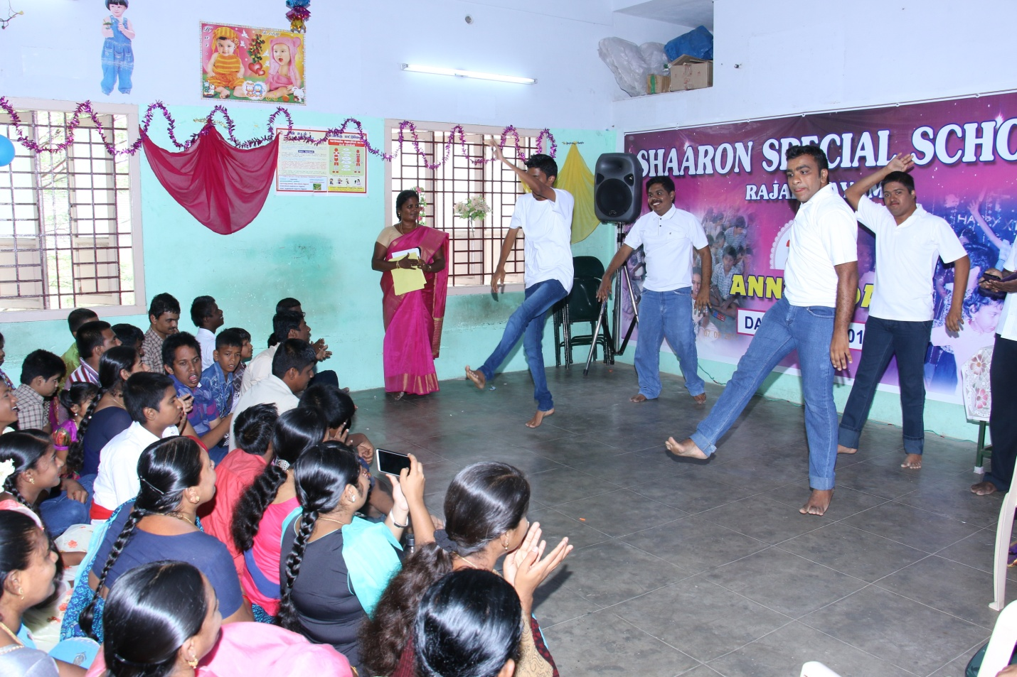

Dancing our children

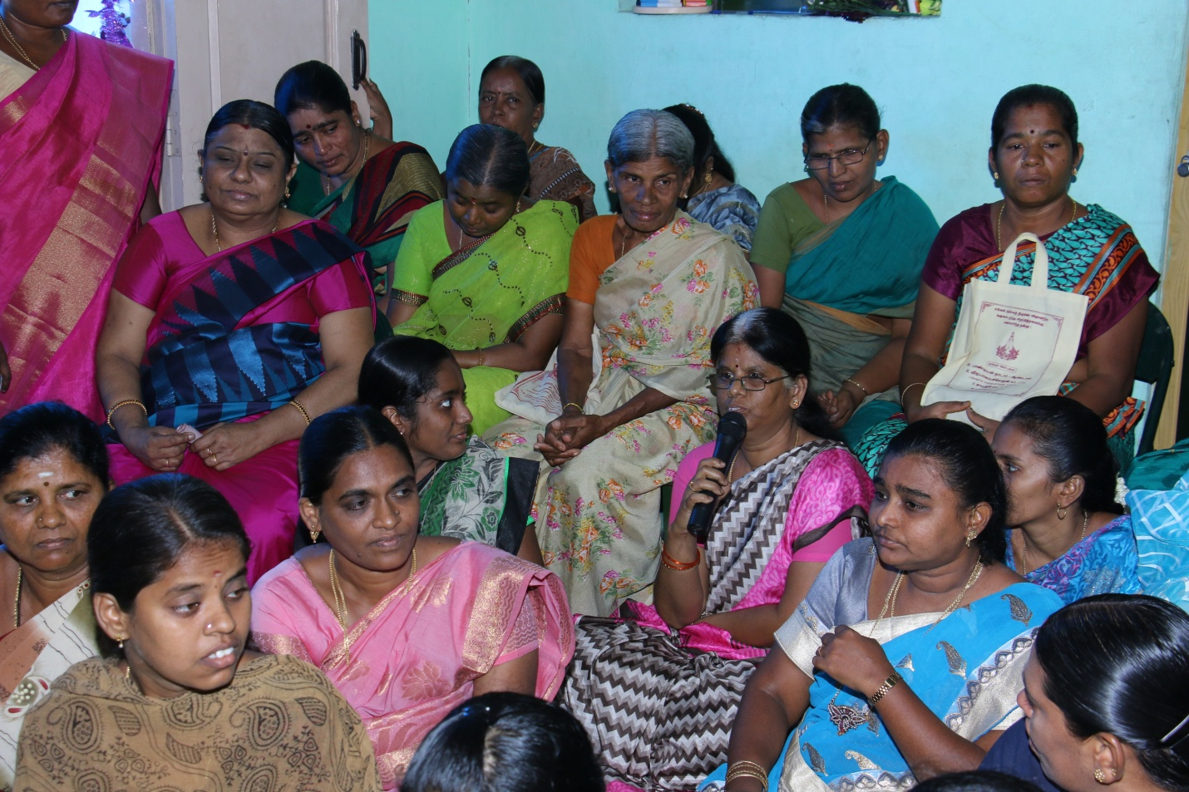

Our parent ( Jothy amma )was giving a application to the government through the MLA.

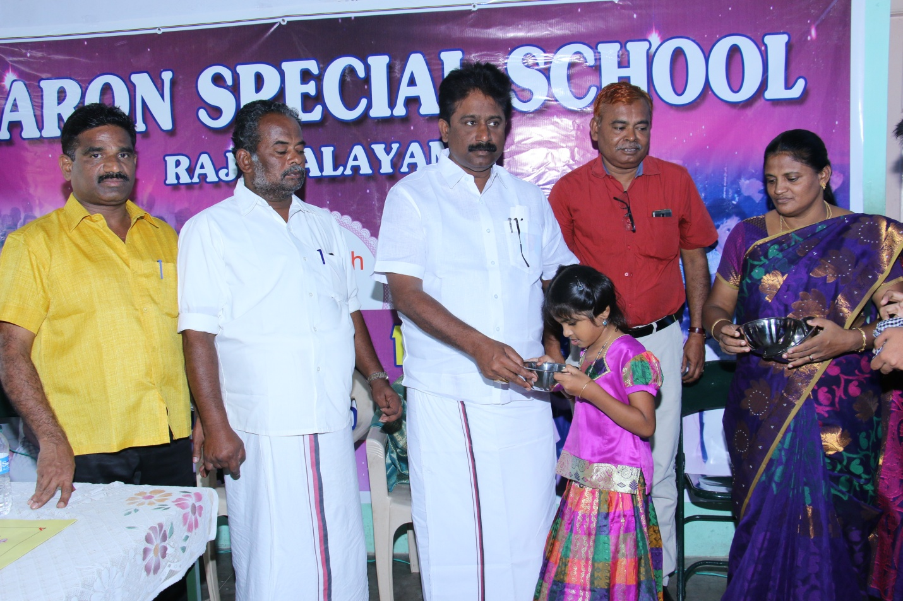

Price distribution

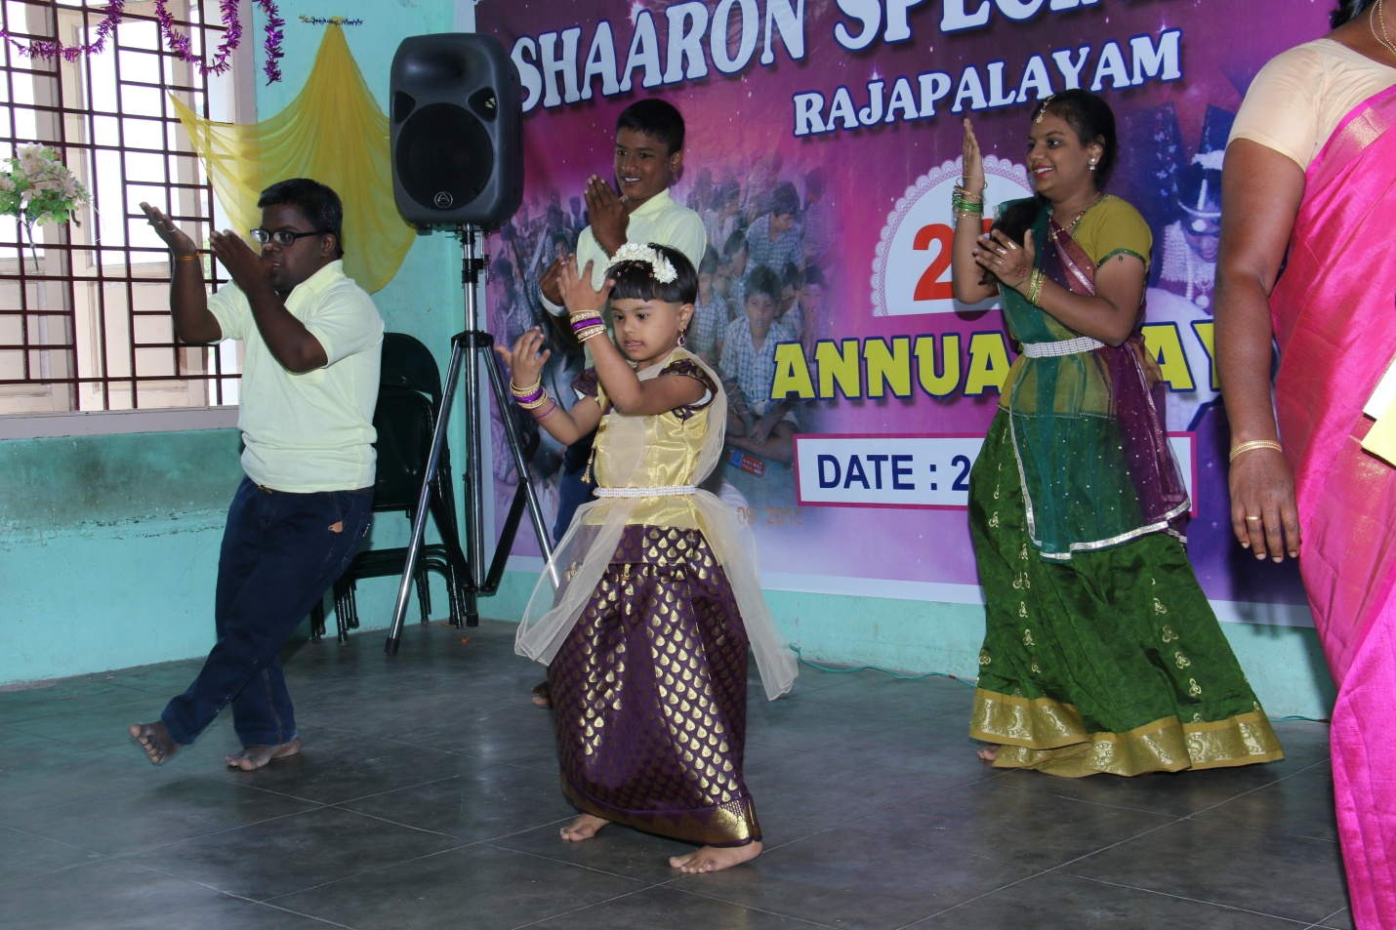

Dancing our children

Sports

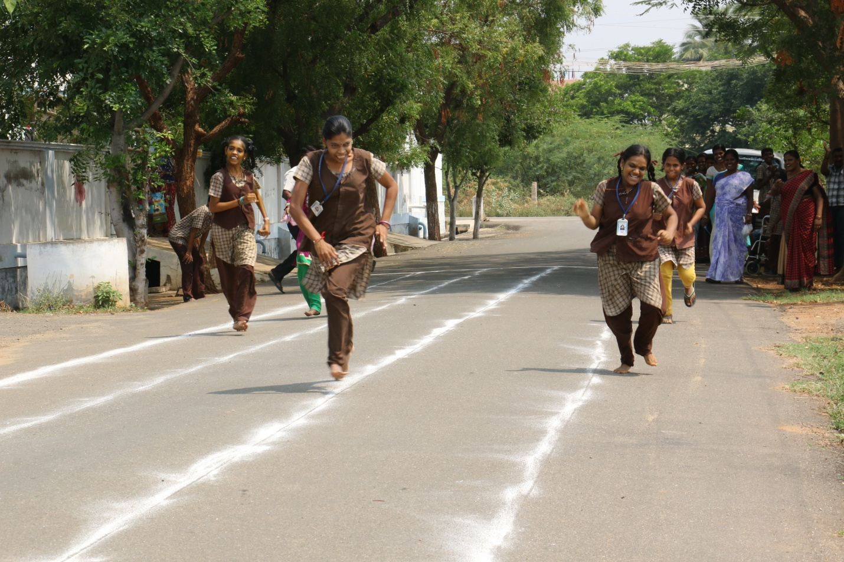

Running Race

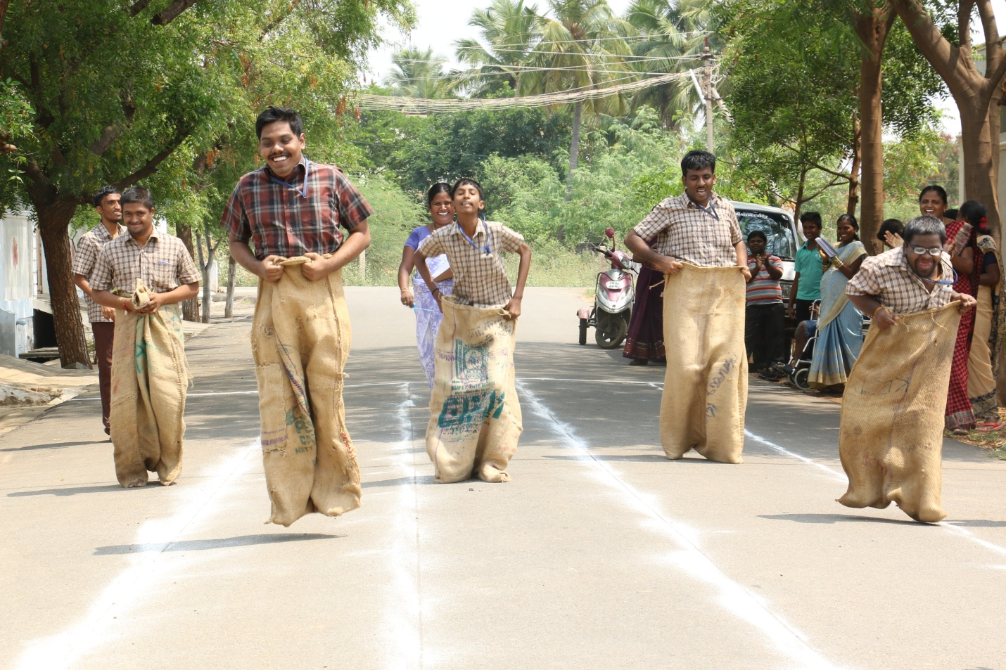

Sack Race

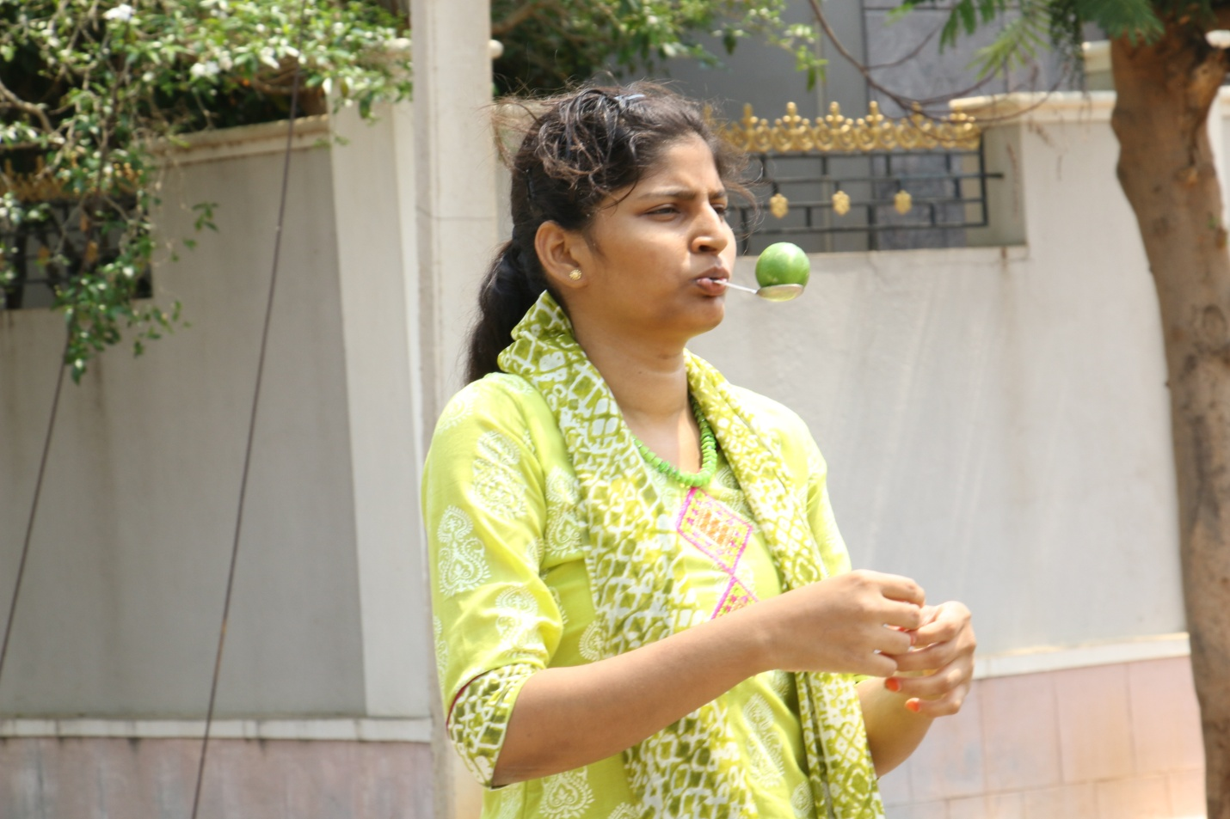

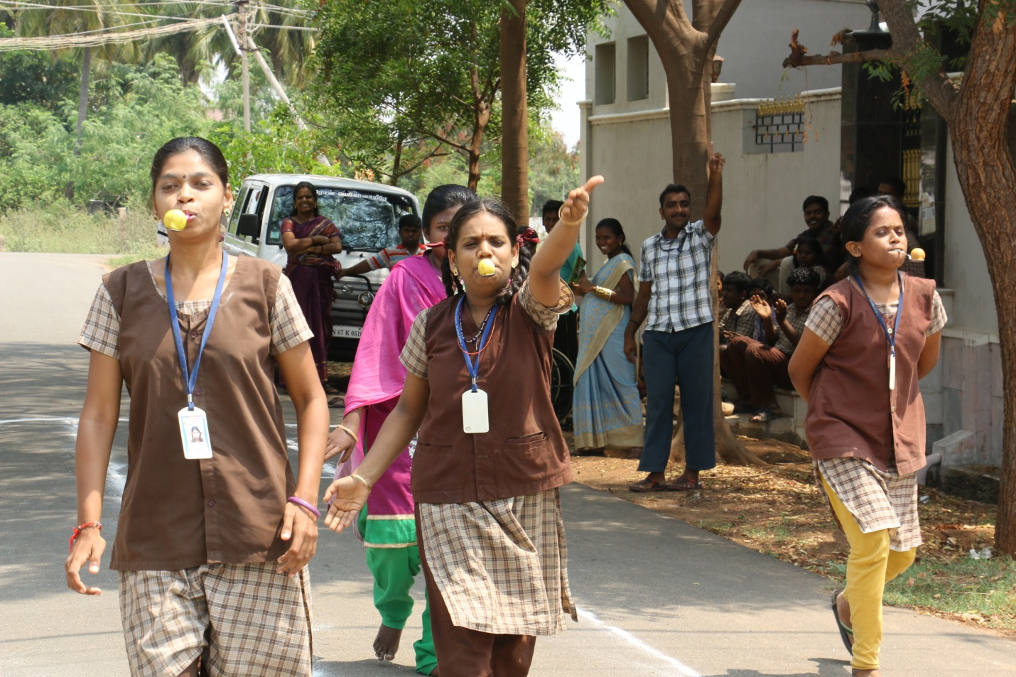

Lemon with spoon

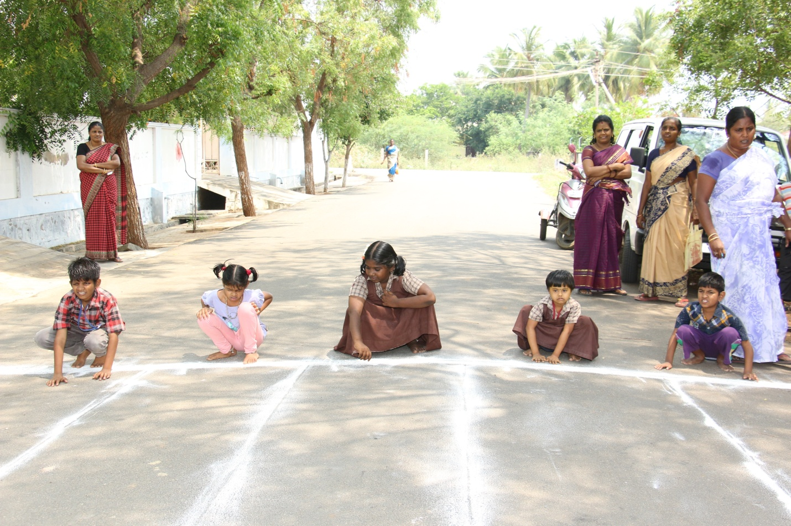

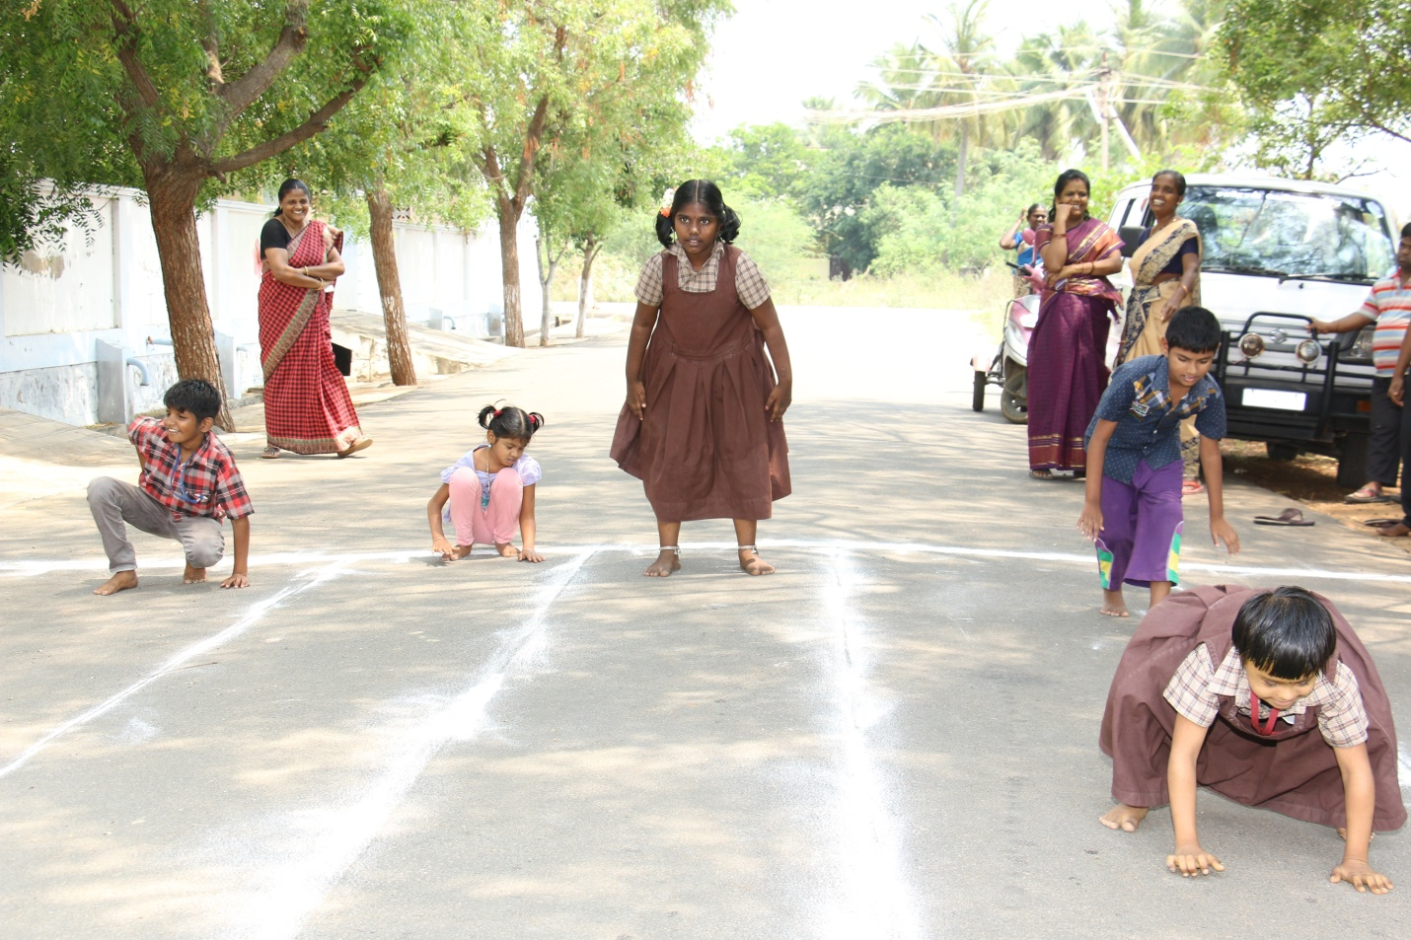

Frog Race

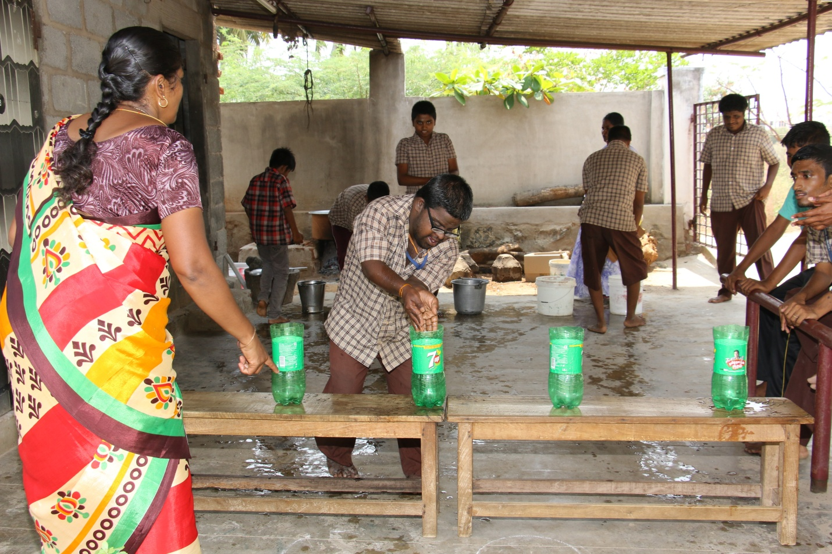

Filling the bottle

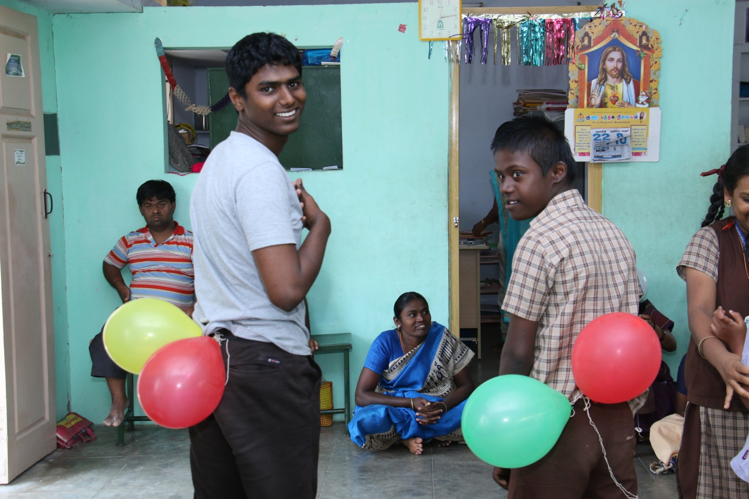

Breaking in the balloon

