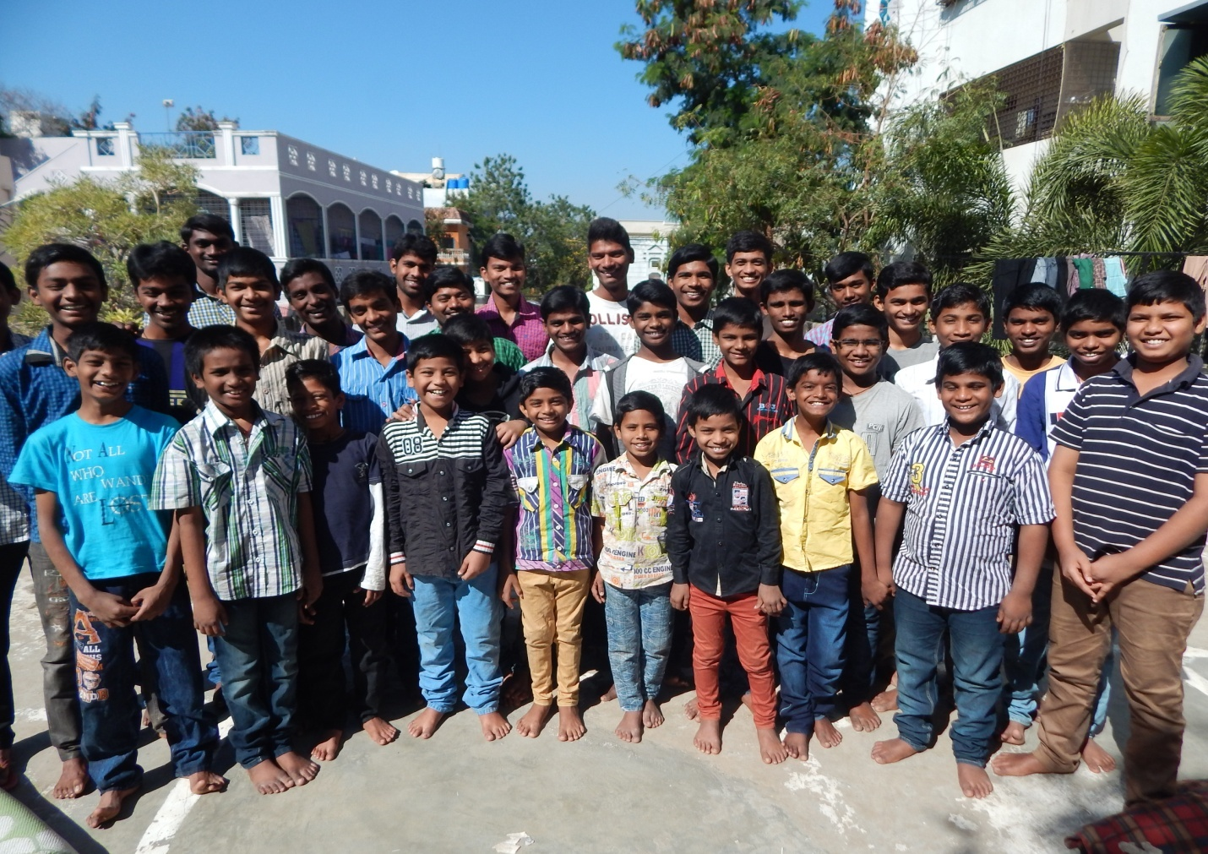MANCHIKALALU PROJECT REPORT FOR ASHA 2014-15

Thank you very much to Asha foundation and kindhearted Mr. Venkat for the great help and support they provided to our organization. We would like to share the progress we made and show the great impact it made on our children.
* Balraj pursuing MBA and also got job this year as a Senior Marketing Manager in ICICI BANK, Hyderabad.
* Sharan got appointed this year as Floor Associate in Walmart India Limited, Hyderabad.
* On completion of IntermediateNikith (65%) is planning to do B.com and Sai Naresh (79%) is planing join in Engineering.
* Kasi completed his Masters in Commerce and searching for a job.
* Sampath and Sandeep completed Bachelors Degree in Commerce and planning to do M.Com.
* We have not taken New Boys in this year 2014-15.
* Few of our boys acted in a short film named "SPANDANA"- which is based on the sensitive subject; influence of caste of Orphans on their education and job Reservation. This is sent to Prime Minister of India. Please watch this movie for 15 minutes. Link: https://youtu.be/fUhnlMB58c4.
* Two of our 10th class boys got failed in maths subject and getting prepared for instant exam thereby not wasting anacademic year.
* Right now there are 36 inmates in our home.
With your support, we were able to support 30 children by paying the fee for their education. Please find the details below table.
Donation received from Asha | 4,20,000.00
School fee for 24 boys going to school (till 10th class) |  | 2,19,000.00
Paid fee for Mr. Mani Kumar for his VFX Course final |  | 54,000.00
Paid fee for Mr. Sai KiranB.Tech. |  | 34,000.00
Paid fee for Mahesh B. Pharm |  | 34,000.00
Paid fee for Veeresh C.A. |  | 34,000.00
Paid fee for Kasi M.Com. |  | 17,000.00
Paid fee for Balraj M.B.A. |  | 28,000.00
Total |  | 4,20,000.00

Following are the expenses per month (Apart from Education)
Home Rent | 19,000-00
Staff Salary | 40,000-00
Provisions | 30,000-00 ( Including Rice )
Milk | 9,000-00
Electricity & Phone | 8,000-00
Water Tankers | 12,000-00
Medication | 6,000-00
Evening Snacks & Fruits for Children | 3,000-00
Miscellaneous (cloths , Birthdays, slippers ect;) 10,000-00
Total 1,37,000-00

Plan for 2015
We want to thank our current supporters that helped us with the needs like education, accommodation, grains, cloths etc.
- MAA TV Channel
- Other Sponsors
This year (2015) we requirefollowing support for education needs for our children
Total requirement | 6,23,250-00
received from MAA TV | 1,00,000-00
School fee for 22 boys going to school (till 10th class) |  | 2,47,250-00
College fee for 14 boys |  | 3,76,000-00
Present requirement | 5,23,250-00
we are trying our best to fulfill the above needs. At this point, we were able to meet them partially and looking for more help.
We also take few other needy children referred to us by Police Dept, Print & Electronic Media and some foundations. We want to accept some of them into our home and provide the homely environment. But we are not able to do so for a couple of reasons:

- Do not have enough space at the current house. With the supporters like you we have purchage bare land and looking for funds for construction.
- Need more financial support for their education
- Need more support for their general and special needs to bring them into the main stream
- Need more support for their medical needs.

We want to thank you all at Asha and their supporter for providing the support and enable our children have a homely environment.
We would like to request for further support for the above needs. we request for the support of Rs.5,23,000-00 to meet our most prioritized needs given below:
- Education needs for 22 children at school, to arrange tutions for highschool boys.
- Education needs for 14 children at college,
- Training preparation for Bank exams,
- Training needs for B.Tech students,
Any amount of support is really appreciated.

We are also looking for a little bigger facility so we accommodate more need children. Here are couple of options we are exploring:
- Rent bigger house, in order to accommodate more needy children, we trying to rent a bigger house in the same locality (west marredpally, Secunderabad) as the school which children are studying now in RM High School will be nearer and also not to loose the local sponsors. However rents are at a higher side (40,000-50,000 per month) which will not be able to afford. So looking for help for it too. At present we are paying rent 19,000-00 per month for present house.
Our bigger aspiration
Construction of house in purcheged land.
- Still trying to get support from state government in the city area.

Please do let us know if you have any questions on any of the topics in this report. We are more than happy to share the information.
We want to welcome any of the NRIs or your local representatives to visit our current facility. Please advise if I can coordinate with anybody locally.
Please let us know any documentation you may need. You can always reach us at daddy_manchikalalu@yahoo.co.in or on my phones: +91-40-27718817, +91-9848211992.

Please find the couple of pictures attached.
Thank you very much and appreciate all the help and the efforts you are putting for the needy children and humanity.

Thank you.
Sarath Kumar Puppala,
President,
Manchikalalu Organization.
