JKSMS Visit (Padmanava Sen – 10th Jan 2017 – padmanava.sen@gmail.com)

Snapshot of Visit:
- Visit Summary
  - Met Mr Narendra Kumar (Project coordinator) near Hawamahal, Jaipur on 10th January 2017 around 9-30 am.
  - Visited the center at Paharganj area and interacted with kids.
  - Mr Kamal Kishore arrived and went to the office of JKSMS after visiting the residential hostels run by JKSMS.
- Overall impression
  - JKSMS has been working grass-root and very well respected in their field areas. Their outreach is beyond Jaipur and they have many centers running imparting vocational skills (working with USHA CSR wing and other partners).
  - These center mostly targeted to the migrated population in Paharganj areas not only acts introduce kids to “interactive learning methods”. It teaches them hygiene, manners and ways to express/communicate.
  - They work with Government schools and mainstream these kids after six months to 1 year as needed. The quality of education was quite satisfactory based on my interaction with Kids.

Details:
Background - More than 80000 people live in Paharganj area in the jewellery business. They came mostly from Bareilly, UP. Some of them keep coming and bringing more people in turns. There are people from West Bengal as well. Most people where they work are Urdu speaking. The area is very congested and communally sensitive area. Most kids from these centers are mainstreamed within 2 yrs. However, there are some kids who work in family business and do not want to go to formal schools (more time commitment). That is why in these centers, both theoretical and practical knowledge are imparted so that they can be a better entrepreneur. JKSMS also run training centers as well apart from ILM centers where they provide skills in Jewellery making. There are not many Government centers in these areas because of group requirement (minimum 30) and age requirements.
Operations – The visited school has started in 2008 and it runs from 9 am to 2 pm. After school hours, skill development training runs in these centers. Also, back up coaching and computer training are provided in already mainstreamed students from Government and private schools after school hours. During regular ILM hours, there are 3 teachers. Apart from that, skill development teachers and computer teachers are also employed for the after school hours activities. For the kids, who work outside school hours, their parents do not create problems any more. After the modifications of Child Labour Law, children can work with their family legally as long as parents provide facilities for learning without the minimum 14-yr requirement. Jaipur, (as a whole, Rajasthan) otherwise has a lot of child labour problems. Even the Jewellery business agents used to create a lot of problems in the early days and then they have to mobilise the community. They convinced the requirements of skilled workforce and the need of training/knowledge. In recent years, free market has lots of Chinese jewellery products and hence the local market needs to create better products at competitive rates. Hence, people understand the need of proper skill training and use of technology. JKSMS also runs hostels for under-privileged kids partly working with Government.
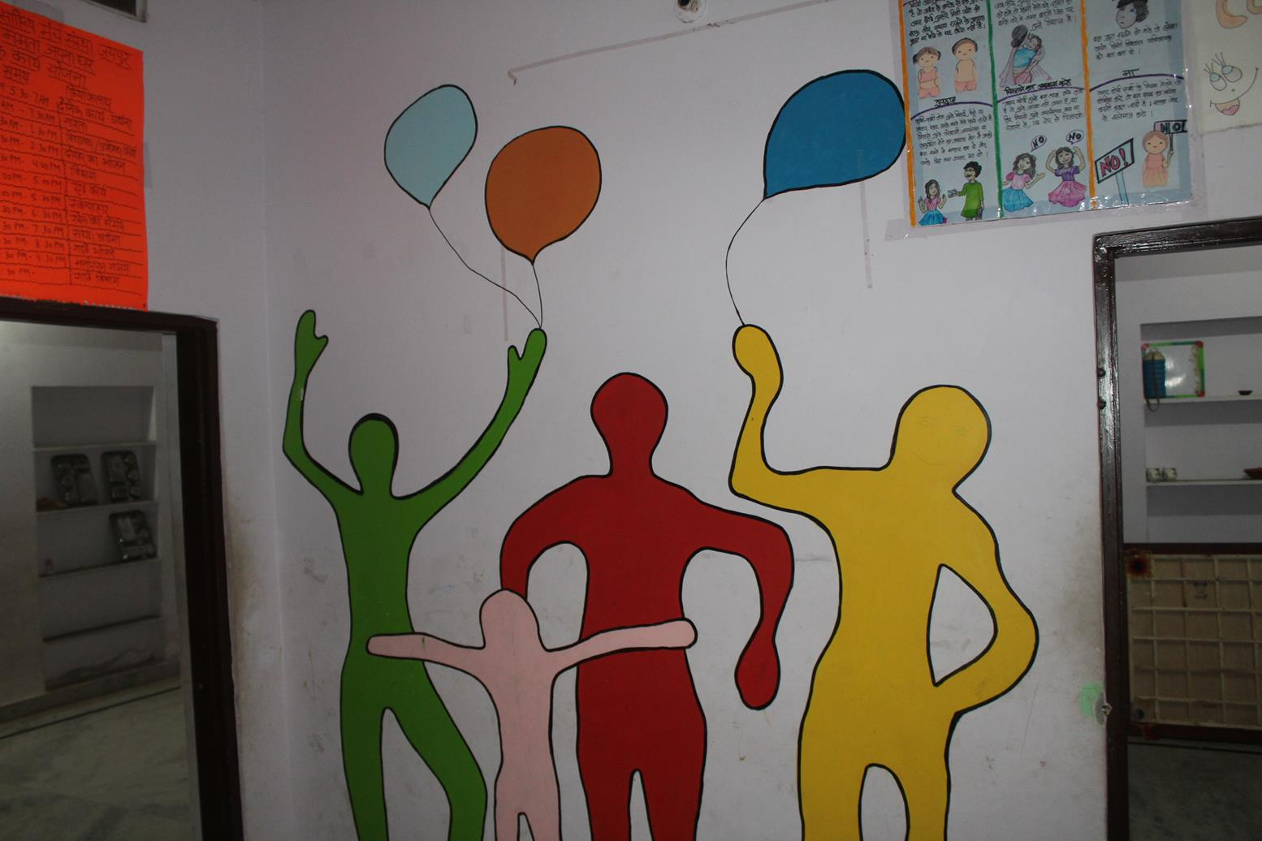
Wall drawing in Hostel run by JKSMS
Interaction with Kids
There is a log book under the Child Health Educator initiative. Children maintained that as well making sure everyone follows standard hygiene practices when they come to school. This is impart to good habits that they can improve their lives. 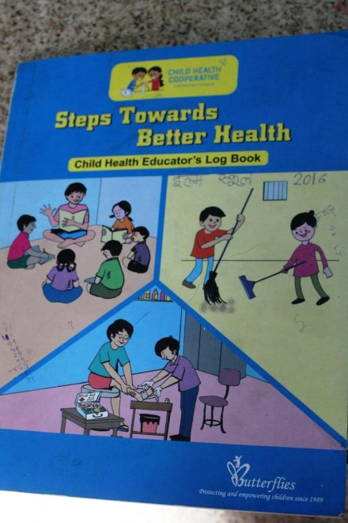 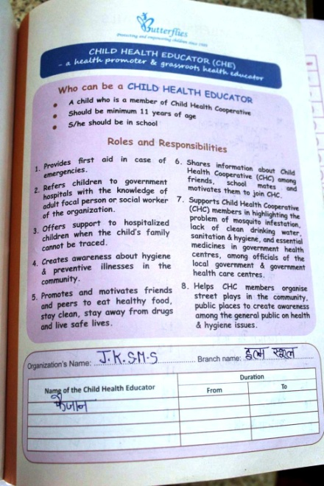

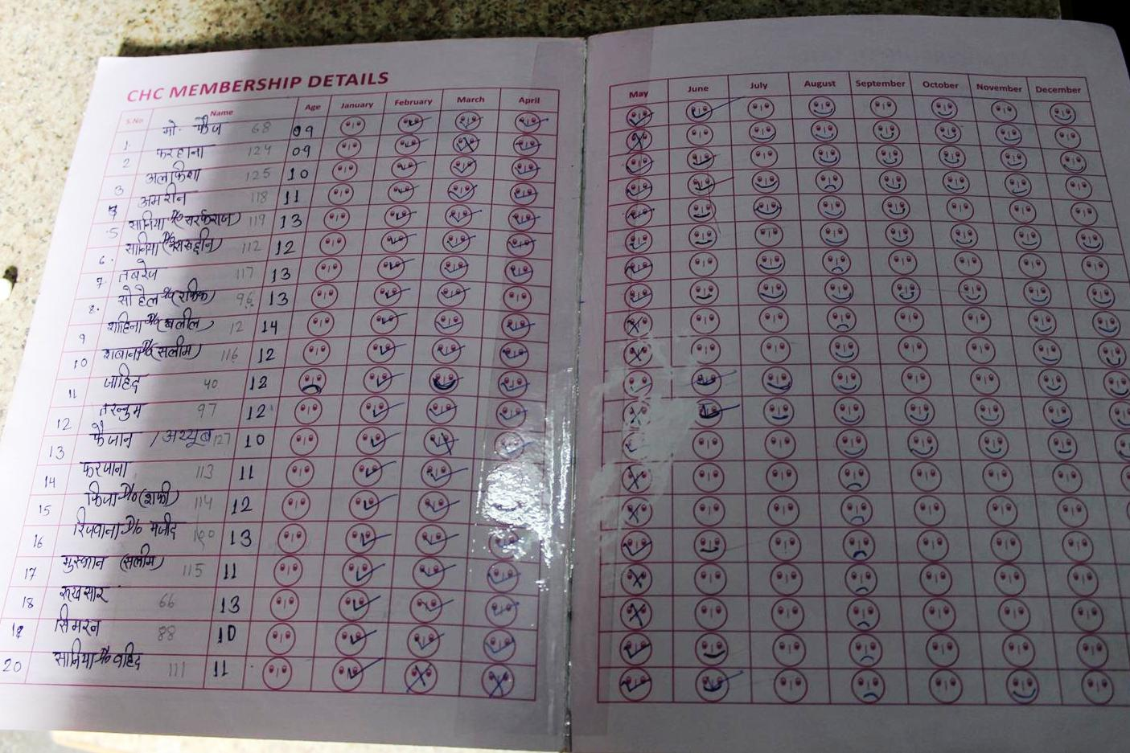
CHE Book
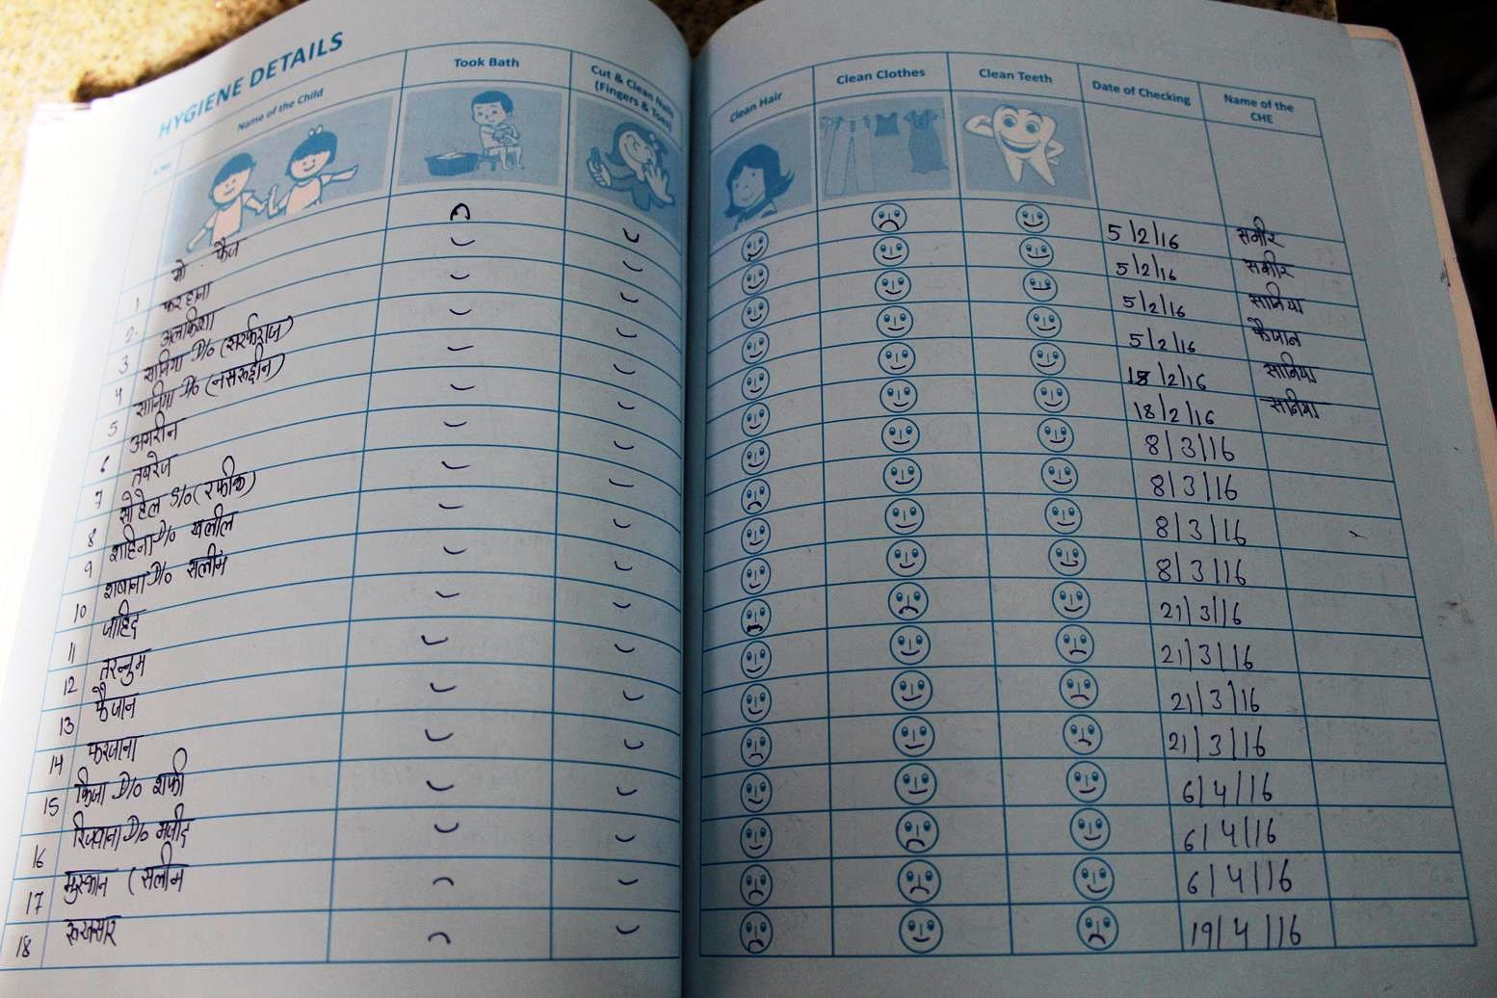
Health Check Tables
I have checked the regular language skills like Hindi reading, English vocabulary (words starting different letters) and simple additions. Most students can do that. Overall the children are well trained and smart. There are two classrooms based on the levels. The classrooms have a good number of charts and very good learning materials used them to introduce to numbers, alphabets and words. I spent around 2 hours in the school before leaving for their office.
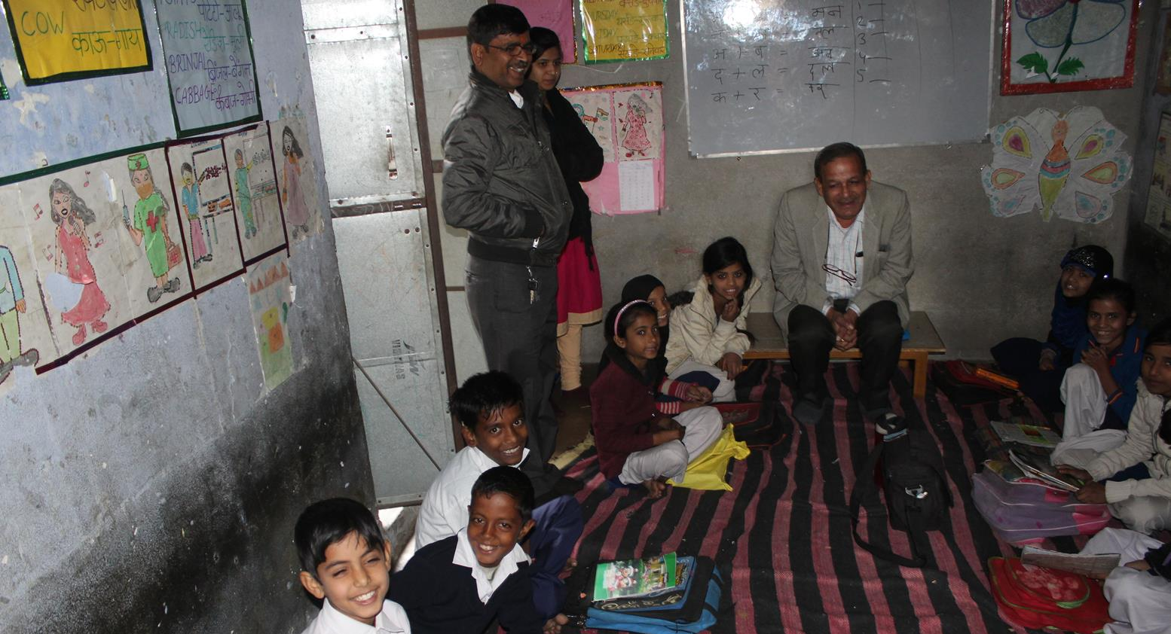
Mr Narendra Kumar and Mr Kamal Kishore interacting with the kids
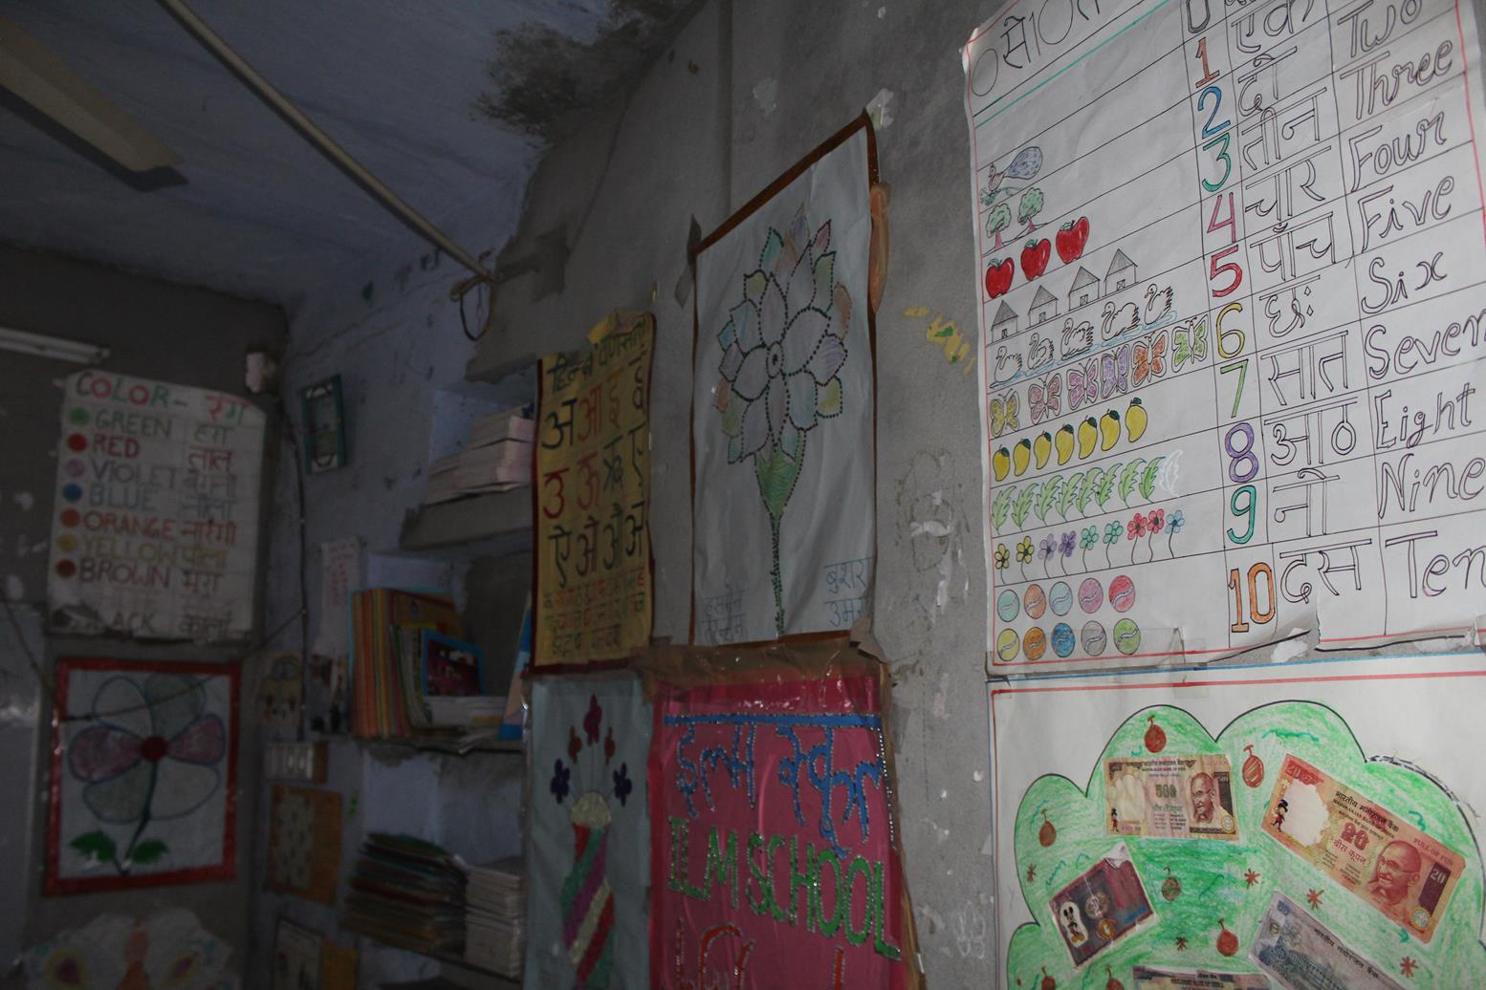
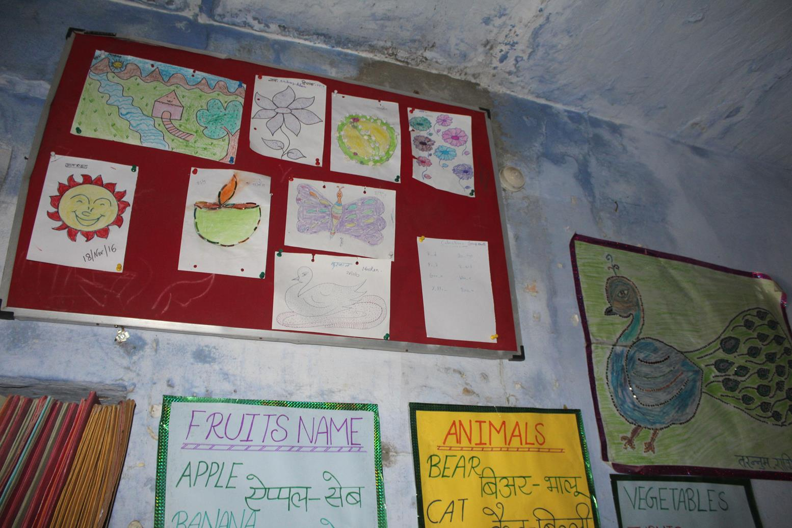
Classrooms of ILM School
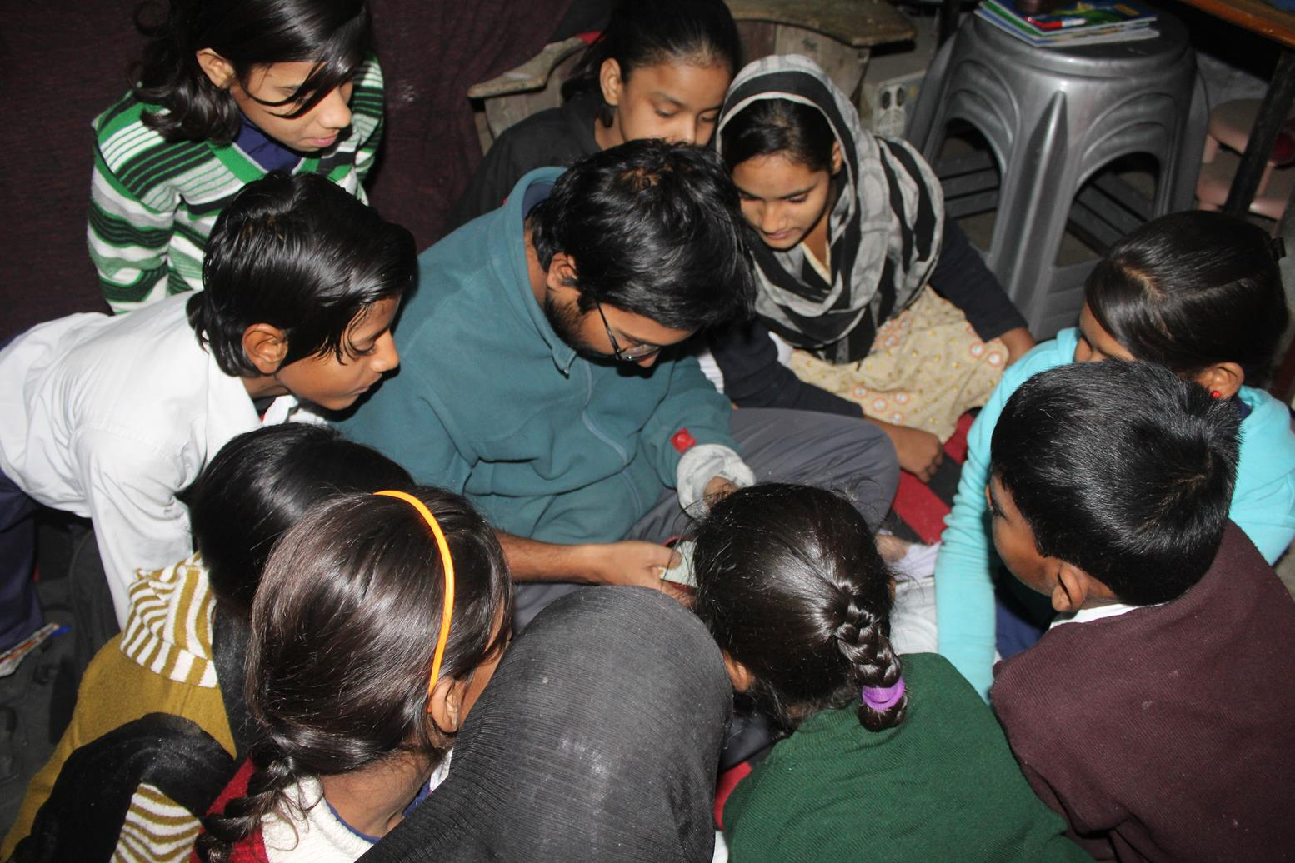
I was showing a video of my tiger encounter
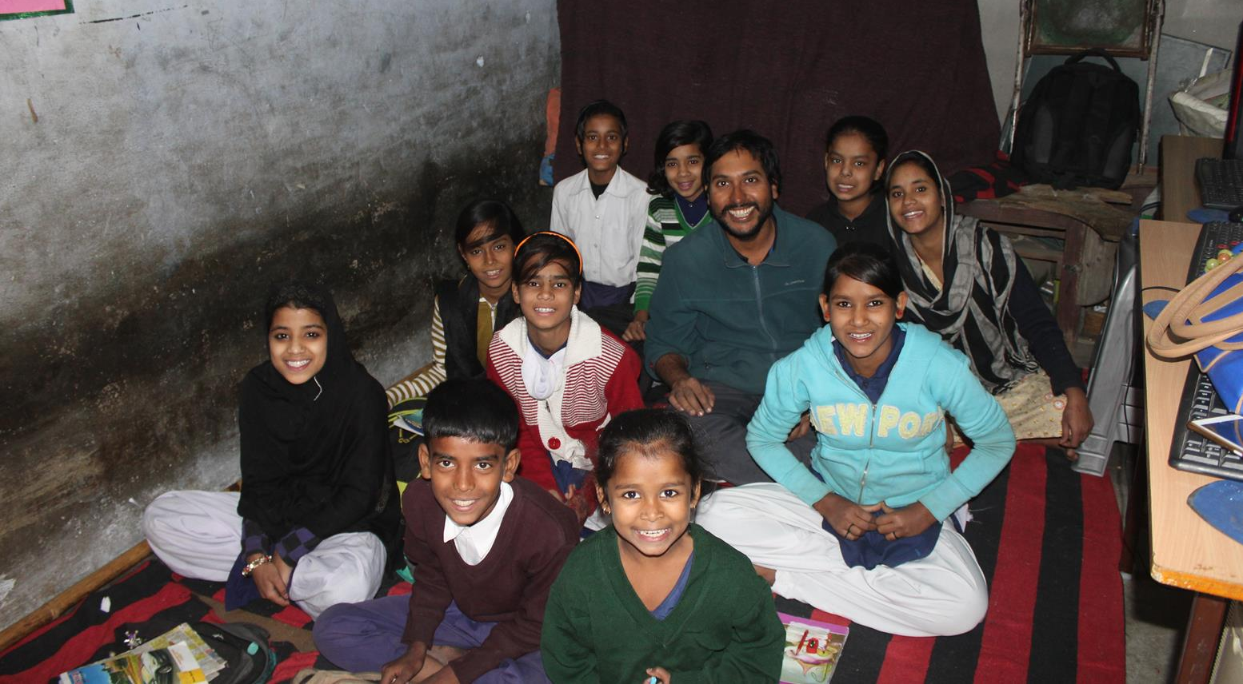
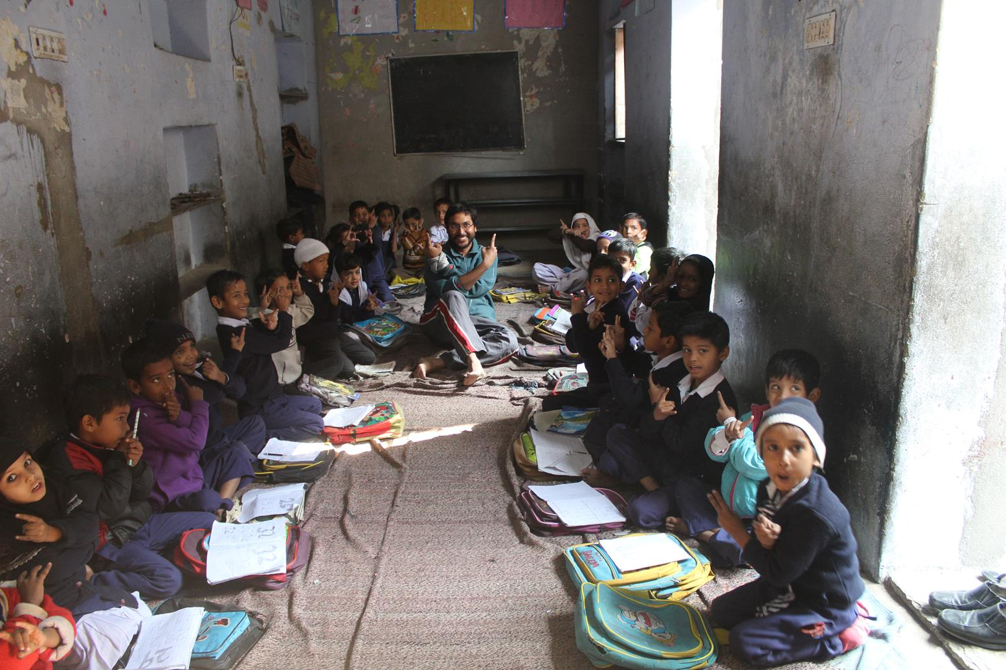
Me with the kids

