SUMMARY OUTLINR FOR ACTION PROGRAMME ON CHILD EDUCATION
BELONGING TO THE UNDER PREVILEGED COMMUNITIES (AGRAGATI)

1. WORKING TITLE:-Educational initiatives leading to socio-economic changes.

- LOCATION(COUNTRY, PROVINCE, CITY)

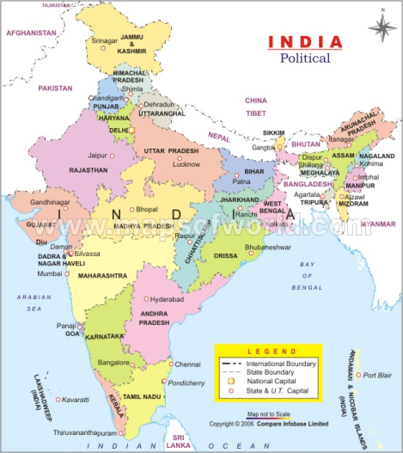
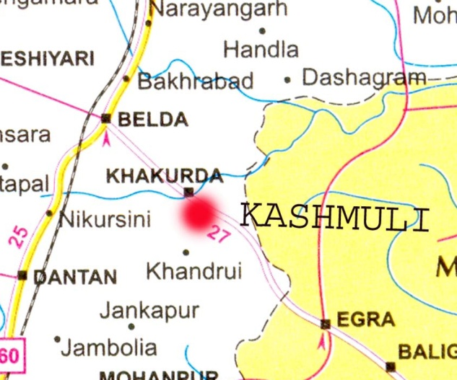

Country : India
State : West Bengal
District : East & West Medinipur
City\police station : Belda
Project Site : Kashmuli (about 10 kmts. from Belda)

- Background of the area and justification

In a country like India almost a large number of villages suffer from some basic maladies where a large section of people has no access to potable water, sanitation, shelter and education, so an efficient Health Care system is wishful thinking. It is the basic aim and objective of the Sarvik Vivekananda Gram Seva Sanstha to adopt the villages and implement projects by which the economic standard of the people improve the village become self sufficient and further the basic amenities for the village people should be made available to them. The basic amenities which is very much lacking in the selected village. It is a fact that the poor and the needy backward people of this project area could not or rather did not try to get organized themselves as yet in the direction of development due to the pressure of the circumstances. In a sense this may also be due to lack of awareness or ignorance which has been instrumental to keep them away from the development initiative so far undertaken by the Government and the other development agencies. This initiative will help the beneficiaries to be organized and be made aware about opportunities available.

The villages chosen here for conducting project activities are the remotest, backward area of rural West Bengal, situated in the district of west Madinipur.To begin with the village Kashmuli is situated in the district of west Madinipur under Dantan 2 block about 190 kilometers away from Kolkata metropolitan city. The area is pre-dominantly tribal and scheduled cast belt and the inhabitants solely depend on agriculture to earn their livelihood. More over as the land belong to some rich families, a large chunk of the population earn their livelihood as daily labourers, and remain jobless during of agricultural season. Hence most of the population is extremely poor and live in in-human condition. This project started to reopen a 8th grade school which was closed year 2009 due to funding problem. This school was established by a donor from Canada ( Sujit Chakrabarty) in a rural village of west midnapur, Egra block on 2007. This school was established in an area where mostly poor, underprivileged families are living and there is no high school around the place. SARVIK, a volunteer organization from Kolkata helped to find donor and continue running the school. But after two years they are out of funding, resulting the school was closed. Although few families can afford the cost but most of the families did not able to afford the budget of the school. Once this school will run for few years SARVIK can approach to government for funding for teachers salary and others and government affiliation.

4. Objectives

The village is inhabitant by pre-dominantly scheduled cast, scheduled tribes other economically and socially backward communities deprived of education, shelter, sanitation, drinking water, health care etc. Sufficient economic development and adequate literacy- these two things are the pre-requisite for a welfare society. Even after 60 years of independence these areas are lagging the both. Our main thrust to address the problems as a whole.

The present project has two clear objectives.

- The primary objective as to give education to the children.
- The second objective is to make them self- sufficient and confident to stand upon themselves.

5. Action programme

Both the objectives would be realized through a comprehensive curriculum and set up of school in the project village. The environment of school area to be free form dust of noise and ensuring the rooms are bright clean and well ventilated.

- Provide primary and junior-high education to the age group 3-14 years.
- Prepare the children upto class viii standard based on the curriculum of school education to facilitate them to get admitted to the secondary schools of format education.
- Set up hostel for the children of poor, needy and under privies communities.
- Conduct socio-economic programme through work education like gardening, Bee-keeping, Mushroom and food processing etc. to make them self sufficient and confident.
- Promote ethical and cultural values through arts and crafts, dance, drama, music, brotachari & other extra curriculum activities.
- Provide supplementary nutrition to ameliorate there nutritional deficiency.
- Provide basic health care.
- Provide physical fitness programme and other recreational activities to ensure that children enjoy their inalienable childhood rights.

6. Target group

Children belonging to the schedule casts, scheduled tribes and other socially and economically backward communities in the age-group 3 to 14 years.

In the wider sense children above fourteen years would be covered to impart vocational training to raise the economic level of the community.

7. Major Activities

- Identify, select, orient and train staff,
- Identify the Gram Panchayat and the location for planning of the school and hostel.
- The school will conduct according to the WBBSE educational system.
- Enroll 150 students to undergo the course of pre-primary and primary education
- Select 25 students for the residential hostel.
- Conduct vocational training with 20 trainees in each batch.

8. Institutional Framework

The Sanstha is an integrated development centre was founded in the year 1993 consisting with ex-trainees of Ramakrishna Mission Samaj Sevak Sikhsana Mandir, Belur Math, Howrah. Since then constantly rendering services through its different wings in the field of education, health and hygiene with stress on rural sanitation, socio economic programme with emphasis to develop employable skills among unemployed youth through vocational and technical training, child and women welfare etc, under constructive guidance and advise of Swami Vivekananda.
Our network spread mainly in the rural and ruro-urban areas of different districts of West Bengal and Orissa respectively implementing several programmes aimed at education, health education, health care both preventive and curative, income generating programme by imparting vocational training on different trades, environmental awareness development etc. We have a team of professionally qualified and well experienced personnel having a well disciplined volunteer force with a rural base to implement our schemes and programmes.

9. Financial budget

i) Honorarium of Headmaster Rs 5000x12 months Rs. 60,000.00
ii) Honorarium of a Teacher (Work & Physical Rs 3000x12 months Rs. 36,000 .00
Education)
iii) Teacher (4 persons) Rs 4,000x 4 x12 months Rs 1, 92,000.00
iv) Lady worker/Attendant (2 persons) Rs 1500x2x12 months Rs 36,000.00
v) School uniforms Rs 150x150 Rs 22,500.00
(Shirt Rs. 100/- Pant Rs. 50/-)
vi) Books & Pens Rs. 250x150 Rs. 37,500.00 vii)Recreational, sports & games items Rs 100x150 Rs 15,000.00
viii) Supplementary food (Nutrious) Rs 6x150x200 days Rs 1,80,000.00
ix) Health Care (General) Rs. 100x150 Rs 15,000.00
x) Computer literacy (2 nos Computer) Rs. 18,000 x 2 Rs. 36,000.00
-----------------
Total RS- 6, 30,000.00
============

(Rupees six lakhs thirty thousand only)

Now we would request you to ensure your financial support to run this school so that the children may continue their studies and be self reliance.

9. Support provided by the participating Institution.

Be it may kindly noted that the activities of study centers, hostel and socio-economic program as stated in the project would be financed by our own /others resources. Also we state manpower and all such other inputs as are necessary to realize the objectives of the programme that are not specifically being contributes by funding agency.

Development could be ensured only when the children could be guided to be active, aspiring and confident form their childhood. The progress would be slow but steady, effective and be able to take upon the responsibility of their own development in the years to come. Welfare of the society depends on the well-being of its children and education. Only adequate education can achieve this goal. So we intend to take up initiatives to educate the children at the grass root level in a comprehensive way supported by work education so that they may learn employable skill also from their childhood.

