Dear Volunteer

Thanks for conducting this site visit.

The following set of questions is only a suggested guideline. Some of the following questions may not be relevant or applicable to the particular project you are visiting, but please do try to answer as many of them as possible. Please note that Part sB & C necessitate that the information be gathered through conversations with the children and their parents, and not simply the group's teachers and staff.

Please feel free to attach any documents/photos you feel are pertinent to the project.

Thanks.
- Asha for Education

---------------------------------------------------------------------------------------------------------------------------------------------------

Date: December 22, 2015.
Name of the Project: Prerna – 4 (Vocational Training & Placement of 120 Students)

Name of the Organisation Running the Project (if different): Etasha
Was your site visit announced? Yes, it was planned No, it was a surprise visit

 | Project Contact | Your Name  (Asha volunteer conducting the visit)
Name | Dr. Meenakshi Nayar | Anil Gujral
Address | ETASHA Society,  E 48 Greater Kailash Enclave II,  New Delhi 110048  India
Phone(s) | +91 11 29221320 / 21 / 22
Fax | +91 11 29213319
E-mail | etasha@etashasociety.org | anilgujral46@yahoo.com

PART A: Particulars about the organization and its environment

1. What are the different focus areas of the organization? (give a rough estimate of the % of their total effort/funding)
Community development % Education ___ % Health %
Other 100% (please specify) Vocational
2. What is the administrative structure of the group (e.g. Board of Directors/Grassroots-based)?
a) Governing Council (14 members) + 2 Permanent invitees : employed in the Governing Council.
b) Overall control is with the President & CEO (Meenakshai Nayar).
c) 25 Facilitators (Teachers).
d) 6 Community Mobilization Teams
e) A few committed volunteers (free service).

3. Are there any other organizations working in the area providing any one or all of the services provided by the visited organization? (Briefly mention their names and their objectives)

Organization | Objectives of the organization
Basix | - Vocational Training (Govt. Projects/funded).
Khazani | - Vocational Training (Privately funded)
4 – 5 others | - Health, Education, Sports.

Note : Only Etasha is a non-profit organization in the vocational training segment.

PART B: The organization and the community it serves
(Information to be gathered from parents and children)

1. Approximately how many families live in the area? - 50,000
2. What do the parents do for a living? (Agricultural worker, Daily wage laborer etc.)

Mainly small traders, vegetable vendors, auto-rickshaw drivers, gardeners, security guards, drivers, construction labor.

3. At the time of enrolment, does the school ask for the names of both parents?
Yes No, just the father’s name No, just the mother’s name
4. How often do the teachers meet the parents?
- During enrollment process
- During the training programme, in case of specific needs (e.g. attendance).
- After completion of the course at “certificate” ceremony.
5. How do the parents participate in the organization's activities? (e.g. by contributing their time, money or labor in the school’s activities etc.)

Parents contribute only financially : -

- Registration fee : - Rs. 100
- For 3 Month course : - Rs. 250 pm.
- For 4-5 Month course : Rs. 350 pm.

6. Are there any Government Schools in the area? Yes No
7. If yes, how far are the Government Schools from the community?

- Within the community.

8. Why did the parents choose this school over the Government School?

- Not applicable, as Etasha conducts programmes supplementary to, or after school courses.
9. When you visited, how many children were present in the class?
What is the regular class strength? - 15 - 20
Comments:

10. Do the children seem to enjoy coming to school?

Yes

PART C: Project particulars
(Information to be gathered from students and staff)

1. What is the mode of teaching in the school? (Check the appropriate choices)
A. Formal (State Board, Central Board etc.) till what class?
B. Non-Formal Education (NFE) do the students also attend formal school Class 12.
C. Vocational
D. Other . Please specify Participative / Interactive / Experimental
2. If A (Formal), up to what grade(LKG, 5th, 7th etc.) does the school conduct classes?
- Not applicable
3. If B (Non-Formal Education) how many of the children also attend formal schools in the area?

If none do, does the project plan this for the future?

Not applicable as only Class 12 pass students are accepted by Etasha.

4. If Non-Formal Education, does the organization create its own study material (books, games)?
- Yes

5. If C (Vocational), what do the children do after they finish training?

- Placed on jobs.
6. How many staff or volunteers are recruited from the community? - 20%.
How many of the staff are women? - 80%
7. How many teachers have left the school in the past one year, and why? 2

- One for higher education and one who was considered ineffective (total: 2)
8. How many new teachers have joined in the past year? - 6

9. Does the organization train the teachers? Yes No
If yes, how do they provide the training?
Yes, teachers are trained through : -
- Class room courses, on-the-job training.
- One-to-one mentoring by Master Facilitators.
10. How much is the staff paid? - Faculty : - Rs. 15,000 to 40,000 p.m.; others Rs. 6500 to 15,000 p.m.
Is it on par with the salary paid to the staff in the Government schools? Yes No

PART D: Financial resources of the organization Last yr. Asha granted Rs.8.50,000 to
(Feedback from the person conducting the site visit) Etasha for 120 students : i.e. Rs. 7,000
per student.

1. Do you think the proposed amounts in the budget are reasonable? Yes No Maybe

2. Are all items covered in the budget? Yes No Maybe
Comments:
All costs are covered (cost of facilitator, training material and stationary, exposure visits, community
mobilization, local travel, publicity material, administrative support, infrastructure, placement
consultation) Less fees charged from students.
3. Is there anything you think should be added or removed from the budget?
Yes No
If you recommend any changes to the budget, please explain your reasons for this.

4. Did you discuss the proposed changes with the project? If so, please describe their response.

- No Applicable

PART E: Comments
(Feel free to attach documents if necessary)

See Enclosure.

Enclosure to Ethasha Site Visit Questionnaire

1) Etasha is a non-profit organization imparting vocational training offering the following courses : -

Course | Objective | Content | Duration
Computerised Office and Data Entry | For careers in E-Commerce, ITES and Modern offices for Data and Customer Handling Jobs in Reputed Companies. | Computers and Internet, Typing Skills, Spoken English, Personality Development, Office Working | 4 months
Customer Service & Work Culture | For Customer Service careers in the Service Sector | Selling Skills, Basic Computers, Spoken English, Personality Development. | 3 months
Customer Service & Information Technology – CS & IT | Jobs in Service Sector Organizations and Modern office | Usage of Computer and Internet, Typing Skills, Selling Skills and Customer Service skills, Spoken English, Interpersonal Skills and Social Confidence. | 5 months
Confidence in Accounts, Taxation & Tally | For Accounting Careers and Jobs in Reputed Companies as Accounts Assistant, Tally Operator, Front Office Assistant | Basic Accounting Principles and Practices, Tally 9.0, Computers and Internet, Spoken English, Time Management & Interview Skills, Confidence & Personality Development. | 4 months

Etasha claim to be the only non-profit organization in the area, in vocational training. Also, as per their philosophy they do not wish to bank on any type of Govt. funding.

2) The following subjects are common to all the above courses : -

- Spoken English
- Intra-personal skills development, including social confidence building.
- Interpersonal skills, including anger management.

3) Besides the usual class room course, Etasha holds one-to-one sessions with the students, in-between and during the programmes. The sessions are held by a senior counselor.

4) Etasha is planning to introduce a new skills programme “Employability Trainer for the IT Industry”.

5) 4 students were interviewed (out of about 20 present), to obtain a feedback on how they rate the quality of education, quality of staff, infrastructure including class rooms, adequacy of teaching staff, timings etc.

Contd…..2/……..
- : 2 : -

All seemed to be very happy with the course content, quality of teaching, and quality of staff. The students seem well-motivated, as they felt they were learning many new skills which they could not have visualized earlier e.g. computers and spoken English. Also, the teaching methods include innovative techniques like group discussions and role play. They felt confident of being able to use the education for being able to achieve a useful career.

6) Students were also happy that Etasha is not limiting itself to merely imparting skills but also helping the students to plan their future.

7) Sometimes foreign staff take classes, whom the students find difficult to follow in terms of accent, speed of speaking etc.

8) One common feeling was that the class rooms and other spaces are small, relative to the number of students, and more space is required (this was also noticed in a class room where a group discussion was in progress, with a large number of students crammed into a small room, with not enough seats for all).

Also it was felt at the toilet space in particular was too limited for the number of student / staff.

9) A view was also expressed that the number of teaching staff needs to be increased for greater personal attention.

10) A round was made of the premises which seem to be relatively organized. Attached are a few pictures of the interior and exterior of the Institution.

EXTERIOR OF ETASHA OFFICE (SIGNBOARD YET TO BE PLACED)
Etasha Office
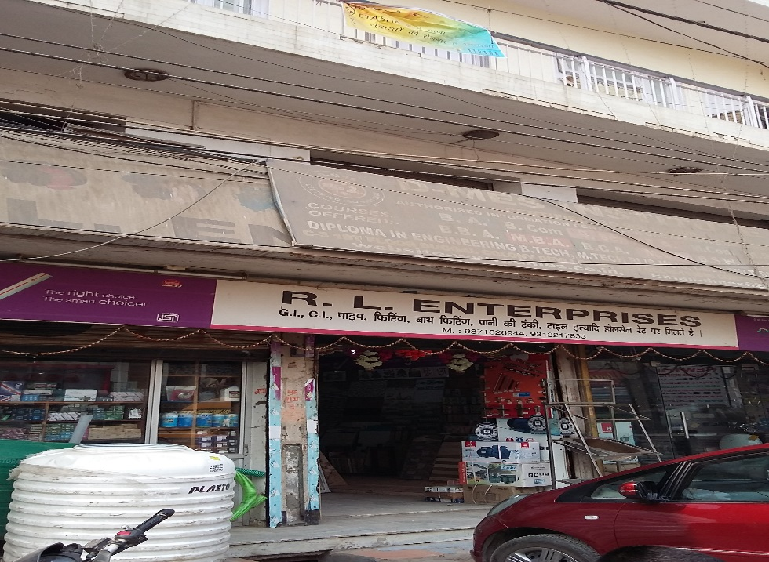

OFFICE
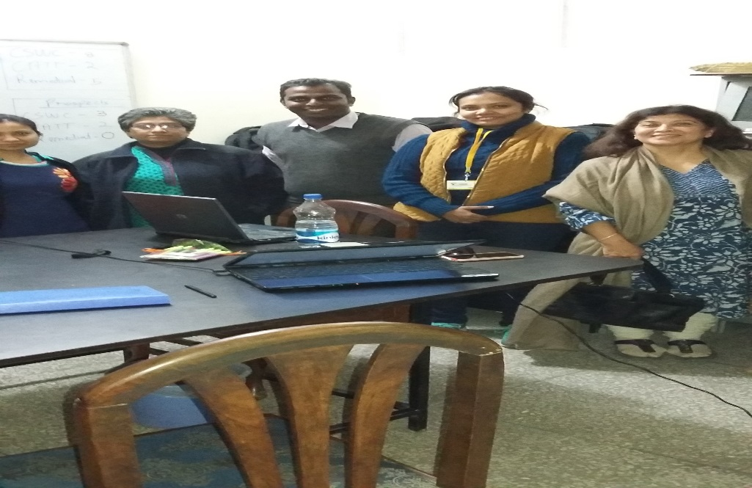

CLASS IN PROGRESS

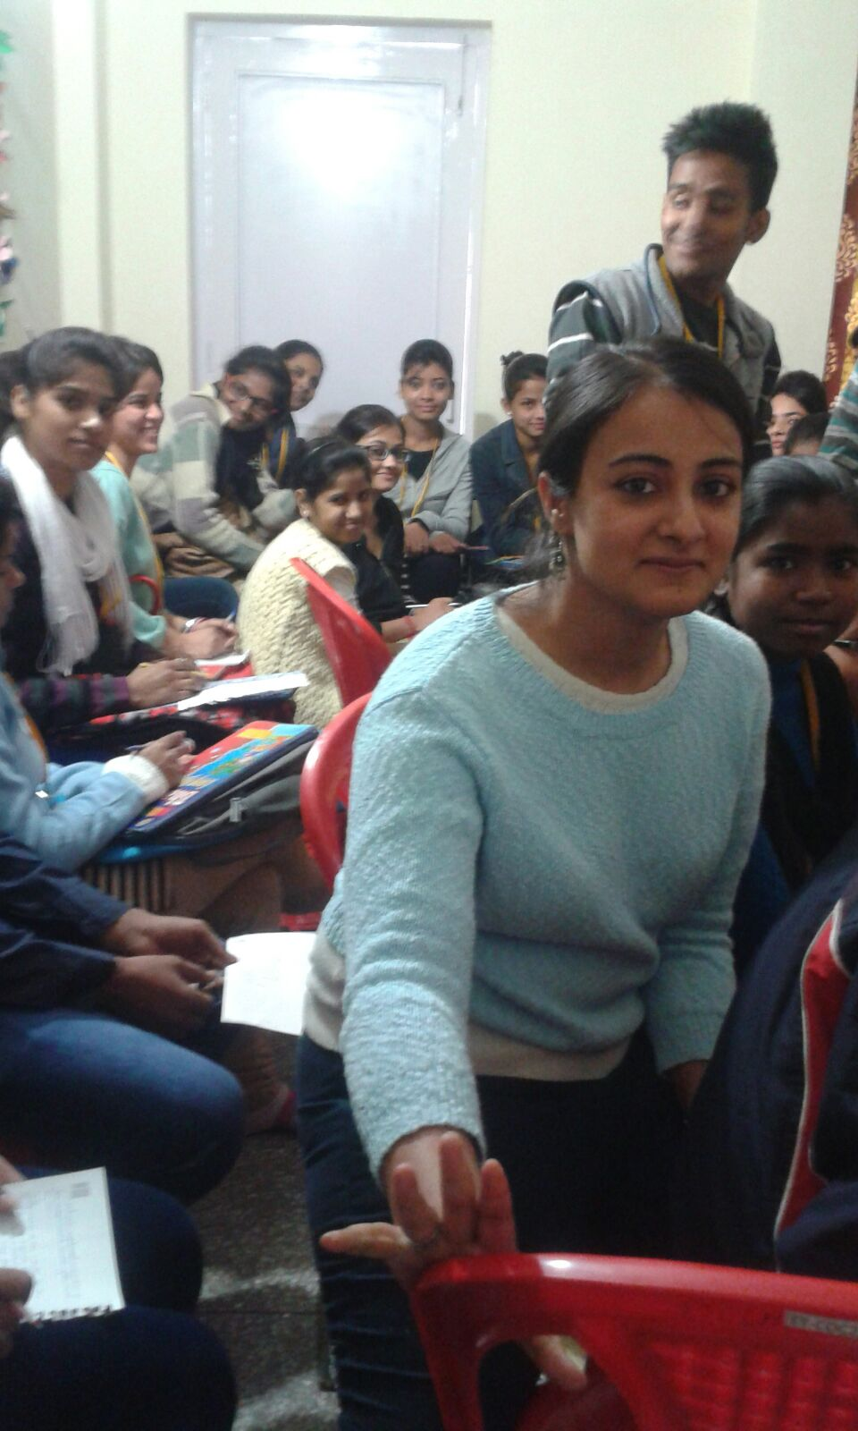

Made on : - December 22, 2015.

