Etasha Manzil Site Visit 2018

By Ankit Kumar
Nov 3, 2018

Introduction
This site visit has been done to understand the current progress and impact of the Etasha Manzil Project. This project is a life skill and career counselling program for government schools. It is currently being run in and around Sarita Vihar area of Delhi. The project is aimed at giving exposure to students from lower economic background. Currently, it’s been two years after launch of the program.

Current Scenario
Their career highway session is for 10 hours for classes 10th and 12th. Since time is a constraint (considering they have to get time from regular school hours), it is done in a two-day session for 5 hours each. The student strength in each class is around 35 on average. This covers psychometric test and exposure to relevant career options and means to reach them for each student based on the thorough feedback of their written inputs.

Their life skills workshop is meant for 8th, 9th and 11th class, which is done for 1.5 hours per week for each class with a student group of 15-30 students. This covers various contents like team work, time management and resource management skills which is ingrained in students through activities and hands on sessions. Separate sessions on sexual education and health needs of students are also taken for increasing awareness.

Currently the number of schools adopted is at 5. It is run by professional counsellors with a background in social work and psychology. There are currently 5 full time counsellors. Each school is also assigned a sitting counsellor who checks on regularly on special cases including dyslexia, sexual abuse cases or any other psychological help which children will need. On severe cases, the students are referred to nearby hospital for further follow ups.

Observations

- The classes are running efficiently with a good course content.
- The staff are courteous to students unlike the teachers of these government schools.
- Since the observed class was a boy only one, I could see the difficulty in handling class, but the staff were adept in that.
- The participation of students in both career highway and life skills classes were good. Students seemed interested and valued the inputs in the class.
- The feedback from principal of school was positive. As per his observation, students were involved in little rough and criminal activities in the area and after involvement of the NGO, there has been a reduction in these cases.
- According to staff, there has been a good behavioral change in the students too.
- The informal interaction with students outside classes also stated that they value the lessons taught in these workshops.
- Data from Khanpur and Madanpur Khadar shows on average a 90% positive feedback of students on the usefulness of class and content.
- Questionnaire filled with basic details:
- Success story and feedback from students attached below:

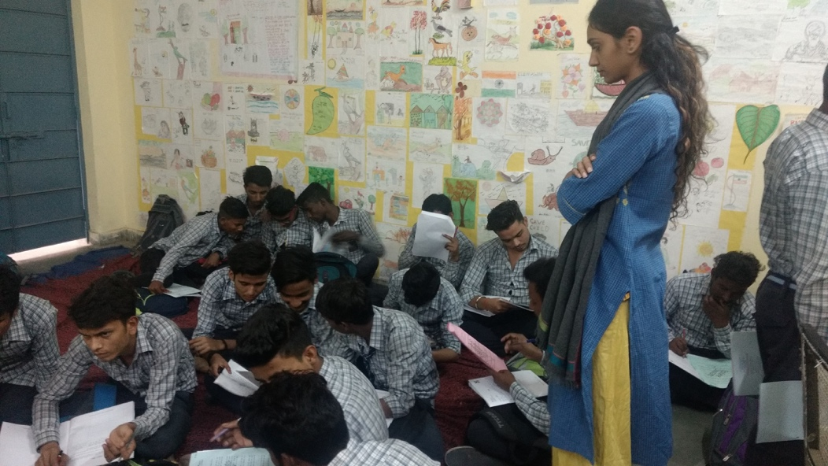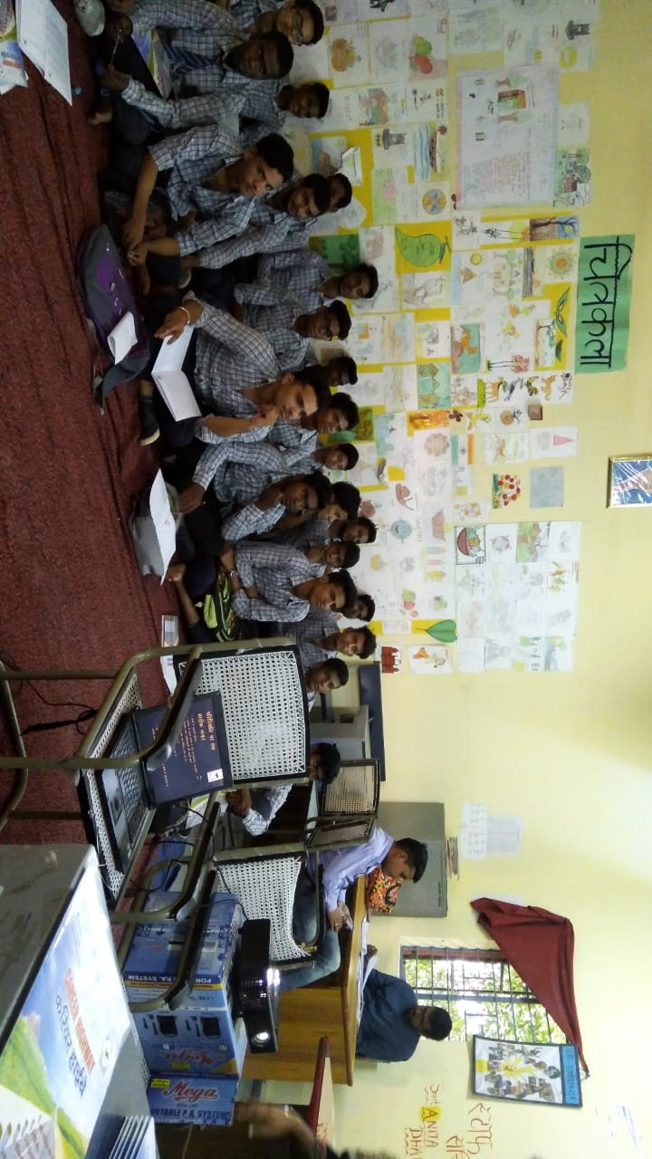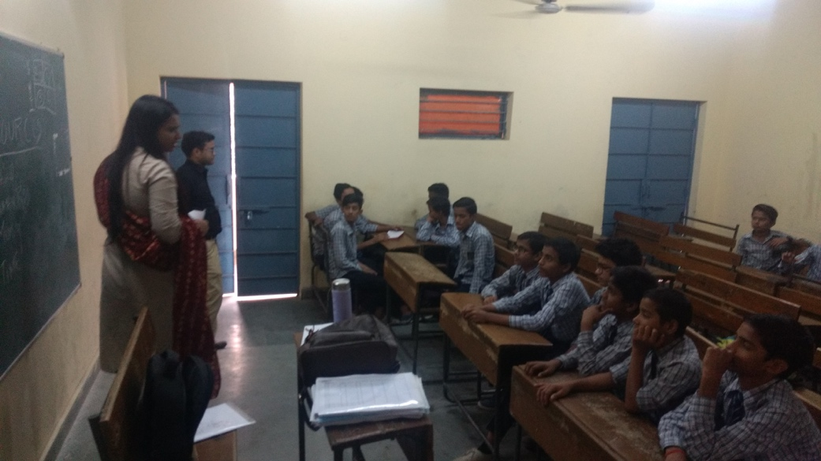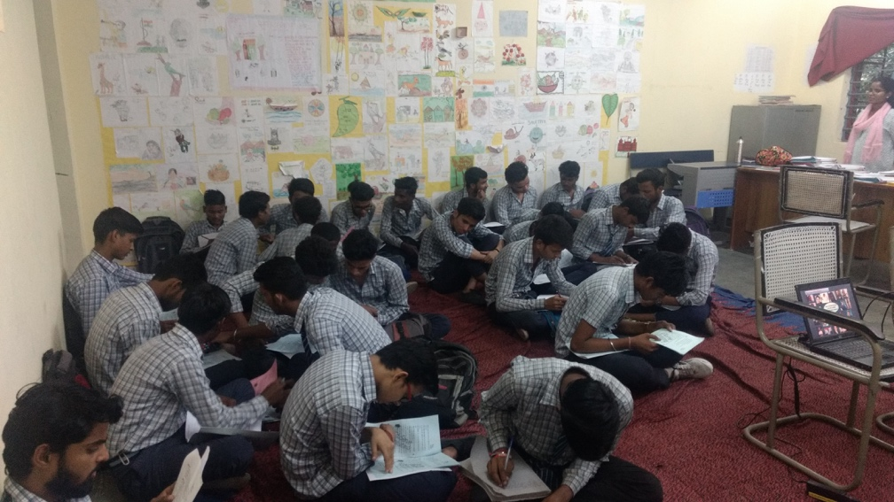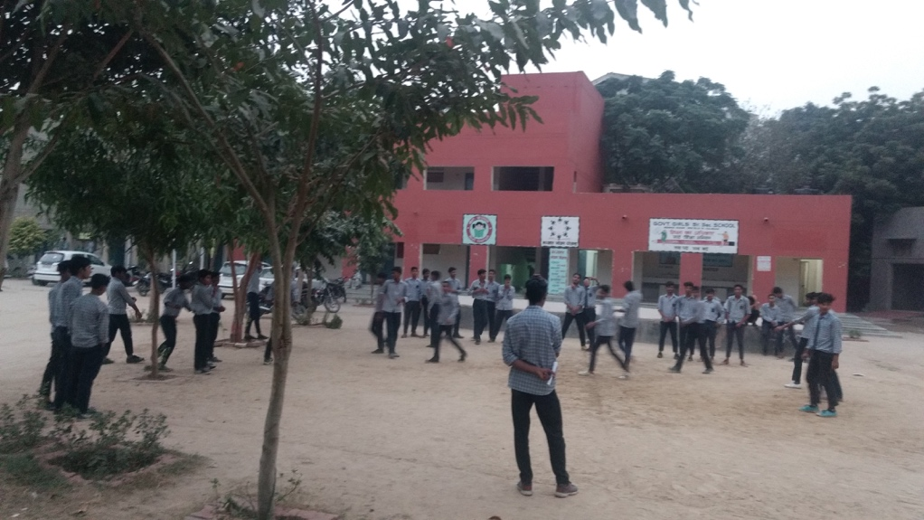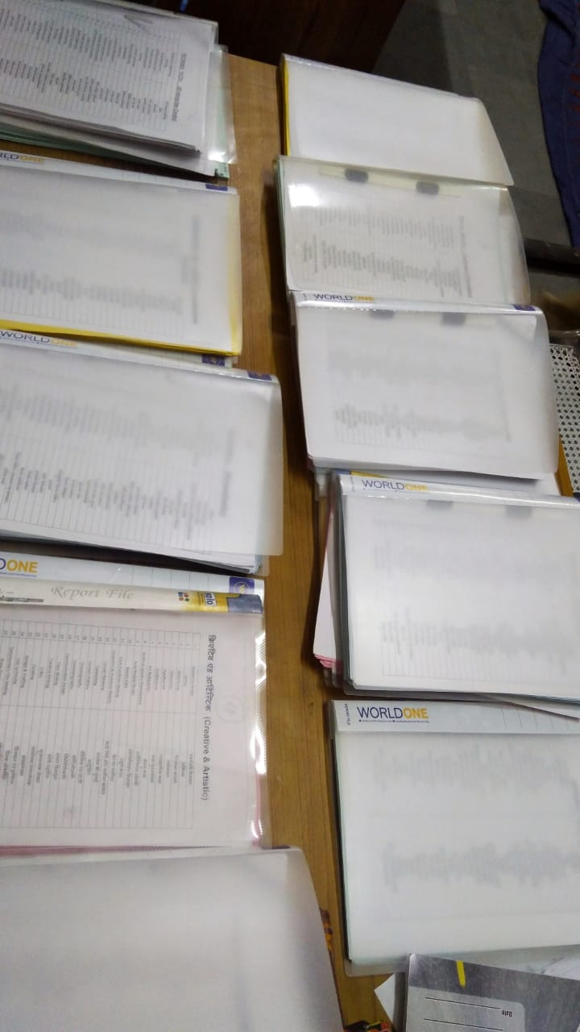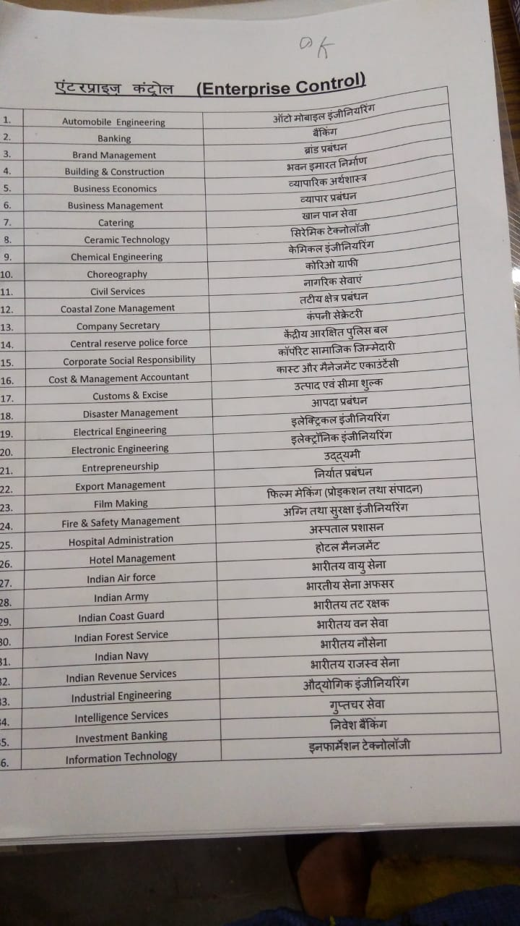

Current Challenges and Yearly Plans
- The program heavily depends on the support of school staff. This sometimes becomes a challenge especially when exams and other academic or other activities require time bandwidth.
- There is a need for more quality staff for increasing expansion and taking multiple classes in school. Currently in the school I visited, only Boys session is covered, and Girls session is getting missed out. Time, fund and quality staff are constraints along with approvals.
- There is a constant need from staff and schools for spoken English training. Since this is an important value add for any future career after school, the organization will need fund support to take this up.
- The plan for this year is to focus more on teachers training for better conduct of classes and effectively increase the support structure for the program in schools.

My suggestions/recommendations
- Though the government has seen the project as a positive help in schools and has urged them to expand to nearby 50 schools in south east Delhi, due to staff and fund constraint, I feel they are restricted currently. There is a need to see how it can be expanded to multiple schools by adding increased infusion of funds and hiring more staffs to cover it. The model is replicable and hence if the government support is there, my suggestion is that the steps of expansion should be taken. Asha should analyze this and see how they can further help in this expansion.
- I believe there is a need to track the students’ progress and see how exactly the impact of these sessions has been. Currently student level data of how many students are taking the sessions, their suggested careers and actual careers being taken is not kept. This will need to be maintained for a better understanding of content improvement and feedback for classes.

Conclusion

Etasha Manzil is doing right actions for building up supplementary structure for life skills and career counselling in the government schools. With right structure of feedback and additional funding, it should expand further into more schools and cover all aspects of life skills training in schools.

This site visit was done by Ankit Kumar ( Kumar.ankit351@gmail.com ) on behalf of Sindhu Kashyap ( sindhukashyap@gmail.com) , Asha Volunteer.

