Site Visit - ANK Delhi

Done by : Paritosh Sarda (paritosh.sarda@gmail.com)
Sandeep Morthala (sandeep.morthala@googlemail.com)
Date : 28.03.2011

This is a planned visit, we had informed Abhishek Kishore that we would be visiting ANK on 28th March. On the planned date Abshishek met us in our hotel and took us to ANK center in Khirkhi Village extension.

In the center ANK has following 2 programs:
- Learning center for school drop out children
- Computer and basic learning center for youth

Computer and basic learning center is target for the youth who have education up to 10th standard but they do not have any job. In the center they were tough basic computer skills like working with Microsoft office and basic spoken English, these skills are much needed as there are several shopping malls and other industries in the near by areas.

Learning center is meant for children who are not going to school. Asha Frankfurt supported this project in 2010 (http://www.ashanet.org/projects/project-view.php?p=1062). When we visited the center, the classes were already finished and only one student who apparently needs some help was there to talk to a teacher. Most of the information below is from our discussions with Abhishek and our observations from the facilities.

In 2010, ANK team has done a evaluation in Khirkhi Village to find out number of children who are not going to school, talk to their parents and counsel them in sending the children to school. There they identified about 70 children who needs such a learning center.

During our visit, we had walked around the Khirkhi Village, which is 300 m from the learning center. It is a typical urban slum with very narrow roads, small houses, no proper drainage system. Most of the families are daily wage workers, auto drivers, some of the women working as household helpers.

During the 1 year classes apart from teaching, ANK also takes children on a day trip to visit museums and organizes art workshops. There are some volunteers from Delhi, who are mainly students, who visit the center and spend some valuable time with children by counseling and teaching some extra curriculum activities. In 2010, they also had a volunteer visiting from Canada, who spent couple of months in the center teaching painting and yoga.

Part of extra curricular activities, they gave each child one disposable camera with 2 rolls. They asked the children to use one roll in taking pictures of the daily routine life and in other roll what kind of life they would like to live. One volunteer also made a calendar out of the children photos and their life stories. (we got the calendar which was for 2010 as a souvenir)

For the students who completed the 1 year learning center, ANK admits them in municipal schools in and around Khirkhi Village. Most of the children has close contacts with the teacher Sumana and Abhishek, if they have any issues or if the children move to different region and difficult in getting admission, they get in touch with Abhishek or Sumana.

For 2011, ANK identified 80 children in Wazirpur region for the learning center. The rental facilities are already identified, because of time constraint we could not visit Wazirpur area.

Conclusions:
- As there were no classes, we could not talk to any children or teachers.
- Regarding the impact of such learning centers, Abshishek had provided information regarding how many children were admitted in schools, but there needs to be a mechanism to analyse the impact from the completed projects (Saidulazabad, Khirkhi Village) after year 1, year 2, year 3 etc.
- Abhishek and ANK team have better understanding of the local community, connect well with the children and their families to understand their issues to provide help wherever needed.
- In our opinion, Asha Frankfurt can support the learning center in Wazirpur by defining monitoring parameters.

Photos:

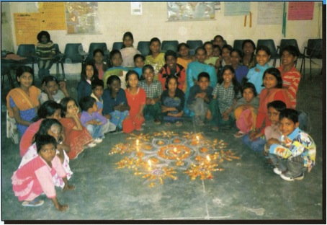

School children photo taken from Calender 2010

