Spandana Site Visit Report
(June 27,2016)

Last year I went on a vacation to India. While I was there, I stopped at Spandana, a nonprofit organization dedicated to helping orphans and special kids. I went with my parents and my sisters. A crowd of children and teachers are ready to welcome us into that building. When I was there I saw a lot of great things like food being provided to the kids, and the kids were also able to partake in art classes, They were also taught dance and other cultural activities by teachers. Teachers explained how they 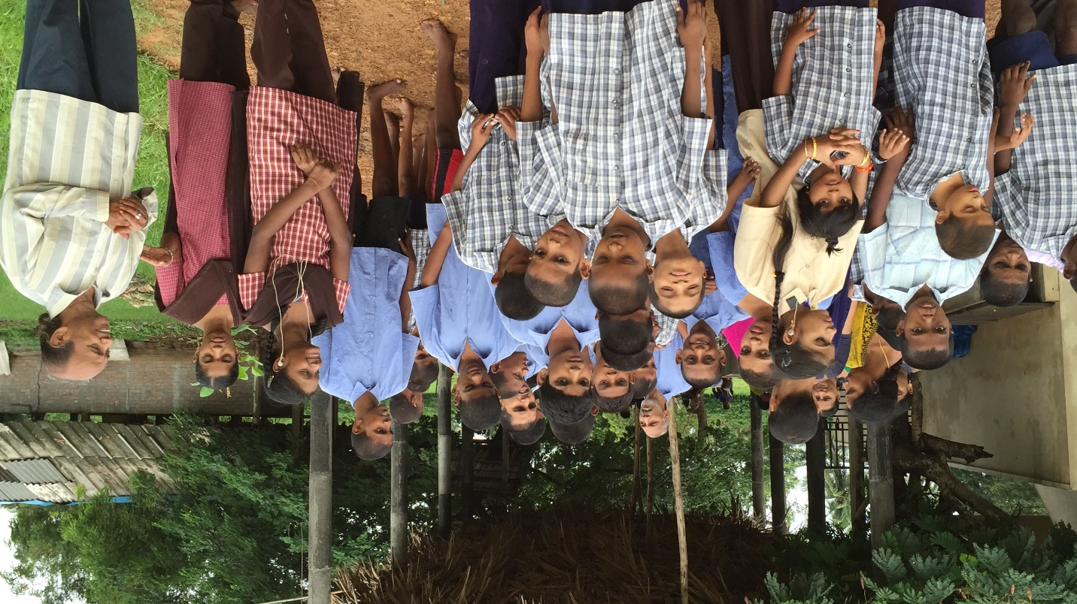work with kids .

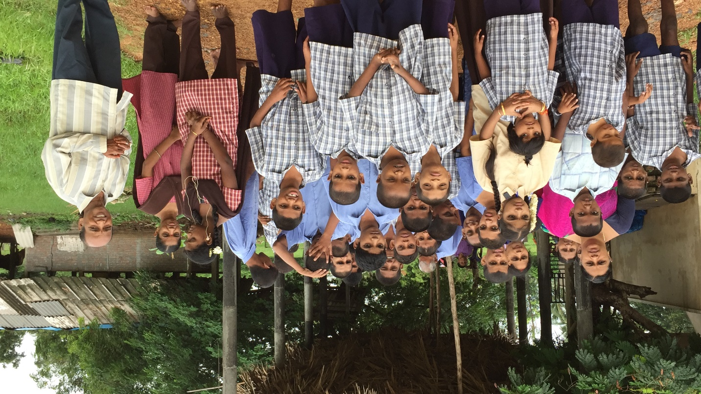

The kids are fed a (more than) filling breakfast, lunch, and dinner every day. There is also a dairy farm located at Spandana . The location is a two-story building where 50 kids are crowded into, as of right now. There are teachers dedicated to all these kids and they are spending all their family time with these kids . Hats off to them .

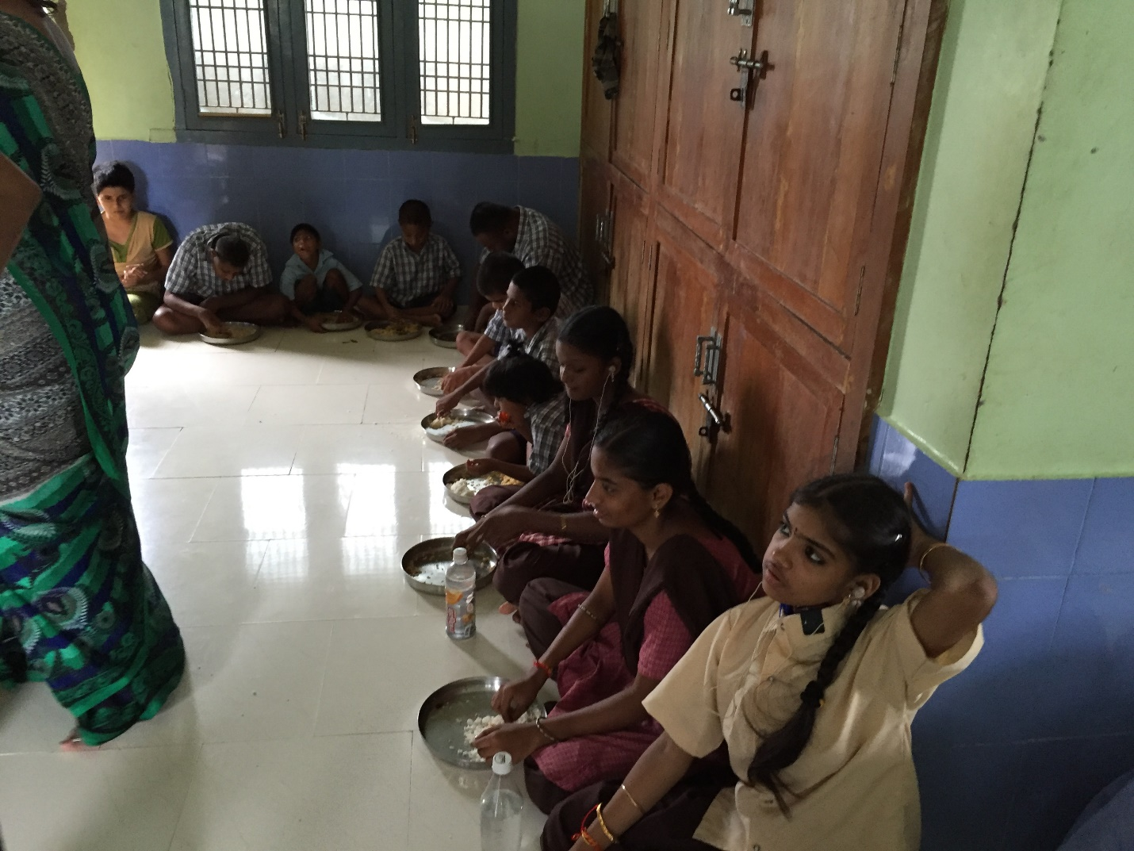

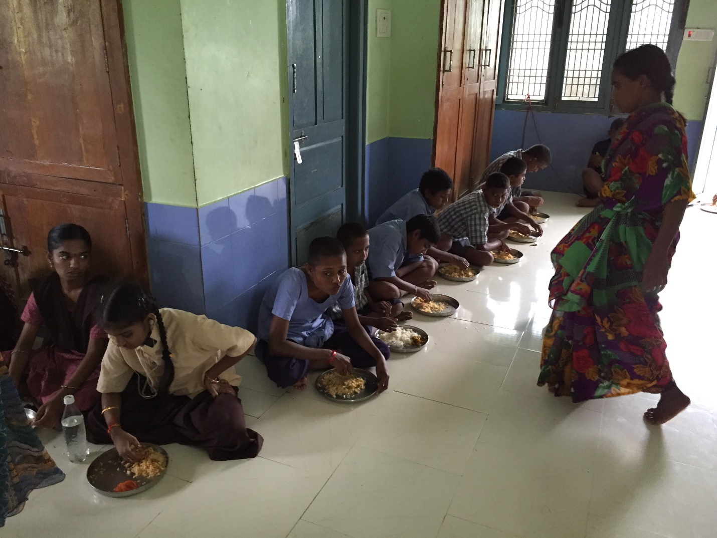

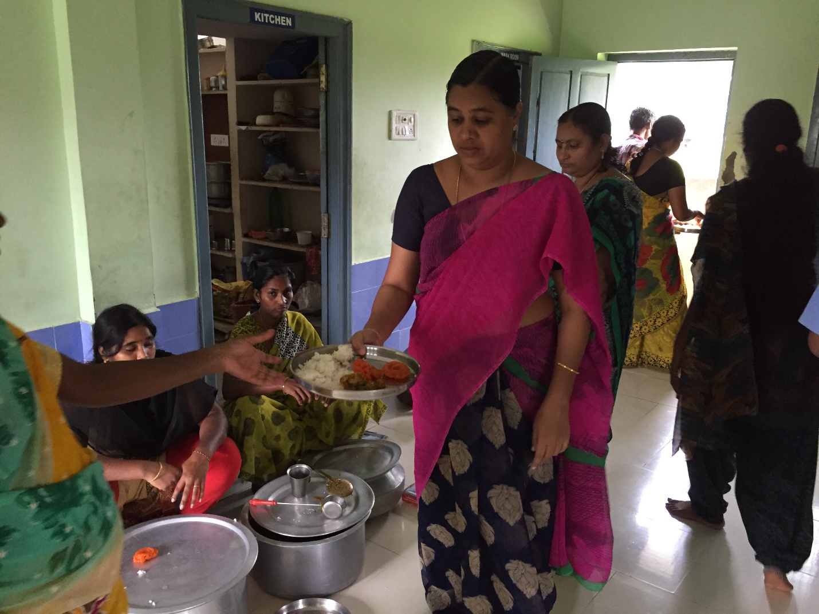

Jithendar garu took us on a tour of the building. We went into therapy room Where kids with disabilities were helped with what needed to be treated. The therapist explained to us how he would help children with walking disabilities by having them practice on a treadmill.

Then, Kids showed us their art and crafts. A couple of kids performed dance and songs. We served food to them at the time of their lunch. Jithendar garu explained about the organization and about the funds.
After that I planted trees alongside the kids .Kids were very happy and we took some pictures with Kids
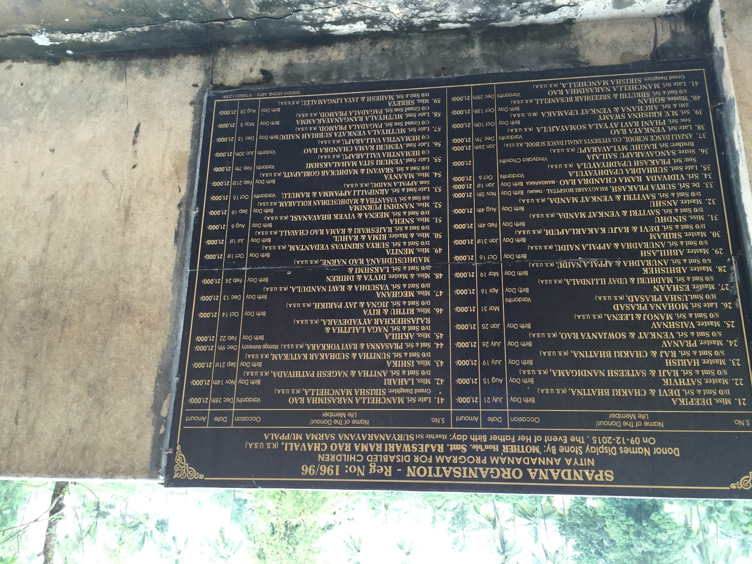

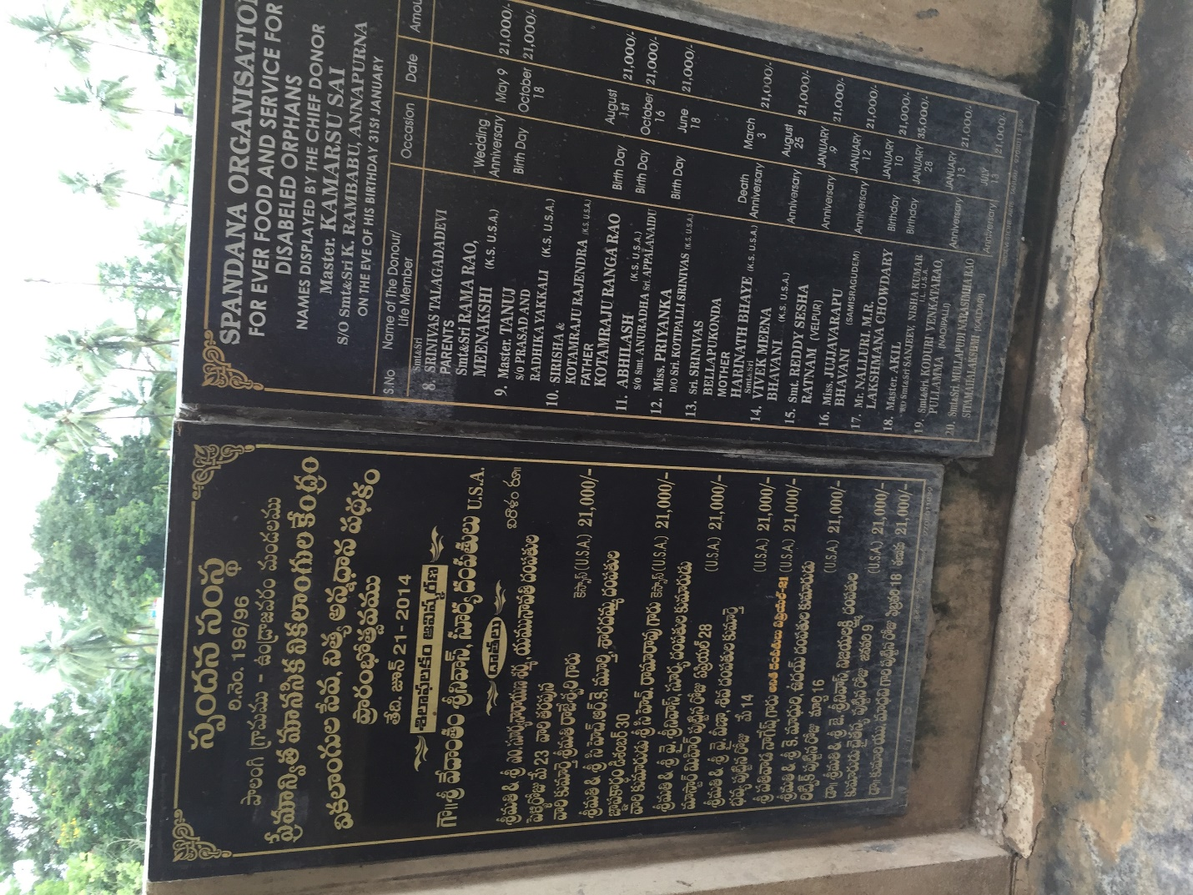

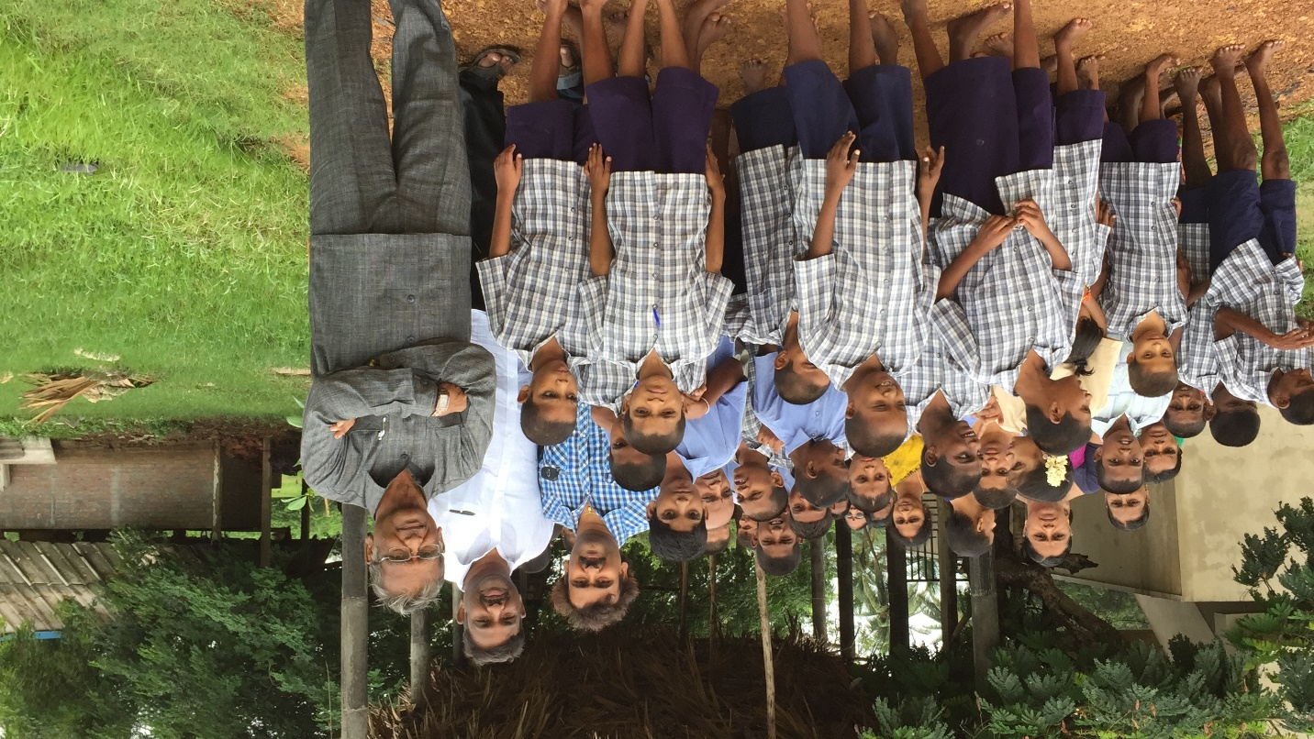
The size of the building is sufficient for now, but as more and more kids accommodate and move, the size of the building will most likely need to be increased. Also, there are not enough toilets for all the kids and staff there at the organization. All in all, Spandana is adequately sized and staffed right now, but as the population there increases, the organization will need to acquire more buildings, clean up and shelter the dairy farm, do things like building separate rooms for male and female, and staff the organization with more teachers, cooks, and workers in the future.

I am very impressed about the teachers and staff. After seeing the kids, I don’t have any words to say.
After a day at Spandana I am truly speechless and mesmerized

