Site Visit Guidelines and Questionnaire

Asha Stanford

Dear Volunteer,

Thank you for taking the time to conduct this site visit. Your visit will provide us valuable, first-hand information about the project, enabling us to better understand its circumstances and its needs. The following questionnaire is designed as a basic guide to assist you in conducting your visit.

The following set of questions is only a suggested guideline. Some of the following questions may not be relevant or applicable to the particular project you are visiting, but please do try to answer as many of them as possible. Please note that much of the information requested in this document has been collected from the project in their proposal. We would like this information validated by a visitor. It is best to talk to as many people as possible and infer the answers based on their responses, rather than than treating this document as a questionnaire. Parts B & C necessitate that the information be gathered through conversations with the children and their parents, and not simply the group's teachers and staff.

Please feel free to attach any documents/photos you feel are pertinent to the project.

If you have any questions, please do not hesitate the project steward responsible for the project at Stanford. We look forward to hearing your thoughts and observations through this review, and thank you once again for your help. Together we can make a difference!

Thank you,
Asha for Education, Stanford Chapter

Preparing for your visit

- You should be able to collect the following information about the project from the project steward (Asha volunteer responsible for the project at Stanford) prior to your visit:
  - Project proposal
  - Past correspondence with the project
  - Any specific information that the project steward is looking for, from the site visit.

- You also need to have some understanding of Asha for Education and our mission. This will help you to tailor your site visit in a more fruitful manner for Asha. You can get detailed information about Asha for Education from our web site at http://www.ashanet.org. Our site visit volunteers often find it helpful to study this web site (and this document!) before-hand, and have a copy of the original or modified project proposal with them before starting their visit.

- We encourage you to talk individually to a broad cross-section of people, including some students, teachers, as well as community members who are not directly associated with the NGO. Such informal interaction is often the best way to learn about the project.

- We also strongly encourage you to fill out this document yourself, rather than showing it to the project coordinators in India and asking them to fill it out.

- This document is only designed as a basic guide. Please include any additional information/insights that you consider relevant with your review.

- We look forward to meeting with you in person and hearing about your experiences, if this is possible. The project steward at Stanford will discuss the possibility of scheduling a presentation at an Asha meeting with you after your visit.

- We encourage you to take some photographs/videos during your site visit, as they will help us see and hear what is going on at the project. As the old saying goes, a picture is worth a thousand words!

- If the organization is running many centers and it may not be possible for you to visit all of them, visits should be made to centers randomly selected by you rather than letting the organization show you centers of their choice. Organizations are known to run their sample centers which they would prefer to show to you.

Basic information
Date of the site visit: 01 Aug 2015
Name of the Project: CSSC – Nimmagadda Anandamma school
Name of the Organization Running the Project (if different): CSSC
Was your site visit announced? (Yes, it was planned) or (No, it was a surprise visit)
Announced 1.5 hr before arrival.
 | Project Contact’s Information | Site Visitor’s (Your) Information  (Volunteer conducting the visit)
Name | Ms Vijayalakshmi | Lakshmikanth G and Sridevi K
Address |  | 7A Vertex Lake View, Nizampet  Hyderabad, India 500090
Phone(s) |  | +919676572424, +919949991770
Fax
E-mail |  | lakshmikanthg@gmail.com
Affiliation to project |  | None
Affiliation to Asha |  | Asha Stanford Volunteer  Member 2002-2006, Treasurer 2004-2005, Secretary (2005-2006)

PART A: Particulars about the organization and its environment (cross-validation of information presented in proposal)

- What is the main ideology of the organization behind the project?
Provide education to girls from their own orphanage and from low income families (auto drivers, construction labourers etc)

- How old is the organization? Started in 2009

- How and why was it founded? Already Available with Asha Stanford

- What are the different focus areas of the organization? (give a rough estimate of the % of their total effort/funding)
- Community development ______ %
- Education ____100___ % (with respect to school funded by Asha)
- Health ________ %
- Other __________ % (please specify) _____CSSC has an orphanage for girls nearby, also has oldage home near Tenali in AP.

- What is the administrative structure of the group (e.g. Board of Directors/Grassroots-based/Volunteer based)?
Loose structure with Smt VijayaLakshmi as general head and a couple of founder members and CSSC volunteers. They are currently looking for new principal. There are 17 teaching staff, 1 admin and 5 helpers (cleaning, general maintenance). File Attached with current salary structure.

- Are there any other organizations working in the area providing any one or all of the services provided by the visited organization? (Briefly mention their names and their objectives)
Organization(s) | Objectives of the organization(s)
Shanthiniketan school | Co-ed school till class 10, provides free education, only uniform and books to be provided.  There are several private schools nearby.  Nearby Govt school in Banajari colony upto class 5.

- Is the organization/founder involved with any other social issues/causes/projects other than running the project proposed?
Running Orphanage for girls
Svayam Shakti centre in Bandlaguda – teaches stitching and cooking (pickle making) etc for women

- When was the project of interest started?

2009

- What is their vision about the future of the project?

Keep increasing classes in State syllabus till class 10 to ensure girls finish a standard of education.

- What were the initial challenges faced by the organization and by the founder when starting the project? How did he/she overcome them? Who helped them through the initial stages?

Initially there were more drop outs (2 yrs ago), they have managed to overcome this by counselling parents and also maintaining a high quality of English medium education that the parents in this community value.

- Has the organization ever approached the government for funding? If so, what was the outcome? If not, why not?
- They have not actively try approaching Government. But now that the organization has grown substantially large with sufficient corpus fund, it is high time the organization approach government agencies for funding or aid.

- Currently, what are the main problems the organization faces for running this project?
Building maintenance funds are not available, they have used corpus funds to get the painting of the school done. Teachers salary for classes 9 required next year when they grow.
- How many centers/schools does the project run? How many of those were you able to visit?

- Svayam Shakti (sponsored)
- Old age home – vetapalam
We did not visit these as they are not part of Asha funding.

- Were you able to choose the project centers to visit? Or were all centers visited suggested by the project partner?
Not applicable.

PART B: The beneficiaries and the community
(Information to be gathered from parents and children)
- Approximately how many families live in the area?
This part of the village is slowly getting integrated in to Hyderabad city. It is located inside the outer-ring road of Greater Hyderabad Municipal Corporation

- What do the parents do for a living? (Agricultural worker, Daily wage laborer etc.)
Auto driver, some are also employed in private companies, daily wage earners

- What is the religious/economic/educational background of the parents/community? (Are the parents able to pay any fees? Are the parents literate? etc.)

Above 500 children – auto drivers, cab drivers, labourers. Mothers are illiterate, fathers may have studied upto secondary school.
80 girls are from the orphanage. More recently, they have 50 children from affordable families also come due to quality of English medium education.

- Does the project/school target specific families (e.g. agricultural workers, families with specific backgrounds, illiterate parents, first generation learners, orphans, sex workers, etc.)

It is open to everyone in the community.

- How often do the teachers meet the parents?
Once in quarter- at the time of report sharing.

- How do the parents/the community view the efforts taken by the organization that runs the project?

Considered as a premium English medium school, as even girls from better private schools have moved into this school for better quality of education.

- What is the motivation for the parents to send their children to school?
Free good quality English medium education.
- How do the parents participate in the organization's activities? (e.g. by contributing their time, money or labor in the school’s activities etc.)
There is no participation from parents currently.

- Has the community supported the project (e.g. financially, donating land, volunteering, etc.)?
Land is donated by Nimmagada foundation. CSSC volunteers work with only transport charges being paid, no salary. The founder utilizes her personal funds also for the cause.

- Are there any Government Schools in the area? (Circle one)
  - Yes

- If yes, how far are the Government Schools from the community?

5 km – until class 10th in Hyat nagar, closer one in Banjara colony until class 5.

- Why did the parents choose this school over the Government School?
Good quality education in English medium, school is kept clean and is also exclusively for girls.
- When you visited, how many children were present in the class?

36 in class 8 funded by Asha Stanford. Other classes were also reasonable full with 30-40 children in each.

- What is the average age group of the children per class? How are they handling older children that need basic education?

They hold a basic test at entry to evaluate which class the child needs to be put into and counsel the parent about it, they don’t go by the age alone.

- What is the regular class strength? What is the boy-girl ratio in the school?
About 32 on average, All Girls school

- Do the children seem to enjoy coming to school? (Site visit volunteers observation)
They are very happy, they get good quality education. They were practicing for Aug 15 independence day celebrations.
- What portion of children from the local community (approx.) attends this school? What portion of children does not go to ANY school? Where do other children in the community go to school?

Information difficult to get.
- What activities do the children do after school hours?

Do homework at home, help with chores at home, watch TV.

- What is the main motivation for the students to attend school?
English medium school for girls- the ability to speak good English is associated with a job and a better lifestyle which motivates these girls who would otherwise become household maids or do odd small jobs.
- What is the drop-out rate among students? Why do they leave the school? (If high, what is the organization doing regarding this?)
This is low. See Q 10 response.

- What do the children feel about the school? Do they feel happy to come to school every day? (Question posed to the children to gauge their replies)

Yes, see Q 16.

PART C: Details about the project and its staff
(Information to be gathered from students and staff)
- How far is the project site from the main town/village? How do the children commute? (foot, bus, etc.)
Parents drop off or come by themselves.
- Are the children charged fees for attending school? (Either school or bus, etc.)
None

- What infrastructure and facilities are available at the project site you visited? (eg. Furniture, buildings, toilets, library, sports, hostels, mid-day meals etc)

- Is the building permanent or temporary construction? Is it owned or rented? What is its physical condition? How are they being maintained at the condition?
Permanent and donated to CSSC.
- How big are the classrooms? How many children per room? How many classes (1st to 3rd etc) per room?
Good size, 30-40 students per class.
- What is the medium of instruction? Is this the student’s mother tongue?
English, mother tongue is largely telugu
- What is the mode of teaching in the school? (Check the appropriate choices)
  - Formal State Board upto 8th grade (LKG to 8th)

- If Non-Formal Education, how many of the children also attend formal schools in the area? If none, does the project plan this for the future- either by setting up formal schools or by setting up a process to send children to mainstream schools?
NA
- If Non-Formal Education, does the organization create its own study material (books, games)? Or does it use NCERT/NIOS books?
NA
- If Vocational, what do the children do after they finish training?

- What are the daily school hours? How many days of the week/month/year is the school open?
6 day week.
- How many staff or volunteers are involved in the project? (Full-time/Part-time/Volunteers) What are their roles? Give breakdown by roll (eg. 2 full-time teachers, 1 full-time volunteer teacher, 1 cook, 1 administrator, etc.)
Please see attached file
- How many of them are from the local community?

- How many of the staff are women? What are their roles?
All women staff. Please see attached.
- What is the education level/teaching experience of the teachers? What is their background?
Graduates and or Postgraduates.
- What is the motivation for the teachers to work in this project (eg. pay, service, etc.)? What are the other employment opportunities that they have in the town/village?

- How long have they been with this project/organization?
- 4 years.
- How many teachers have left the school in the past one year, and why?
Shifting with spouse, getting govt jobs (DSC).
- How many new teachers have joined in the past year?
6-7 teachers
- Does the organization train the teachers? (Circle one)
  - Yes
- If yes, how do they provide the training?
SEAL (sujaya NGO in Mumbai) , Deloitte, CSSC volunteers.
- Where do they live, and how much they travel to work here?
Teachers who wish to live in are accommodated in the teachers hostel constructed in svayam Shakti campus (orphanage)
- How much is the staff paid? Are they happy with their salaries?
Please see the attached. They seemed happy.
- How often do the main founders/organizers/volunteers visit the center? Do they do only administrative duties or spend time at the grassroots as well?
Ms Vijayalakshmi lives in Svayam Shakti when she is in Hyderabad. Others come from city when they visit.
- What does the organization say about education of the child after they leave its school?
They support girls children in orphanage for further studies. But the school is increasing a class per year.
- Were you able to look at actual work of the students? Homework/classwork/tests, etc? Comment.
Yes. They are given really good quality education. Equivalent to most private schools in Hyderabad.

PART D: Financial resources of the organization
(Feedback from the person conducting the site visit)
- What are the different sources of funding for this project? (different agencies/Govt)
Tech Mahindra, Charities Aid Foundation (CAF India)
- What is the annual budget?
See attached
- Are detailed records of past funding and spending available? If possible, please request a copy (of annual financial statements, for example).

- What is the largest portion of their expenses (salaries/infrastructure/etc.)?
Salaries, solar powered, See attached statement. Depreciation seems to be major expense, I did not ask what it is but it is important to ask this question.
- Do the salaries listed on their account books match the salaries that the teachers communicated to you?
See attached statements and teachers salaries. Someone at Asha need to tally this with old salary. Current salaries are more than last years statement
- Do the expenses in the proposal reflect the quality/quantity of material found at the site? (ex. Do the students have uniforms if they have been itemized? Do they have the number of computers they claim to have? Does the food seem nutritious? Are there enough books? etc.)
The expenses they make are clearly evident, as the children are all given proper dresses, shoes, books and the building is well maintained compared to neighbouring building. They are doing a very good job.

PART E: Comments
Please use this portion of the document to attach pictures and make additional comments. Remember, we need you to be our eyes and ears on the ground. Please assess the situation carefully. If it seems weird, do let us know. Some examples of red flags- The school claims to be providing students with uniforms and school has been in session for 6 months, but the uniforms look brand new, The school claims high test results for the children, but when you talk to them they are unable to answer basic questions, etc. If you sense something is wrong or the project partner is being less than honest with us, do let us know.
(Feel free to attach documents if necessary)

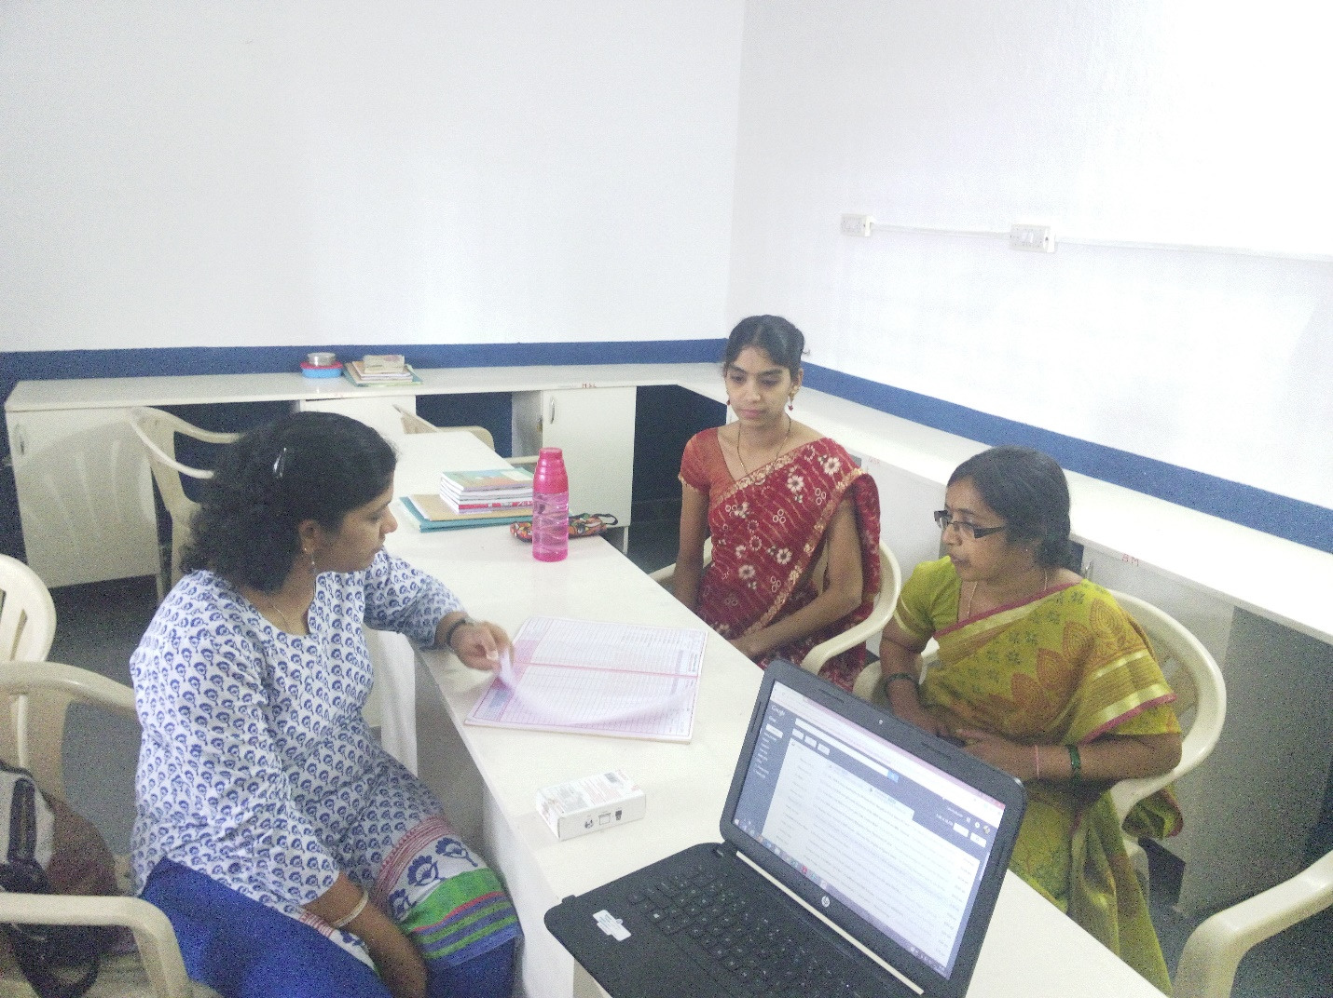

Computer Lab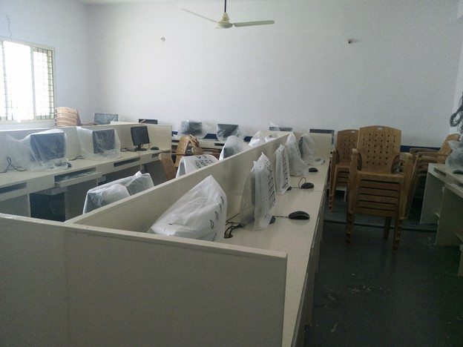

List of Girls Present since the Beginning of Class IV since Asha stanford has funded this 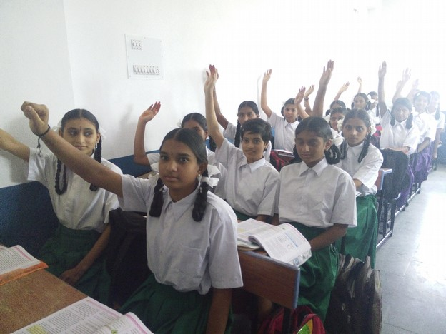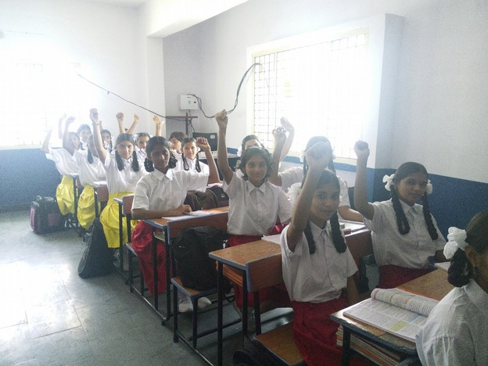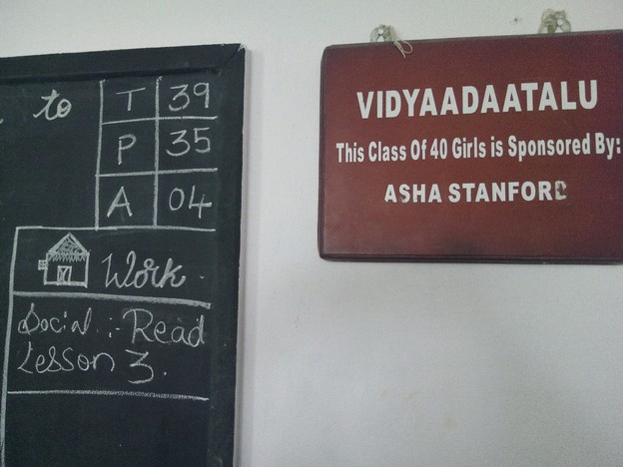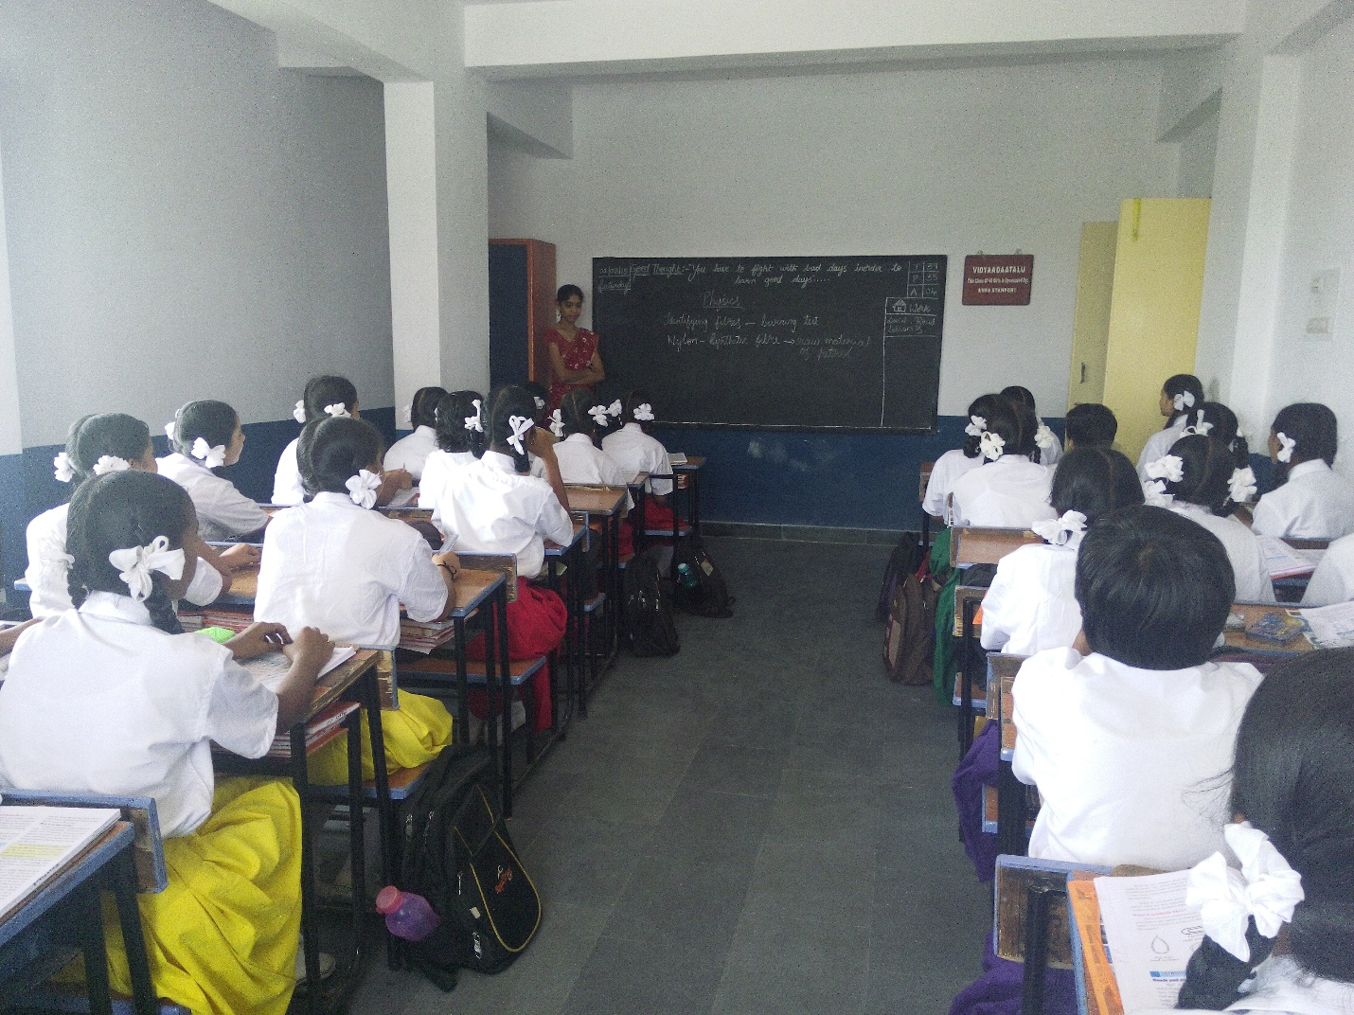Prac
Practice for Independence Day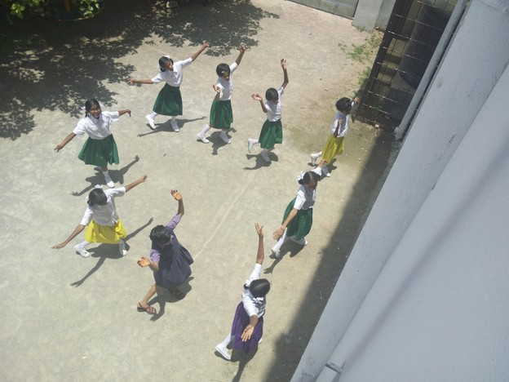

School Supplies Shoes, Books and Dress for annual payment of 850 per child. 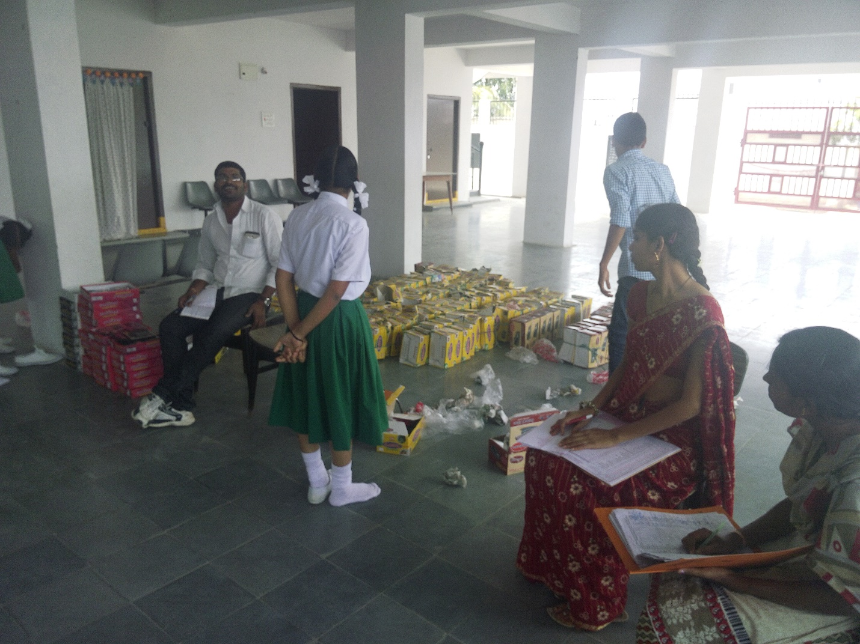S

Girls from Class VIII, Girl with hair cut is from Orphanage and girl without haircut is from local area.