Asha (Trust) Mumbai Annual Report 2018/2019

Asha Mumbai’s Annual Report.

2018 started with further progress at Asha Mumbai.

Asha Mumbai center is running and progressing in full swing.

Academic Programs:-

Daily teaching At Asha from: Monday to Friday

Morning Batch | 8.30am to 12.30pm | 20 students  (Was stopped but will restart from June 2019)
Afternoon Batch | 2:00pmto 5:00pm | 60students
Evening Batch | 5:00pm to 7:00pm | 15students
makerGHAT Batch | 2.30 to 4 PM | 15 to 25 students

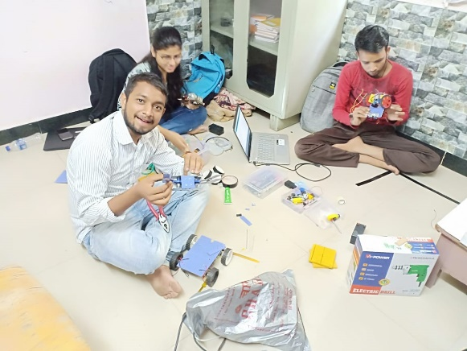
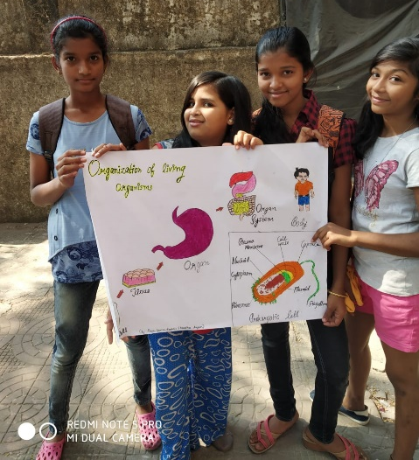
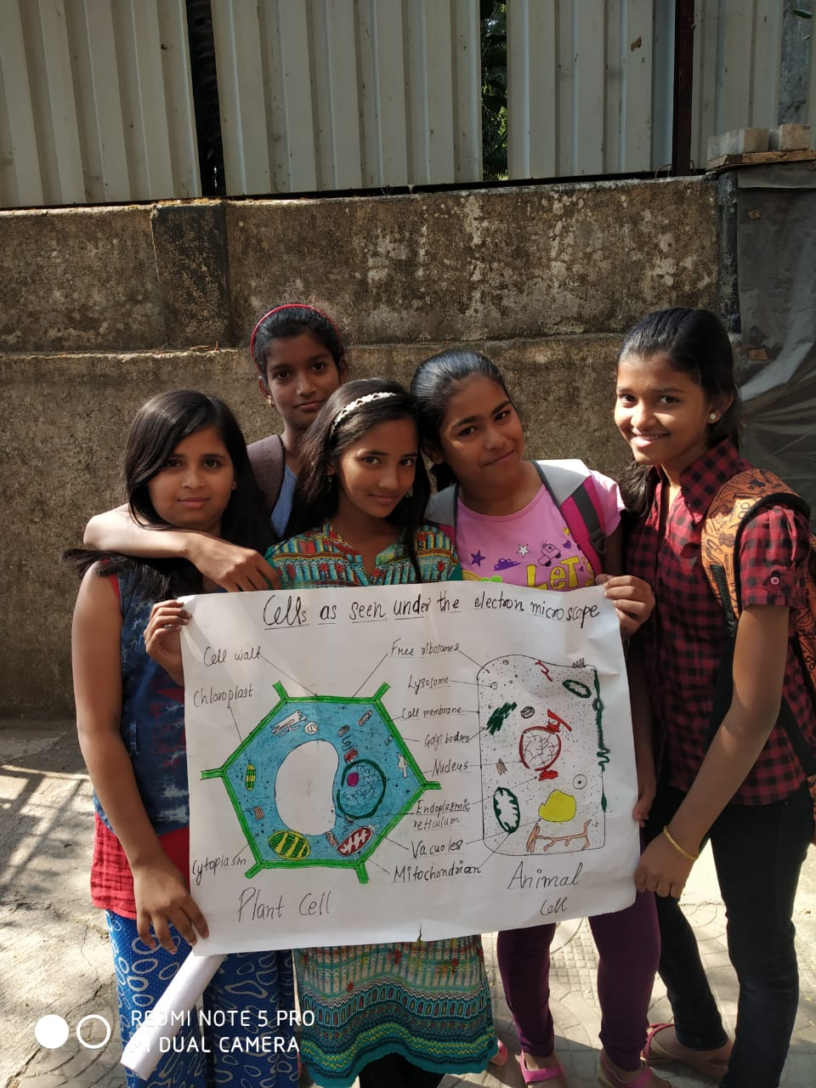

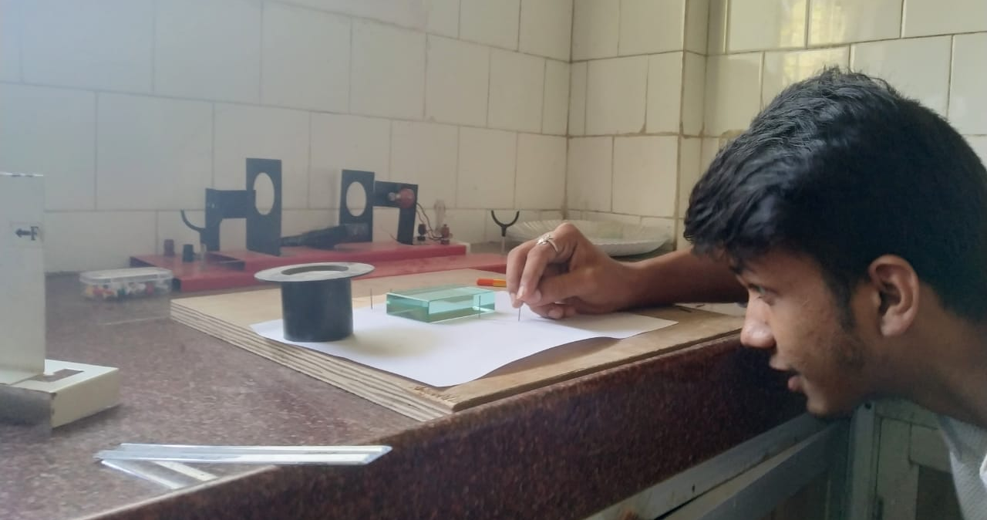
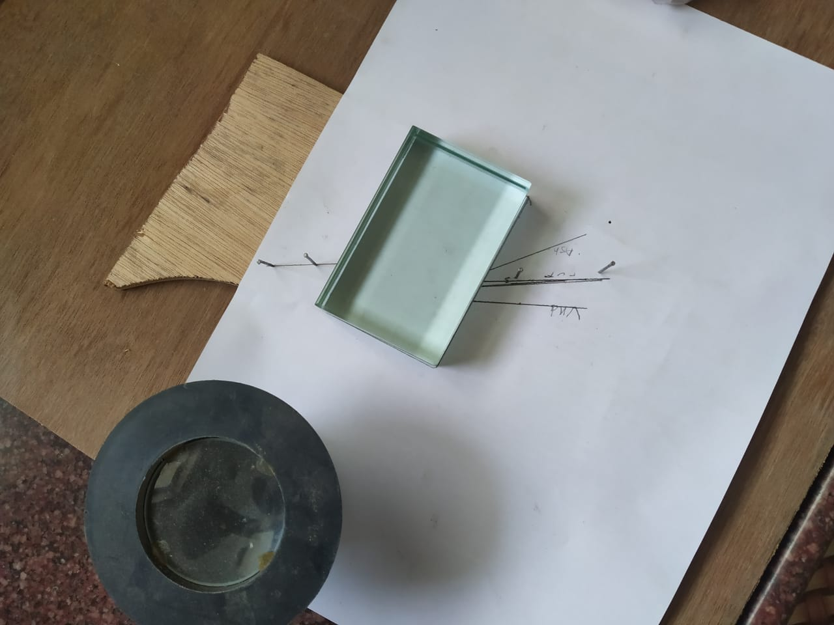
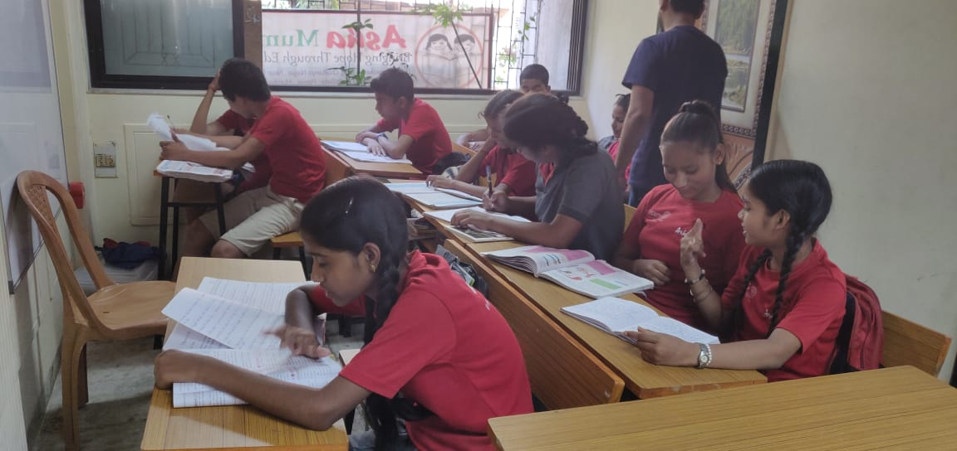

After few months we had to stop the morning batch for lack of teachers. But from this year June are restarting from9 AM to 12.noon. In the Morning Session.
Children get down to the classes as soon as they arrive. There are respective teachers and volunteers for English, science and Math’s and computers mainly. The same teachers then teach other subjects to the kids as well.
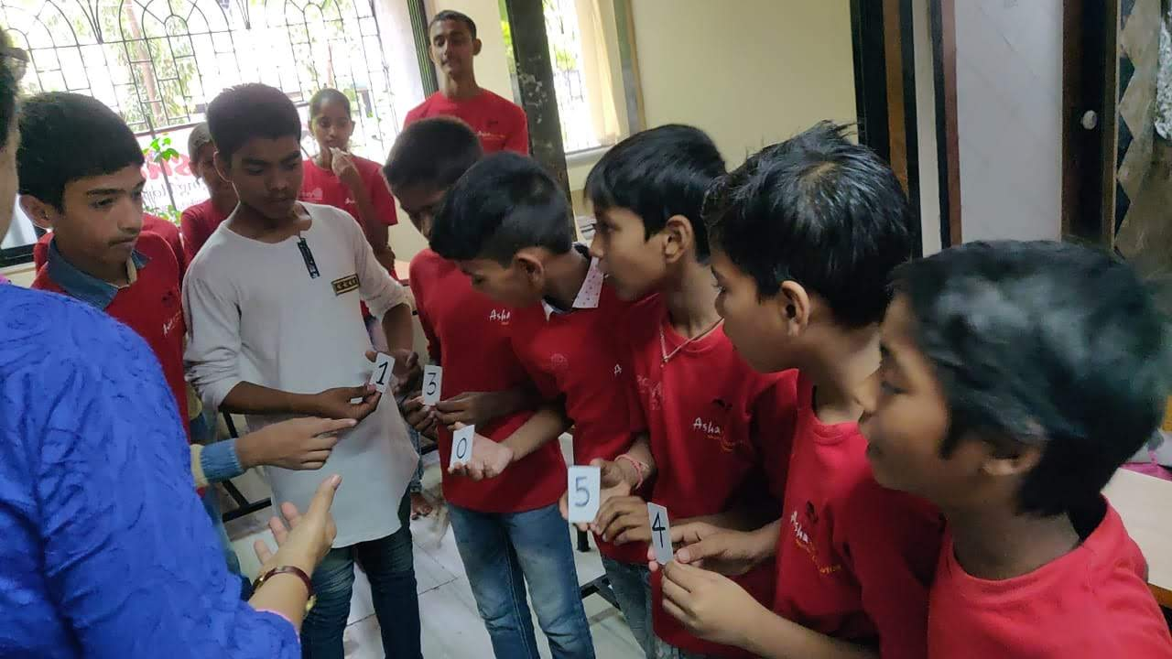
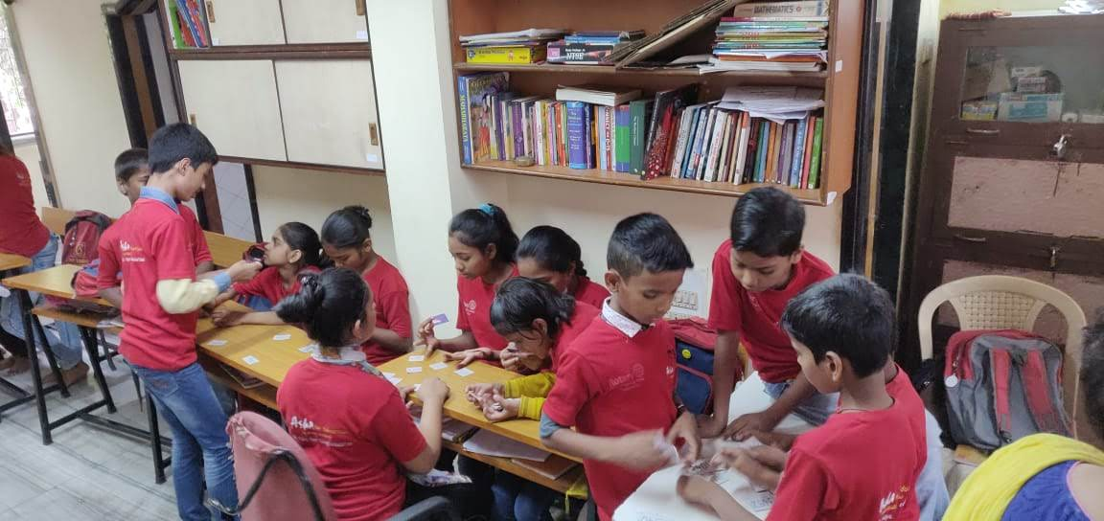

There are around 75 to 90 children in the afternoon batch, from 5th to 10th this year we are doing more of a project based learning than the black board teaching. Our Teachers work hard before taking the classes, they prepare notes and worksheets beforehand. Exams are conducted on regular basis to see where the remedy is needed. Students are guided accordingly.

Weekends: 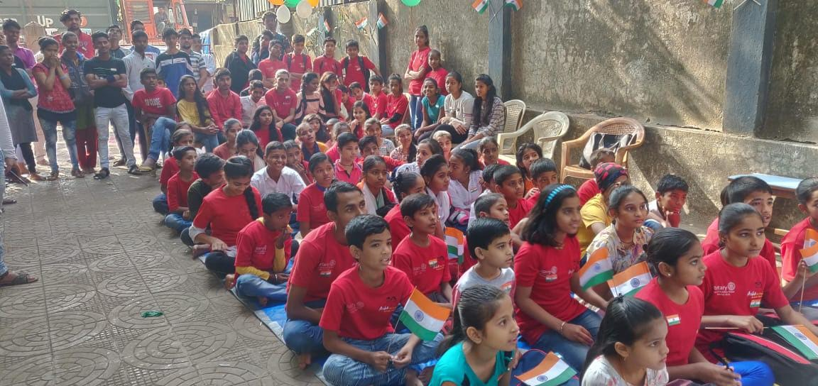
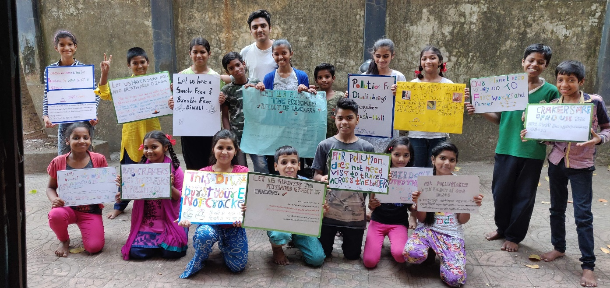

On Saturdays: on weekends children are supposed to do something other than curricular studies. There is a good library of books for reading. Kids are supposed to read play and have some outdoor activities.

Computer Education:
Apart from basic computer literacy we are encouraging the students 8 thstd onwards to do QGIS and like programs in which students are doing some community work as well.
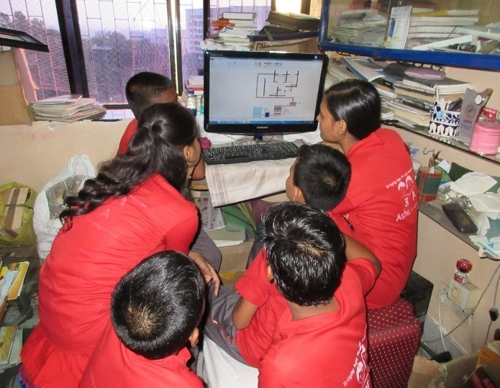
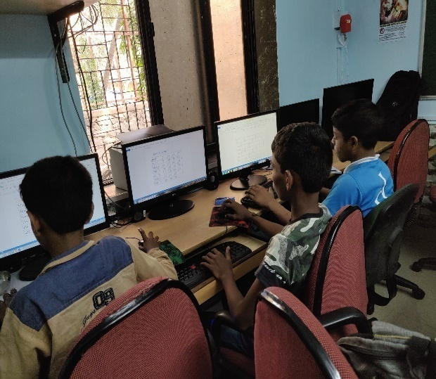

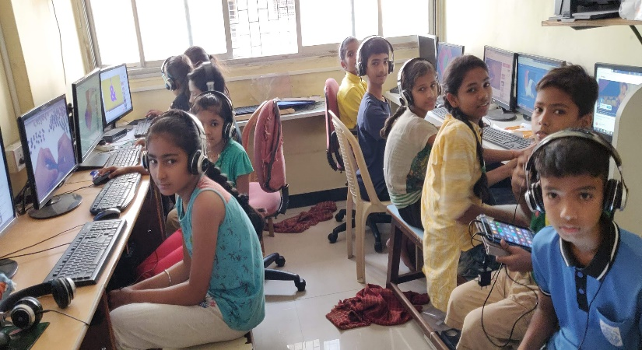
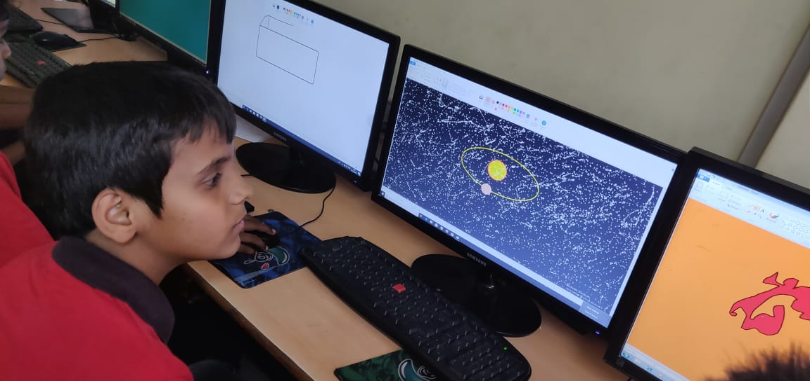

Celebration
NATIONAL FESTIVALS
Independence Day
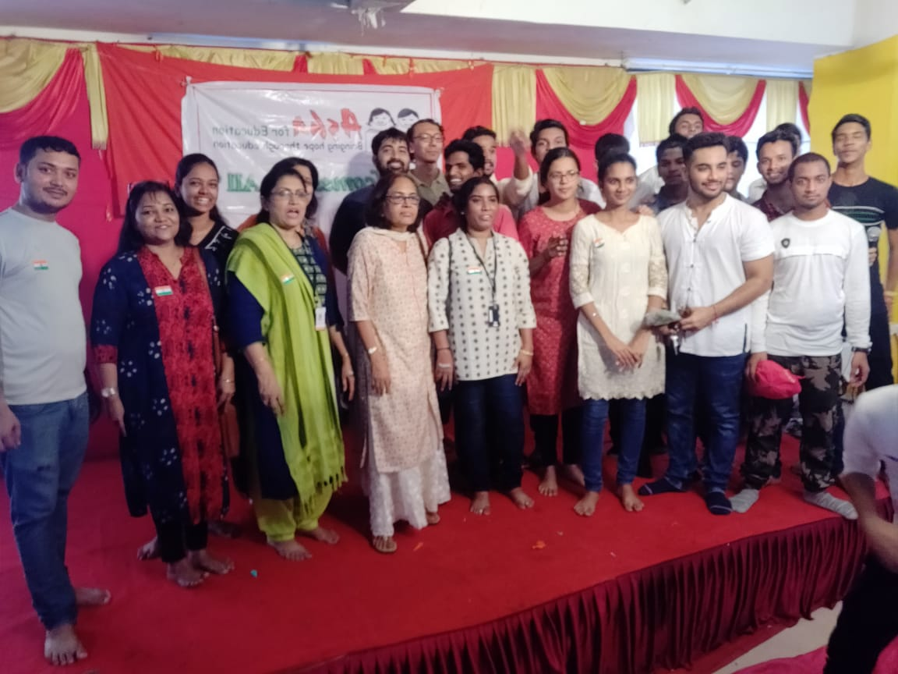
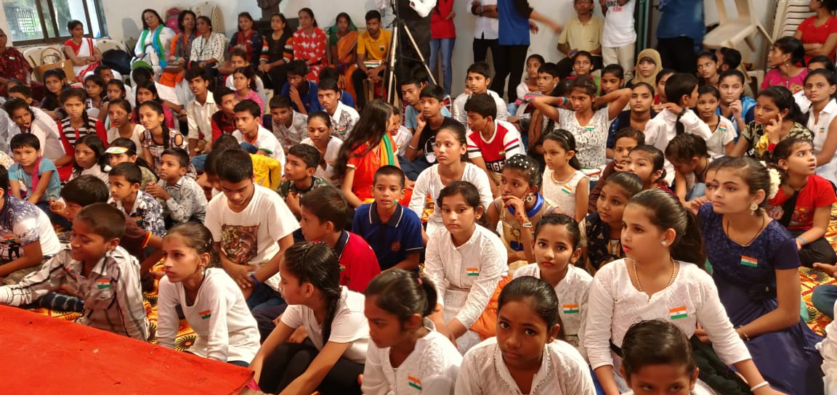

Republic Day
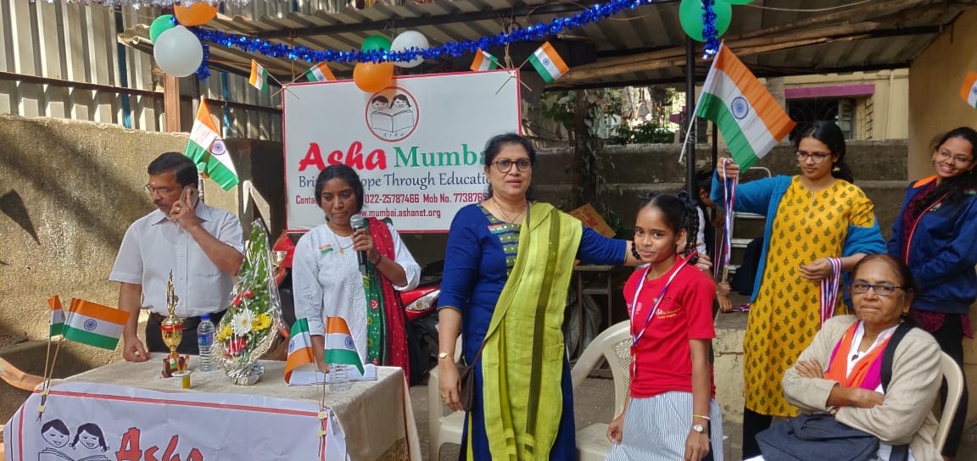
Extracurricular programs:
Creativity
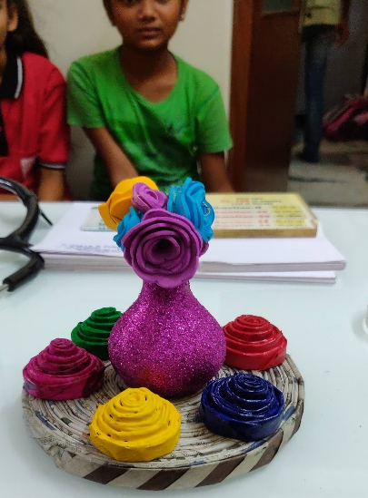
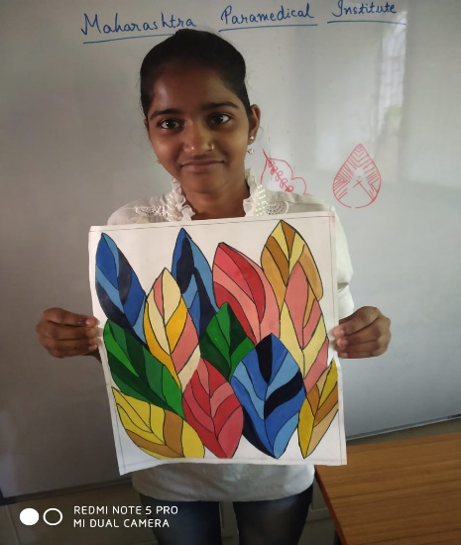

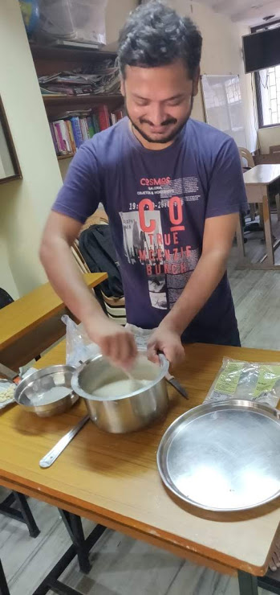
Cooking
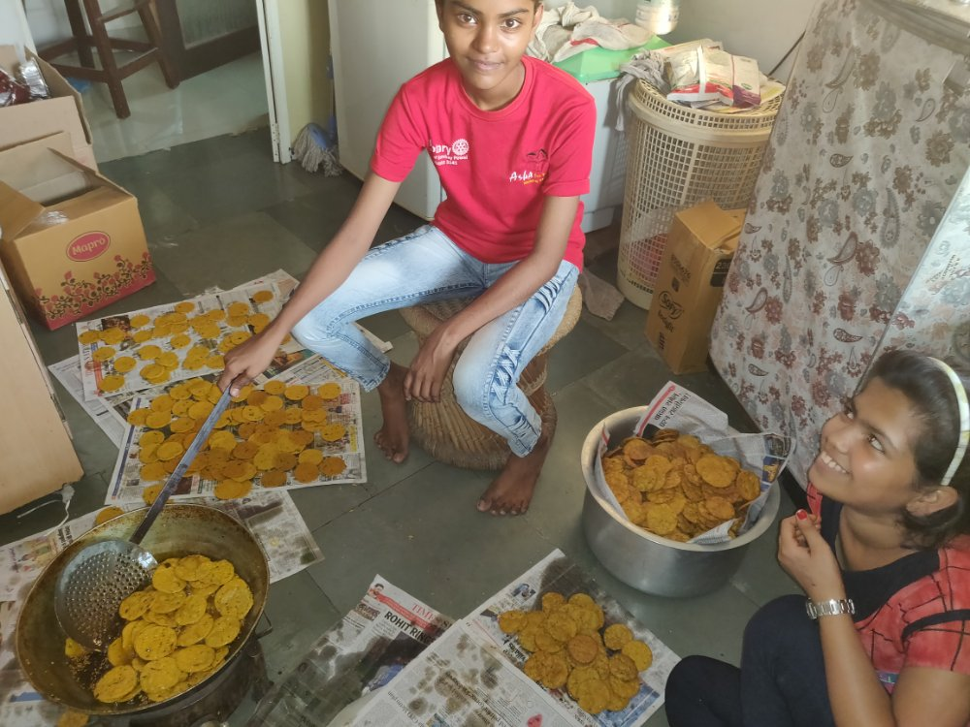
Sports
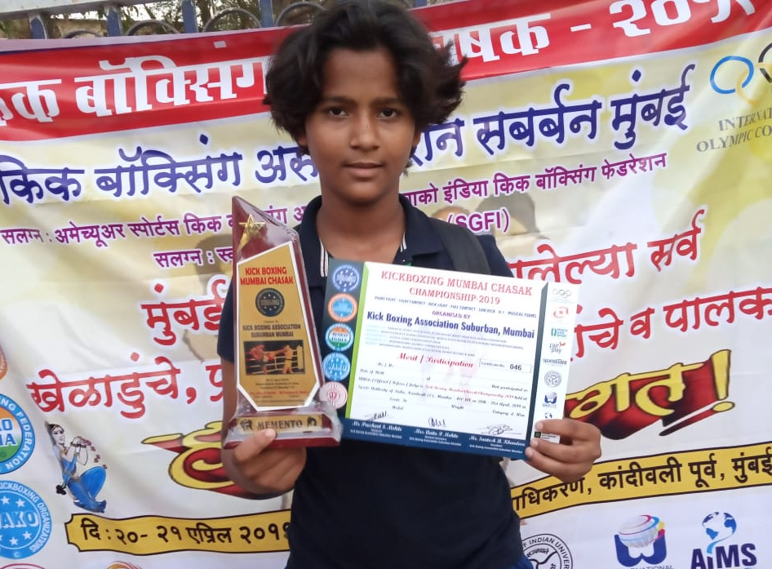
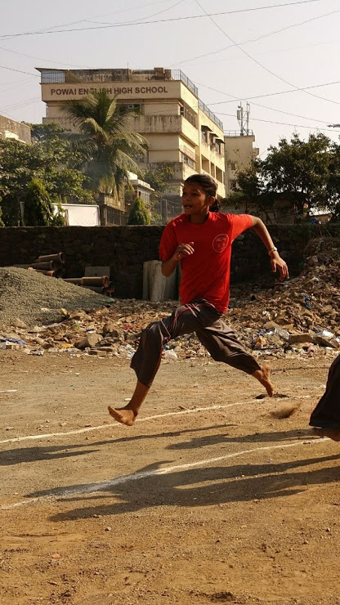
This year Sports day was very much full of zeal and zest. All the students practiced and participated. Sakshi is a champion from Asha Mumbai participating in various tournaments of kick boxing at city and national level.

Environmental Awareness activates:
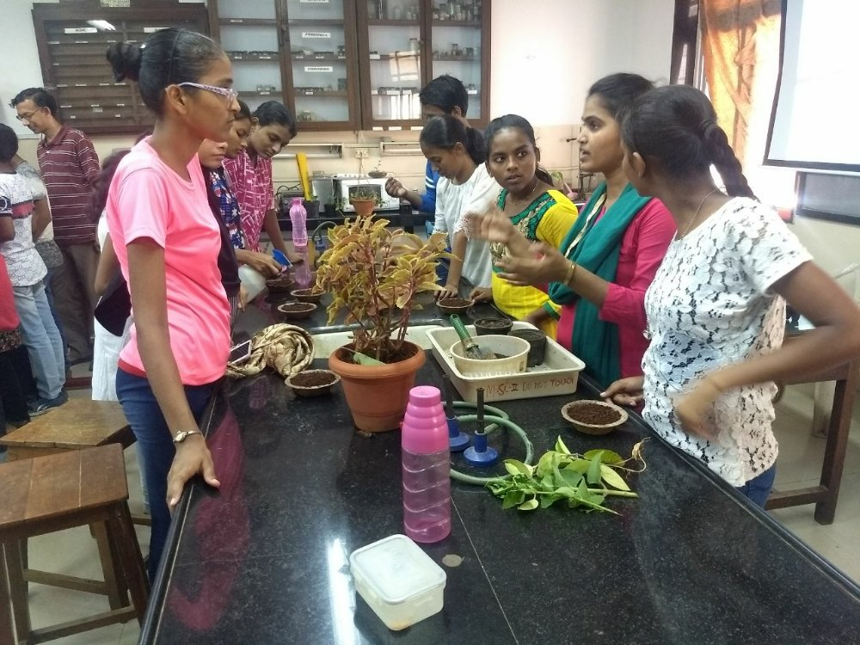
Students learning about Hydroponics Technology
Health and nutrition
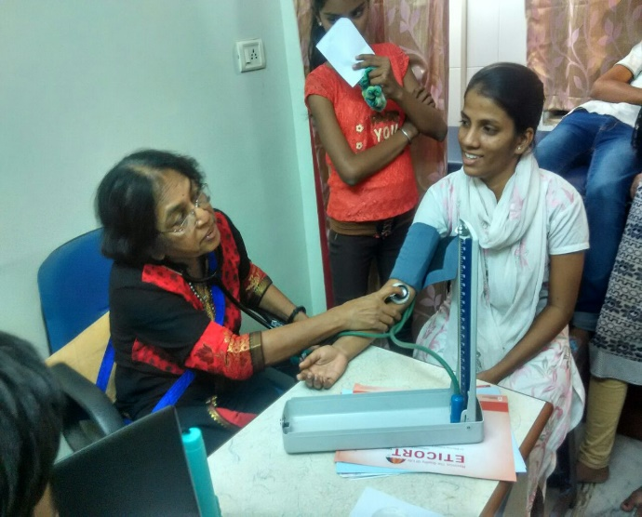
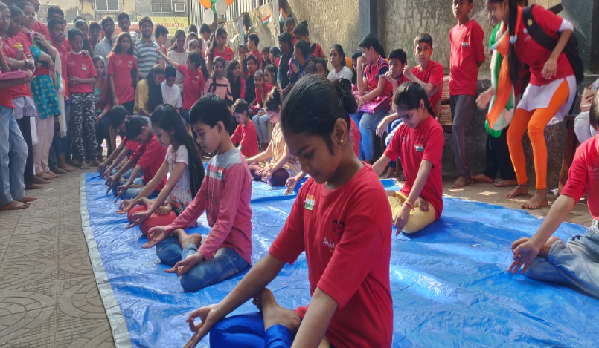

Yoga Class Health Care
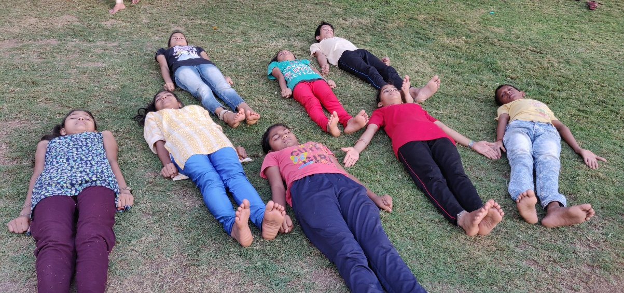

Yoga Class
Mid-Day Meal Plan
At Asha Mumbai we have started a meal plan for kids.

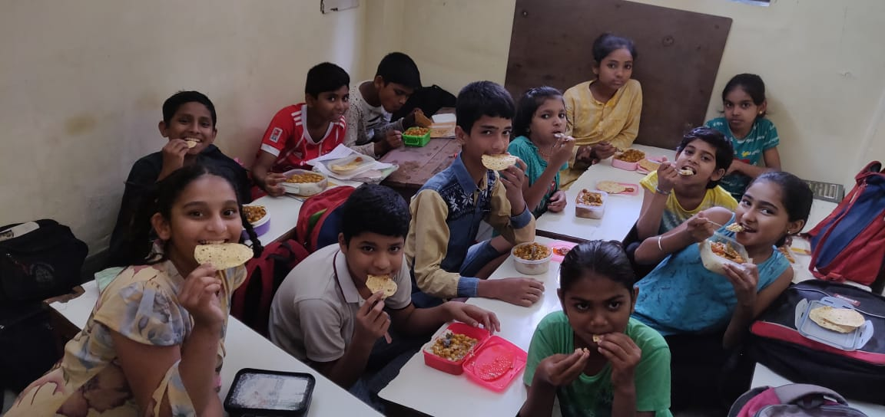
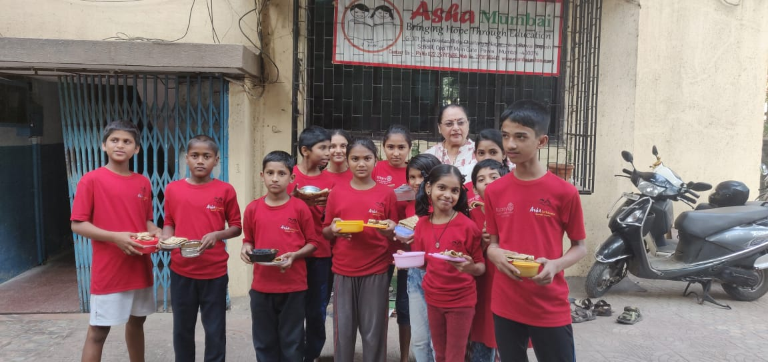

Library

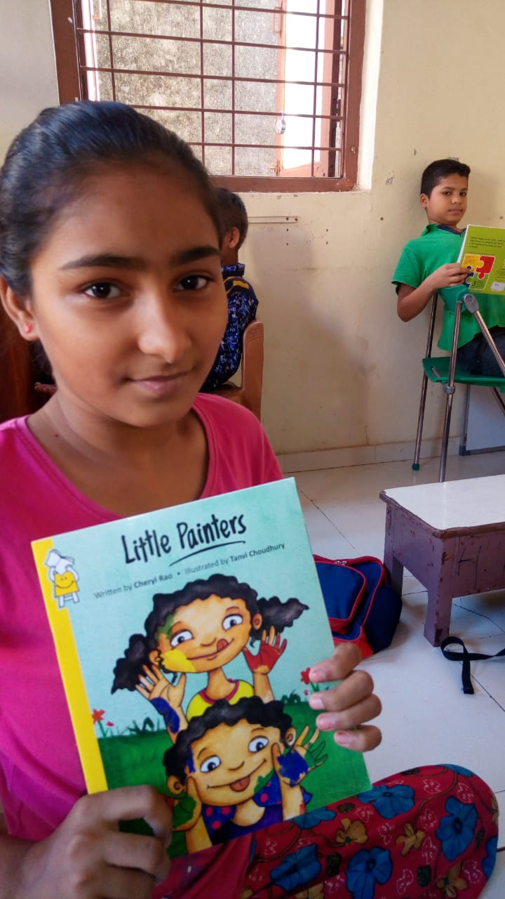
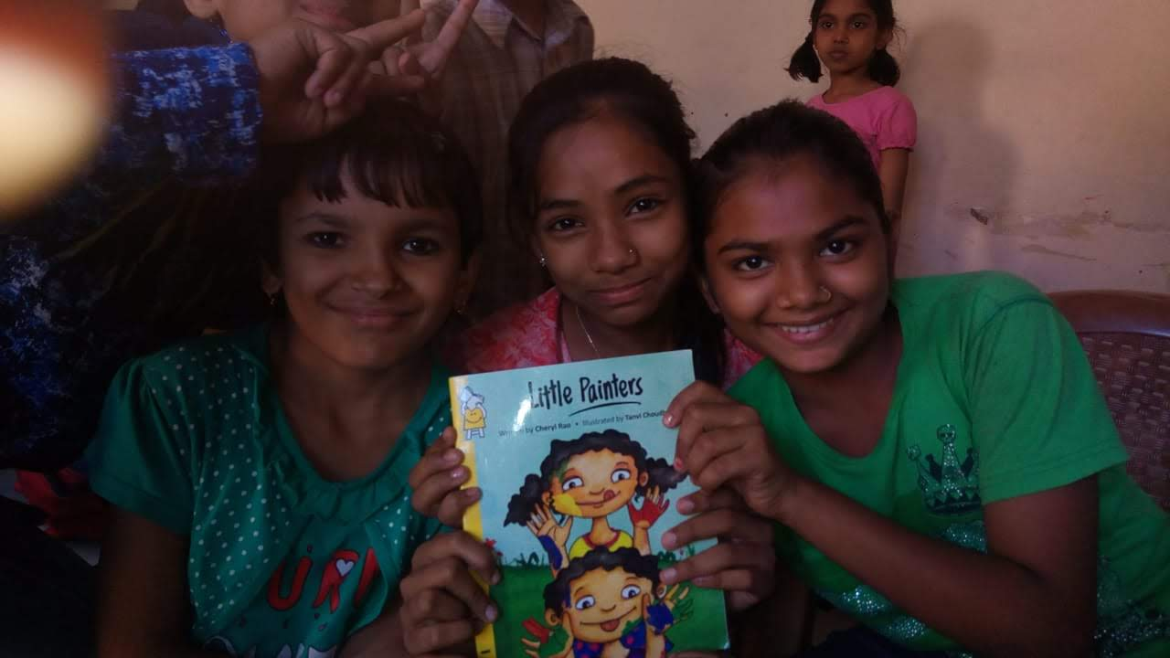

Counselling and career guidance
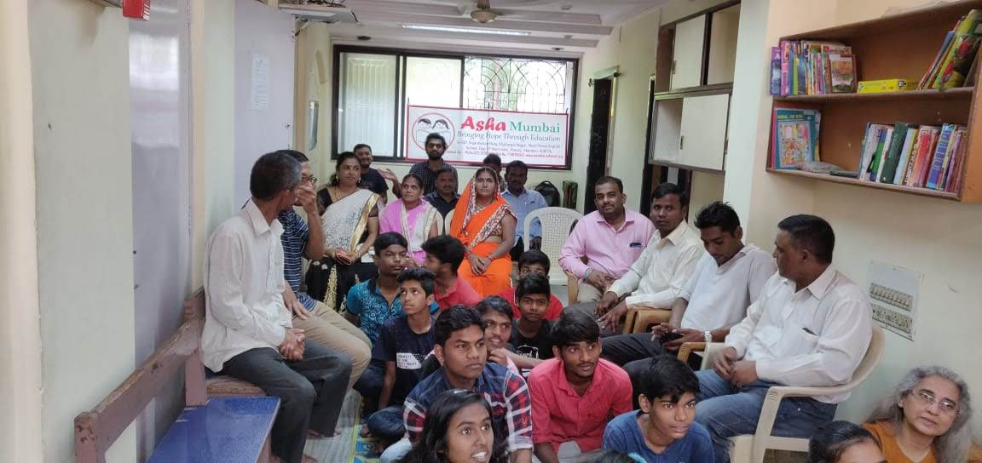
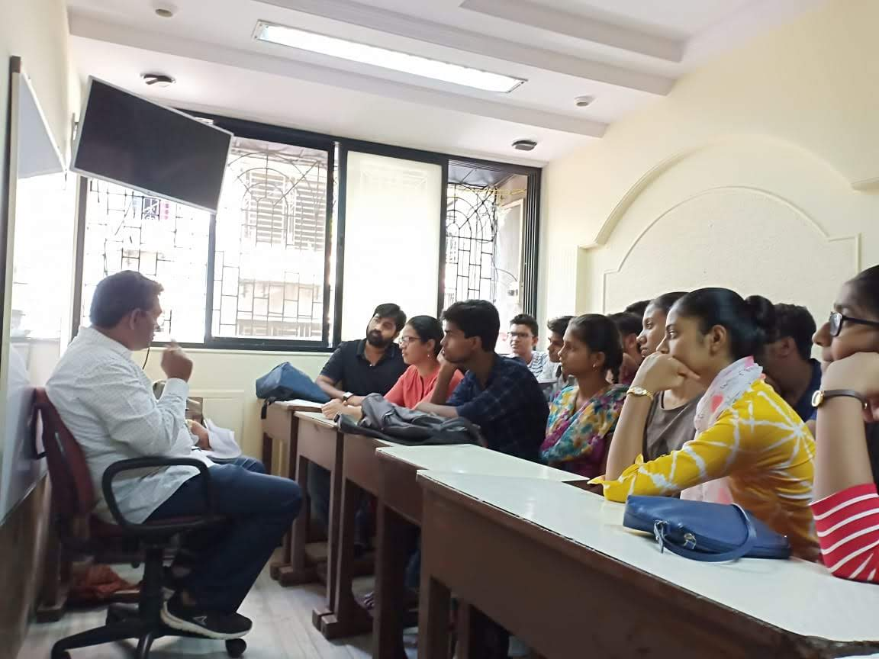

Recreation
Educational Excursion

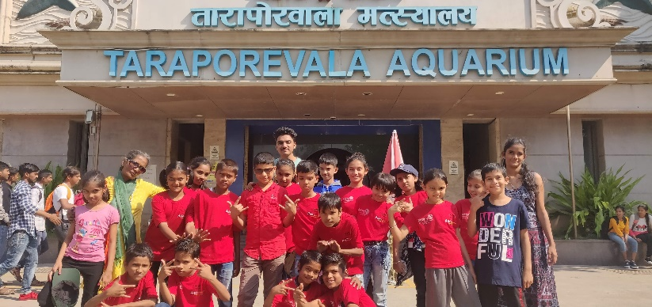
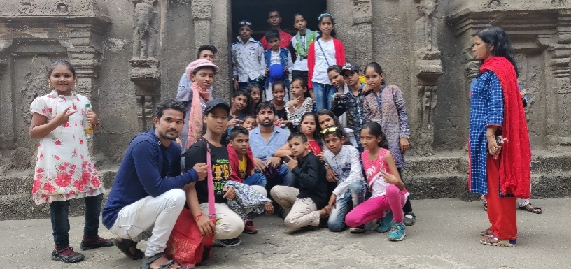

Volunteer Support Asha Mumbai is very well supported by the flow of volunteers from St Xavier’s, IIT B, connect for, etc. Though there are gaps due to volunteers’ own academic commitments.
- IIT NSS Volunteers: -there are 10 NSS students assigned to Asha every year and they contribute a lot to our teaching program.
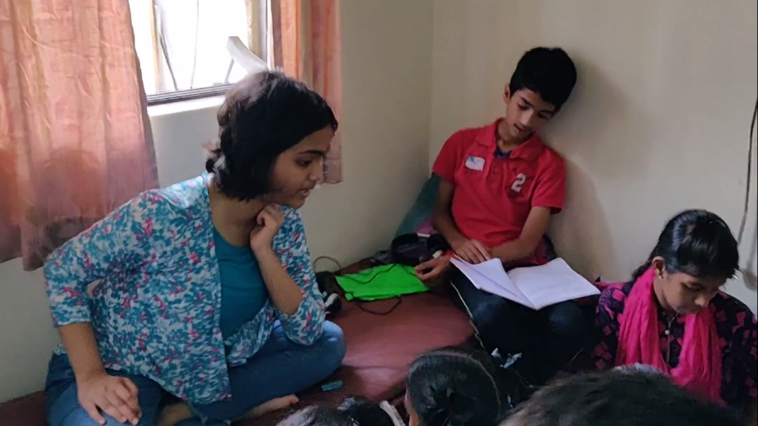

Using technology for learning!!
Children are using Tabs for app based learning at Asha. It has been observed that one understands the subject much better even especially when there is a dearth of very qualified teachers around.And even the qualified teachers can do better job with the use of App based lessons.

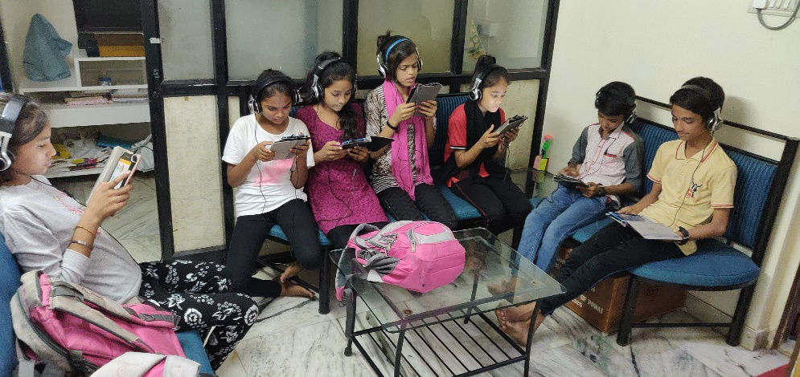

Our association with makerGHAT

MakerGhat is a non-profit community makerspace for people interested in “making”. What is “Making”? - It is the act of creating something, bringing ideas to life, and following a problem-solving mindset. Our goal is to support and encourage people to become “makers” by building creative and unique projects with science, technology, and art. You can come here to learn, build, meet other makers, and even teach!
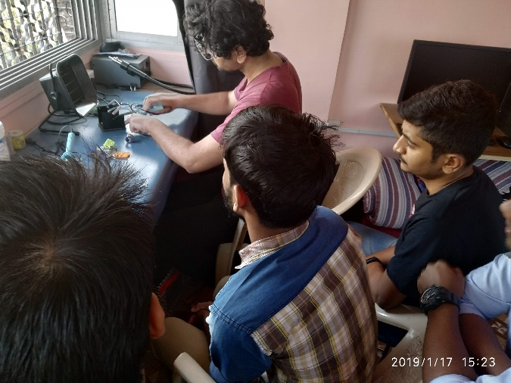
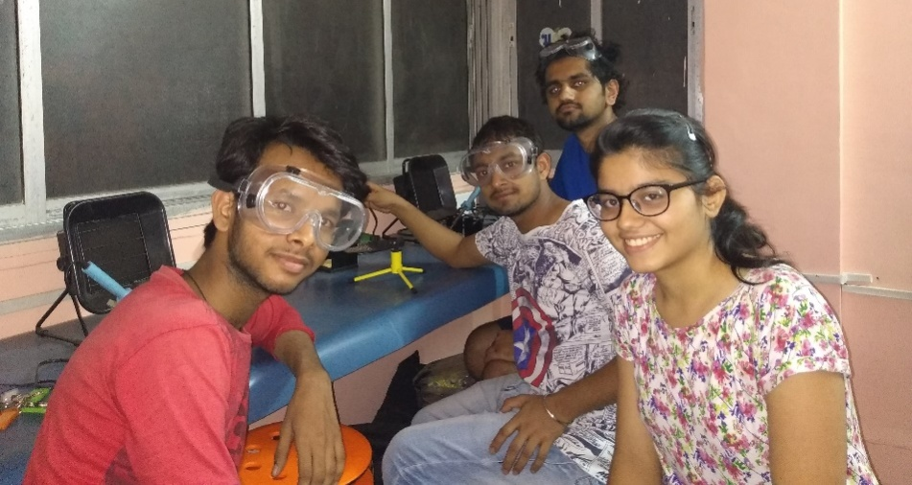

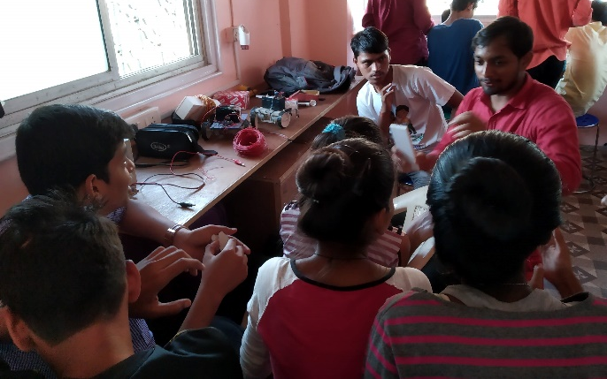
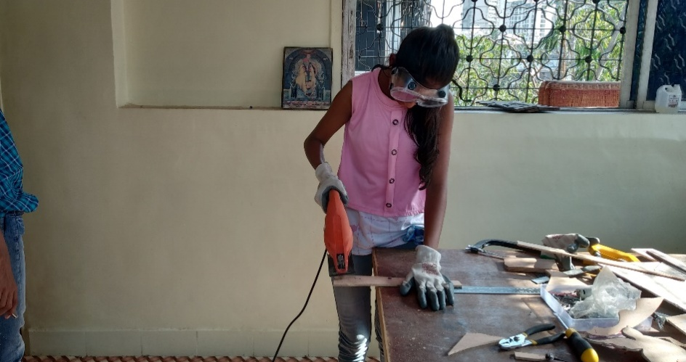

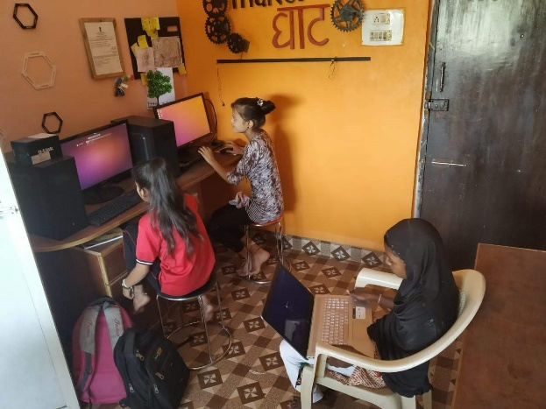
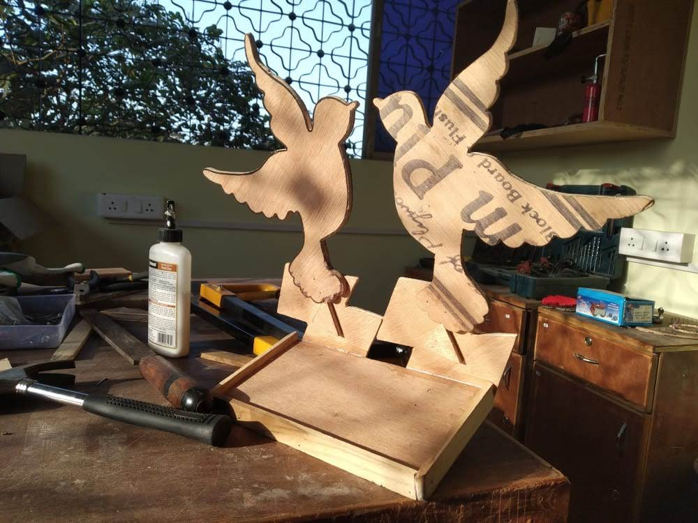

_________________________
Thank You

