Asha (Trust) Mumbai Annual Report 2018/2019

Welcome to Asha Mumbai’s Annual Report.

2017 started with further progress at Asha Mumbai.

Apart from the usual admissions, we have started to coach children for their entrance Exams after 12 th, the opportunity they would not get otherwise.

We have two distinguished teachers, the graduates of IIT Mumbai and one more Ex IIT Chennai post graduate has joined Asha.

Academic Programs:-
Daily teaching At Asha from: Monday to Friday
Morning Batch | 8.30am to 12.30pm
Afternoon Batch | 2:00pmto 5:00pm
Evening Batch | 5:00pm to 7:00pm
Late evening Batch | 7.00PM to 9:00PM

We conduct the classes for the children from morning 8.30 am to 9pm. Children get down to the classes as soon as they arrive. There are respective teachers and volunteers for English, science , Maths, history , geography, computers and languages. We have students from English, Semi-english, Hindi and Marathi medium coming from municipal and low-resourced schools in the Powai area.

There are around 120-130 children from 5th to 12th this year. We have a better planned and chalked out program for teaching. Our teachers work hard before taking the classes, they prepare notes and worksheets beforehand. Exams are conducted on regular basis to see where the remedy is needed. Students are guided accordingly. Our teachers focus on building confidence in students by ensuring that they are good with their basics.

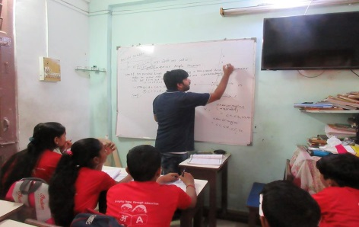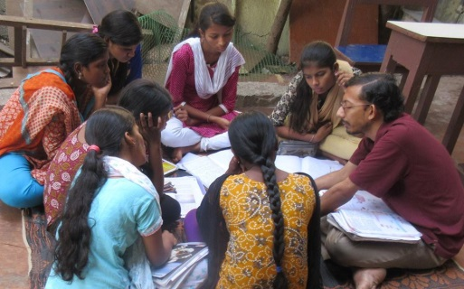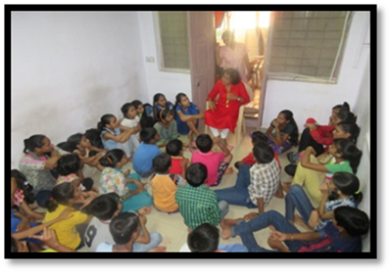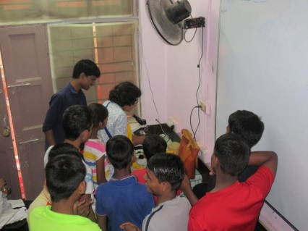
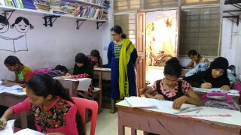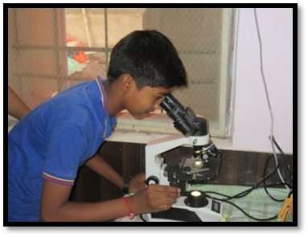

Weekends:

On Saturdays: On weekends children are supposed to do something other than curricular studies. There is a good library of books for reading. Kids are supposed to read, play and have some outdoor activities.

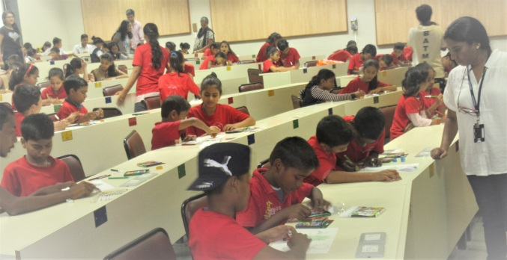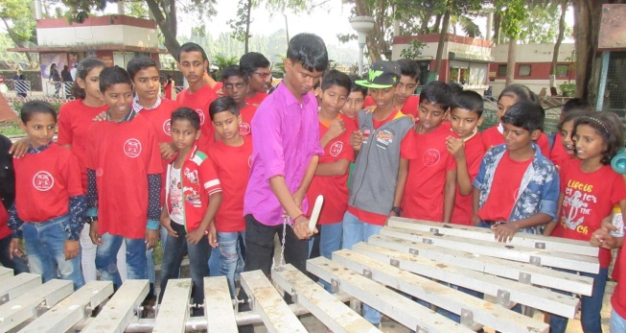
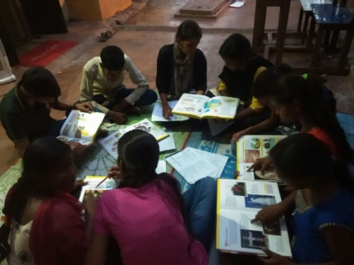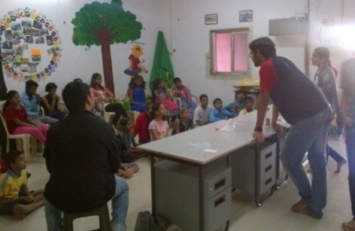

Mid-Day Meal Plan

At Asha Mumbai, we have started a meal plan for kids. We are offering nutritious mid-day meals such as poha with nuts, Upma, milk, Paratha and fruits turn by turn. Earlier we were providing once a week and now it has gone upto 3 times a week.
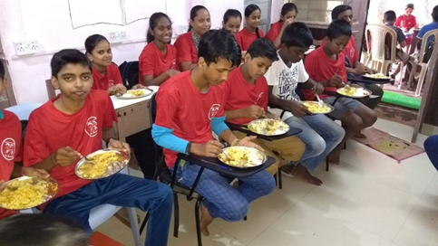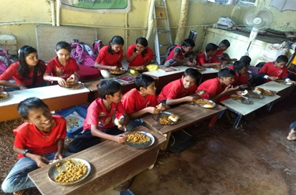

Using technology for learning!!

Children are using Tabs for app based learning at Asha. It has been observed that one understands the subject much better even especially when there is a dirth of very qualified teachers around. And even the qualified teachers can do better job with the use of App based lessons.
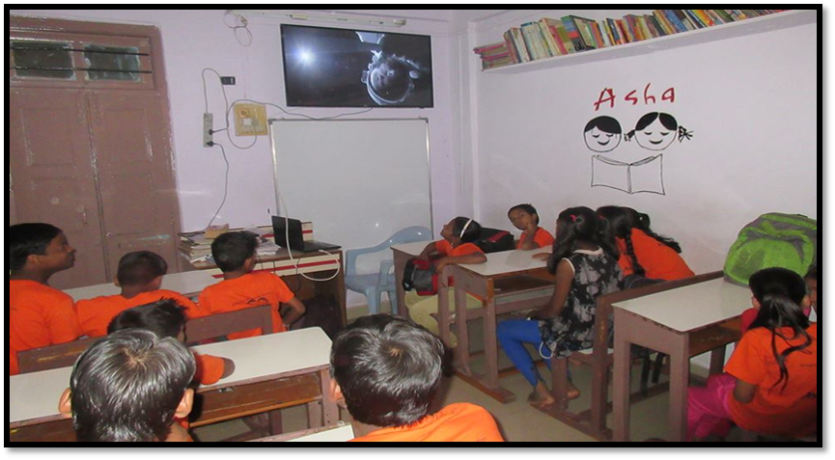

ART AND CRAFT

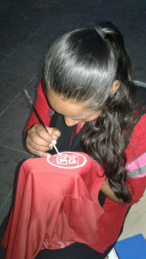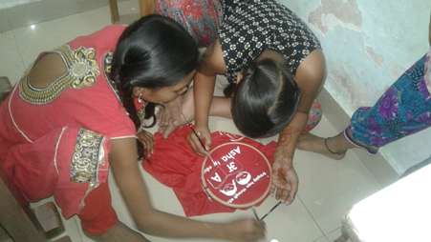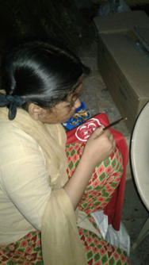
Students are being trained in art and craft. Students are busy painting the ASHA logo on the red t-shirts (uniform)
Computer Education:

With demand of digitization in all the fields of life, we at Asha emphasize on the computer access and learning the basics of computer literacy.
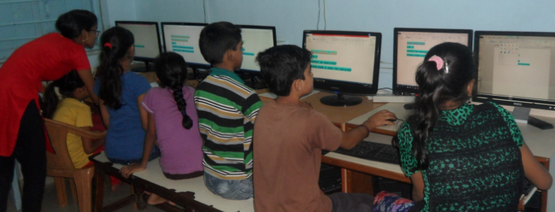

ROBOTICS

Our students showed interest in Robotics during a session with the national Robotics team. In the first level, many schools participated including ASHA Robofun team.
Under the Robotics programme, 7 students from ASHA were selected for the national level competition held at IIT, Chennai. The topic was CONSERVATION OF WATER – RAIN HARVESTING

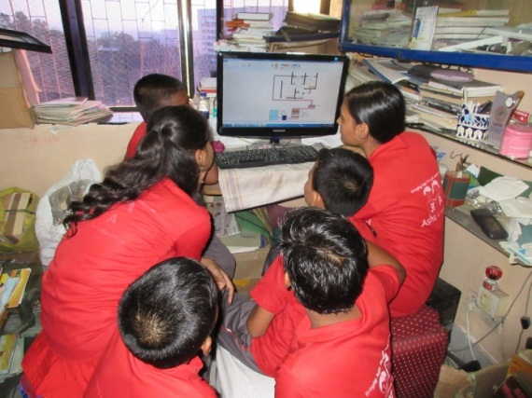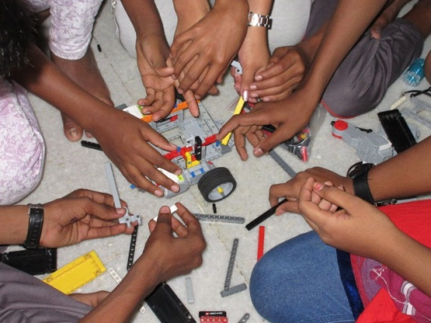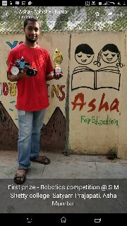

Satyam Prajapati, ASHA, MUMBAI
First prize –robotics competition at SM Shetty college

Volunteer Support
Asha Mumbai is very well supported by the flow of volunteers from St Xavier’s, IIT B, connect for, etc. Though there are gaps due to volunteers’ own academic commitments.
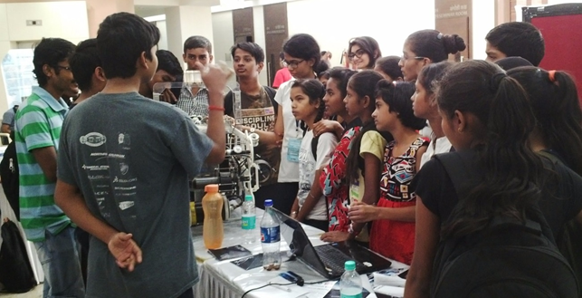

{There are companies and groups which interact with asha to support in various
Curricular & extracurricular activities}

- I volunteer’s Group: -I volunteer an NGO arranged CSR with Synopsys, a software
Company.
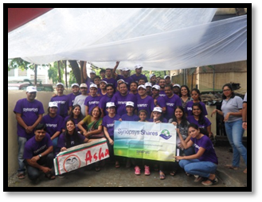

- IIT NSS Volunteers: -On every Saturday IIT Students Organize the live demonstration of various science experiments. Along with that some group also teach dance & painting.
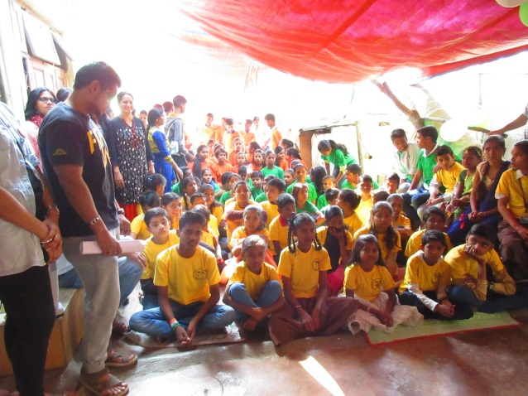

Extracurricular programs:
Sports: -
On 7 th Jan 2018 Asha kids had a fun filled sports day.
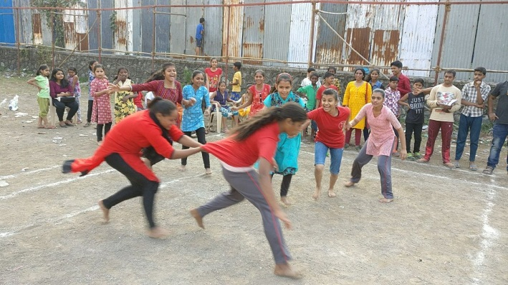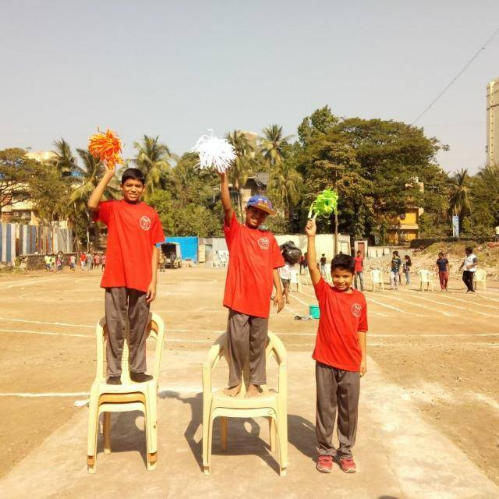
Environmental Awareness programs
In view of the pollution created by the waste plastic bags, Asha has taken up the project of getting clothes bags stitched by Asha Kids’ parents.
It has a three pronged approach .
1)Recycling the discarded cloth material like curtains and bed sheets
2)generating income for the housewives AND
3)creating awareness for not using plastic bags.
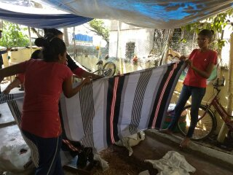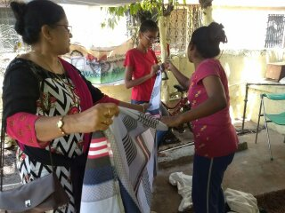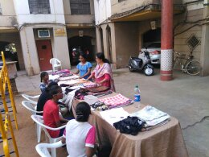

CHRISTMAS CELEBRATION
Children decorated the Christmas tree and sang ‘Jingle Bells’ and were overjoyed to see Santaclaus. They sang and danced with Santa. All of them had a wonderful time. Everyone had snacks and also got presents.
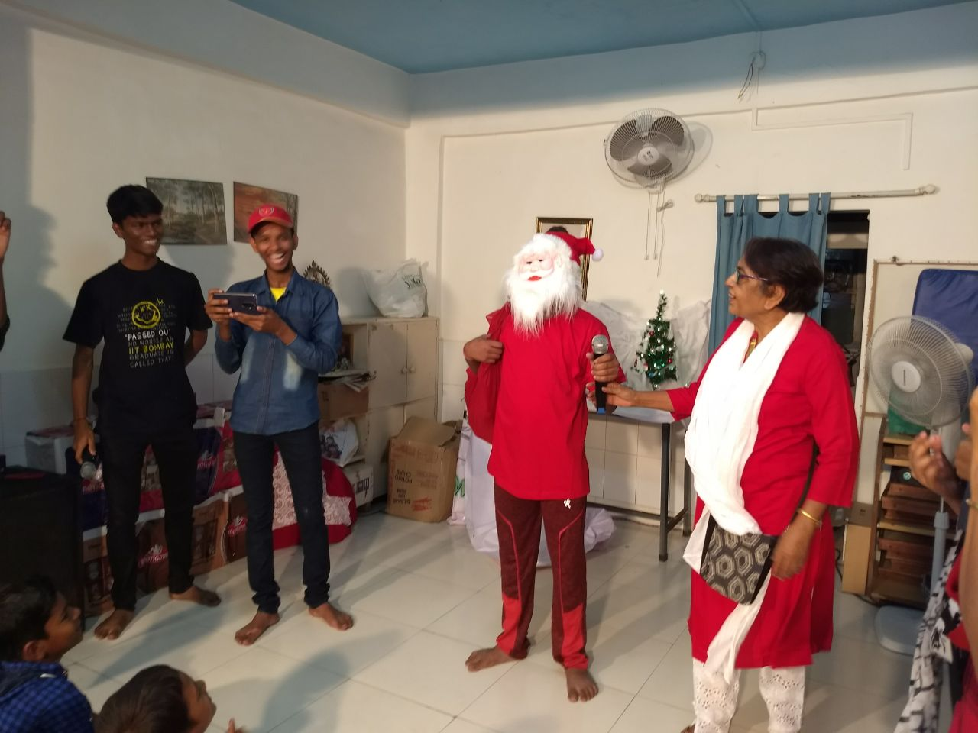

EDUCATIONAL FIELD TRIPS

MUMBAI DARSHAN

Students of VIII and IX were taken to see the historical monuments in Mumbai, the beautiful beaches , famous temples, national park etc. Children also participated in the cleanup of beaches alongwith some volunteers.

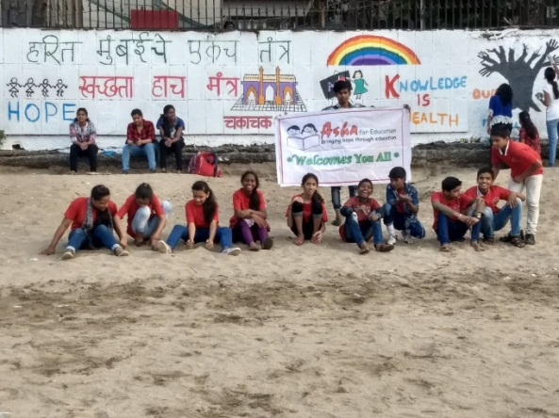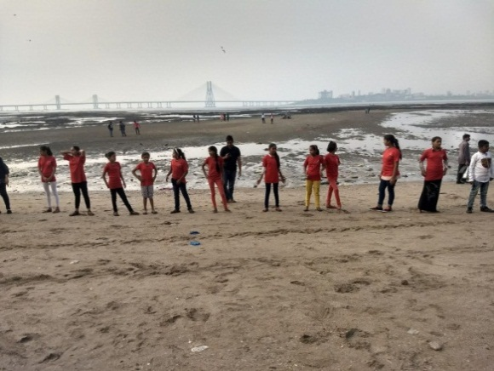

MARCH FOR SCIENCE
In order to promote the culture of scientific thinking, city based scientists, researchers and students participated in the nationwide ‘March for Science’ event on Saturday evening. Students of ASHA too actively took part in the March.
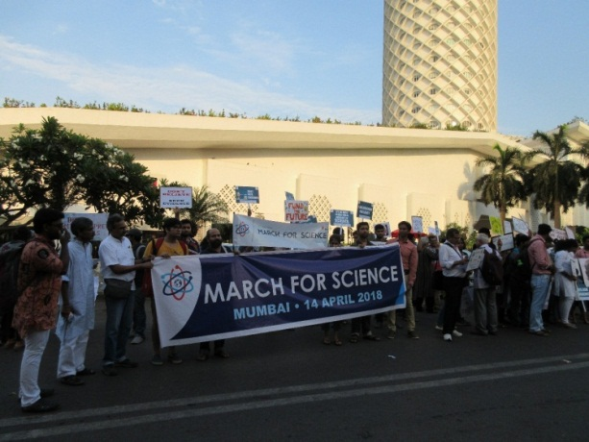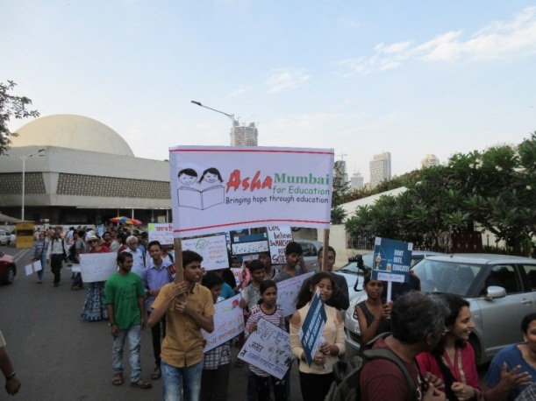
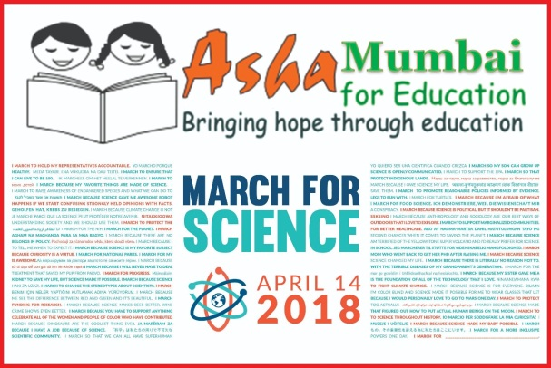 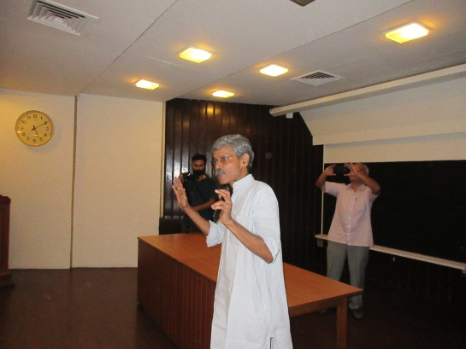Mr.Arunam

VISIT TO SAHI BANGUDA VILLAGE
Visit to Sai Banguda, an Adivasi village , totally rural in the midst of a metropolitan city, Mumbai, was an amazing experience for children. They visited their houses , interacted with the villagers and relished the simple and nutritious food. They also played in the river.
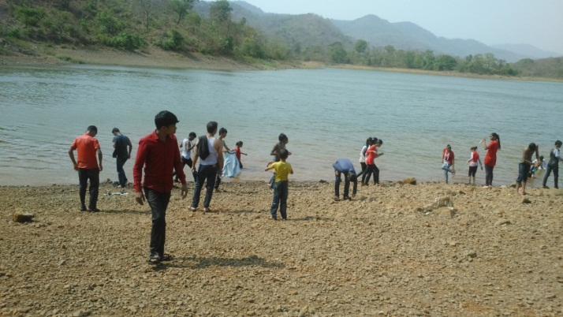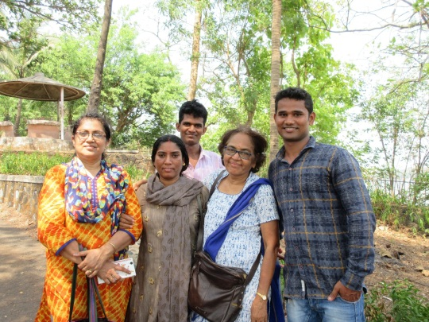

TRIP TO IMAGICA THEME PARK
The students were taken to the amusement park for recreation and rejuvenation after the exams. They enjoyed the speedy fall down a water fall, with steep drops and turns. It was an adventurous trip. By evening, they came back tired but very very happy.
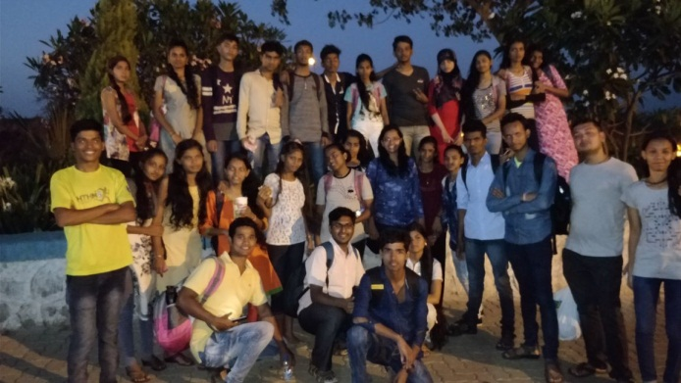

VISIT TO VIGYAN ASHRAM, PABAL

X std students were taken to Vigyan Ashram, Pabal. Students were introduced to the various skill training programmes in new technologies developed under the core support program of Dept of Science and Technology (SEED Division).
Students gained a lot of knowledge about:
- Solar installation and maintenance
- Nursery techniques
- Solar drying
- Fodder technologies – Azolla, Silage etc
- Non Timber Forest Produce processing
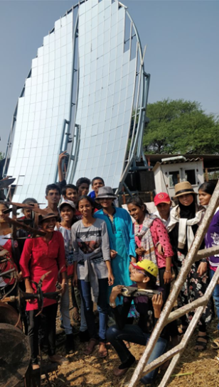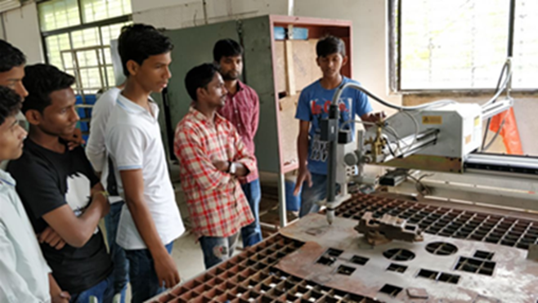

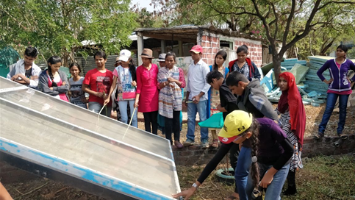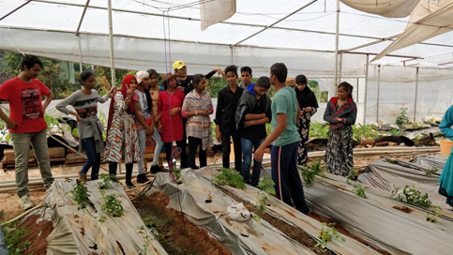

COOKING SESSIONS

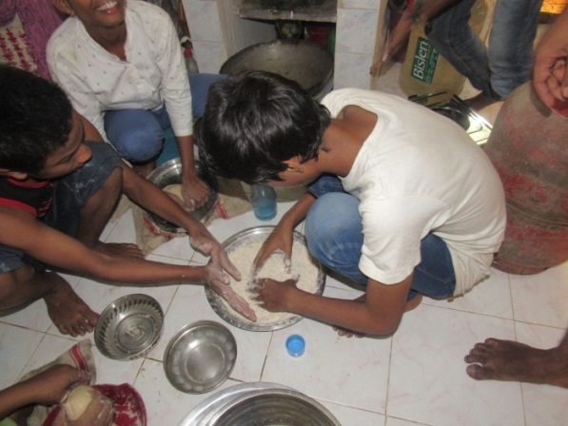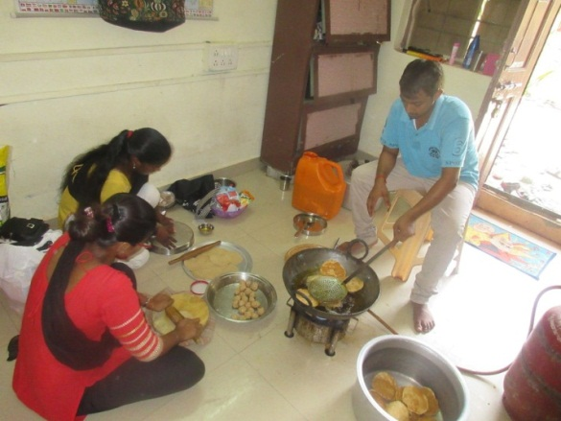

Students cook sometimes and encourage other students to learn basic cooking . Inculcating such habits and values help them to be independent and more self-reliant.

All Teachers

Rekha Bose Abhishek Kumar SuranjanSen Anita Menon
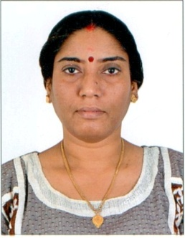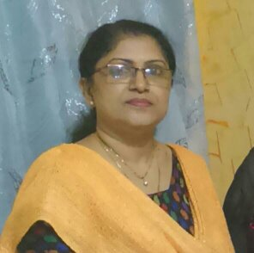
Santosh Misal
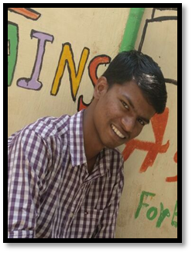 Senior students

Shrawan Kanojiya Yogesh Ratudi Digvijay Maurya
Govind Rajbhar Kajal Yadav Dhiraj Viswkarma Satyam Prajapati
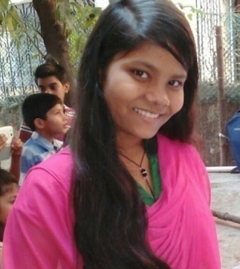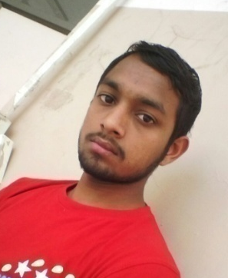

Khusboo Yadav Gulfsa Shaikh

ARTICLES IN THE LOCAL NEWSPAPER ABOUT ASHA

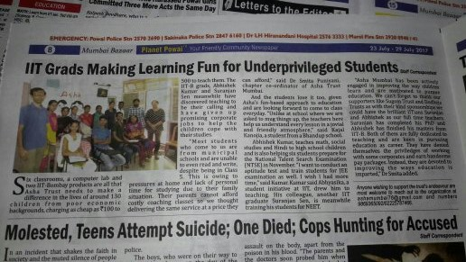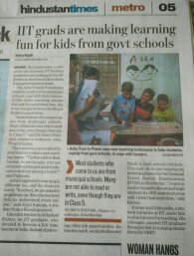

-*Thank you*-

