A Report of Visit to Sankalp Day-Care Centre by Team PRAYAS, IIT Kanpur

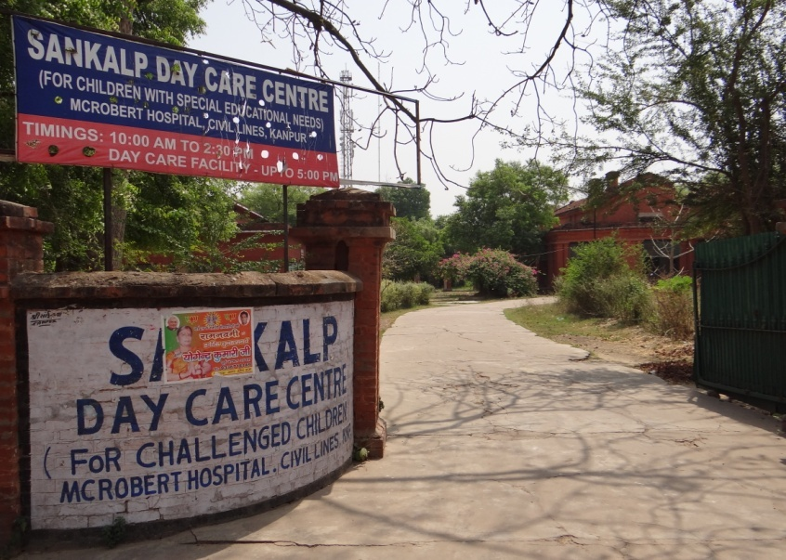
Students of IIT Kanpur associated with PRAYAS, along with few children of class 9-11 visited Sankalp Day-Care centre on 7th April, 2012. Situated in the Civil Lines area of Kanpur, within the premises of McRobert Hospital, the centre has been taking care of children with special needs since January,07. Upon our arrival, we were given an introductory tour of the centre. We observed that a team of few teachers, couple of physiotherapists and a psychologist were engaged with nearly 35 children. We were told that there are around 45 kids in the centre but the strength was low on that day as it was Saturday. The first room we went had some of the difficult cases being taken care of. The second room was a big one having nearly 20 children with a varied age range, from around 10 to 36 years. They seemed somewhat at ease and even introduced themselves excitedly. We also interacted with the children in the third room who also seemed comfortable. The fourth room had the kids who sang and danced on our requests as well. We were quite heartened seeing how patiently the teachers tried to teach those special children and even the children, in spite of their difficulties seemed so jolly.
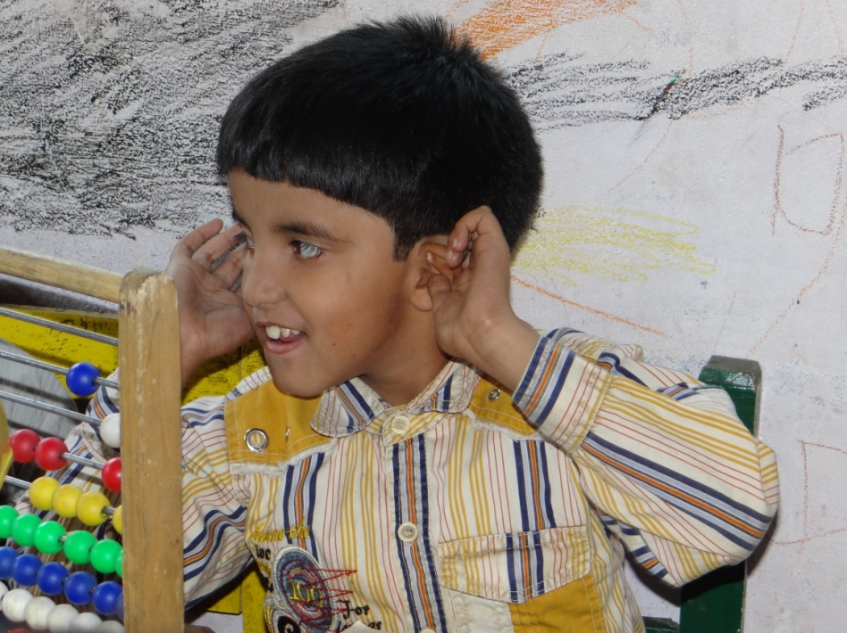
We saw the teachers teaching the kids some basic activities such as picking up objects, sorting based on colour and shapes, etc. After some of amount of teaching, the kids rehearsed a few dances for their Annual Day Celebration and even some of us shook a leg with them.
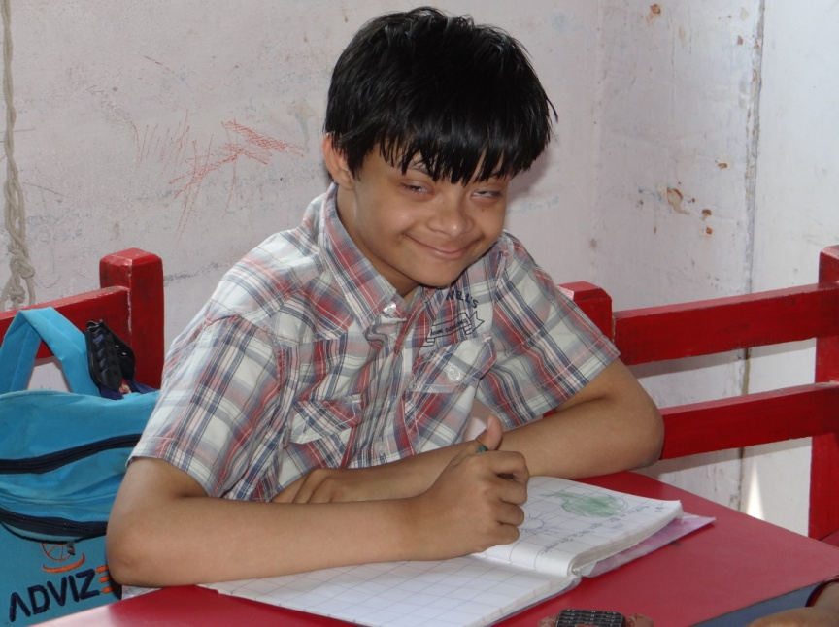
At a corner on the right side of entrance, there was a partition where there was one-on-one learning session going on. Upon asking, we learnt that the partition was there so as not to have distractions during the one -on-one learning session. The kids were being asked to recall and tell story by looking at the four-frame picture story. They were also asked to repeat numbers from 1 to 10. Once a kid's turn was over, next was called in. At one place in the first room, there a few advanced skills like stitching etc. were being imparted to few children. As Dr. Deepti Mishra told us one of the children can do simple clerical/postal works as well.
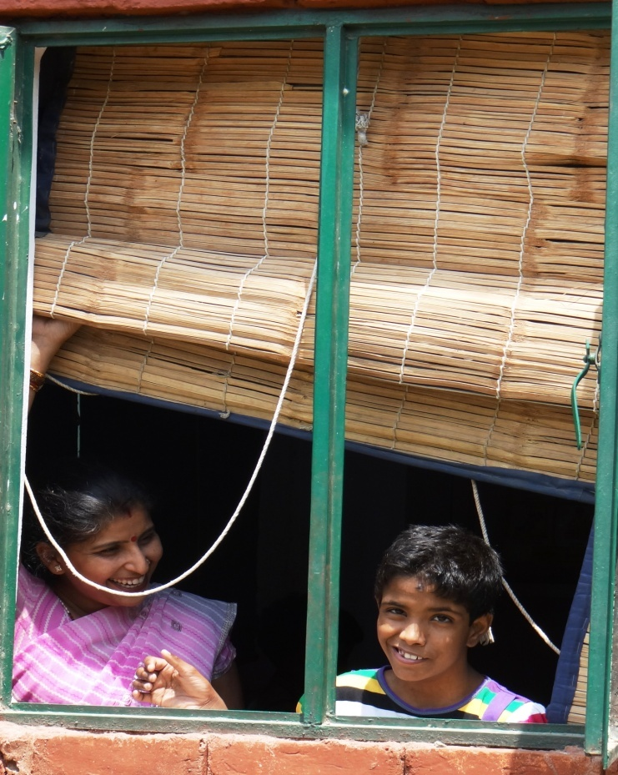
After that we had an interactive session with Dr. Deepti Mishra, who started the centre after being distraught by the lack of medical facilities for the special children after her son was diagnosed with mental retardation. During that session we inquired about the methodology they use to teach the kids and how they manage the centre. We were told that 'reward and punishment ' method worked satisfactorily with the kids. Little incentives like biscuits and chocolates encouraged the kids to be more keen at learning and adding stars against the names of performing students on the honour board and removing them in case of faults kept the children very cautious about learning and behaving well. We also came to know about the major problems that the centre was facing. The major constraint was lack of sufficient space needed for 45 kids. Lack of space was also a major deterrent to having proper infrastructure more friendly to kids and conducive to their learning. Scarcity of experts and trained teachers for special kids in the city was also a big issue. We left the centre at around 1:30 PM.
“PRAYAS”
IIT-Kanpur
“ Ratnakar” <rkme007@gmail.com>, "alok gupta" <alokrax@gmail.com>, "Sambit Mishra" <sambit91.mishra@gmail.com>, "chaturbhuj sambharia" <csambharia3833@gmail.com>, "Kushagra Singh" <kushagragrsingh@gmail.com>,

