Sankalp Day Care Visit in Kanpur (Padmanava Sen – 9th February 2017 – padmanava.sen@gmail.com – Asha Bangalore/Asha Central Team)

Snapshot of Visit:
- Visit Summary
  - Reached Sankalp Day Care in Kanpur accompanied by Asha fellow Mahesh Kumar on 9th February around noon.
  - Received by Deepti ji. We went from room to room in the center and talked to the special teachers
  - We did some interactions with the kids and later Deepti Ji explained how they divide them based on their skill-sets and retardation. Almost every kid or adolescent boys/girls in the center have some kind of delay development or mental retardation. Some of them cerebral polsy and multiple disabilities.
  - Deeptiji showed me the records they keep for each kid and track the improvements.
- Overall impression - There are no Govt school for kids with mental disability. There are some private centers in city but they are very costly. Hence, Sankalp day care fits in that gap nicely and at the same time, tries to make them independent in lives so that nobody considers them as burden.

More Details:
This project is run with a lot of care and compassion. Families of these kids feel helpless and clueless how to deal with their kids. Hence, these kids are considered as burden and sometimes no improvement happens even there is a possibility due to lack of awareness. Sankalp day care does not only provide day care facilities to these kids, they give proper training to make independent. In some cases, there are good improvements in a year in some cases, the improvement is slower. They have doctors who inspect the kid and suggest the course of action. Then they have a matrix of help needed in daily activities (for living), mental functions, concepts of surroundings, academic skills and social skills. They center speech therapy teachers and physiotherapy facilities. All teachers are well trained and most with the organization for quite some time. They have sited multiple cases where speech has sufficiently improved for a child with mental retardation so that he/she can express emotions/needs and can communicate. End of day, the goal is always to get the best out of situation if they can do their daily chores without help and for borderline cases, teach them more than that in academic domain. In my observation, I found very few kids who can work or get employed in future. But the kids look happy and doing much better than before. The best thing we can do to these kids to have more centers like Sankalp Day Care determined to provide a good learning environment never losing hope.

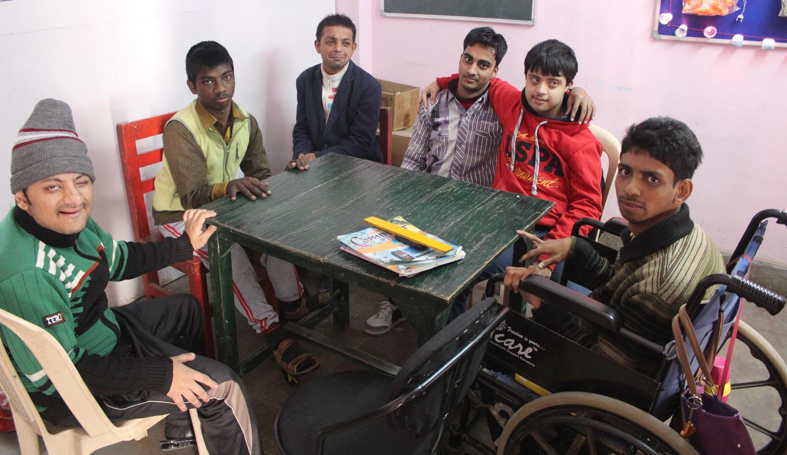
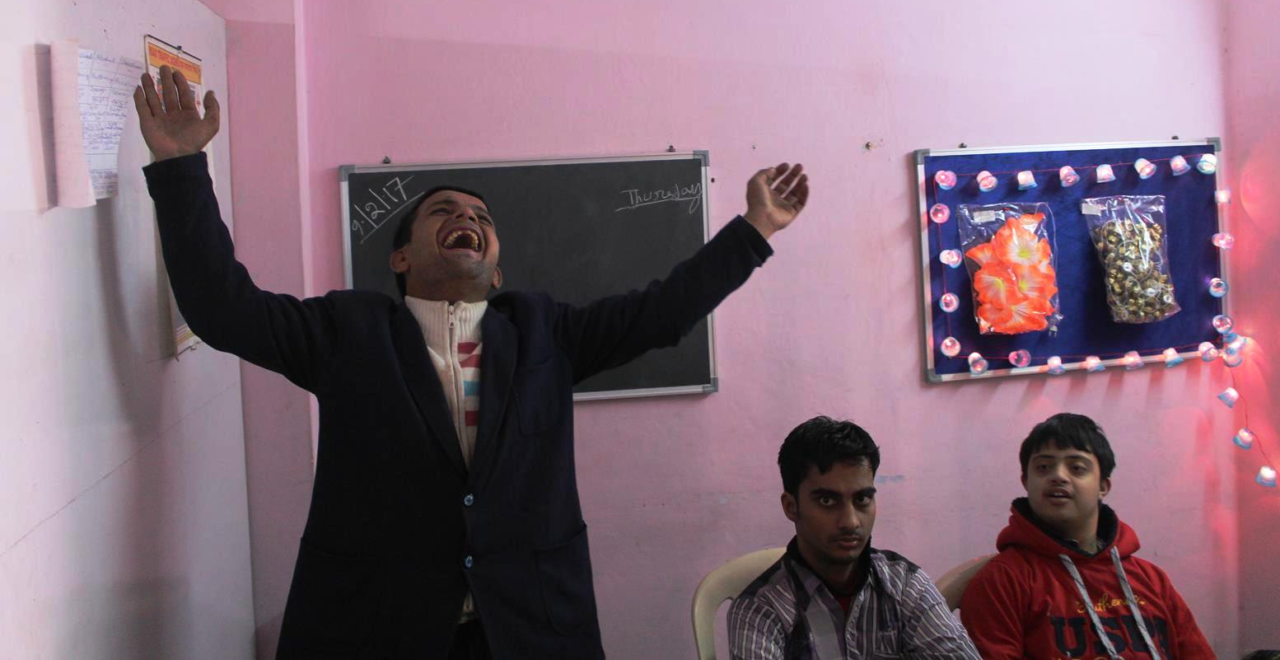
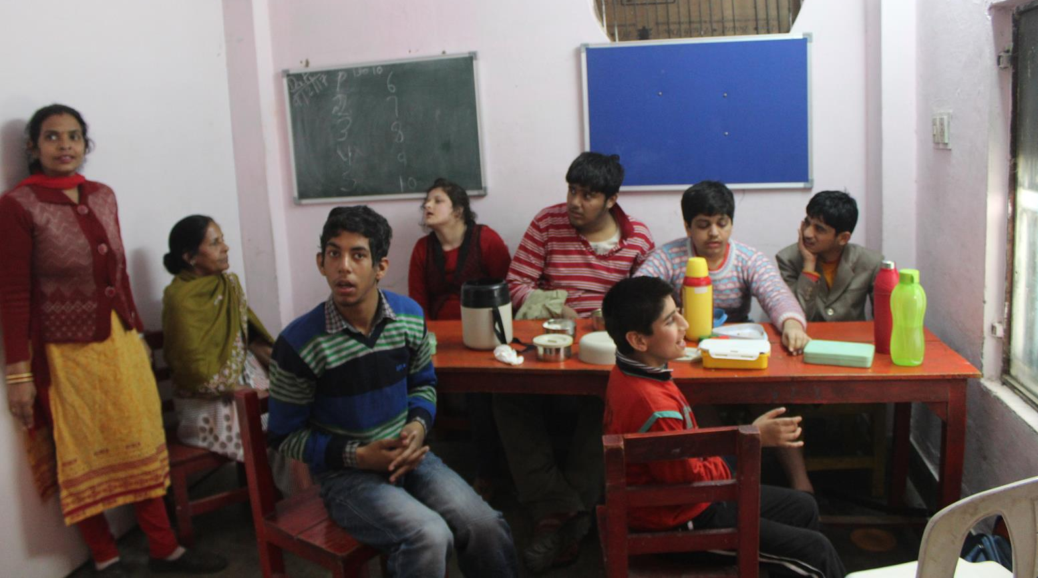

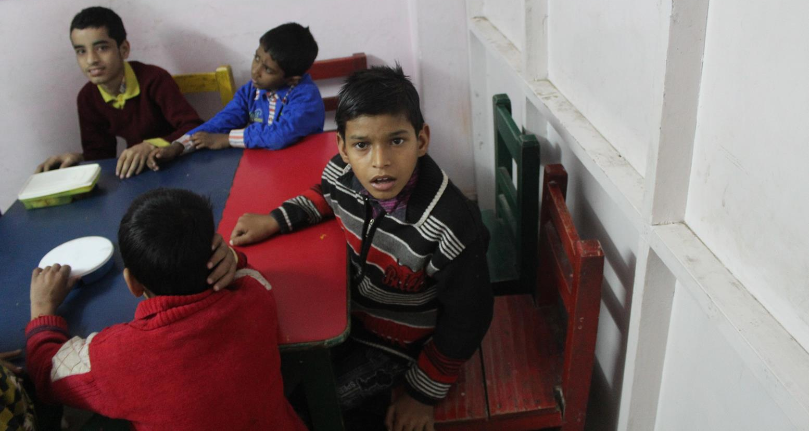
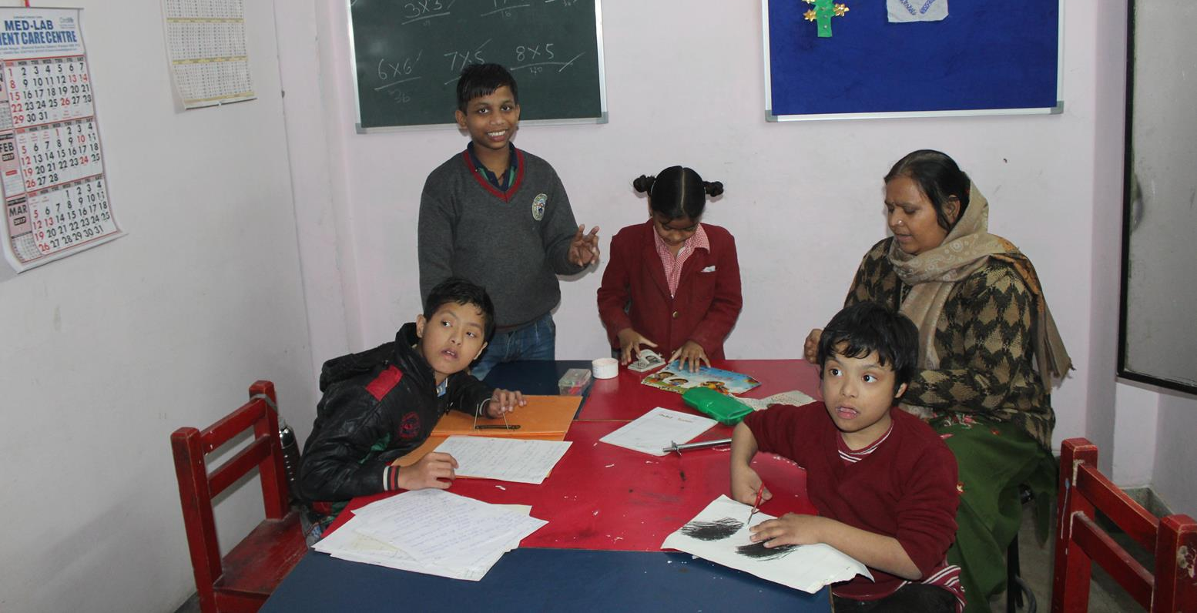
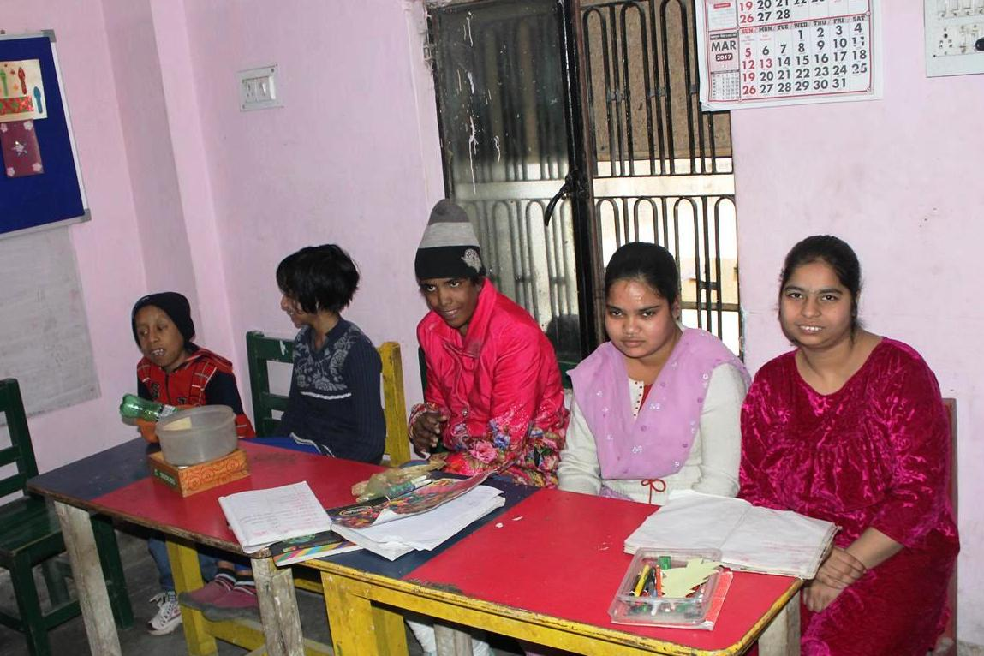
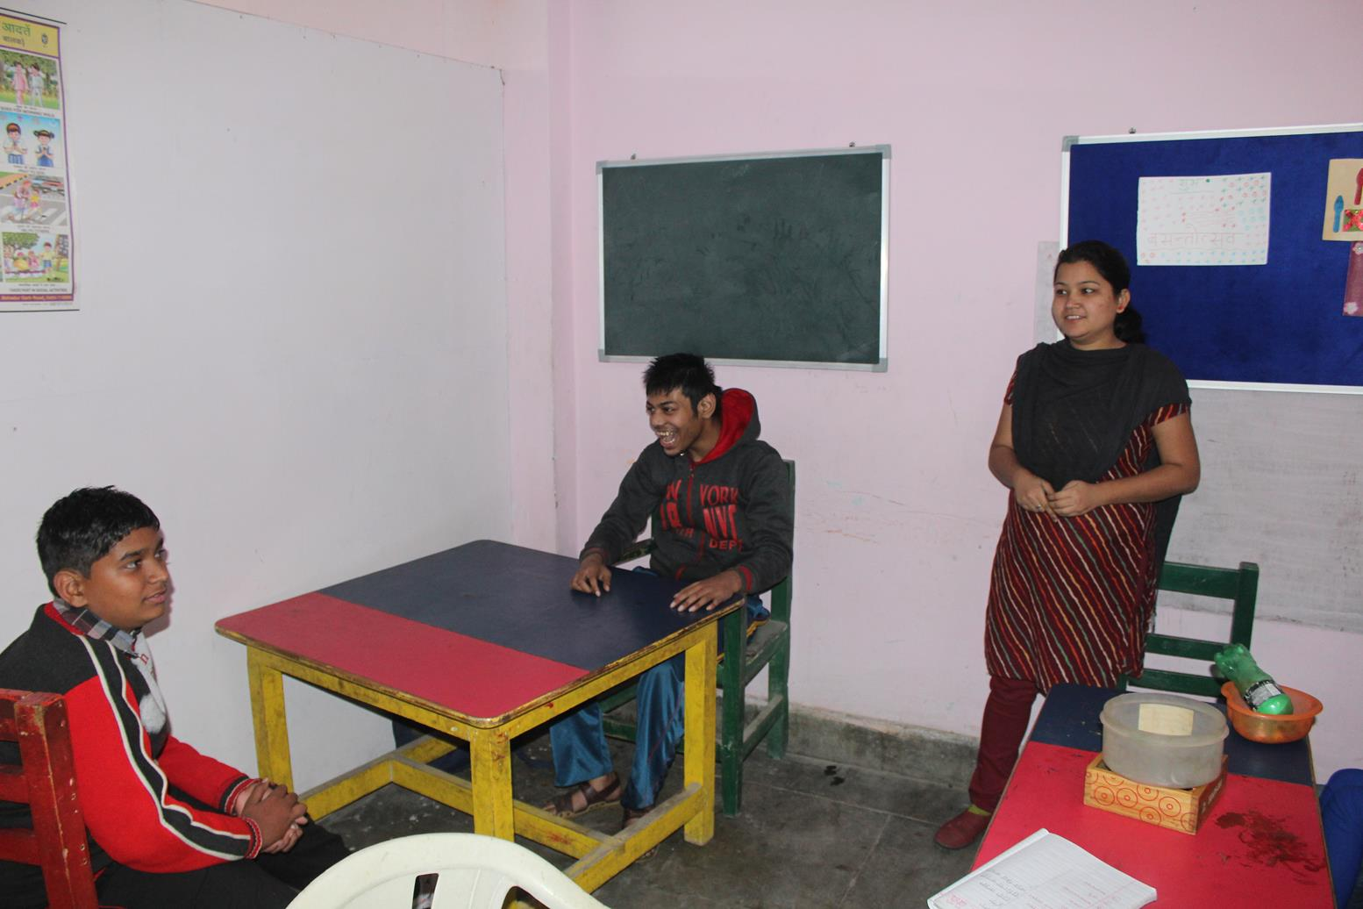
Kids in Sankalp Day Care
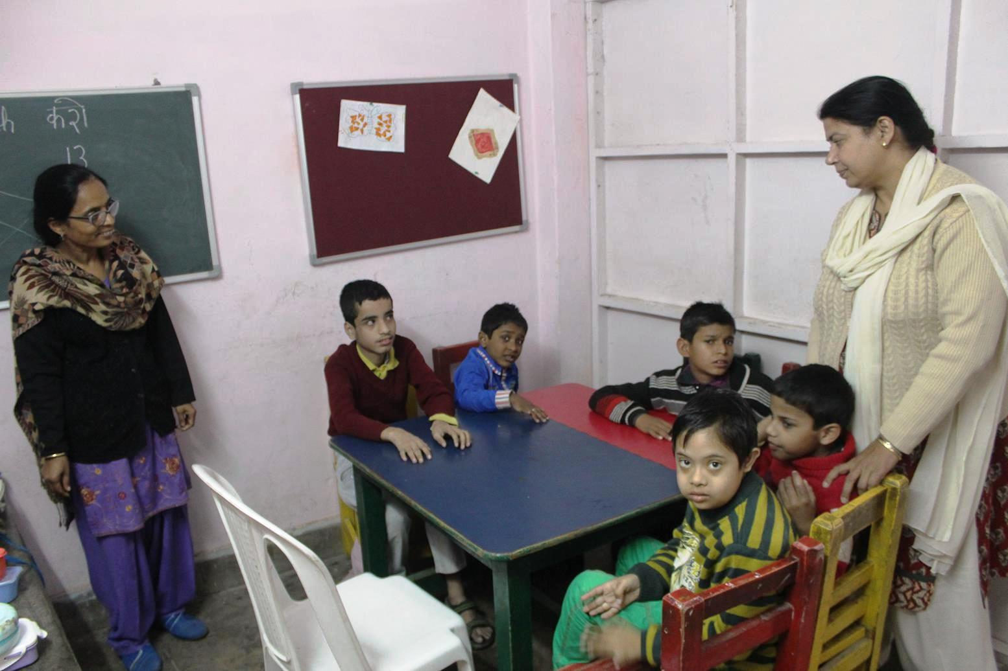
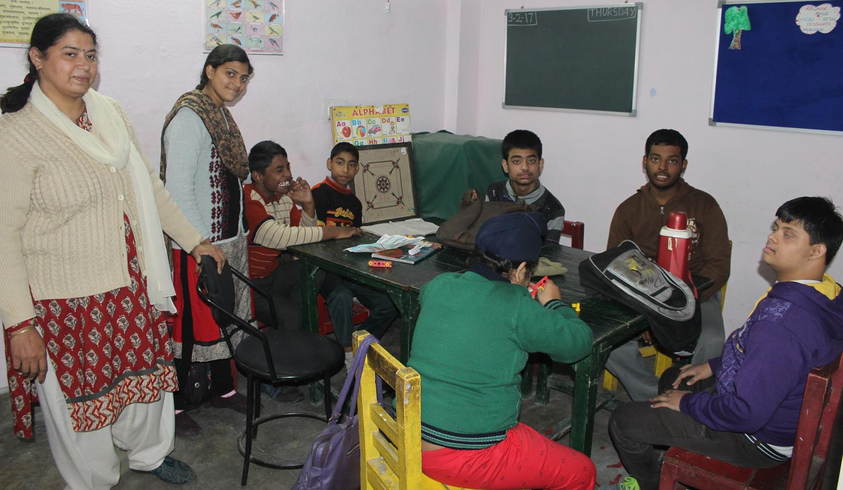
Deeptiji with the kids

