Introduction
Sangamam School has been running very successfully during the year 2018-19with the help and support of Asha for Education, U.S.A. and other likeminded supporters of Amar Seva Sangam. Sangamam literally means integration / meeting. In this school meant for Special children in the age group of 6 to 18, we try to prepare them to get integrated with the society at large gradually to the extent possible in each case.

In September 15 1997, a day care centre was started with just 9 children and 2 teachers. What was initially only a spastic centre has now grown into a full-fledged preparatory school for special children in the age group of 6 to 18. With your generous and kind support our school is expanding its activities. From 1997to 2018 we had enrolled 235 children with special needs out of which 48have been successfully mainstreamed.
Current Status of our School and its Activities.
At present we have 10 special educators and, 3 teaching assistant and 4 helpers besides attending to the needs of 66 children which consist of 50 boys & 16 girls. In addition to that 24 children which consist of 18 boys and 6 girls have been mainstreamed in general schools along with normal peers.

The infrastructure so created includes 6 class rooms, a store room, an office room and a physiotherapy hall. Apart from these a small play area is there in front of the Sangamam special school building which consists of a slide, a pair of swings, a parallel bar and a merry go round
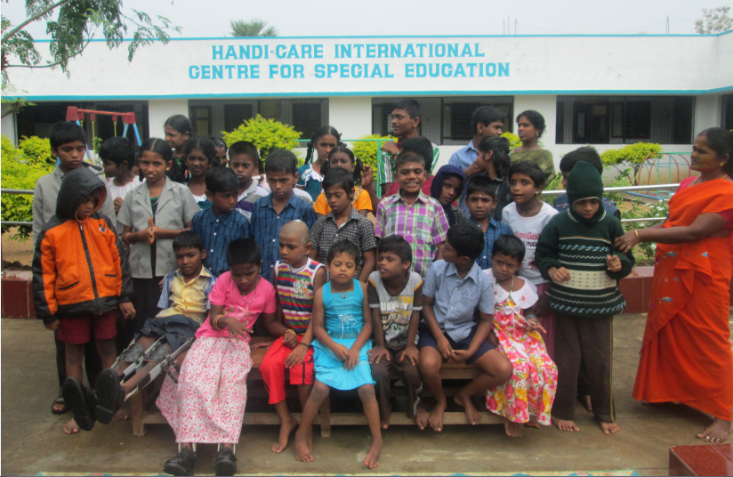

Though Special children covers broad categories of Mentally Retarded, Cerebral Palsy and Autism affected, the “Special needs” is a broad umbrella under which a staggering array of diagnoses can be fitted. Children with special needs may have mild learning disabilities or profound cognitive impairment.

The children are brought to school by the buses which are donated by ASHA foundation. They are provided free uniform, nutritious lunch, biscuits and milk. They are trained in daily living activities, behavioral science, self-care, basic reading, writing and vocational skills. Rehabilitation services like Special education, Physiotherapy, Speech therapy and Yoga are also part of the curriculum to improve their health and intellectual ability.

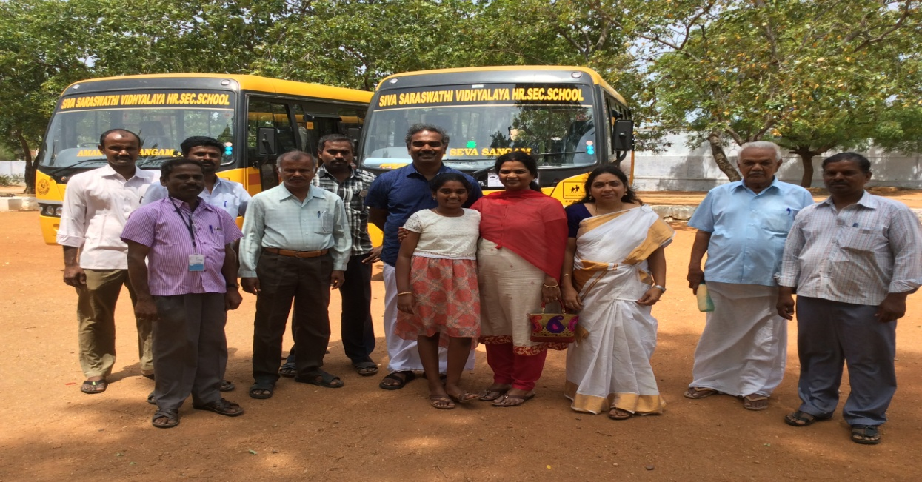

We have divided the classes as Primary, Primary-1, Primary-2, Secondary and Pre-vocational classes based on the ability and age of children. On successful completion of these stages, the suitable children are mainstreamed in our own general school.

- At Primary level, focus is on developing their activities of daily living like grooming, bathing and toileting. Then basic conceptual developments in cognition along with language development and basic reading and writing skills are imparted.
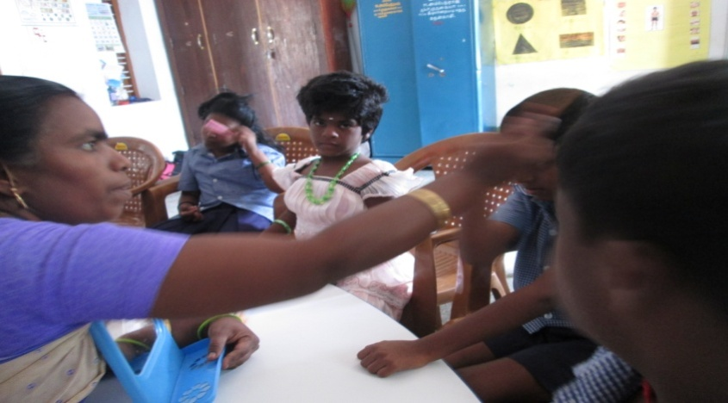

- At Secondary level the focus is on training the children (10-14 yrs of age) in the area of reading, writing, language and arithmetic skills.
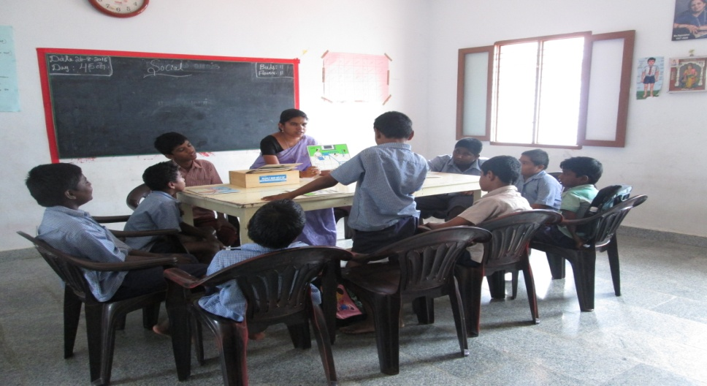

- Once the children are ready to cope up with general curriculum, they are shifted to a suitable class in our High school where they continue studies with general students including physically challenged. The teachers are fully apprised of taking care of the needs of the Special children. Our resource teacher also helps them to carry on their basic academics so that there is a smooth transition.

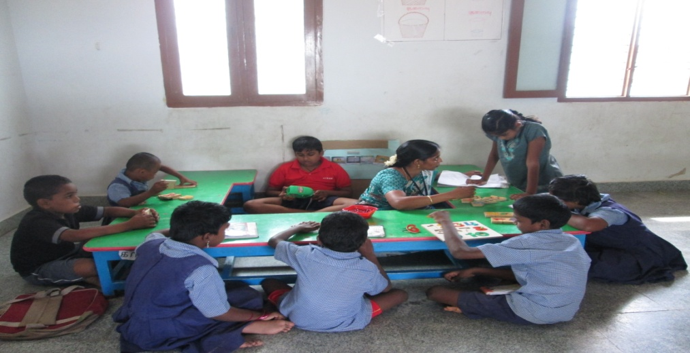

- At primary 1 level, children who have not achieved 80% or more will be transferred to this class and more intensive training will be given as like primary class will be given to the children with different teaching strategies.

- Pre vocational class consists of children of age group 14-18 where they will be given basic training for cutting, pasting and counting which will be helpful for their future vocational and income generated activities.
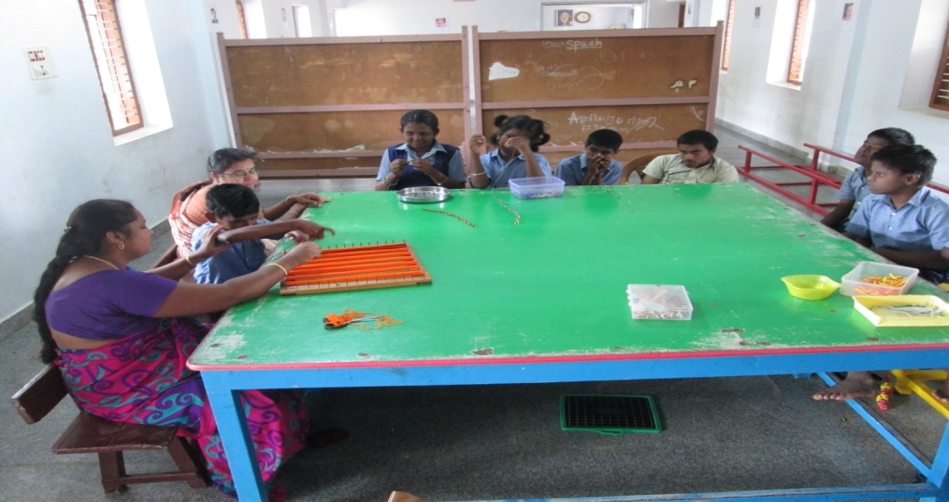

- Our students are encouraged to take part in cultural and sports competitions and have won several cups and shields at district as well as state levels. The events include Singing, dancing, collage work, drawing, art and craft work, fancy dress, 100 / 50 meter running, musical chair, long jump, hurdles, cricket ball throw, long jump, shot put and potato gathering.

SANGAMAM VOCATIONAL TRAINING CENTER (VTC project 2016 – 2018)
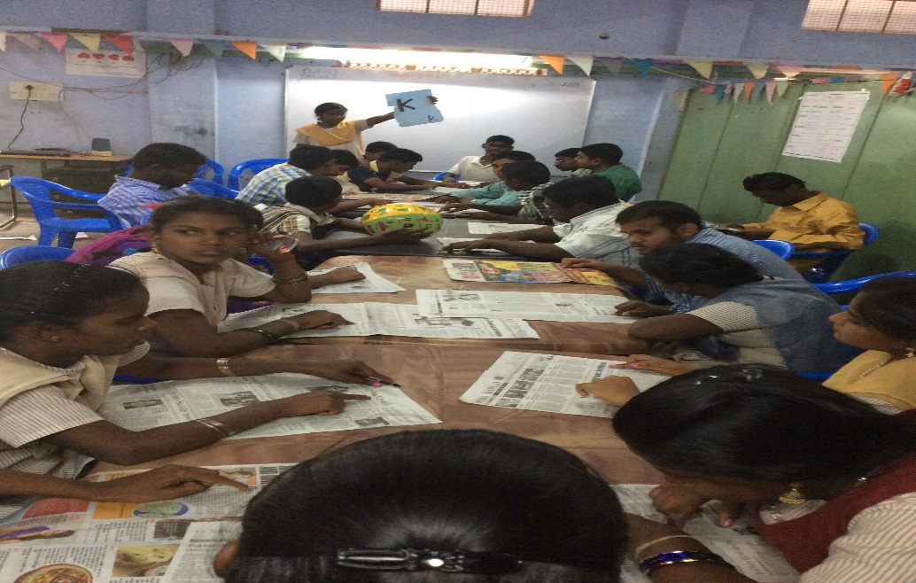
Bangalore based an Indian IT company called AMBA Institute is offering a programme for Intellectually disabled students a non-computer activity in the morning and computer based programmes or activities in the afternoon and trying to find placements for the welfare of them. It is a two year project and they are yet to be issued the Laptops by AMBA.

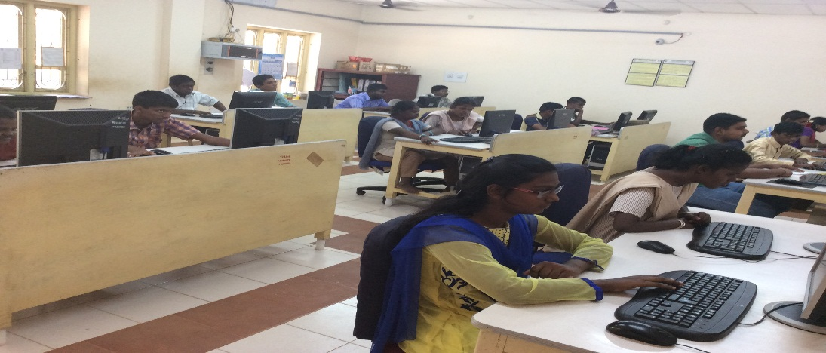

They are trained in Ms-Word, Excel, minor document works etc.,
SUCCESS STORY
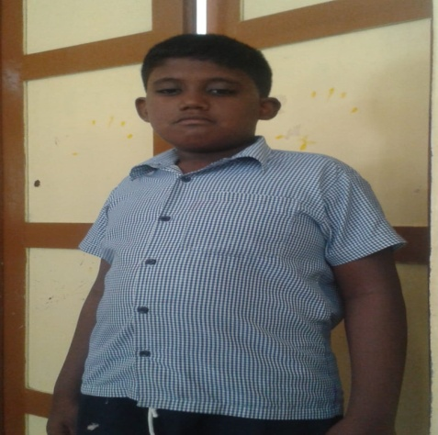
Esakkiraj was born on 08.09.2007. He joined in Sangamam School at July 2016. He is a ADHD child. When he joined the school, he was not able to fulfill his needs and not able to communicate with others. For his activities of daily living he was fully dependent on his mother. While joining, his attention span was about 1 to 2 minutes. He would not sit in one place. He has been given training in Sangamam School from August 2016 in the following areas like Special education, Speech therapy, Occupational therapy and behaviour modification etc.,
Now his attention has improved and his concentration level increased up to 7 to 10 minutes. He can perform his self help skills with minimal support of his mother. His hyper activity has come under control and now sits in one place. He can follow simple instructions. He can frame simple sentences by the proper guidelines of speech pathologist. He can identify his name and good at number concept. Really there is wonderful improvement in his cognitive domain. The child is undergoing age appropriate and need based special education in our school, which would help him in order to include him in the mainstream society for independent living.

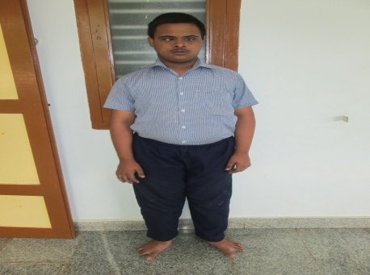
A.Karthikeyan was born on 06.01.2003. Being a Down syndrome boy he was in the mainstream school upto 6th standard in English medium. But there was no academic achievement in his education. When he was joined in Sangamam School there was awesome improvement in his education and social skills. He has enriched his vocabulary and improvement in arithmetic skills and his parents are quite happy over this.

