I am Rajaraman Krishnan, a volunteer of Asha Chennai. On Wednesday the 6th of September, I visited the Sarva Vidhya trust and learnt about their activities. Sarva Vidhya trust has been supported by Asha Stanford for several years. I went to Saradha Vidhyalaya near Panagal Park in Chennai. Saradha Vidhyalaya is a school run by Ramakrishna Mission. They had offered rooms to Sarva Vidhya trust to do their work from here.

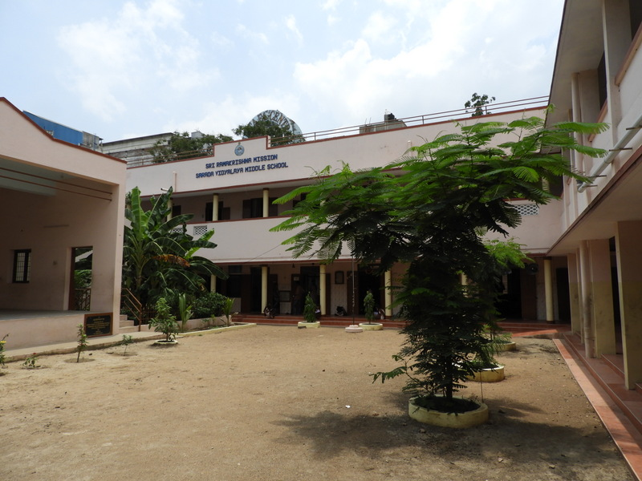

I was received at the school by Ms. Thenmozhi the project coordinator. Also present to meet me were, Mr. C.S.Raghunathan a well-wisher of the trust who has been participating in this project since its inception, Ms. Namagiri an ex-principal of Saradha Vidhyalaya Model Higher who was volunteering with Sarva Vidhya, and Ms. Kamala the accountant.

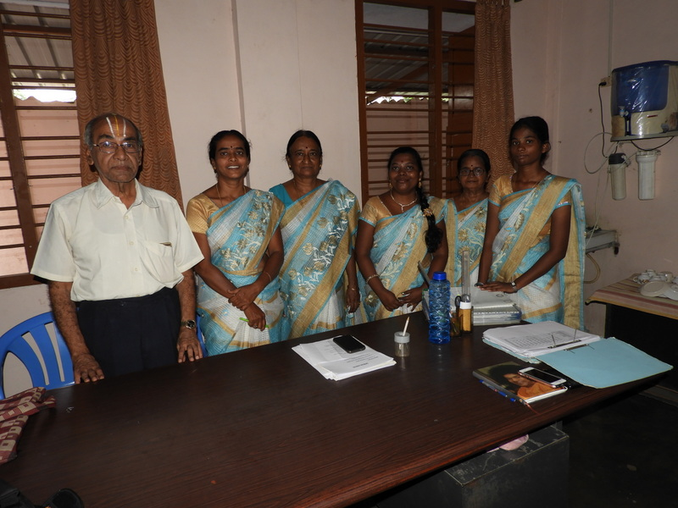

I talked to them for a good one hour to learn about the organization and the project. Sarva Vidhya has been working for the goal of empowering rural women since mid 2000s. They have been having this nursing programme since 2007 or so. While some of their other attempts did not succeed, this has done very well. Its success depends on several external players who have contributed towards this. This includes Sharada Vidhyalaya which has given them the space to run the classes, Shivakumar College of Nursing which has given the formal recognition for the course, and the various hospitals which provide the practical training for these girls with a token stipend. Without all these players in the picture this couldn’t have succeeded. All these students get attached to a hospital for the course of their study, stay there with their boarding and lodging taken care of plus get a small stipend. From this stipend, they also pay a fee of Rs 8000 to Sarva Vidhya Trust for their course. The course itself follows the syllabus for a 2 year diploma laid out by Bharat Seva Samaj, an arm of the planning commission of India. The students get a certificate from Bharat Seva Samaj and from Sivakumar College of Nursing.

This programme also works along with their village programmes. Sarva Vidhya Trust runs education centre in various villages mostly in Kancheepuram Dist and near Vellore. These have made the local people trust Sarva Vidhya as an organization that enables them to get the girls as students for their course.

Besides this they are also giving scholarships to about 85 students of various Saradha Vidhylaya schools in the city (5 of them). They have classes for these children in the evening and also provide them snacks in addition to meeting their cost of education. This is funded by Surya Foundation in the US.

The nursing education work employs 2 teachers, Priyadarshini and Viji. It employs one project coordinator Ms. Thenmozhi, and the principal Mrs. Saraswathi Vaidhyanathan who was travelling in the US and will be back only by November.

The students come to this place for classes 2 times a week (1st year students on Mon and Wed, 2nd year students on Mon and Fri). All the other days of the week, they work at their hospital where they also get practical training. The teachers who have BSc Nursing go on rounds to the various hospitals. Besides these, at the beginning of the first year there is one month of intensive training before they are sent to the hospitals. In addition to the nursing education, they are also taught English and Computers by one lady who volunteers her time for this. There are also other classes on values etc. conducted by volunteers.

The total expenses of Sarva Vidhya Trust comes to about Rs 35 Lakhs. The nursing programme funded by Asha Stanford accounts for some 12.5 Lakhs of this.

After talking to them, I went to the class to meet the 1st year students. The girls introduced themselves. It was interesting that some of the girls were from places that I had recently visited as part of the site visit to Kalanjiyam trust, which is also funded by Asha Stanford. 2 or 3 girls were from Thiruvaadhur higher secondary school, which is supported by Kalanjiyam. A couple of girls were from Koovathur, which is also in that vicinity.

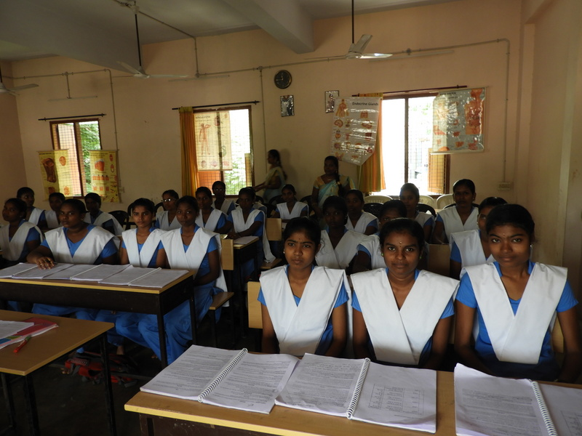

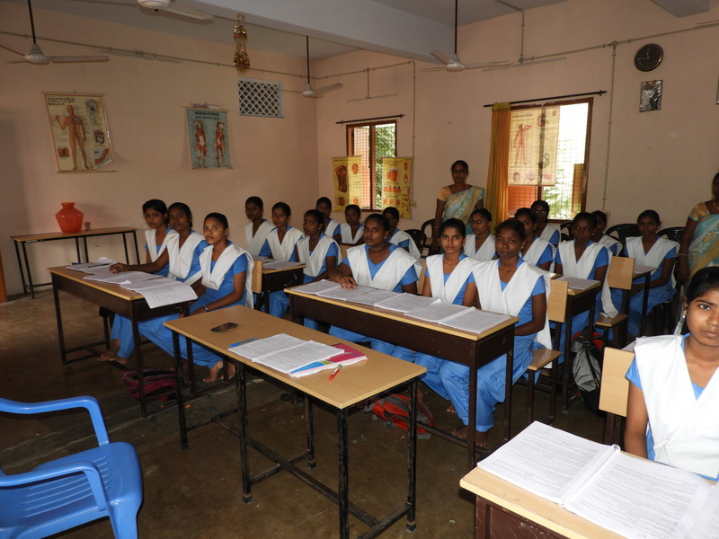

They felt they were benefitting from this and felt they were being taught much better than in their schools. They knew basic things like normal temperature of human body, normal pulse rate etc. They were all missing their homes and would probably not see their homes more than once every 3 or 4 months. This was clearly a big deal for all of them. In some of the hospitals there were more than 5 girls. There were some others where there was only one girl.

After interacting with the students I saw their lab and library. They were reasonably well equipped. They have several dummies that had been specially procured to teach how to do various procedures. They have standard equipment like theremometer, BP measuring equipment, syringes etc. Their library was also being shared by the school.

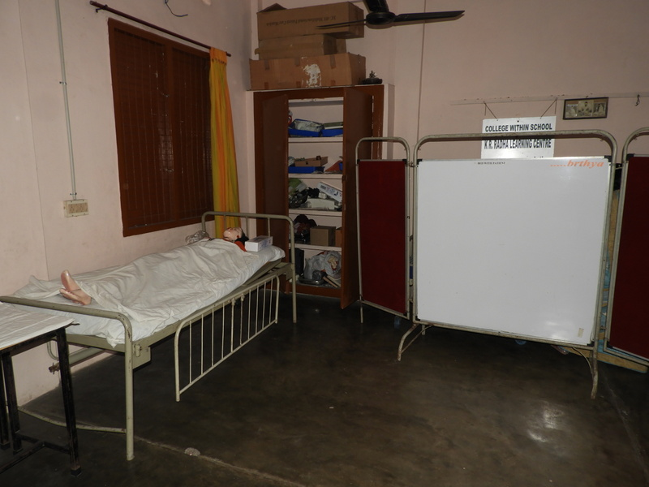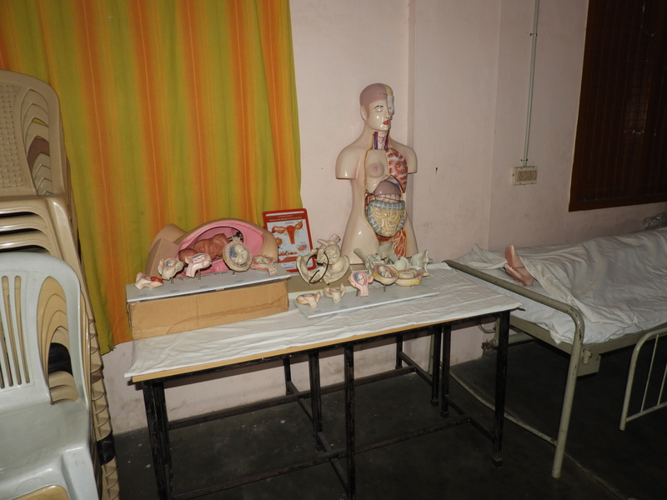

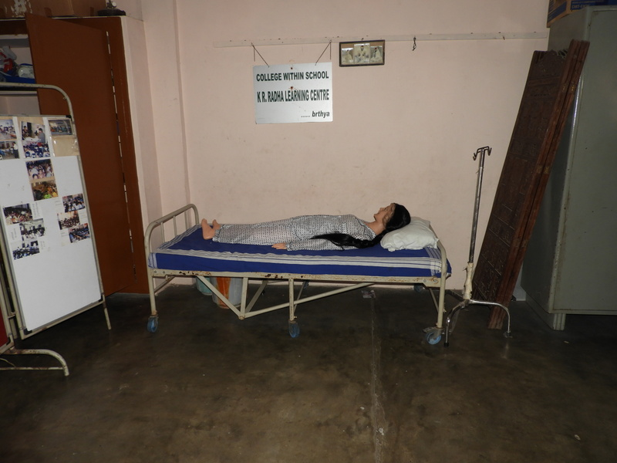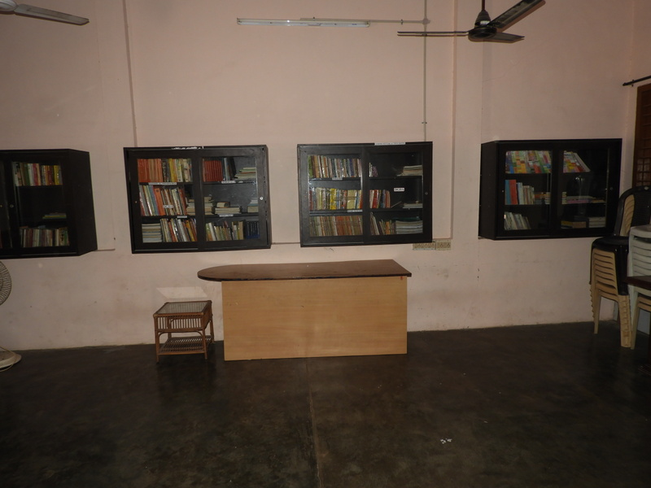

On the whole Sarva Vidhya trust seems to be doing a great service for these girls. I am not sure how much of an impact they are having on the villages where these girls come from. I didn’t visit that side of the project. But even within the limited frame that I could see, I could appreciate the good impact they were having.

