Jivan Vidya - Jan Seva site visit report

Site Visit Done By - Aparna Geet, Rahul Kashikar and Piyu Arole

Date of the visit - December 17, 2016

We made a day trip from Nashik to Nandurbar for the visit and reached Jivan Vidya campus around 10 am.

We received a warm welcome from Martina Tai, her colleagues and the girls living in the hostel.

We noticed that the facilities are clean and well maintained.

Girls hostel building
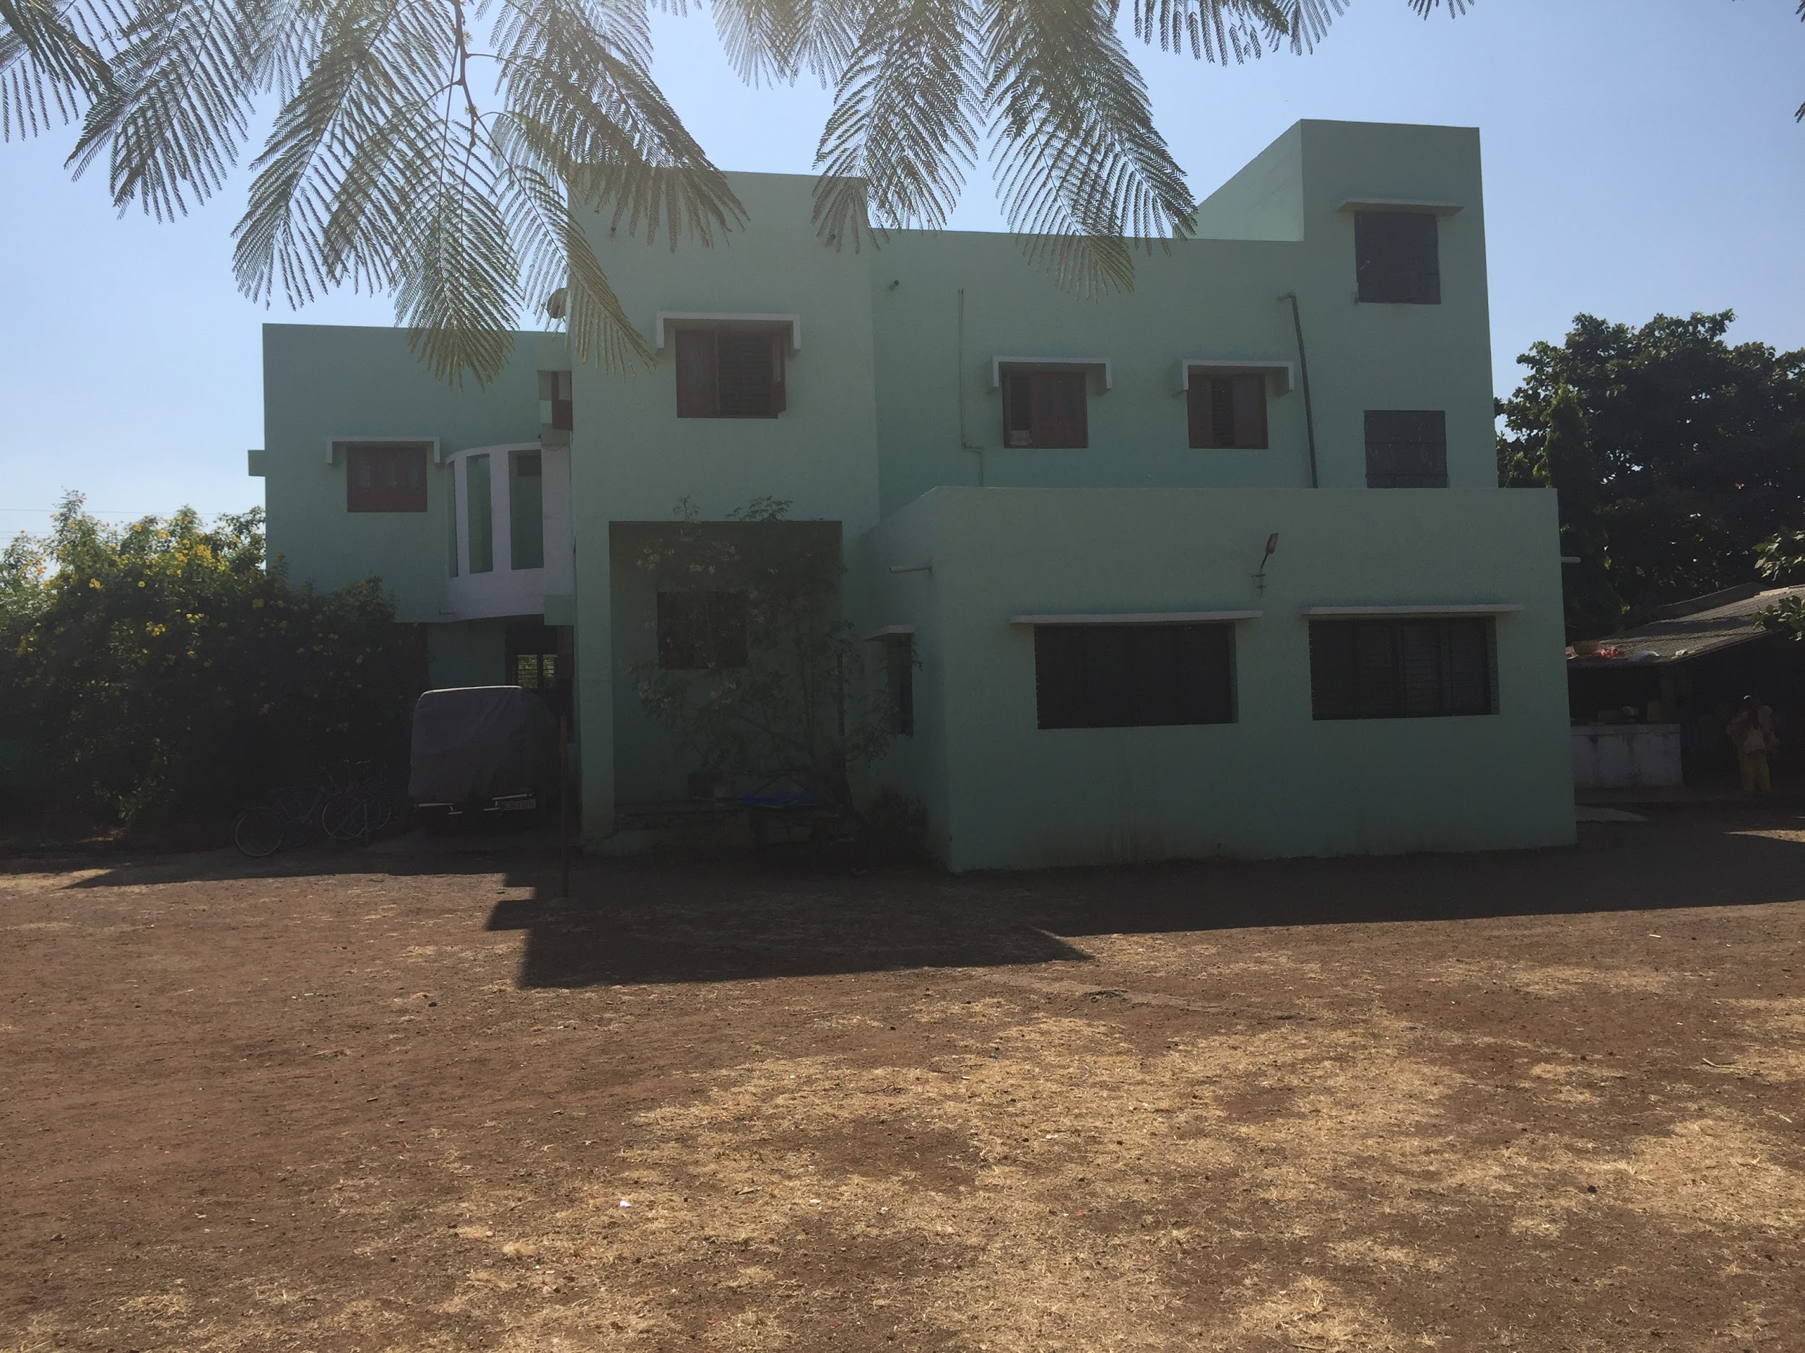

Welcome Rangoli at Jivan Vidya entrance -

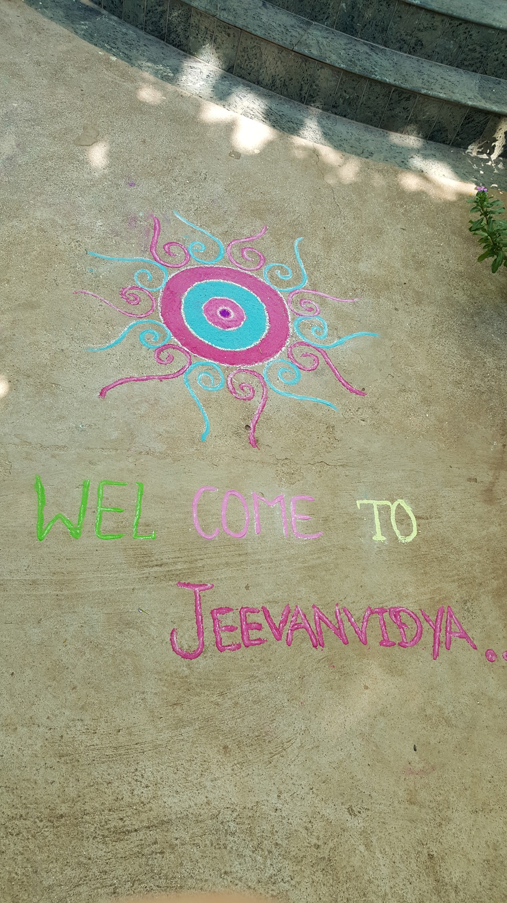

Rahul, Martina Tai and Piyu at the entrance -
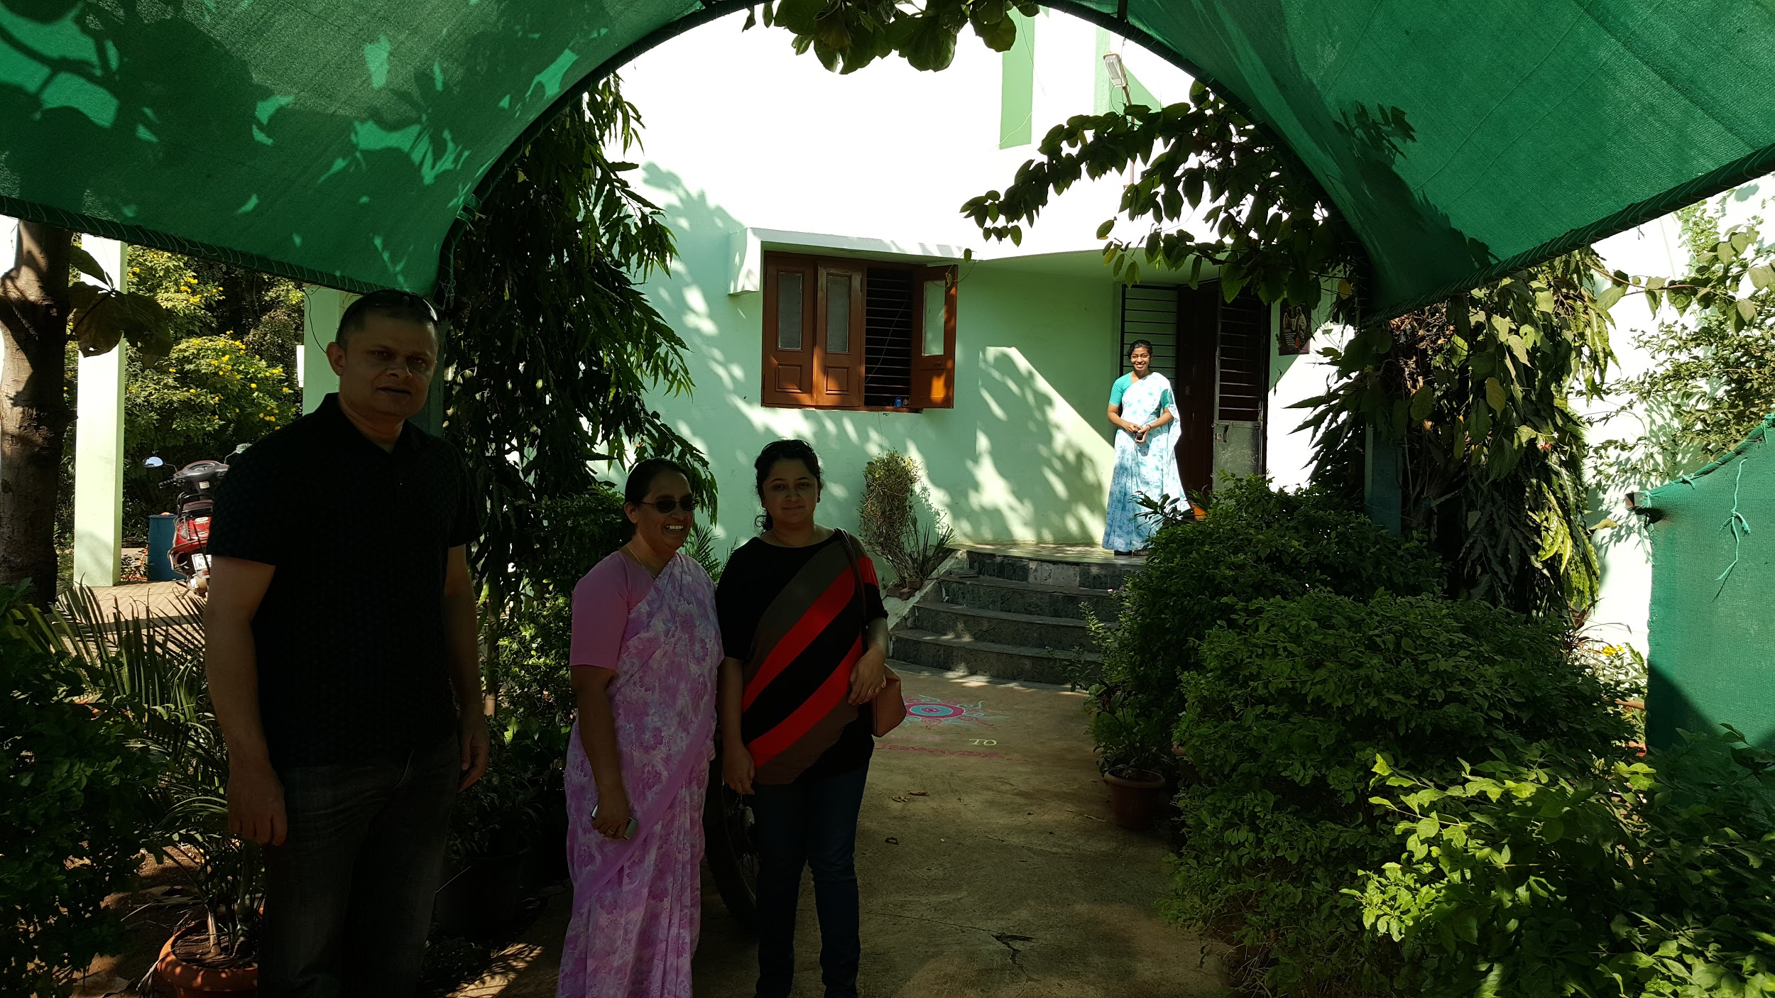

Inside view of the building and computer lab entrance -
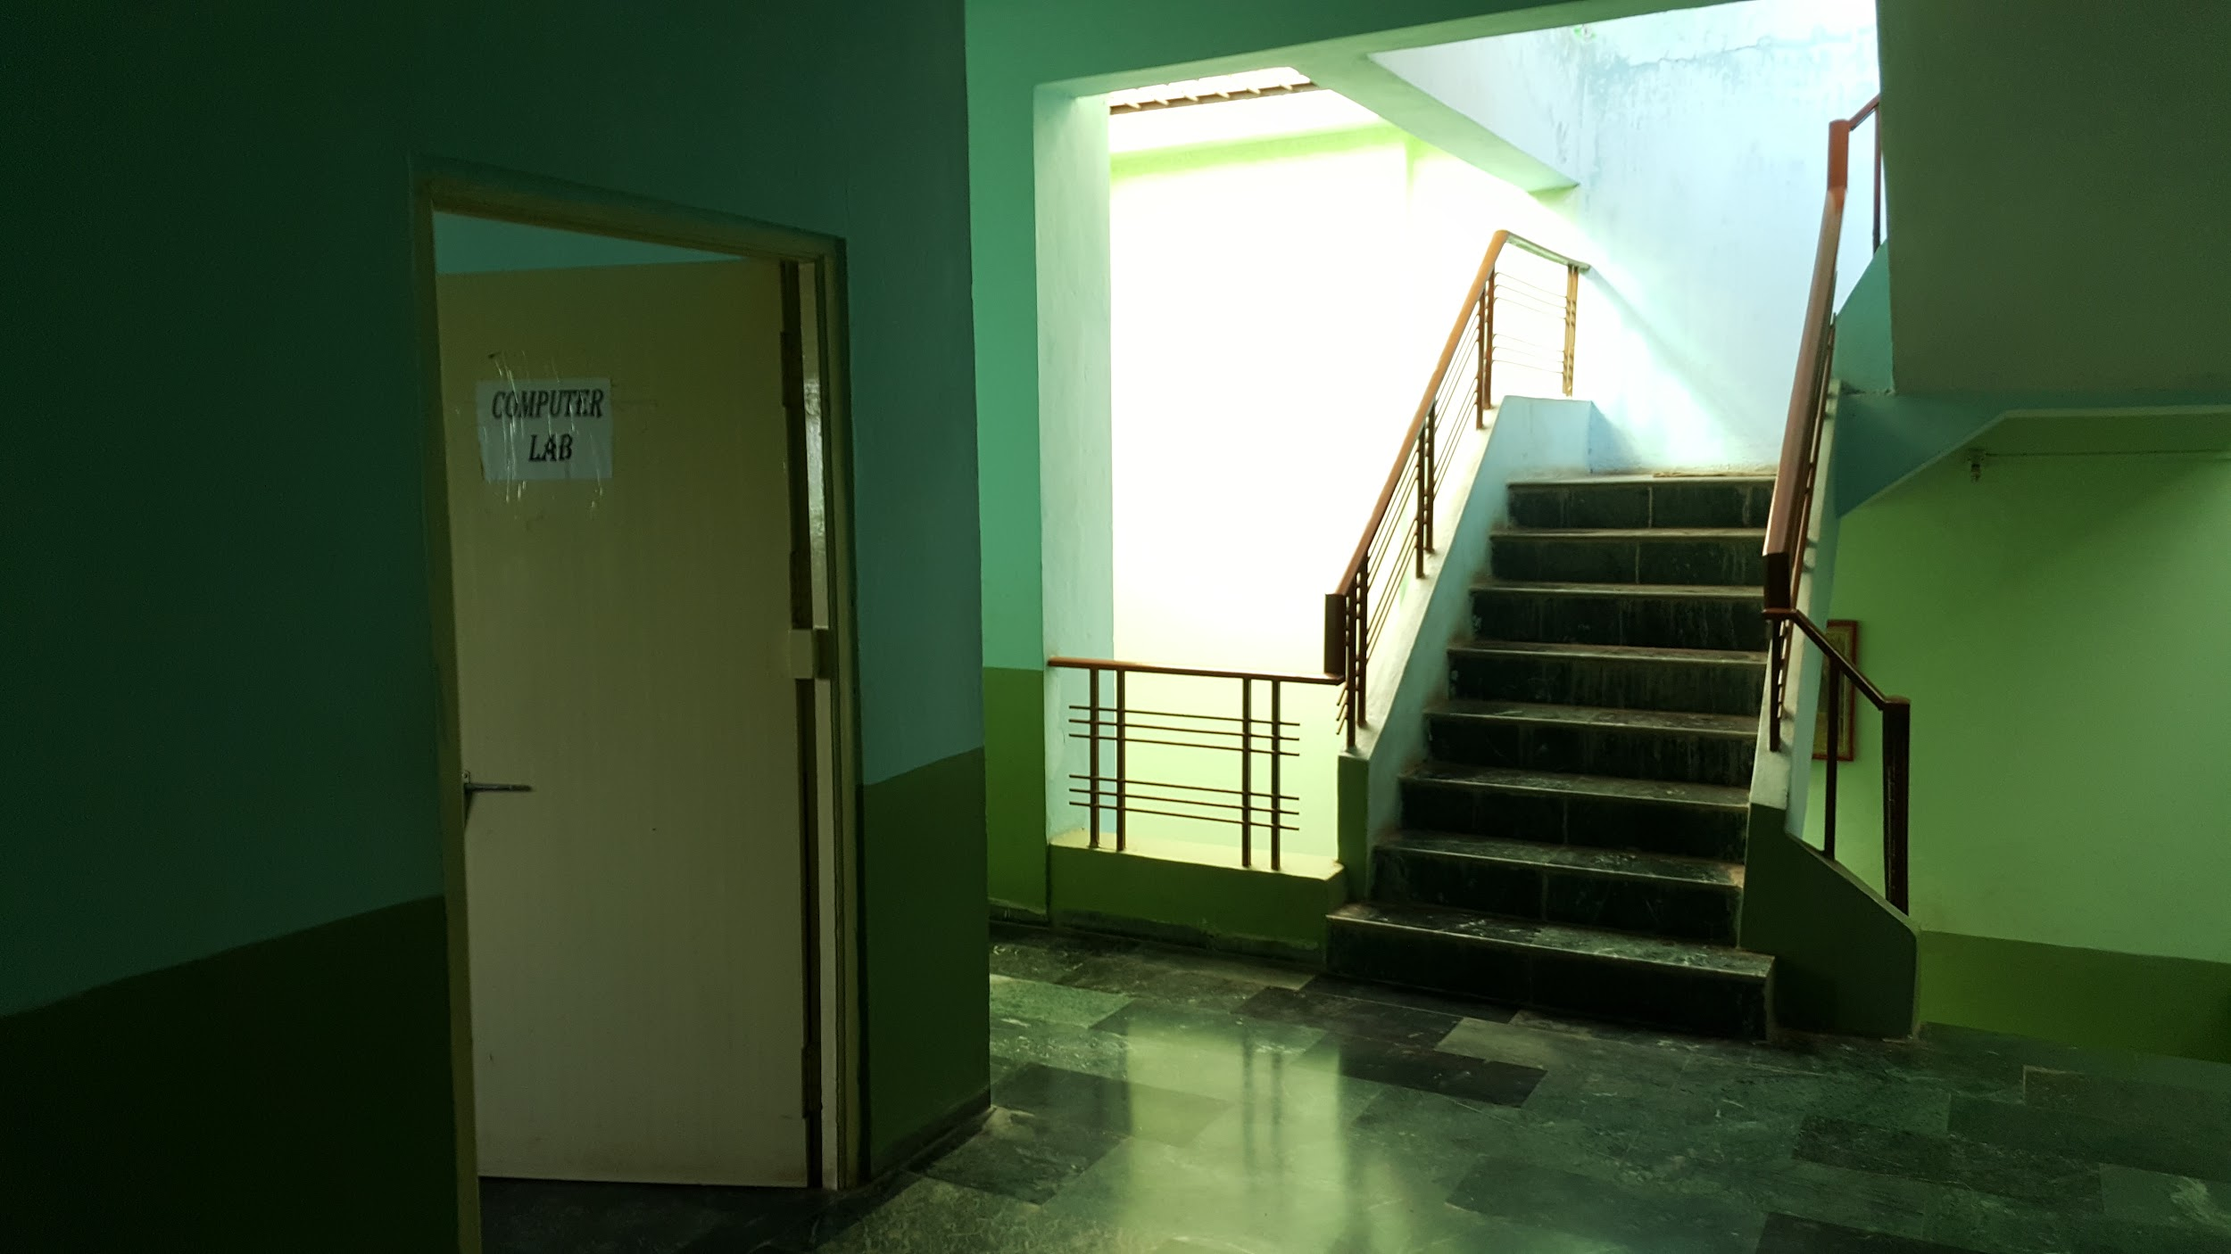

Computer lab inside view -
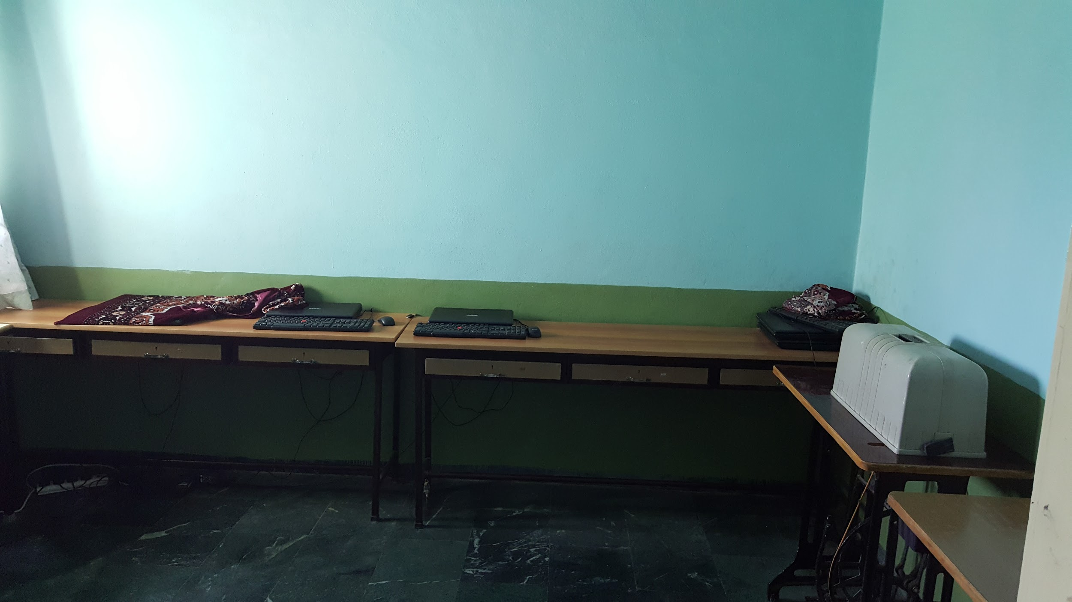

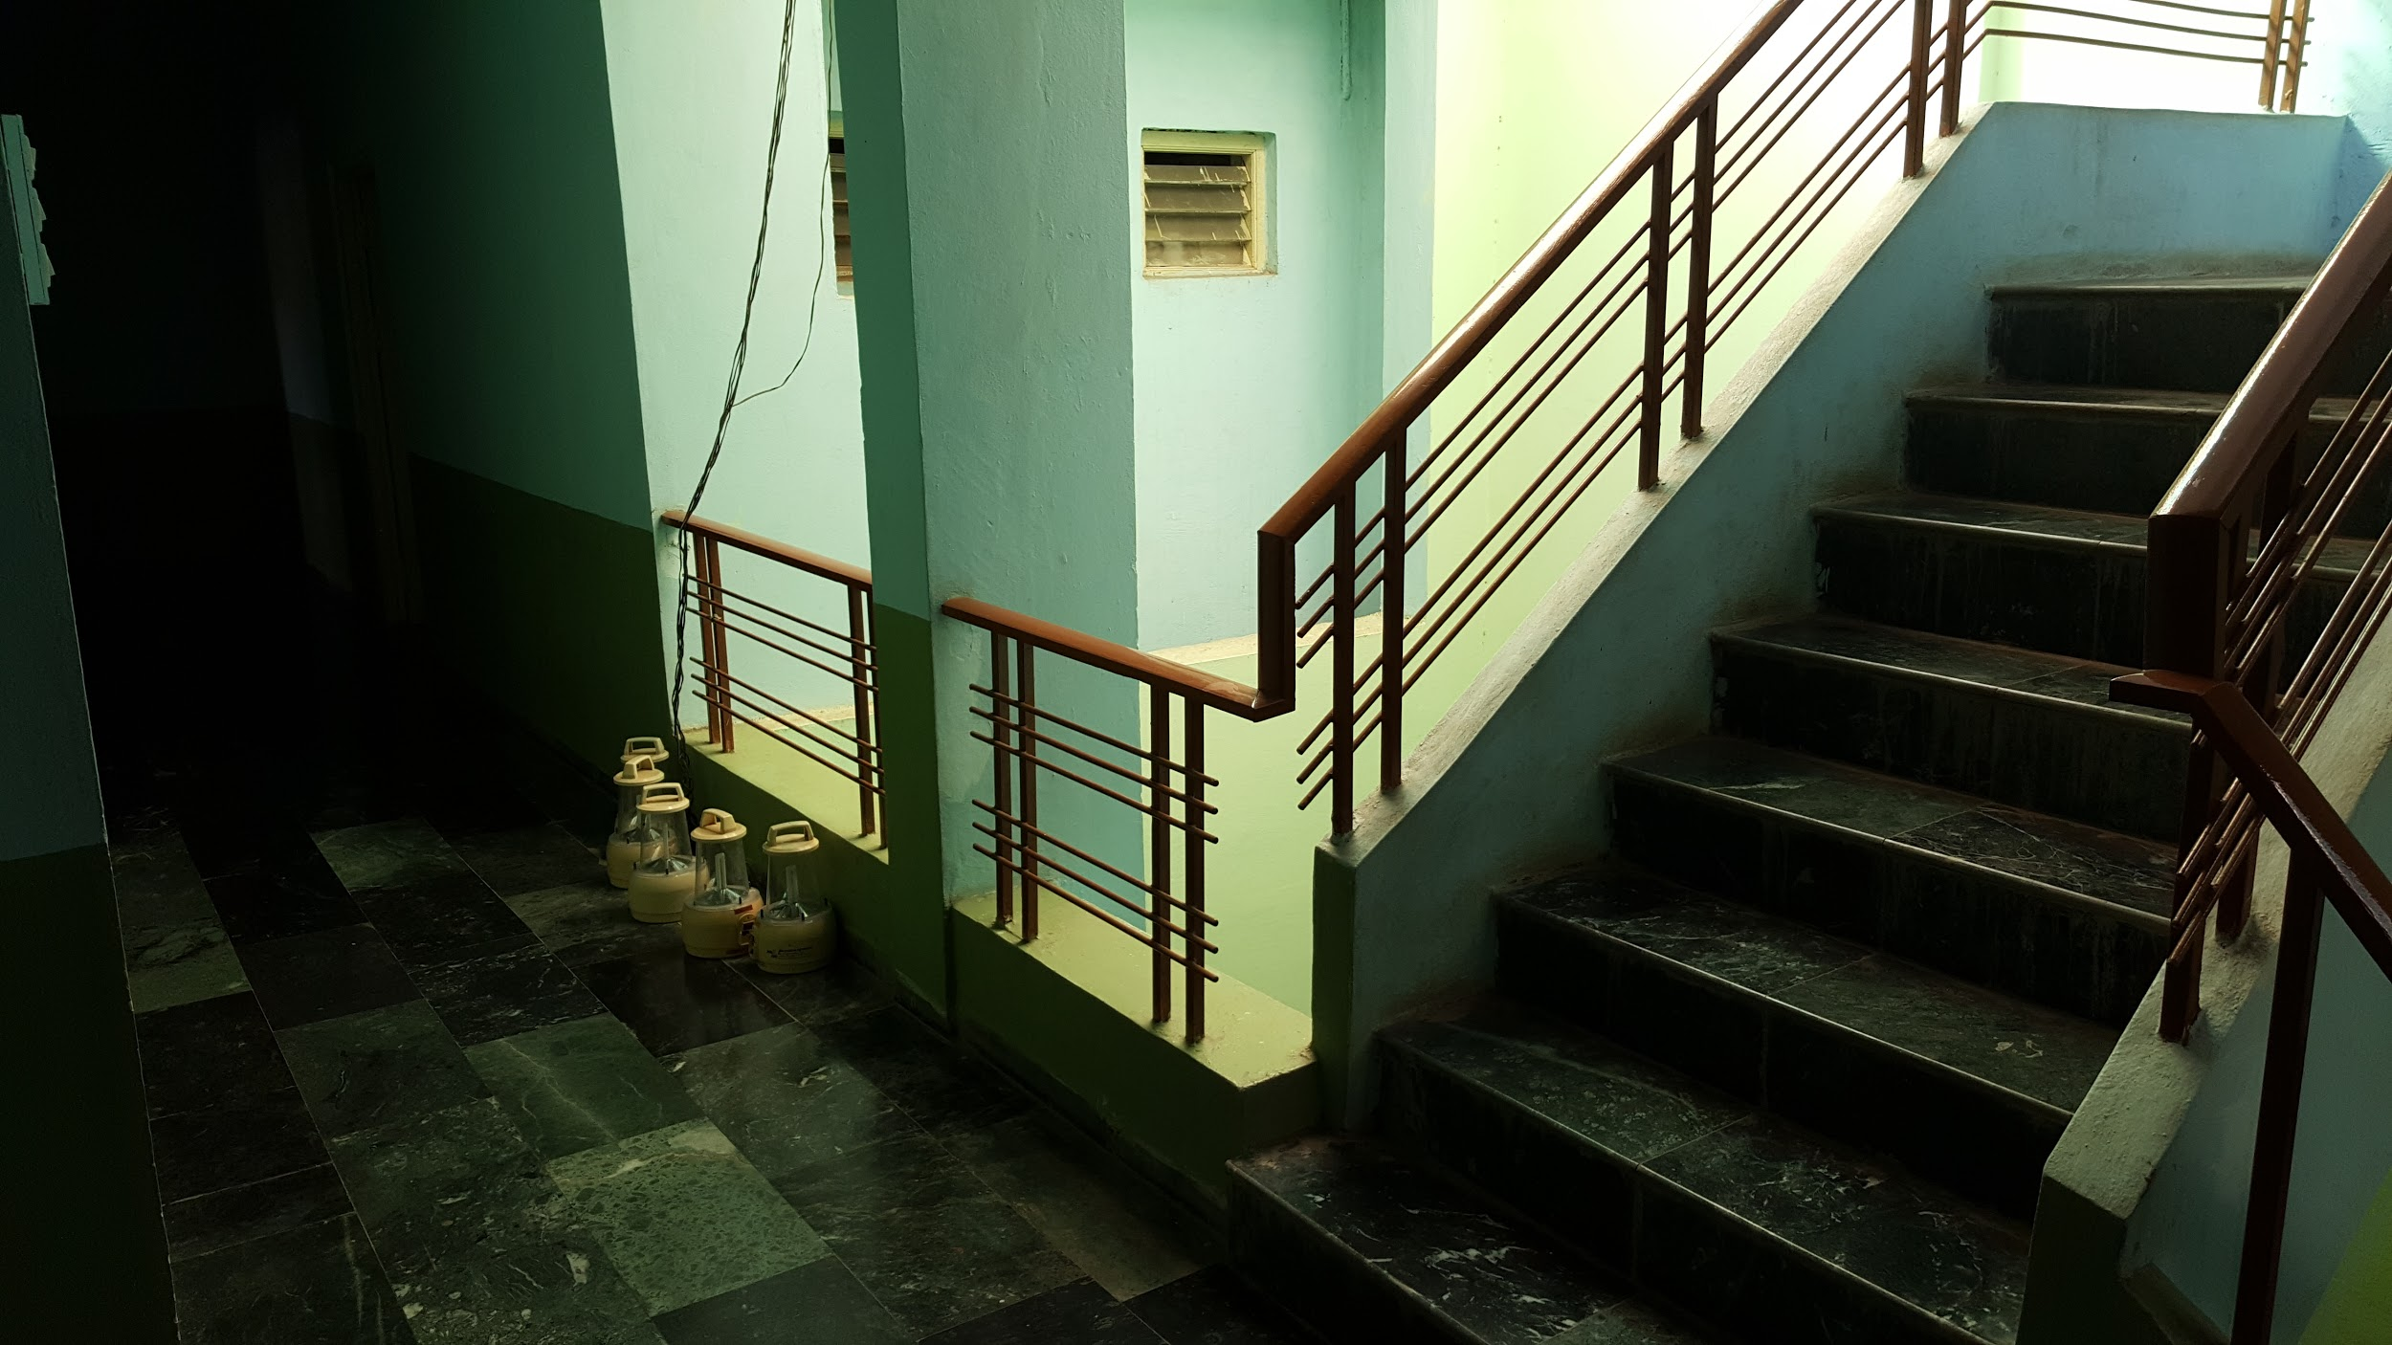

Staff kitchen -
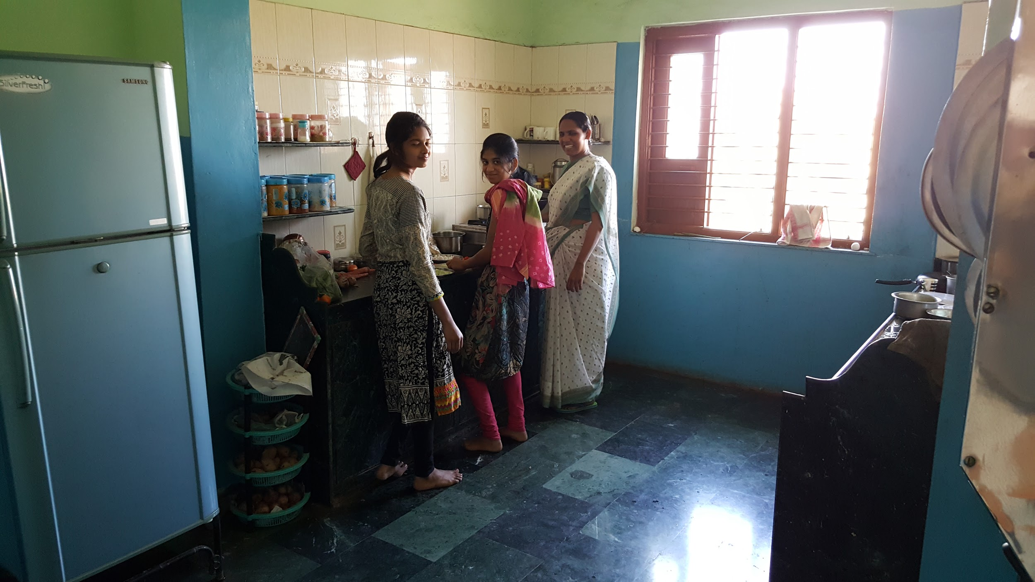

Staff dining room -
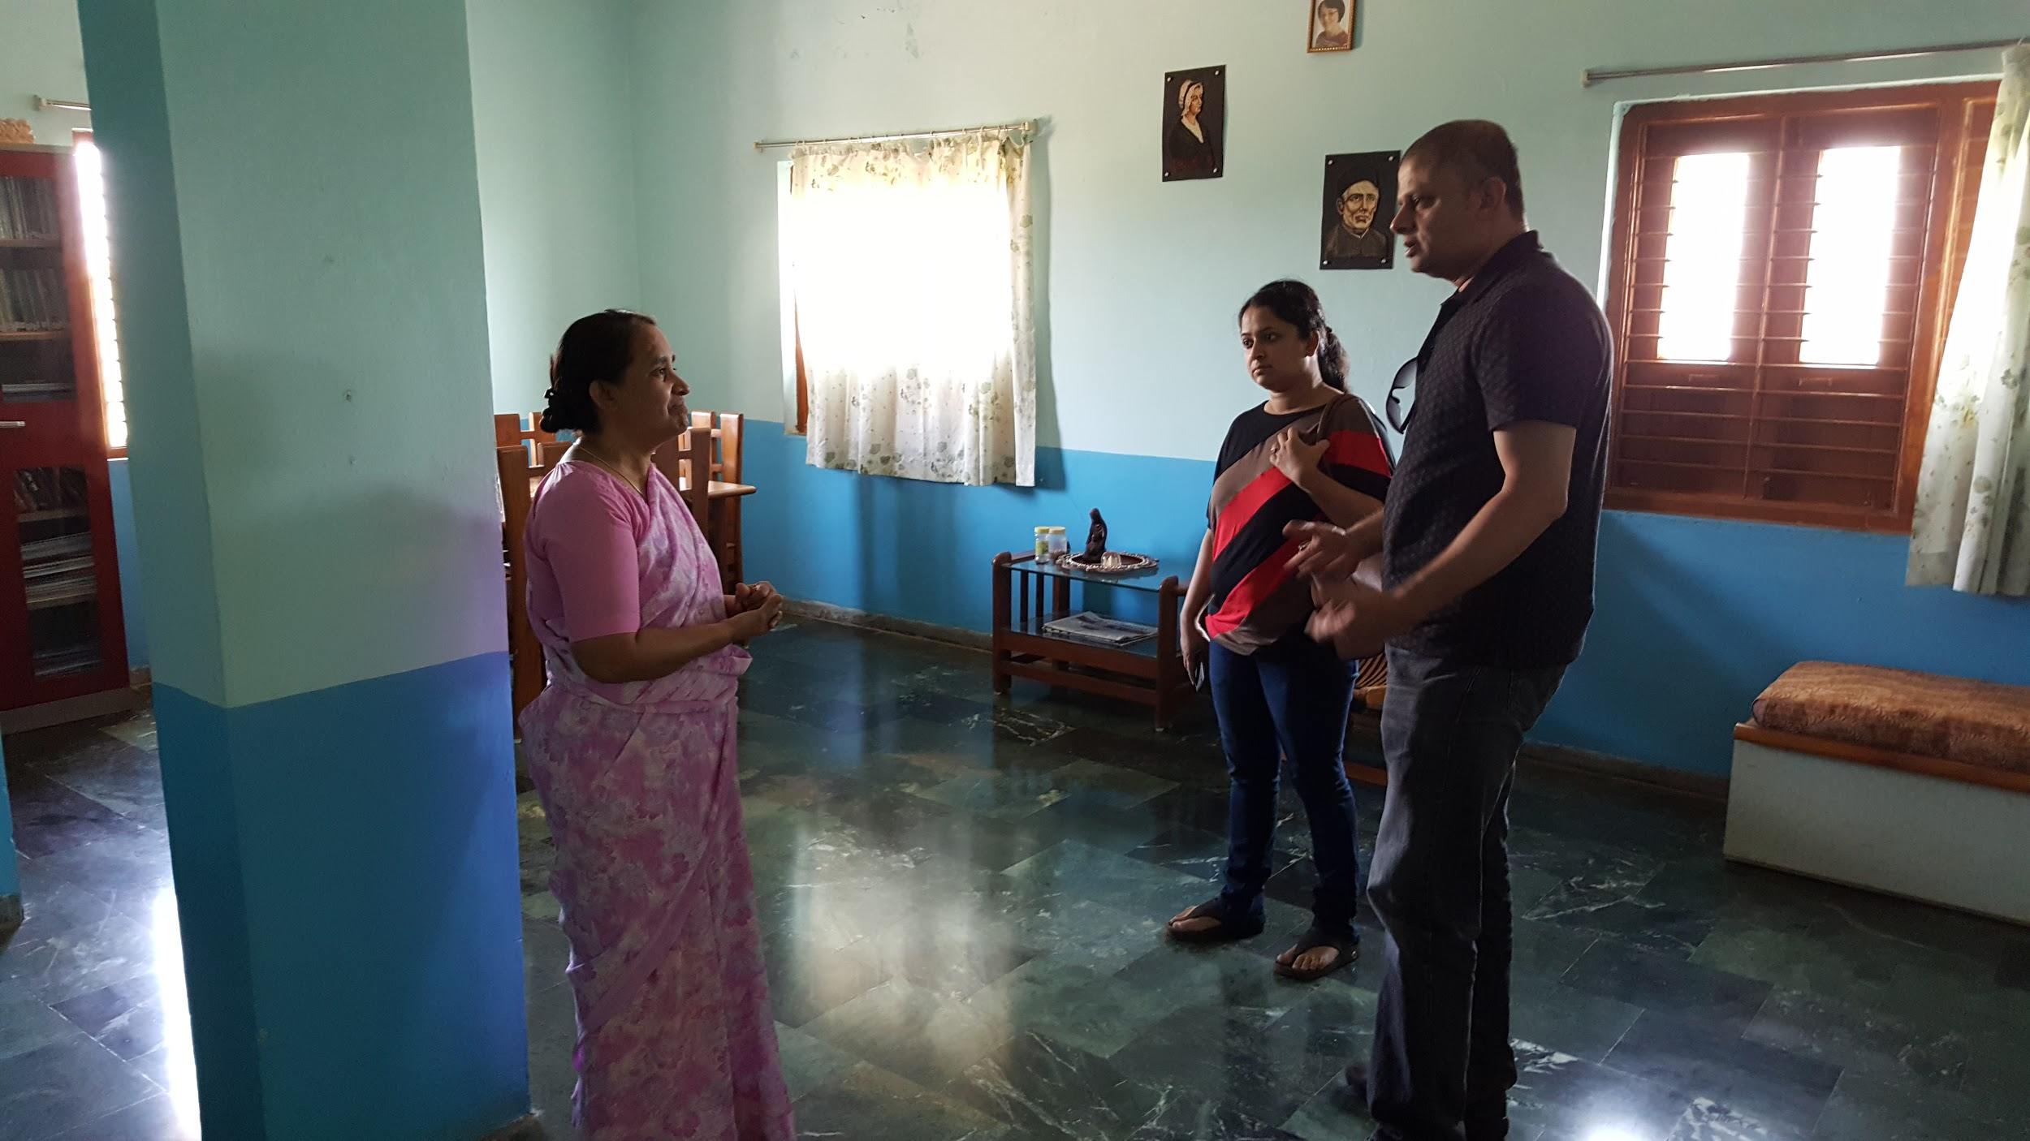

We had very informative conversations with Martina Tai and her colleagues over some tea and refreshments in the staff dining room.

Then Martina Tai gave us detailed information about all the programs run by Jivan Vidya for the girls who stay in the hostel.

We asked various questions about safety, behavior and religion of the girls - all our questions were answered very satisfactorily.

After the tea break, we got a tour of the entire facility. Martina Tai showed us various parts of the building and explained their use.

Then in the activity room were very warmly welcomed by the girls with a welcome song.

Followed by it the girls gave us a power point presentation about all the educational visits, presentations by visiting guests and enrichment programs they had during the year 2016.

Then we got a chance to meet the girls and got an opportunity to have a very open and informal communication session with the girls.

Meeting with the girls -
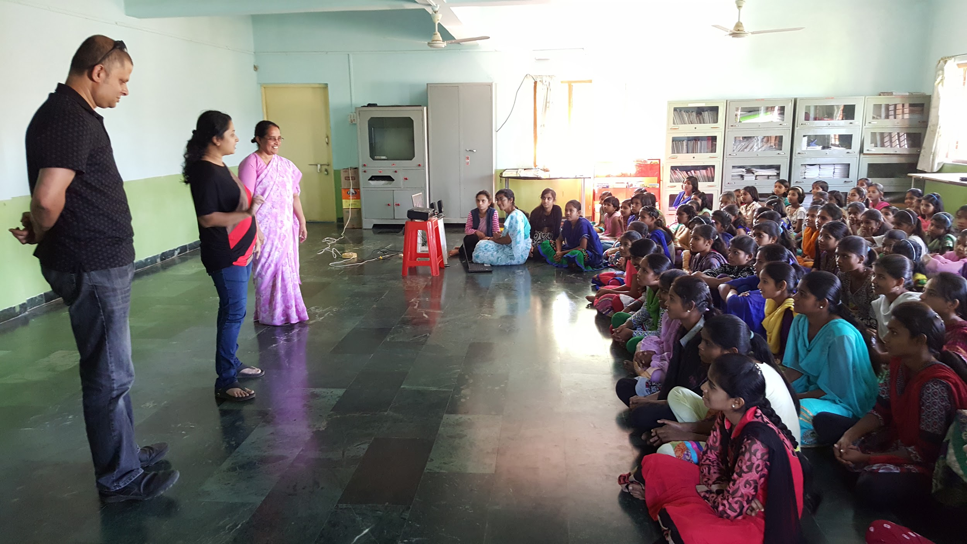

We asked various questions about them like - their families, why they like to stay in Jivan Vidya hostel, what are their dreams for the future, how is their daily time table, what do they eat when they stay at the hostel and so on.

We were touched by how much the girls like Jivan Vidya hostel and the guidance provided by Martina Tai.

After our conversation with the girls, they presented excellent cultural programs. Various dances, skits and songs were presented by the girls in different age groups.

The programs were very interesting and entertaining. We were impressed by the fact that the girls had put them together themselves within a week.

At the end of the presentation, the girls performed traditional Adivasi dance - and invited Aparna and Piyu to dance along with them. Both the visiting ladies very much enjoyed the experience.

After having lunch with Martina Tai and her colleagues, we visited the traditional tribal medicine center/room as well as the herb garden from which herbs are used to prepare the medicines.

Herbal Medicine Growing area
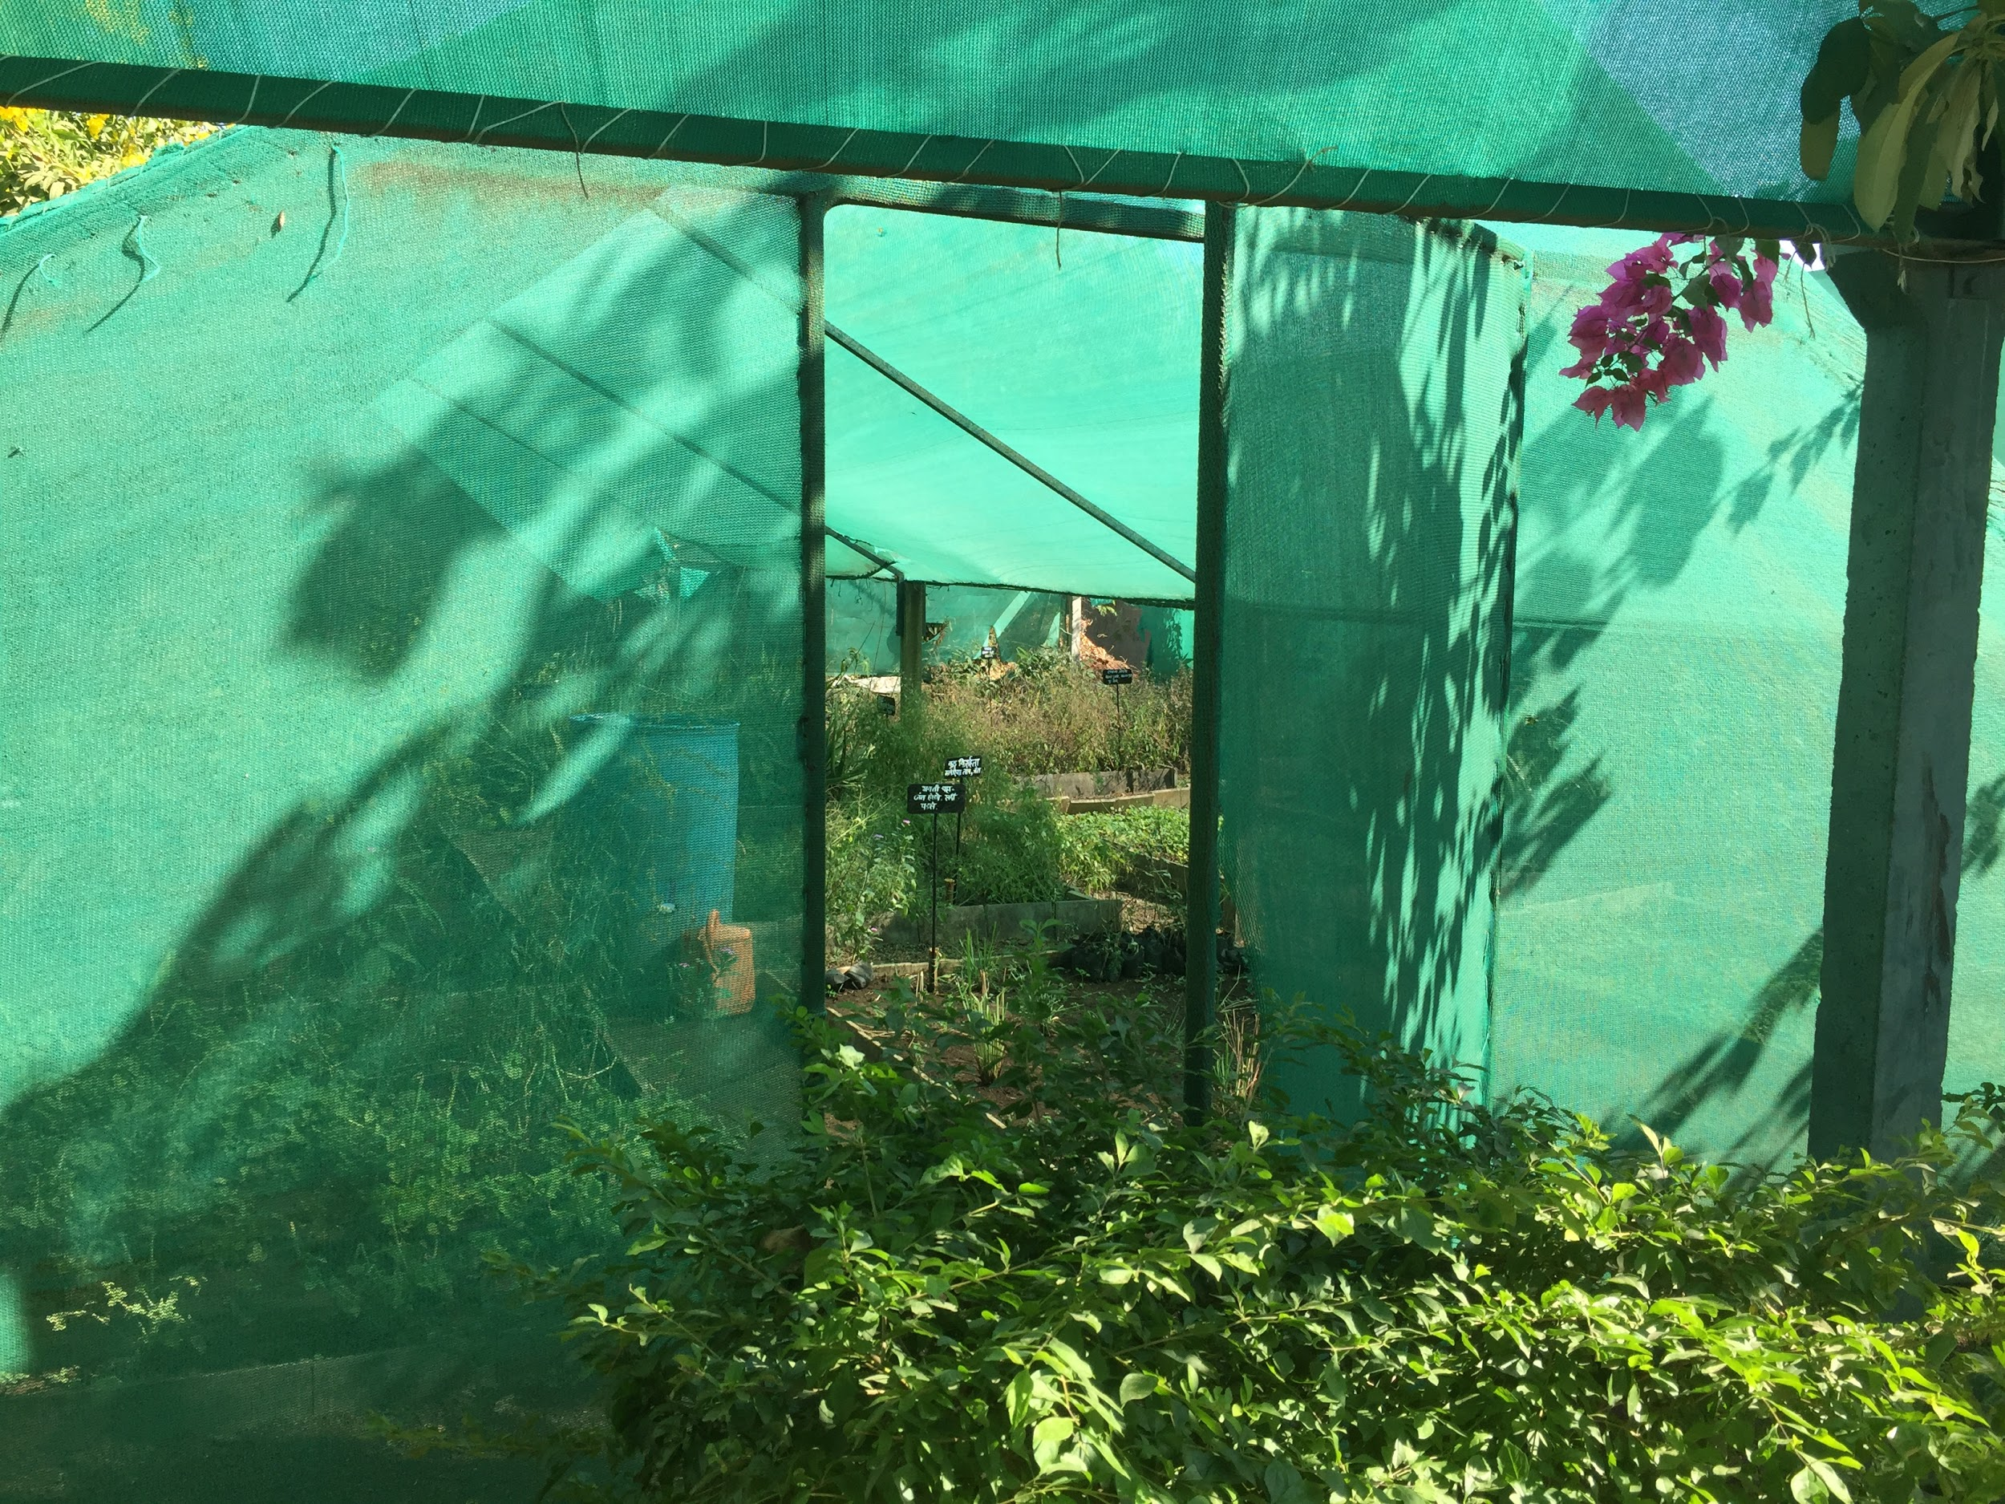
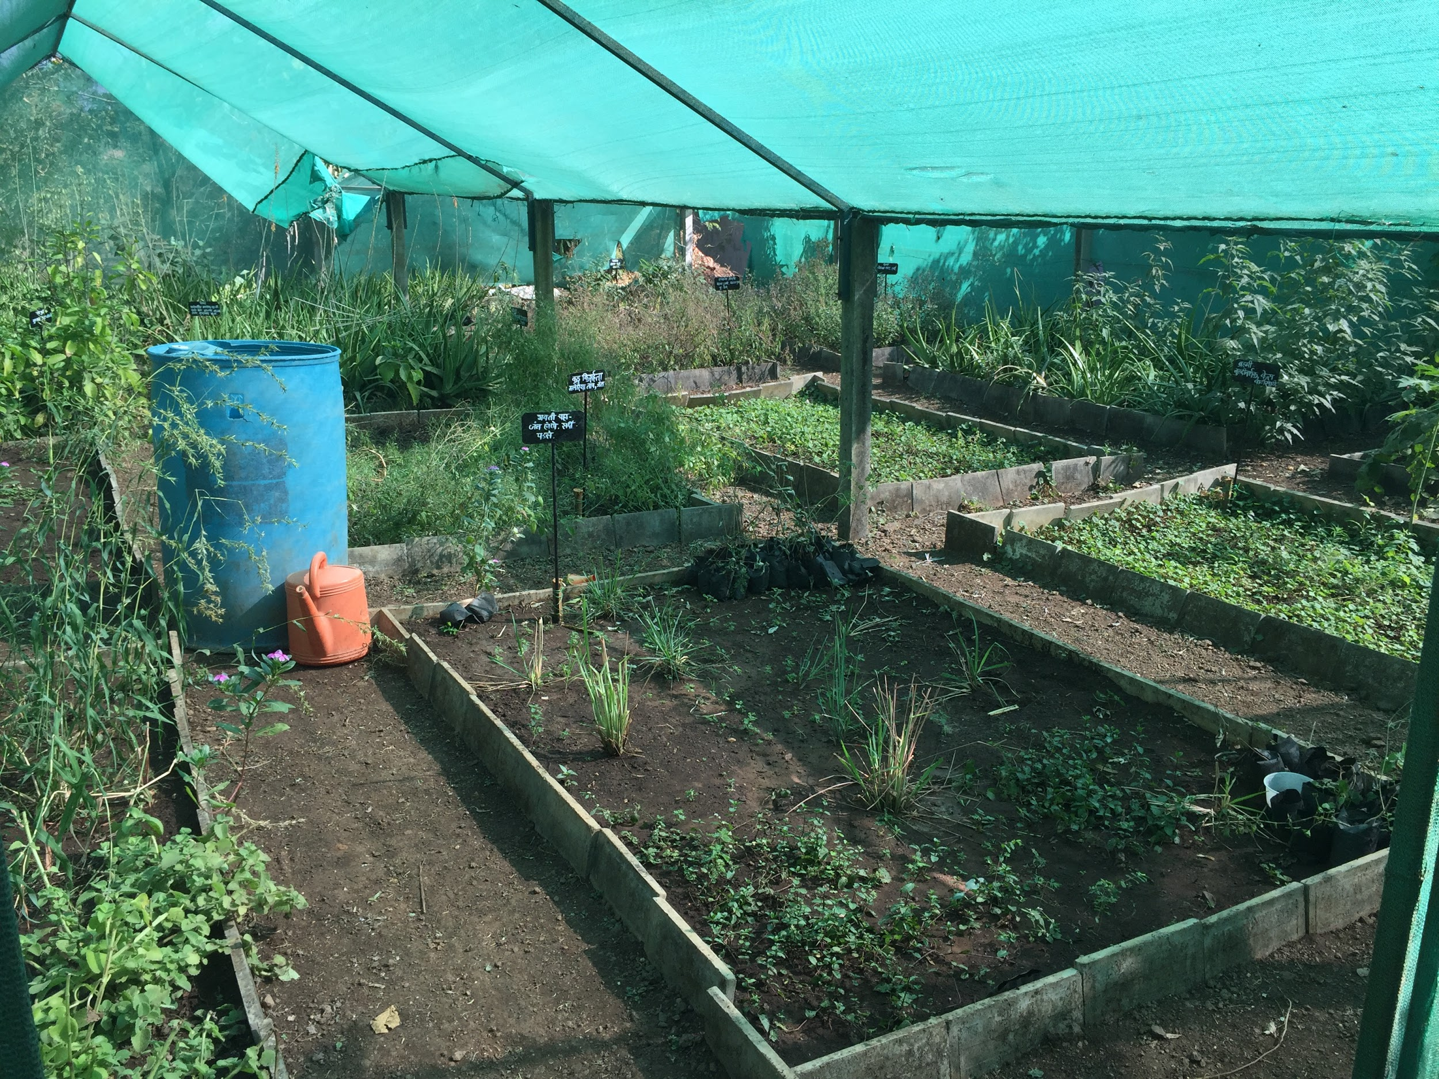

Martina Tai informed us that the practices and procedures to prepare herbal medicines girls are taught to the girls to keep their traditional art and legacy of herbal medicine alive.

Library for girls
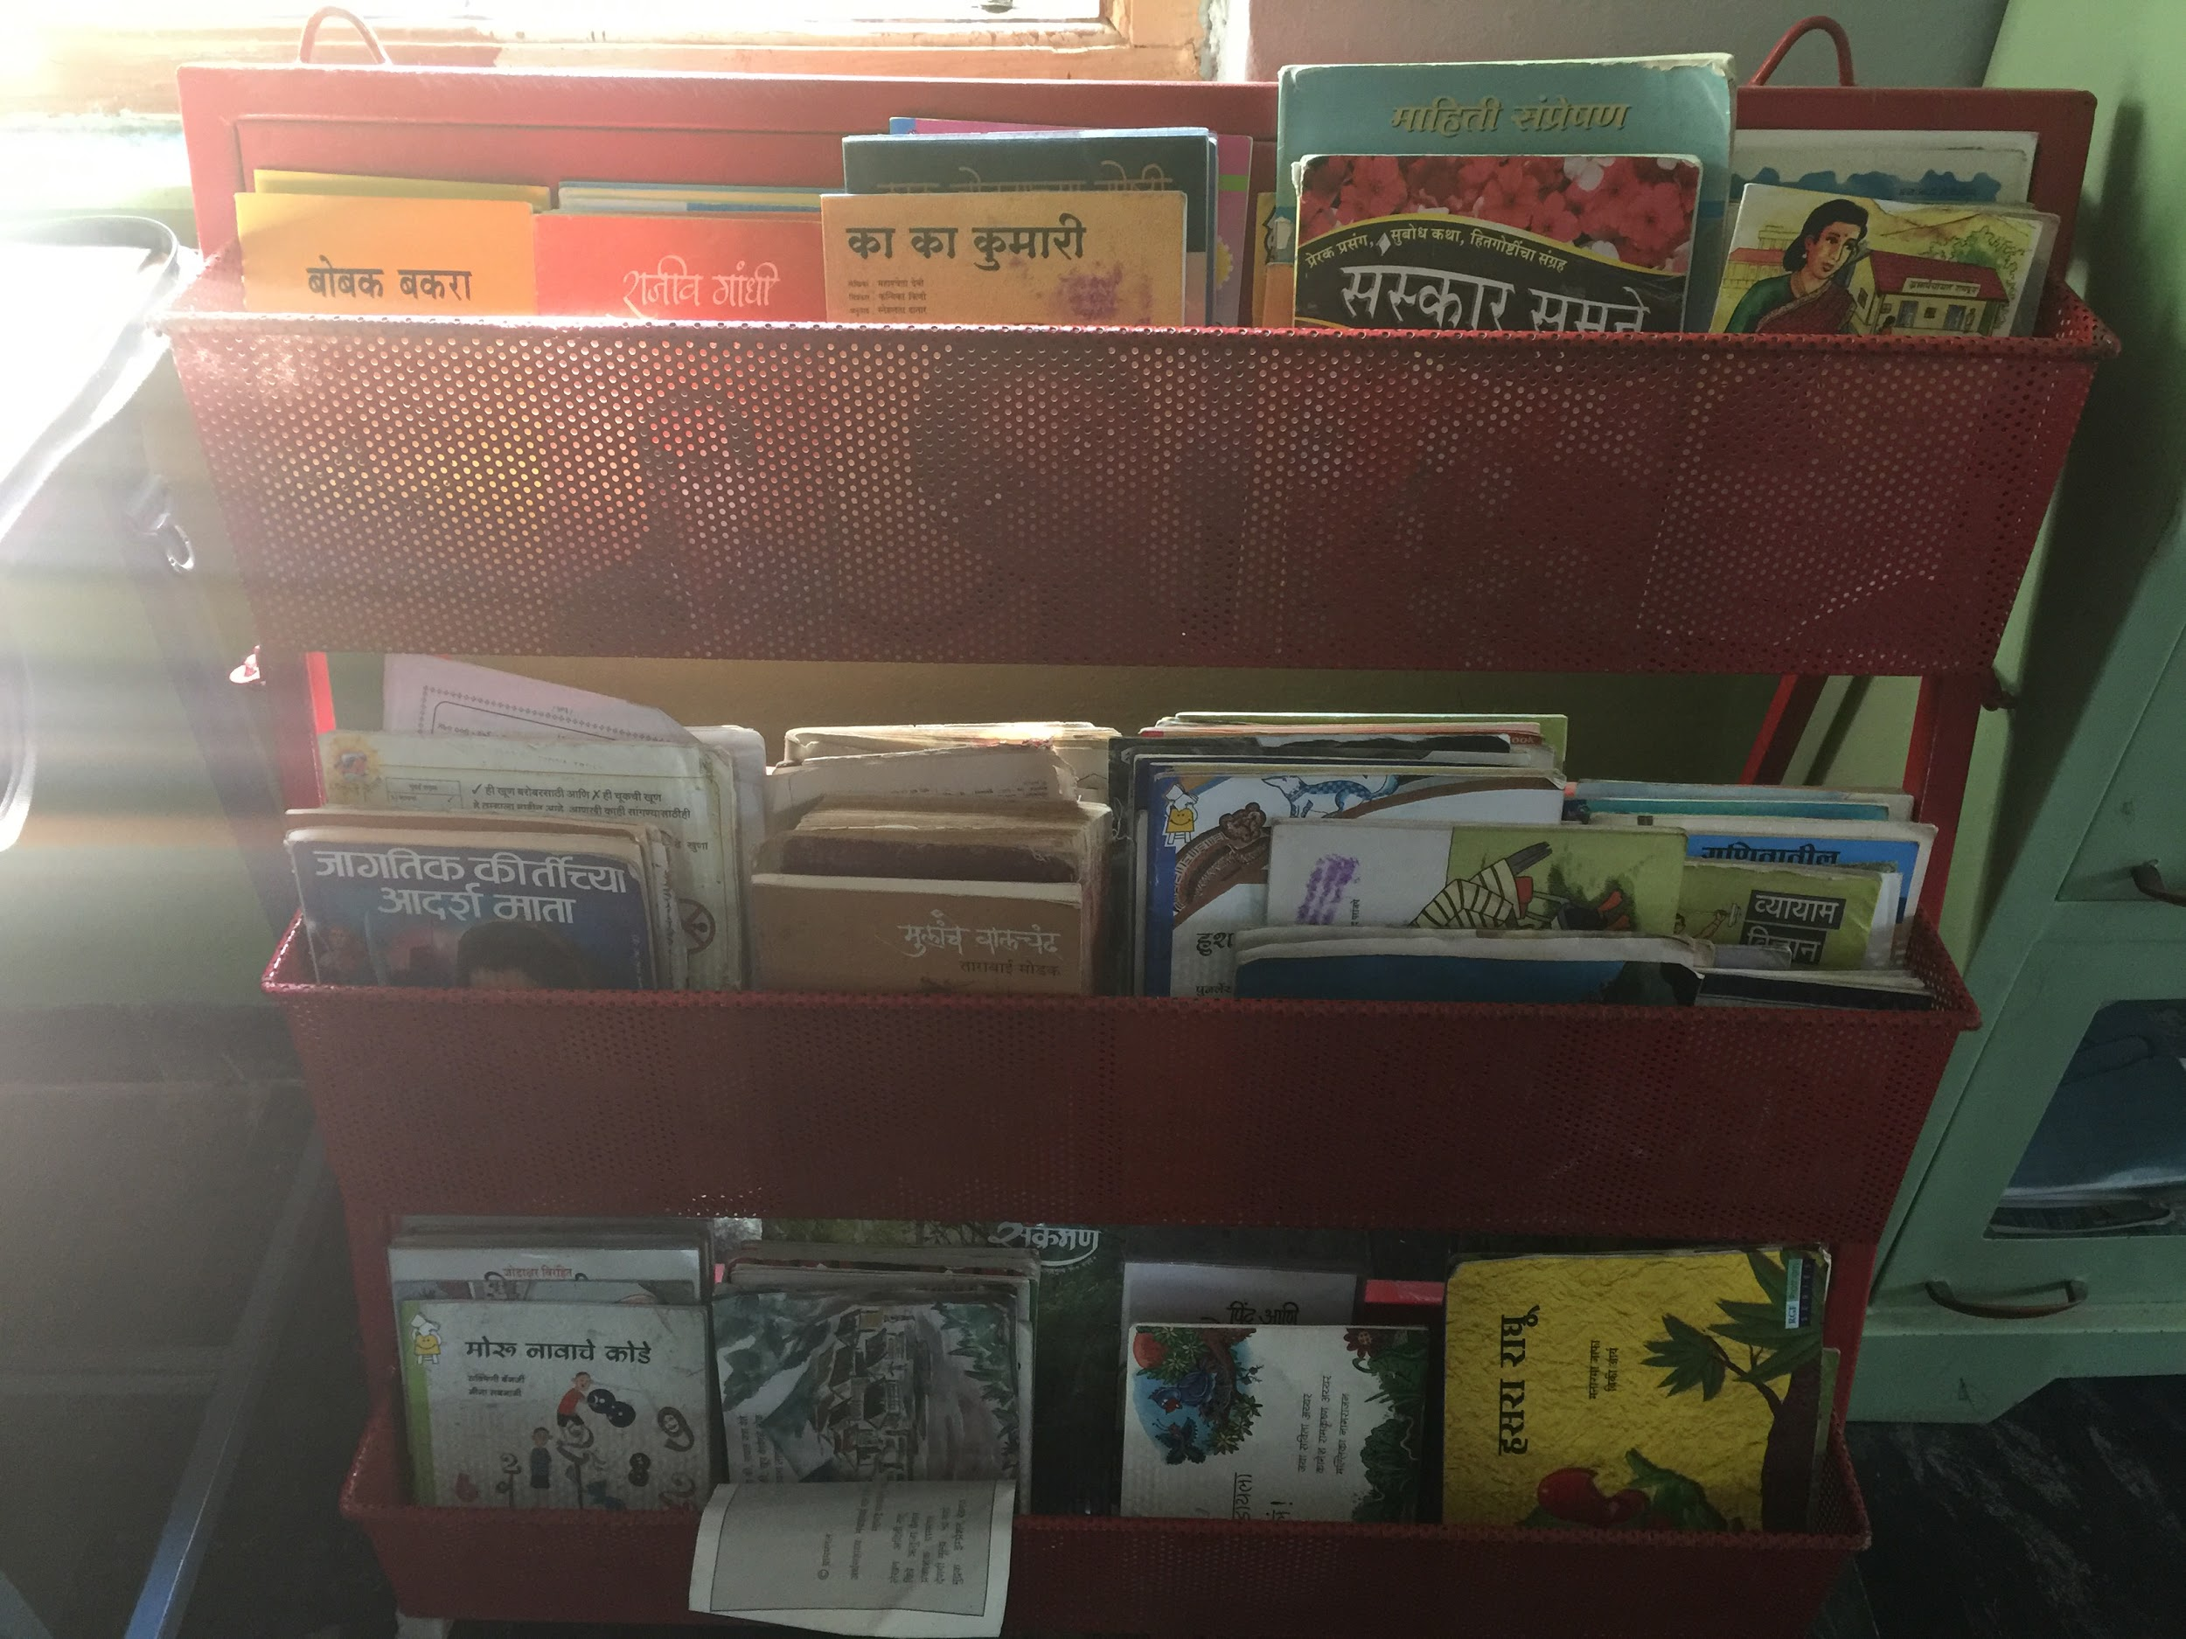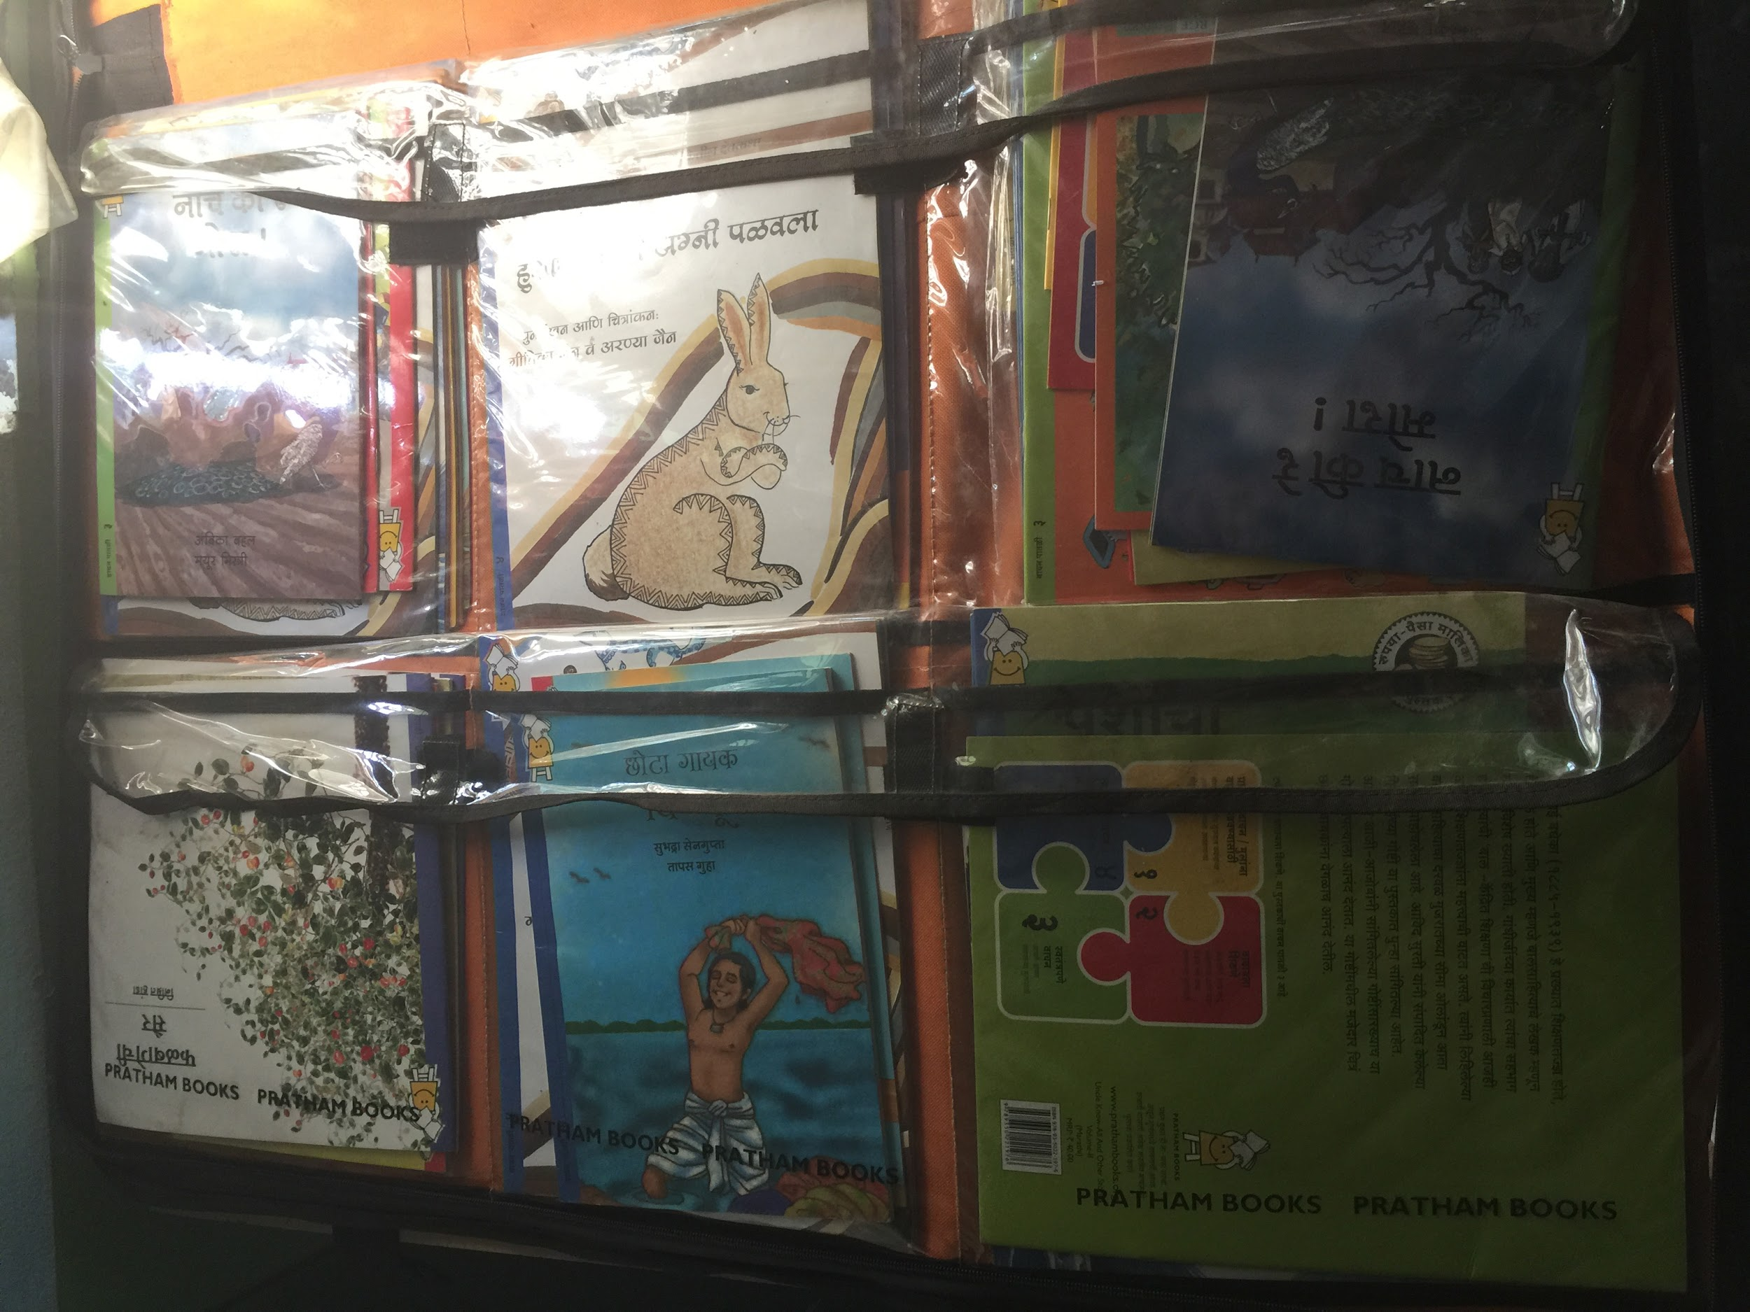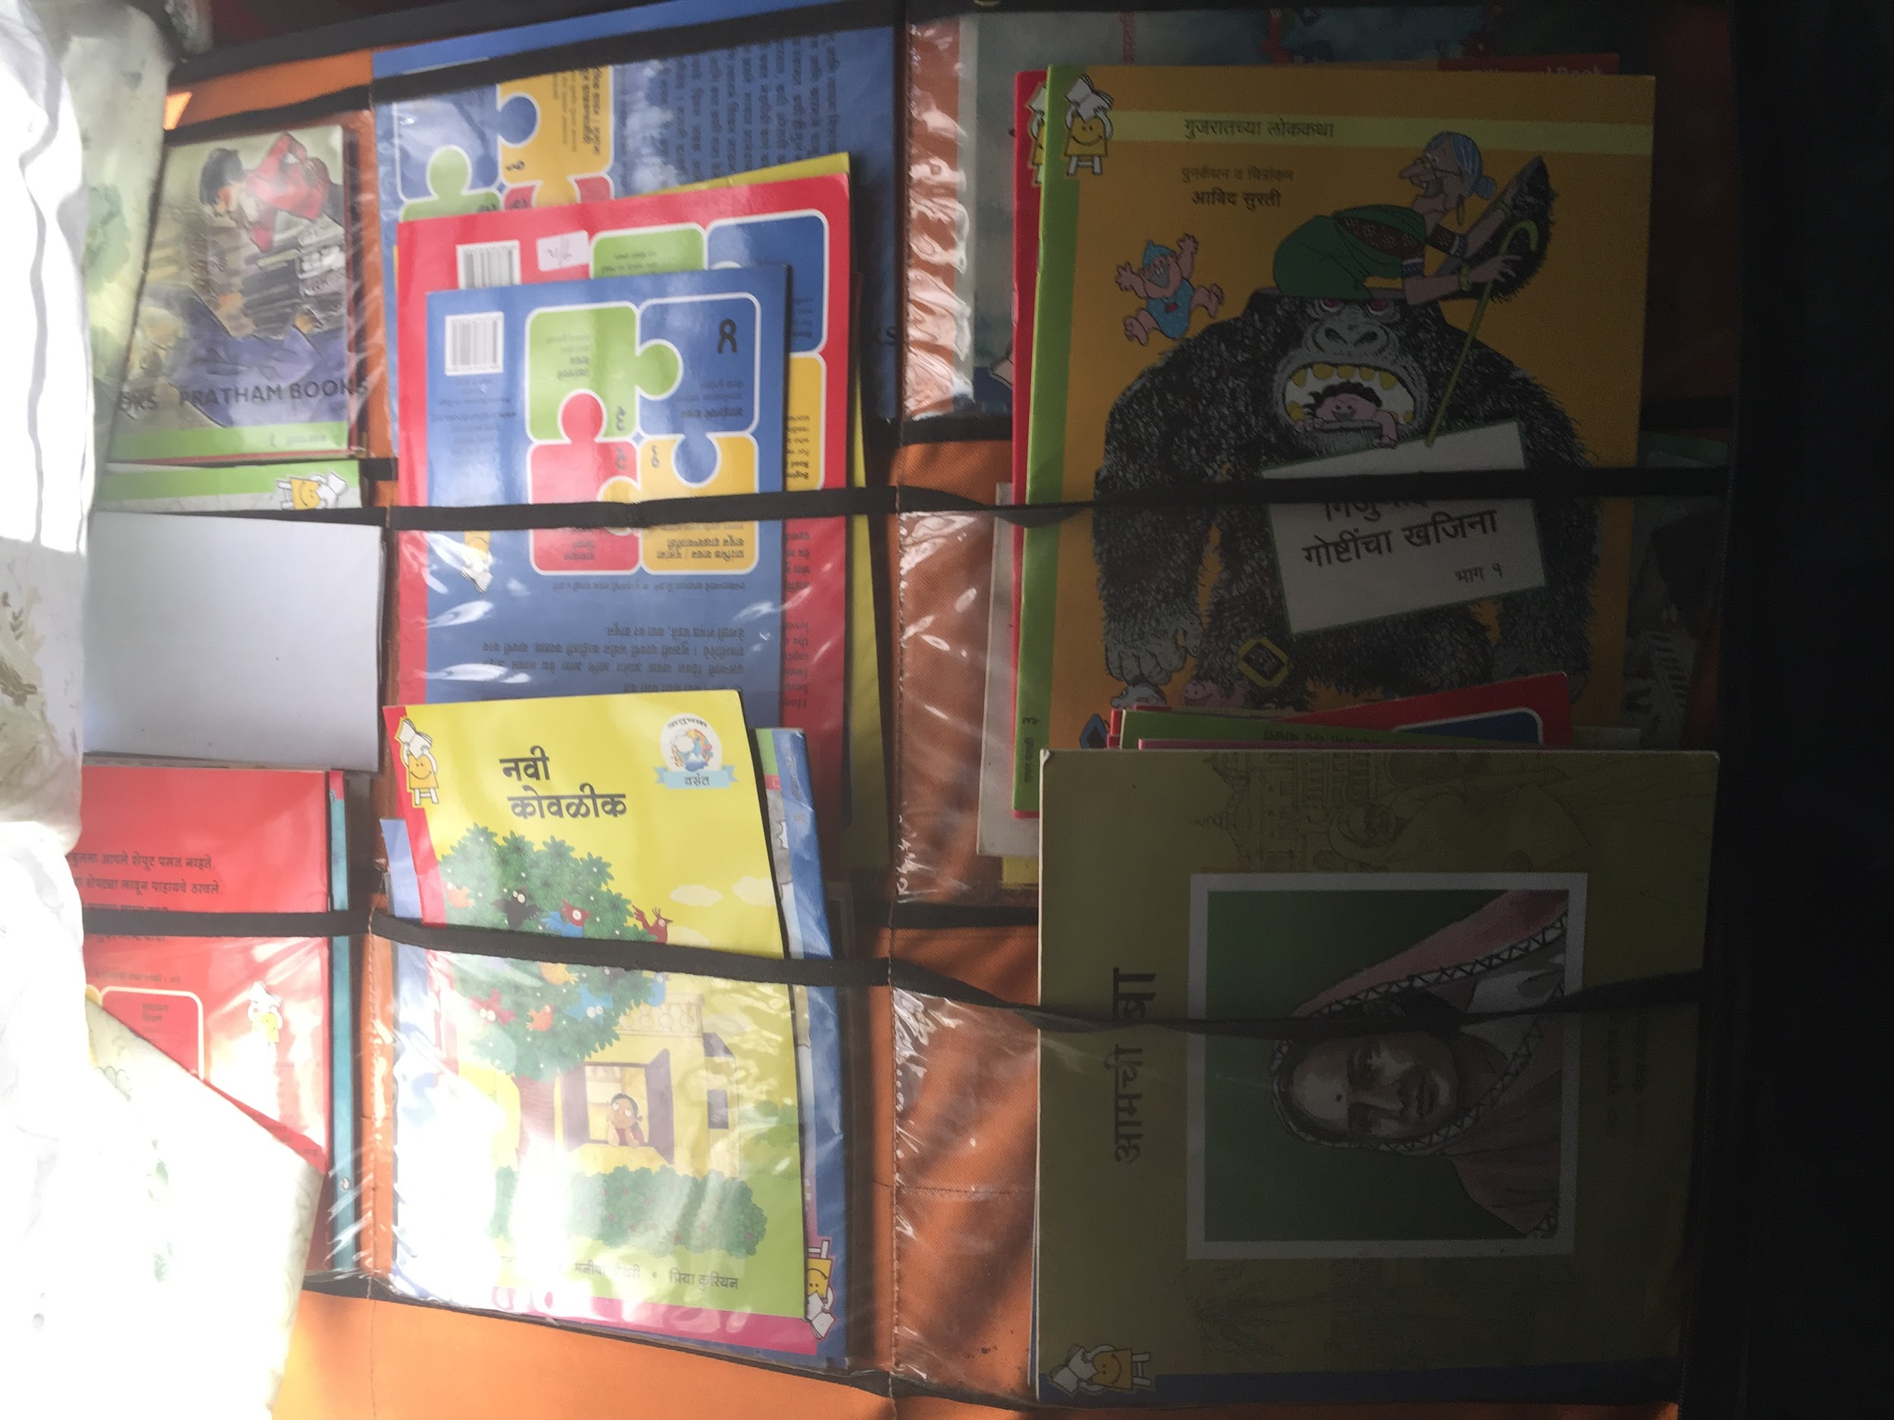

Additional Books and School Supplies
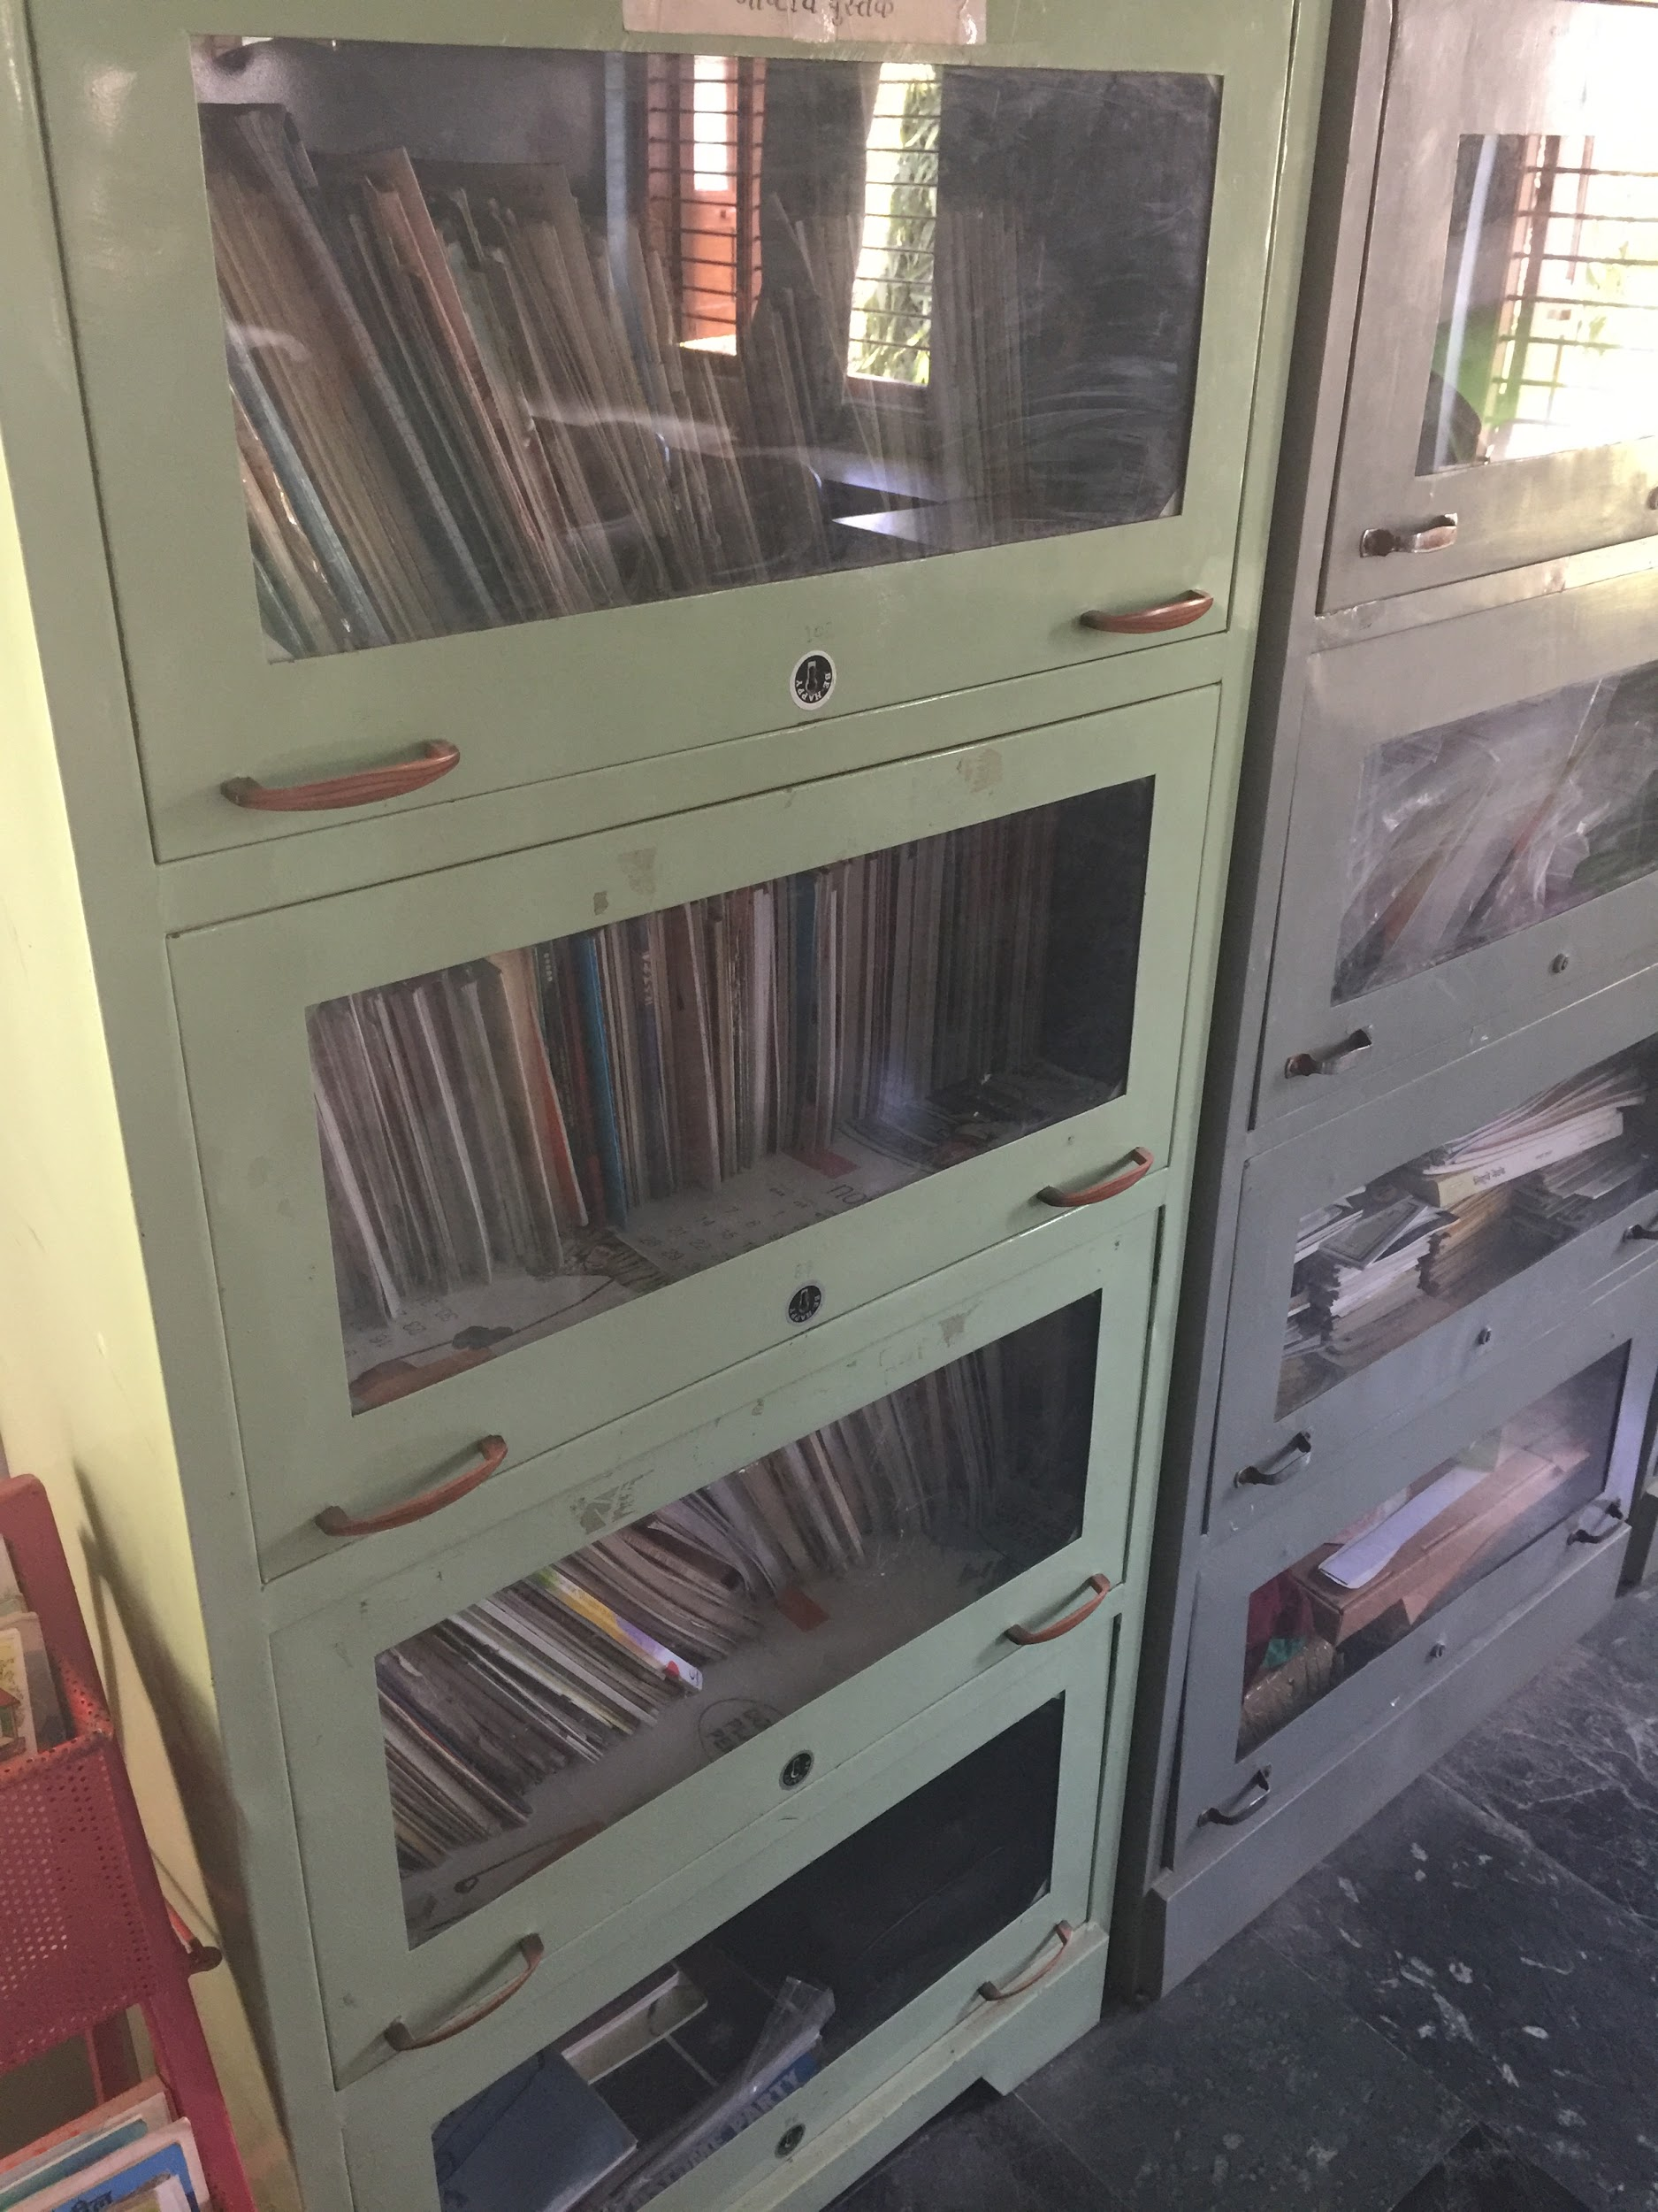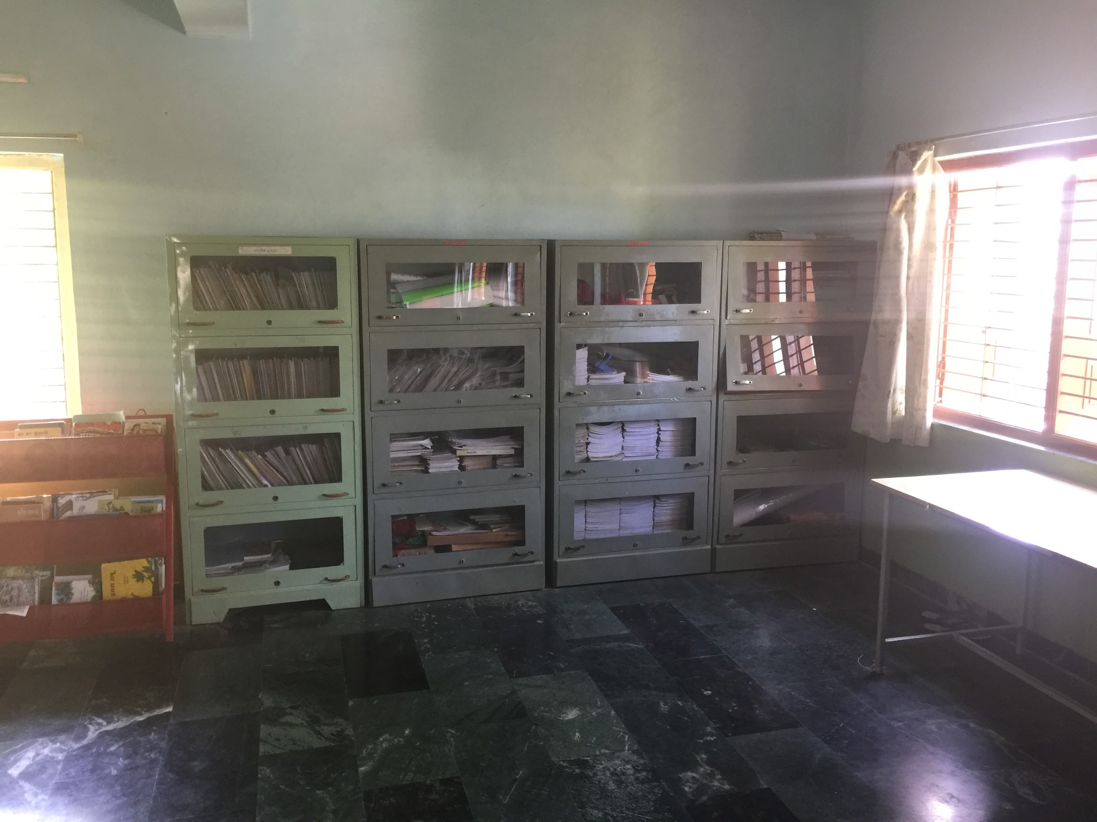

Display board for schools activities and achievements
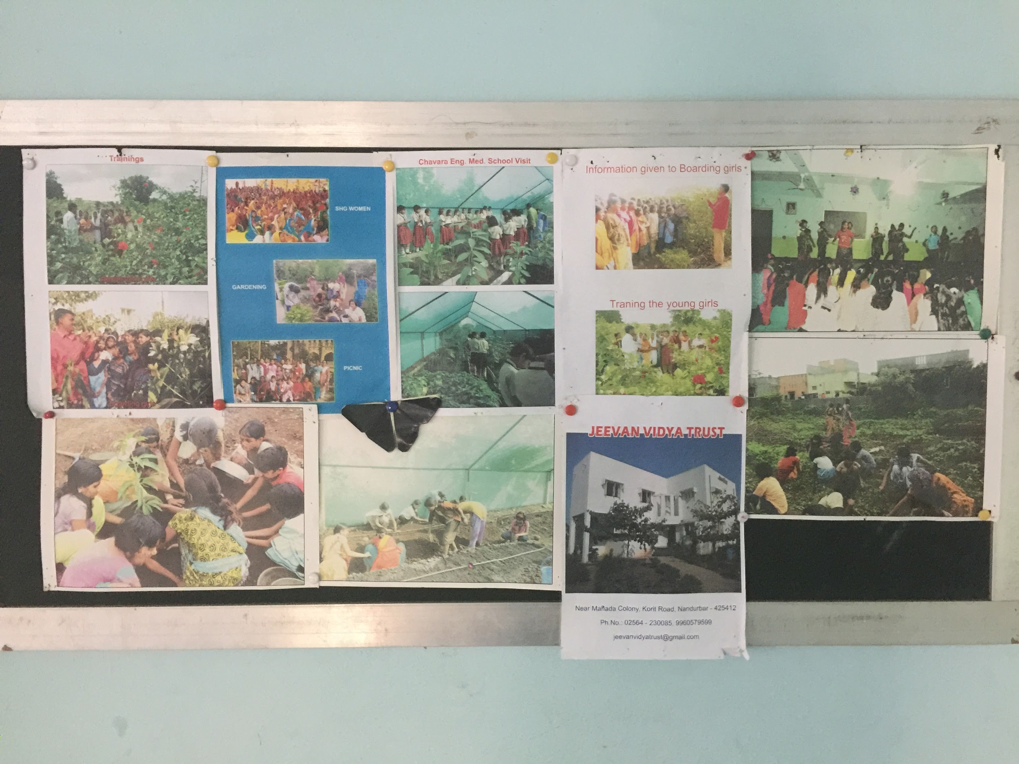

Sewing Machines
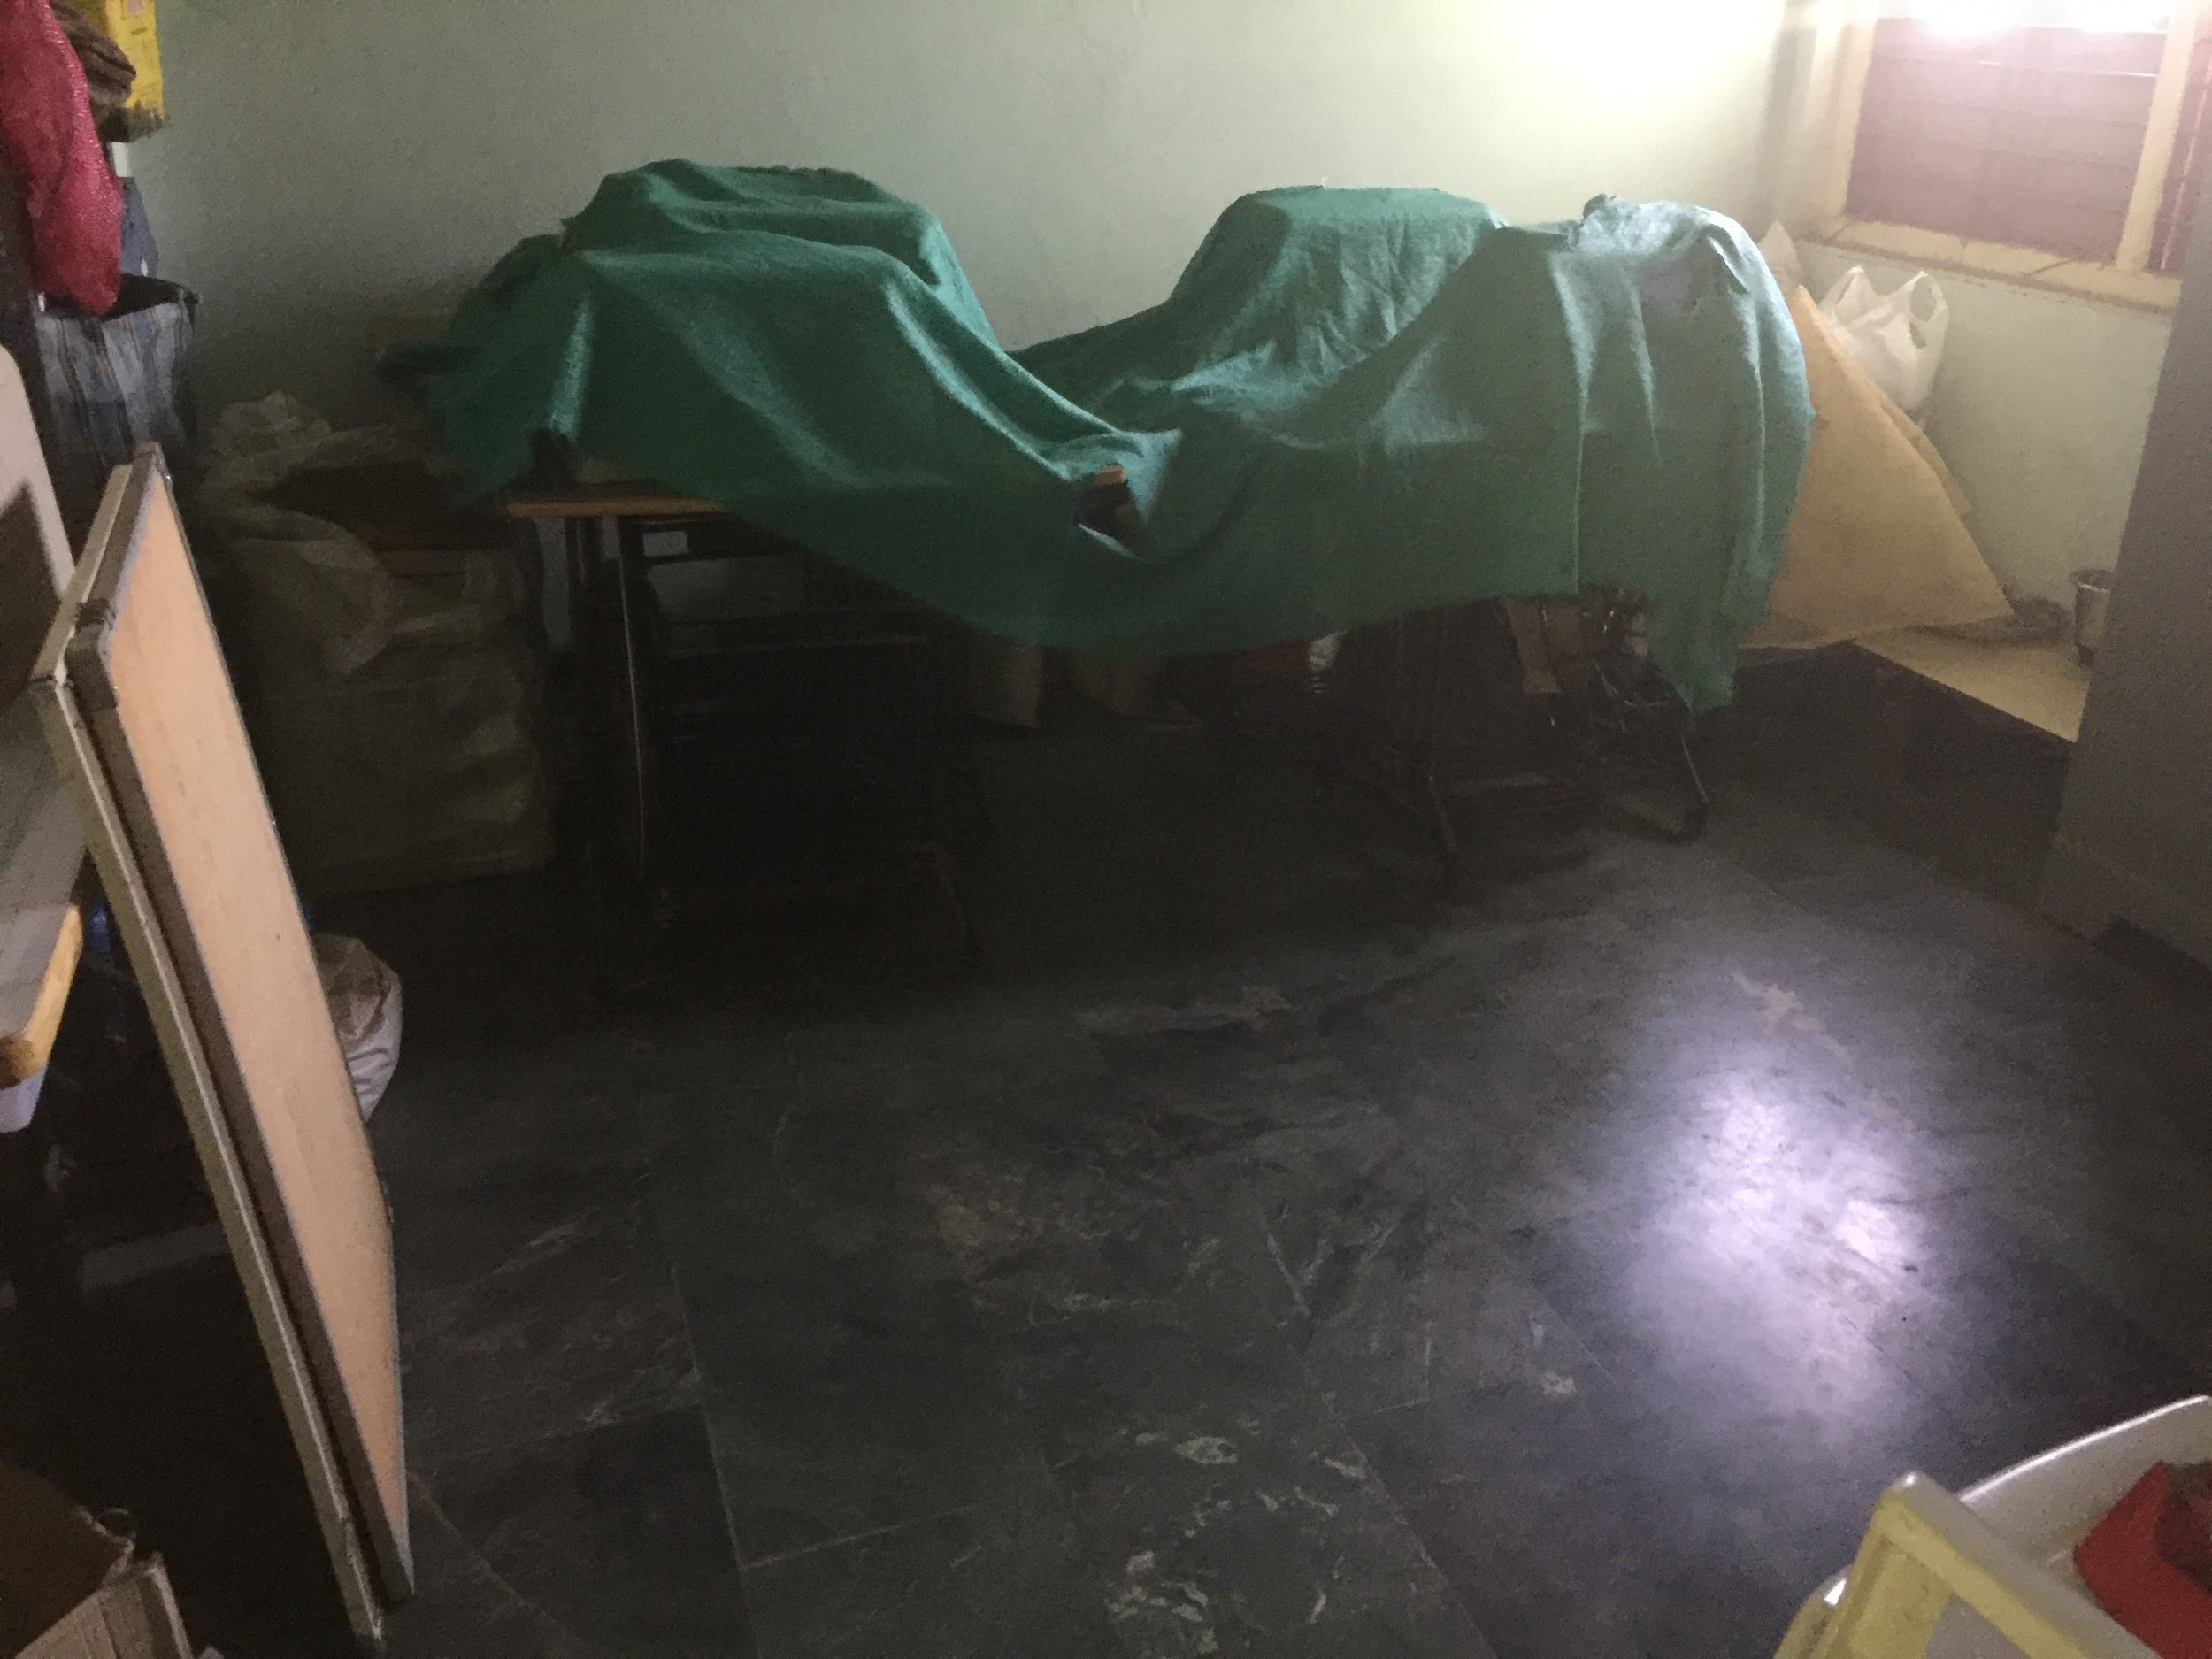

Drying leaves for preparing Herbal Medicine in the open area
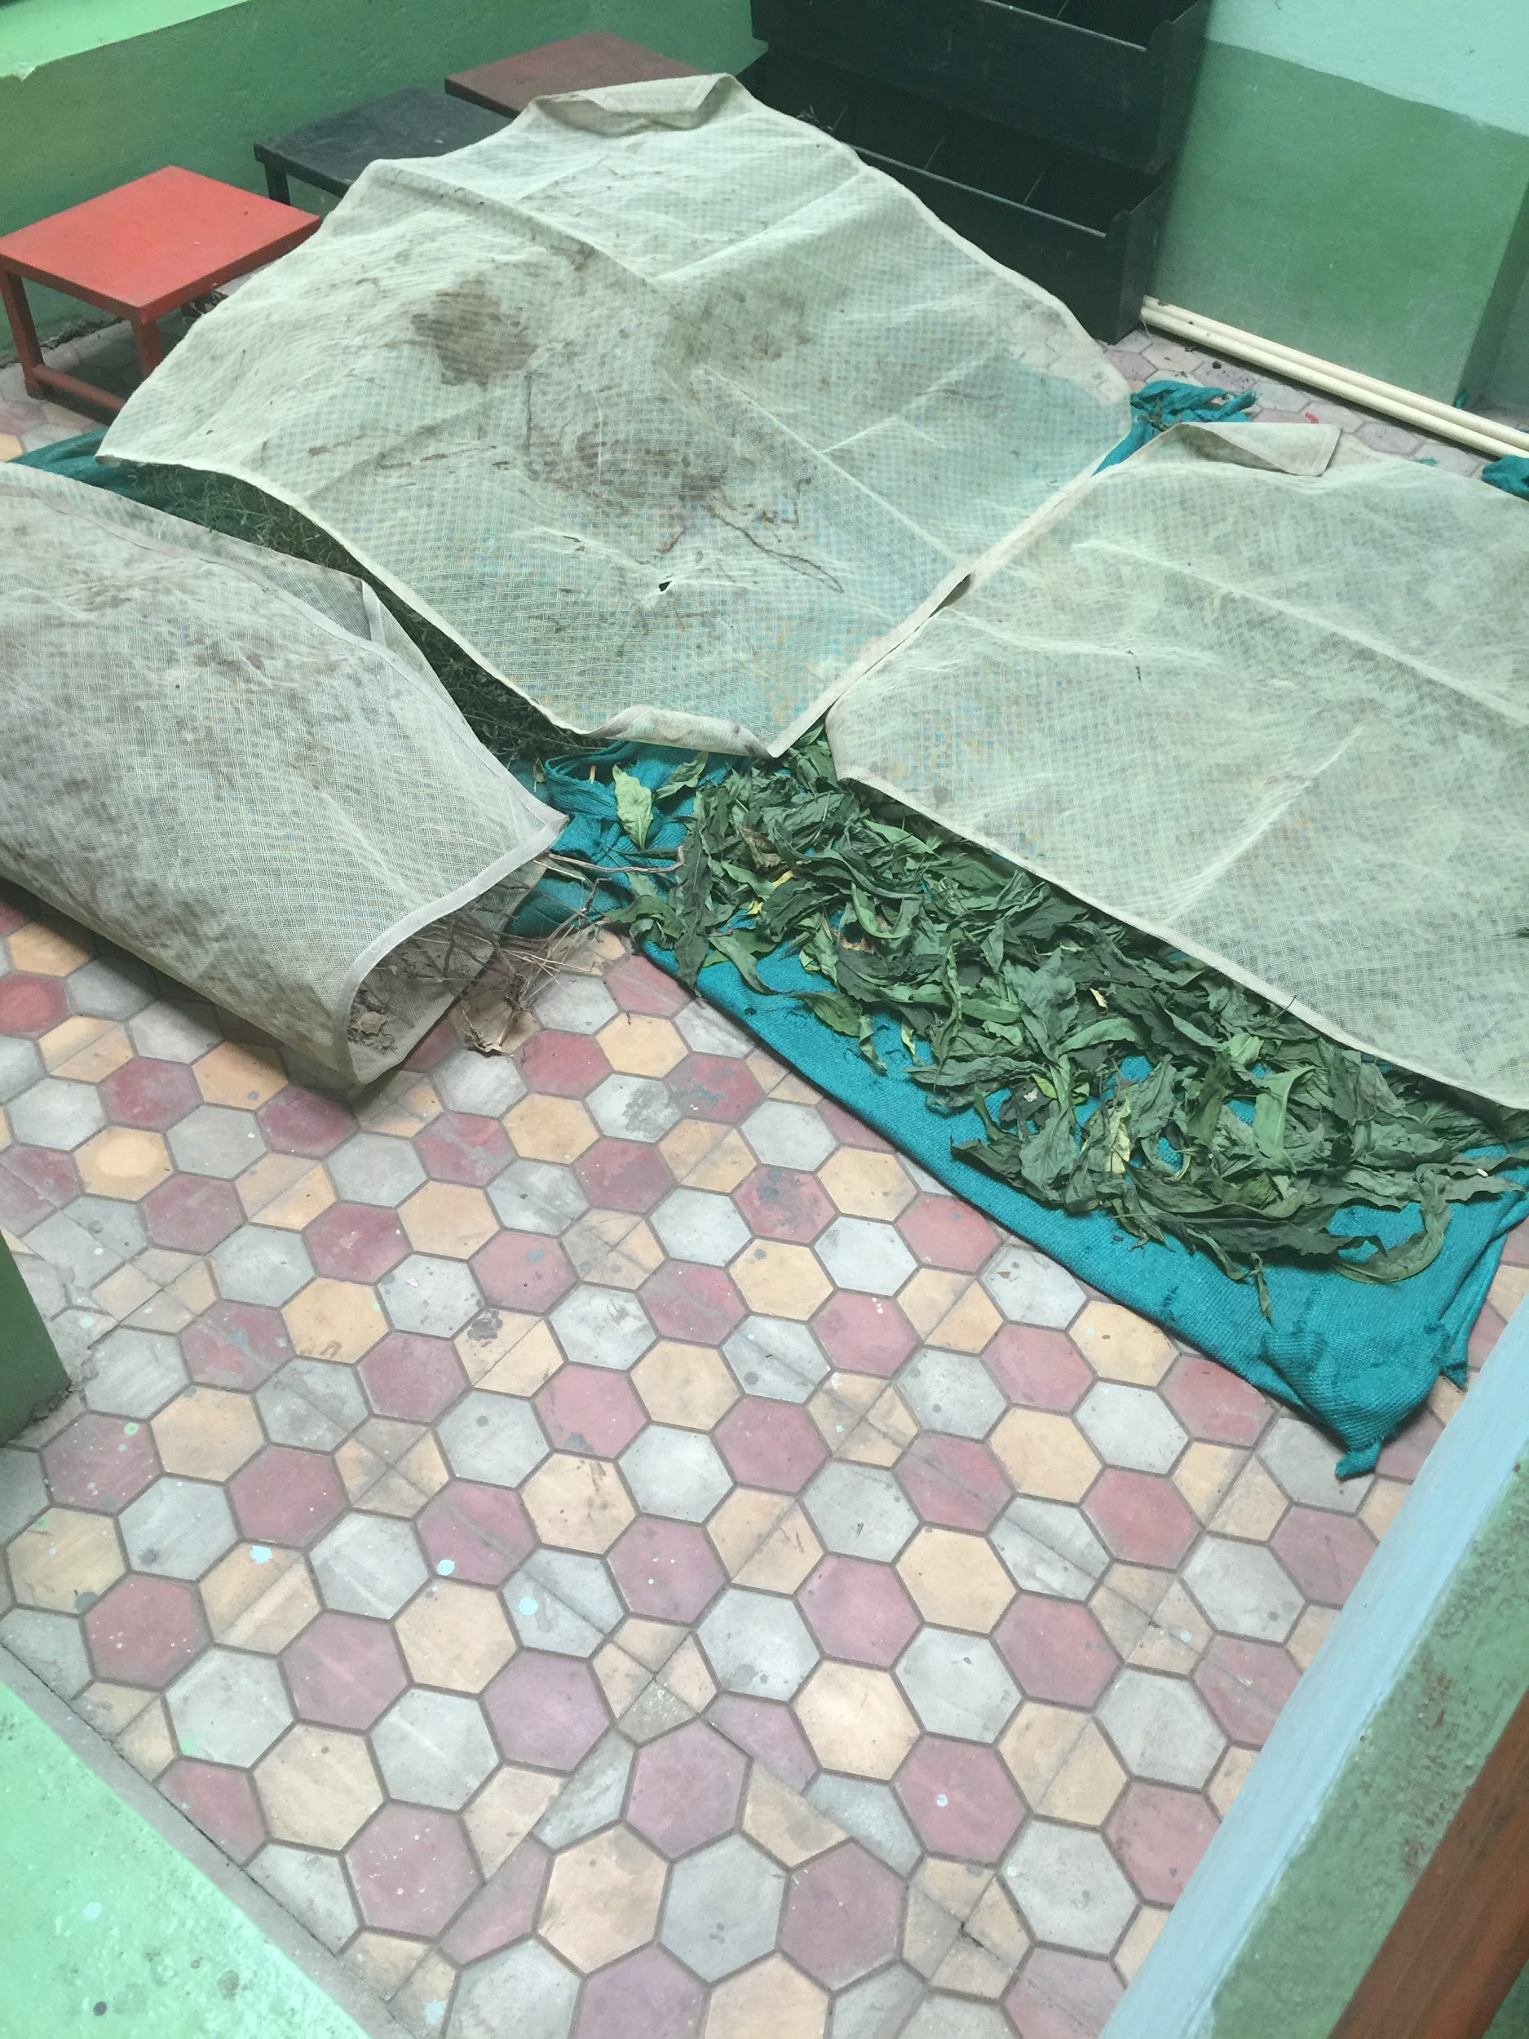

Lockers for Girls with blankets Martina Tai in picture
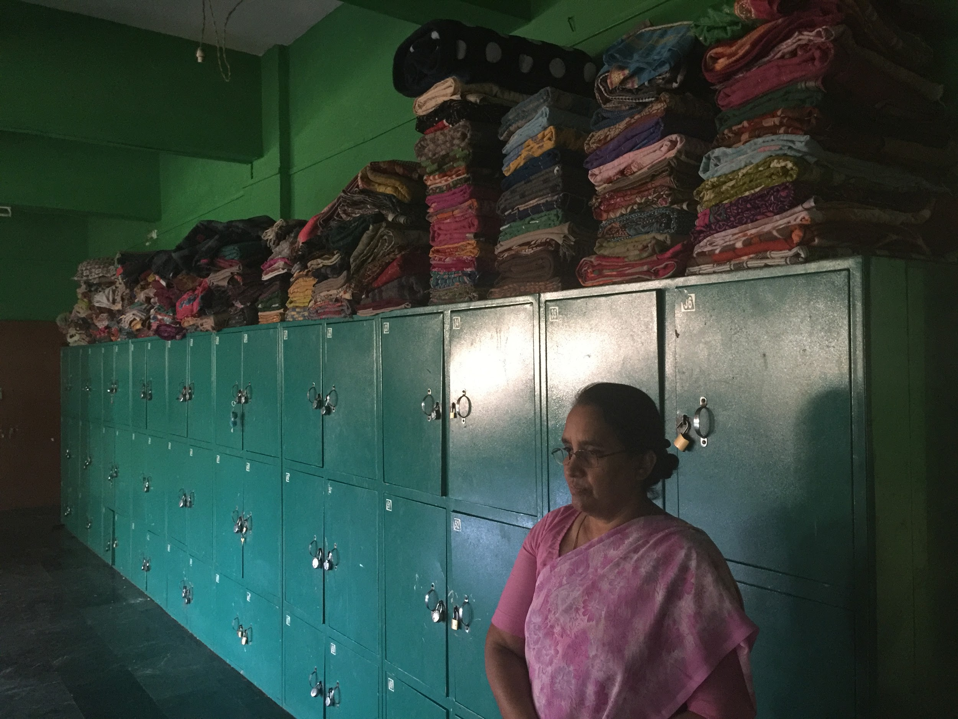

Girls Dining area
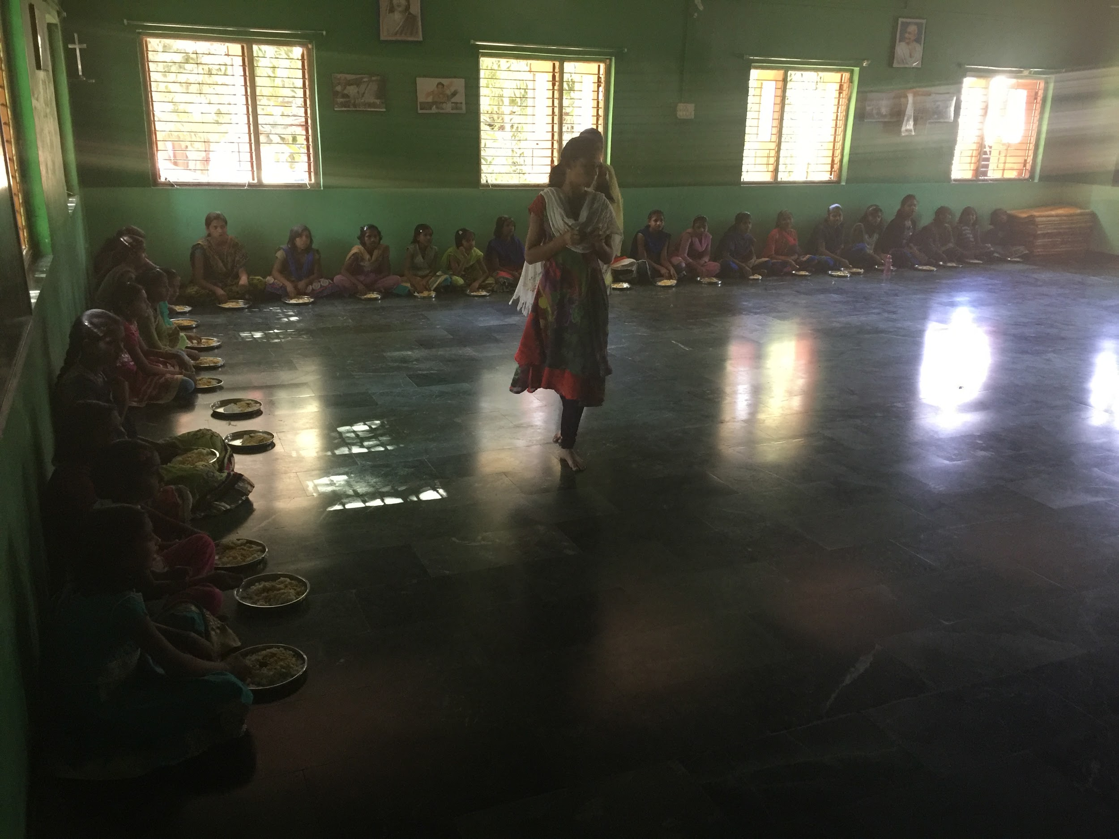

Pantry for food storage
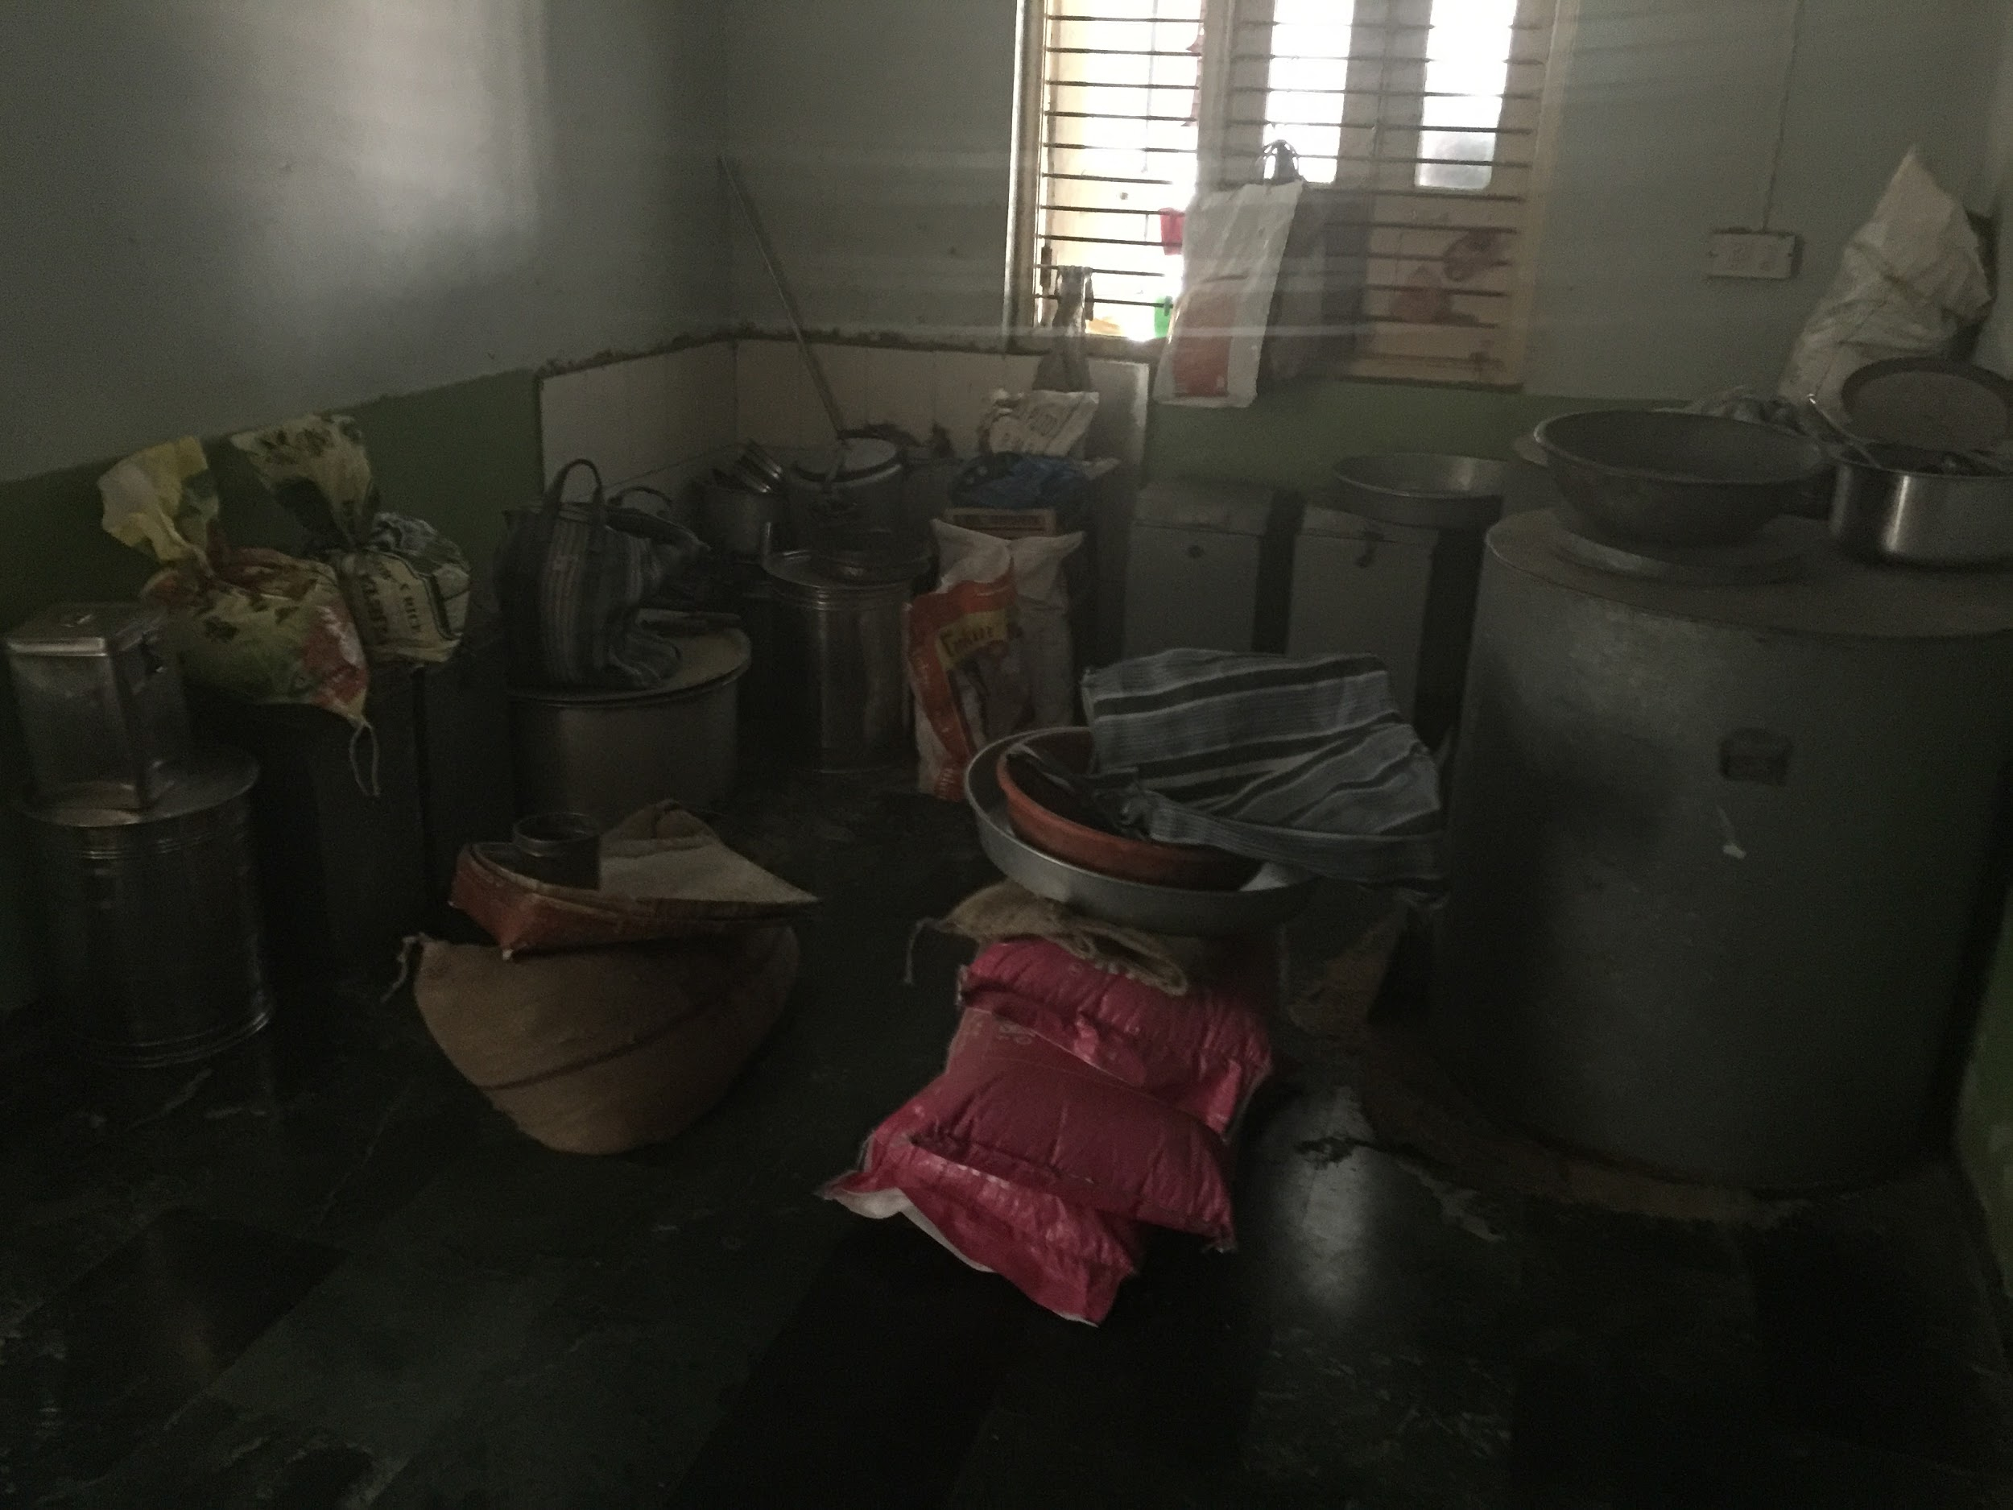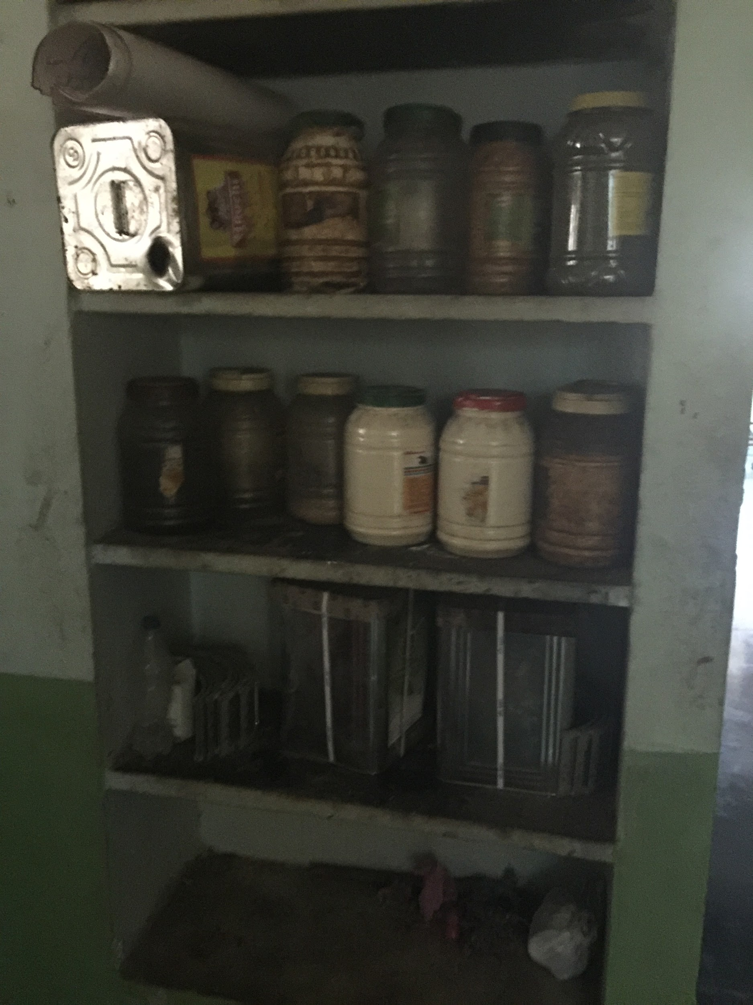

Personal and school bags storage
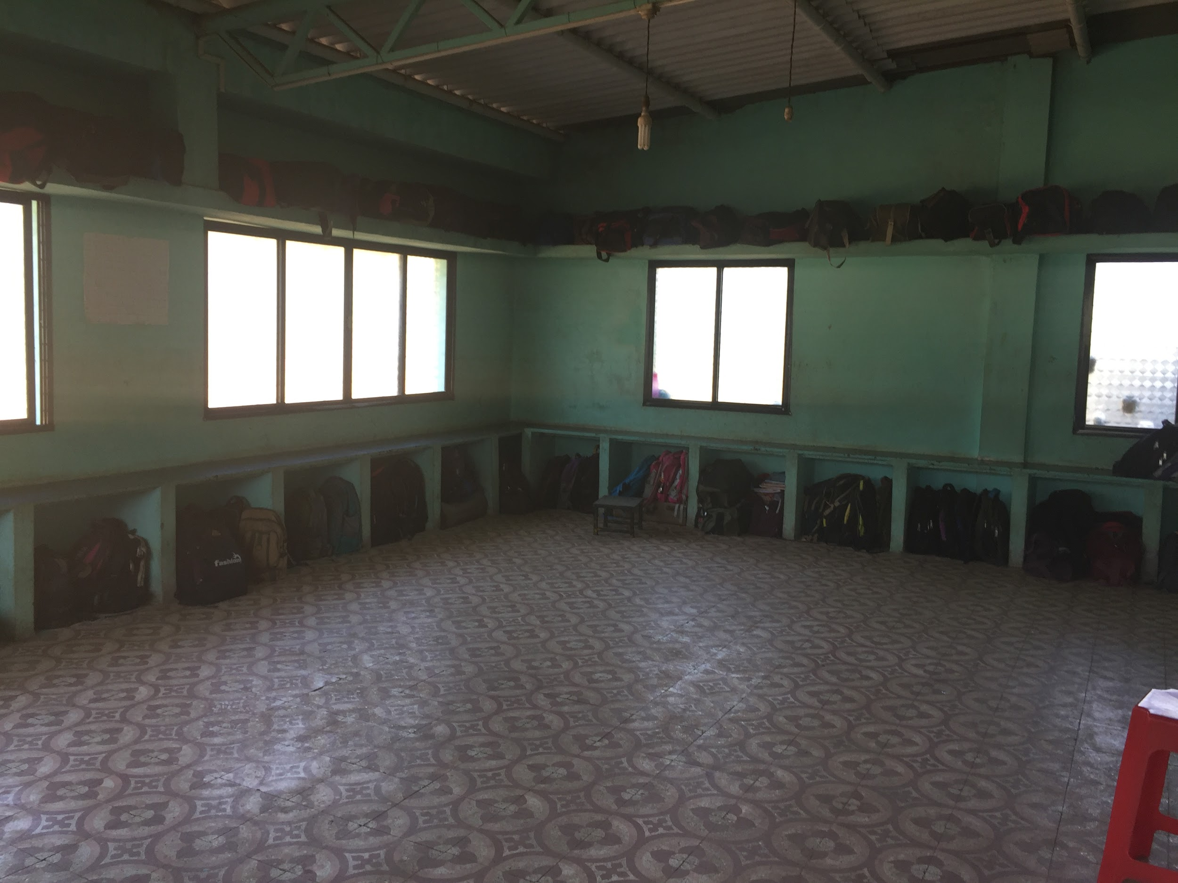

Food seeing area outside of the kitchen
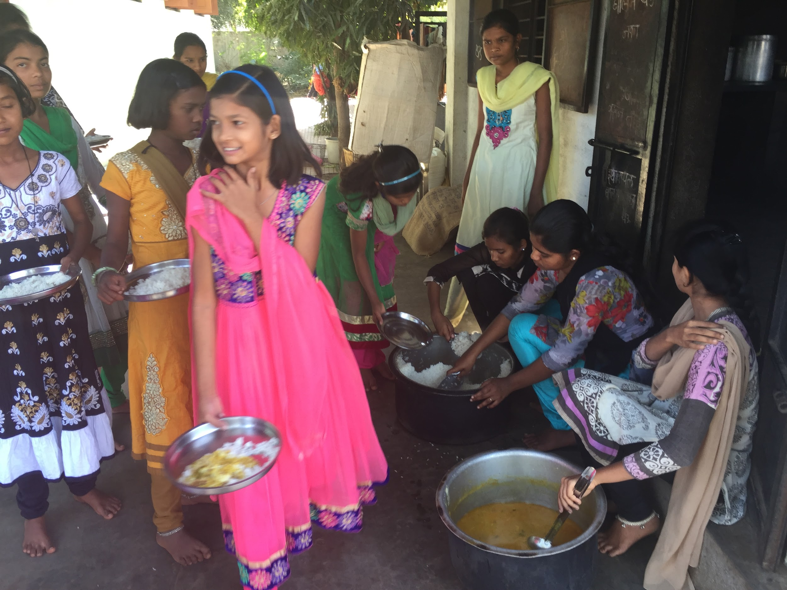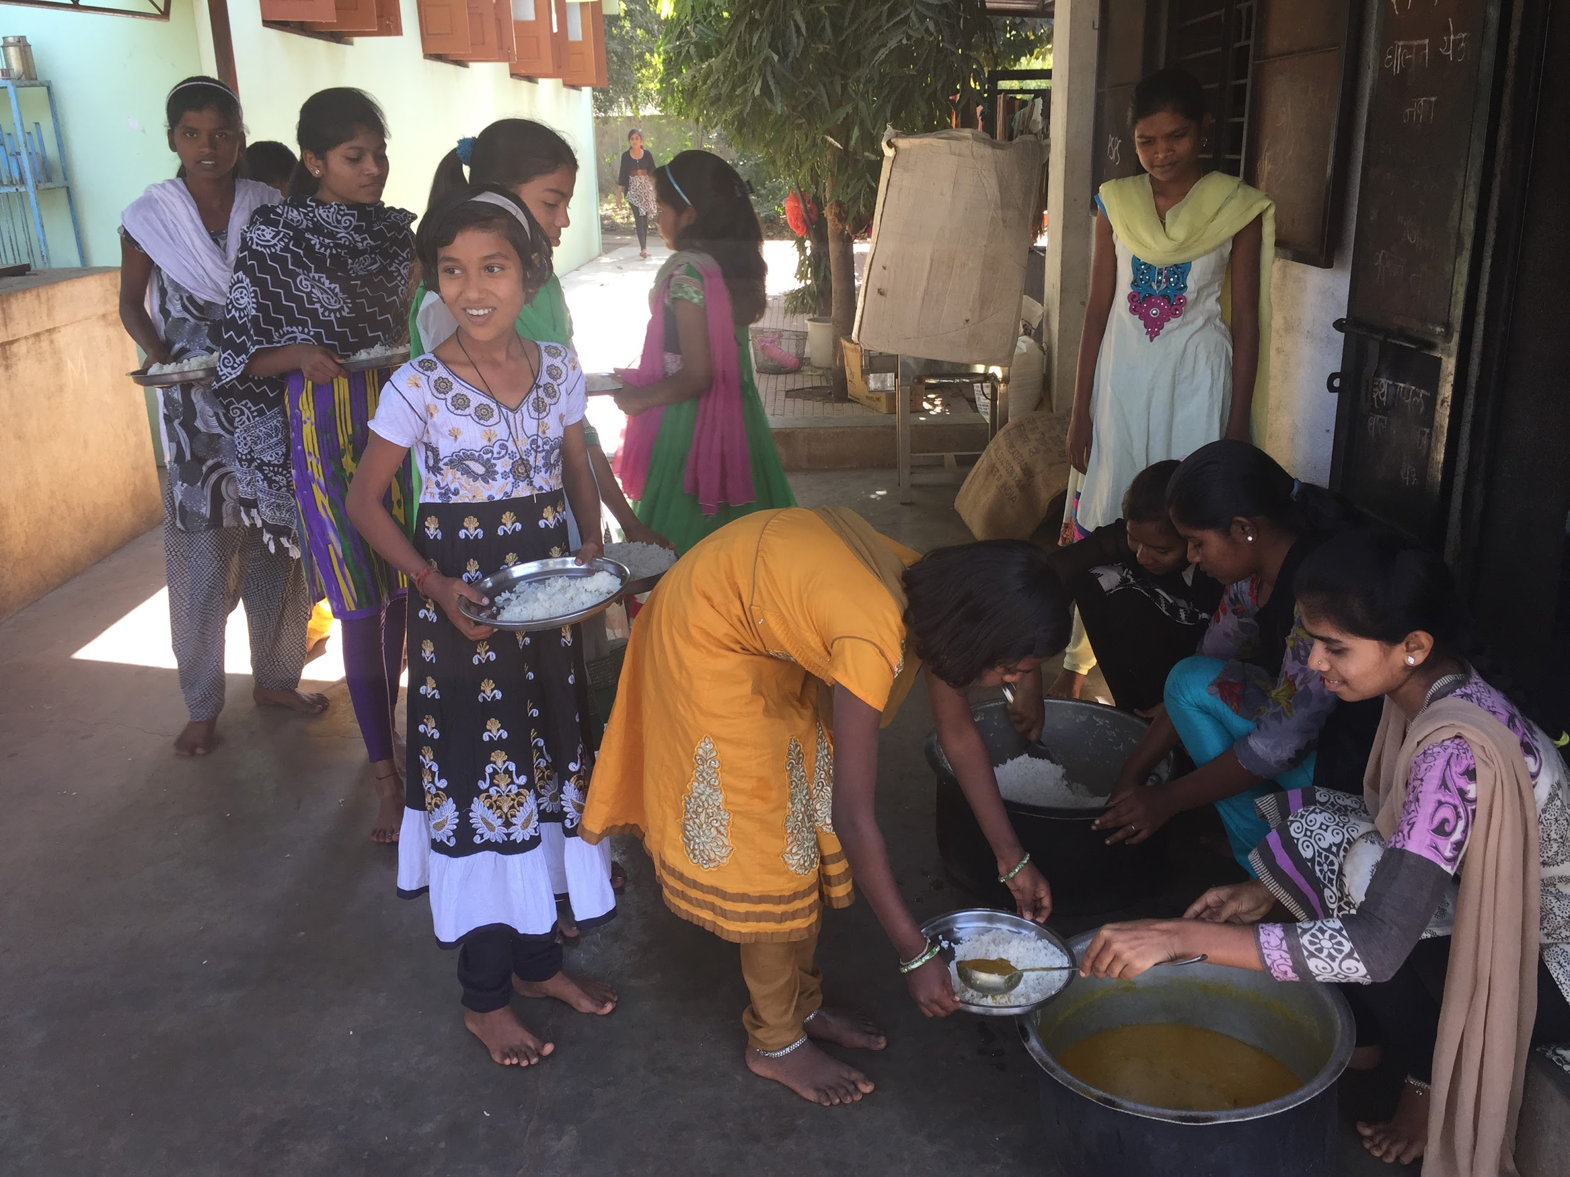

Kitchen
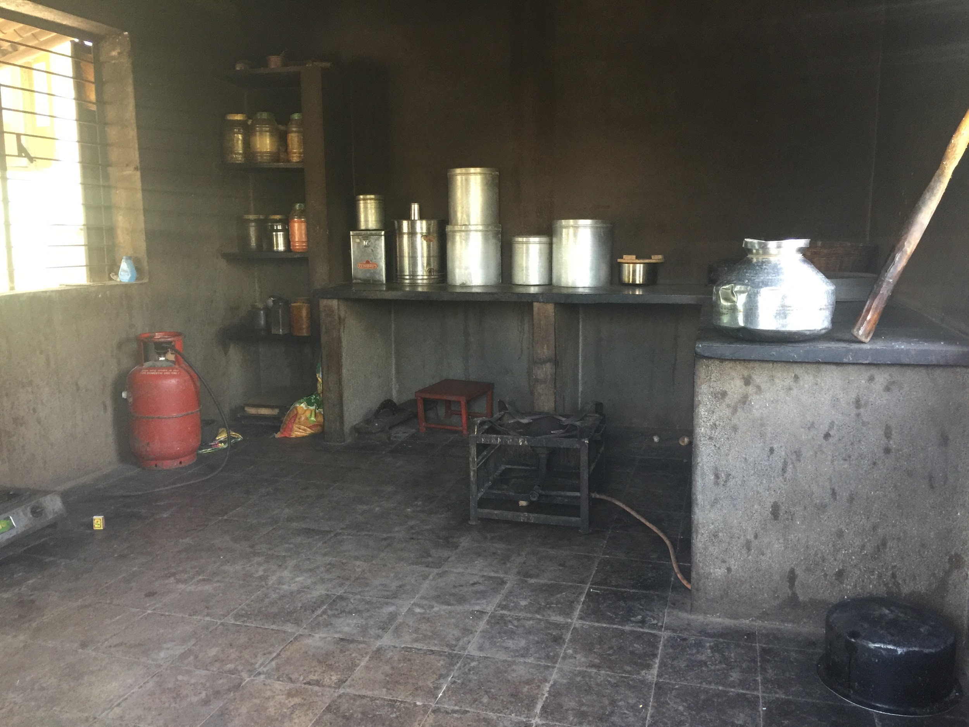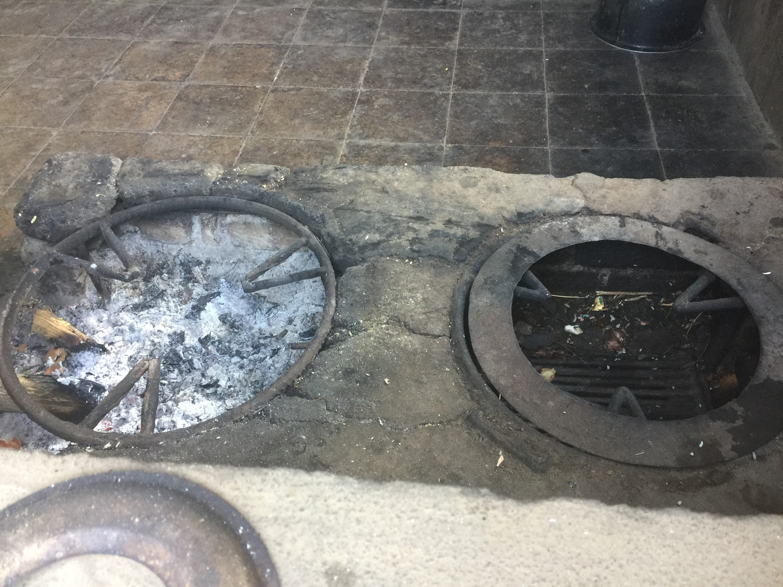

Aparna asking what girls cooked and how they cooked it.
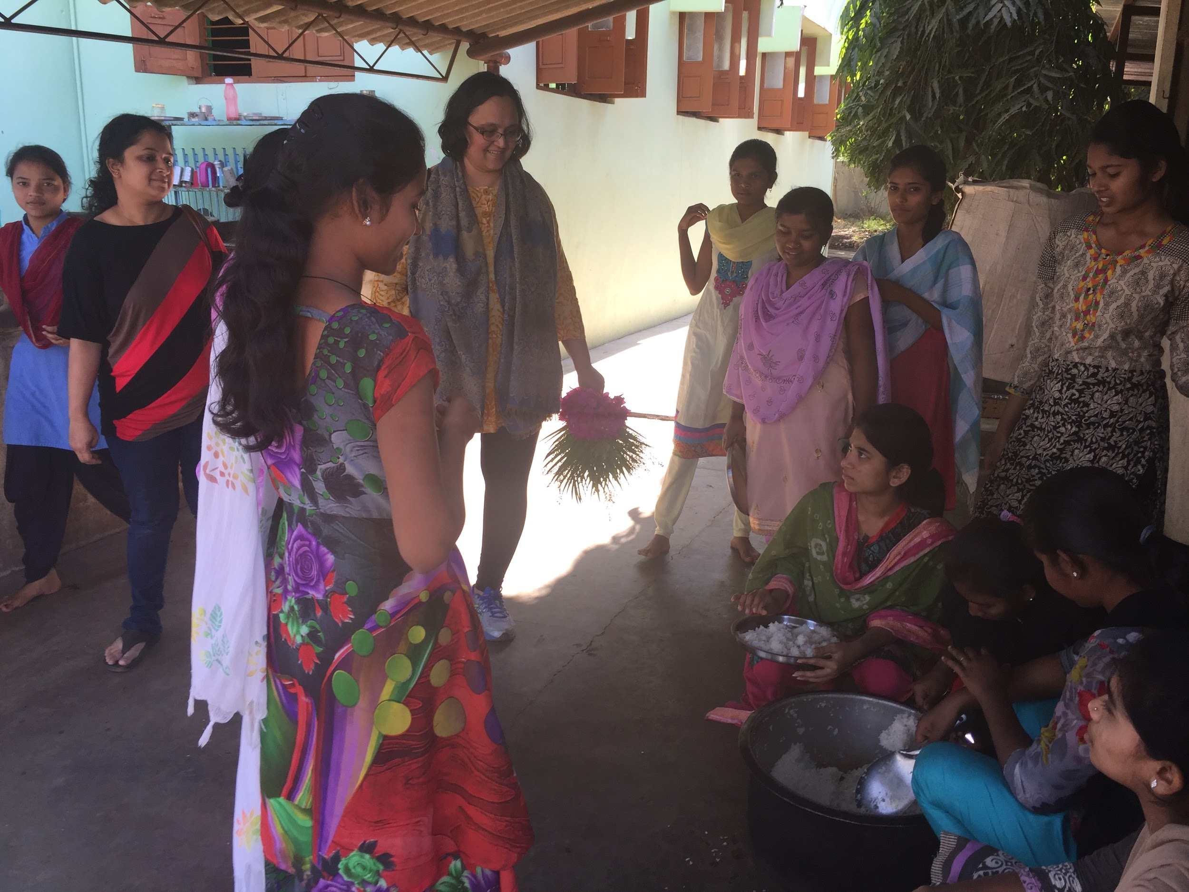

Cycles used by the girls
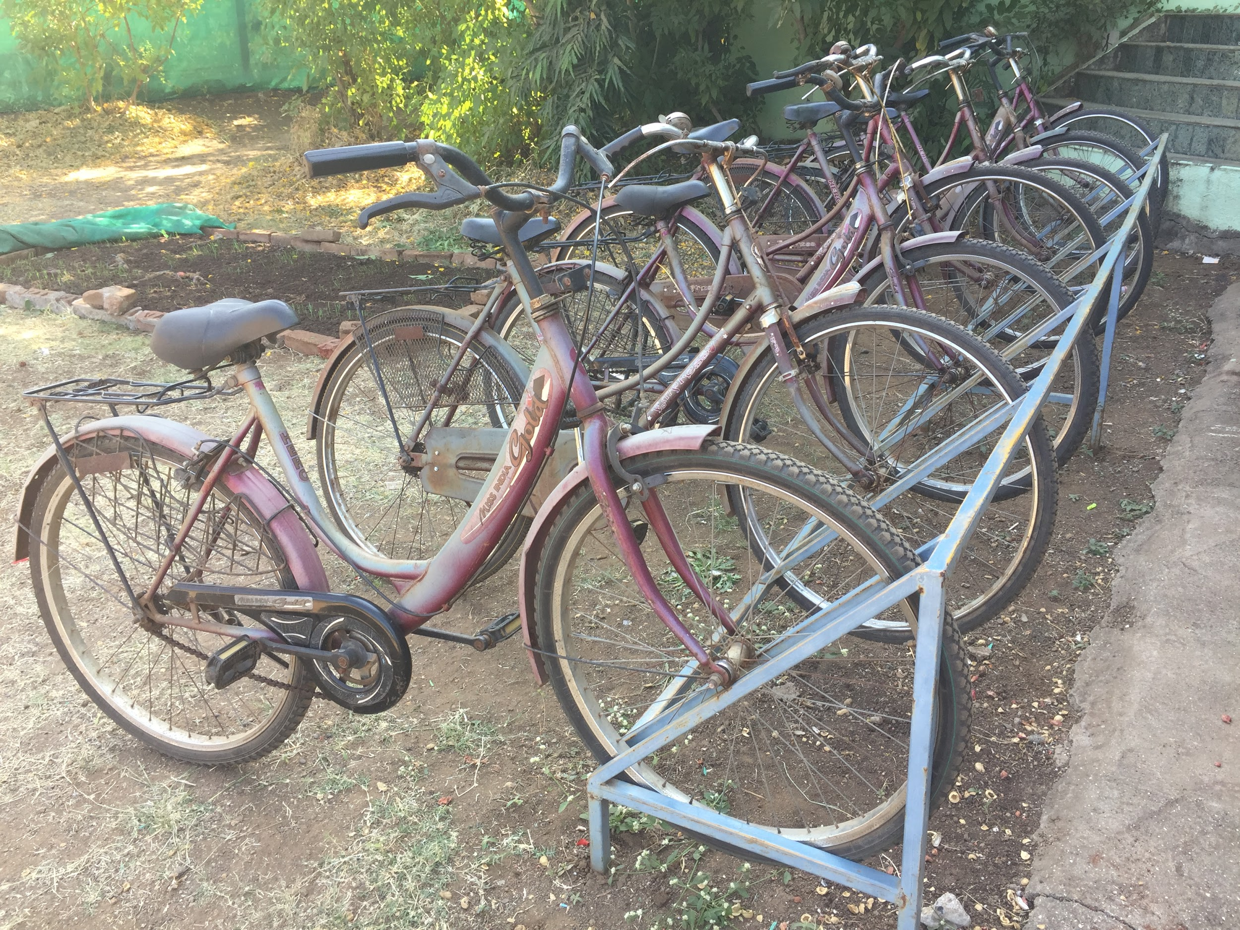

Prepared herbal medicine cabinet
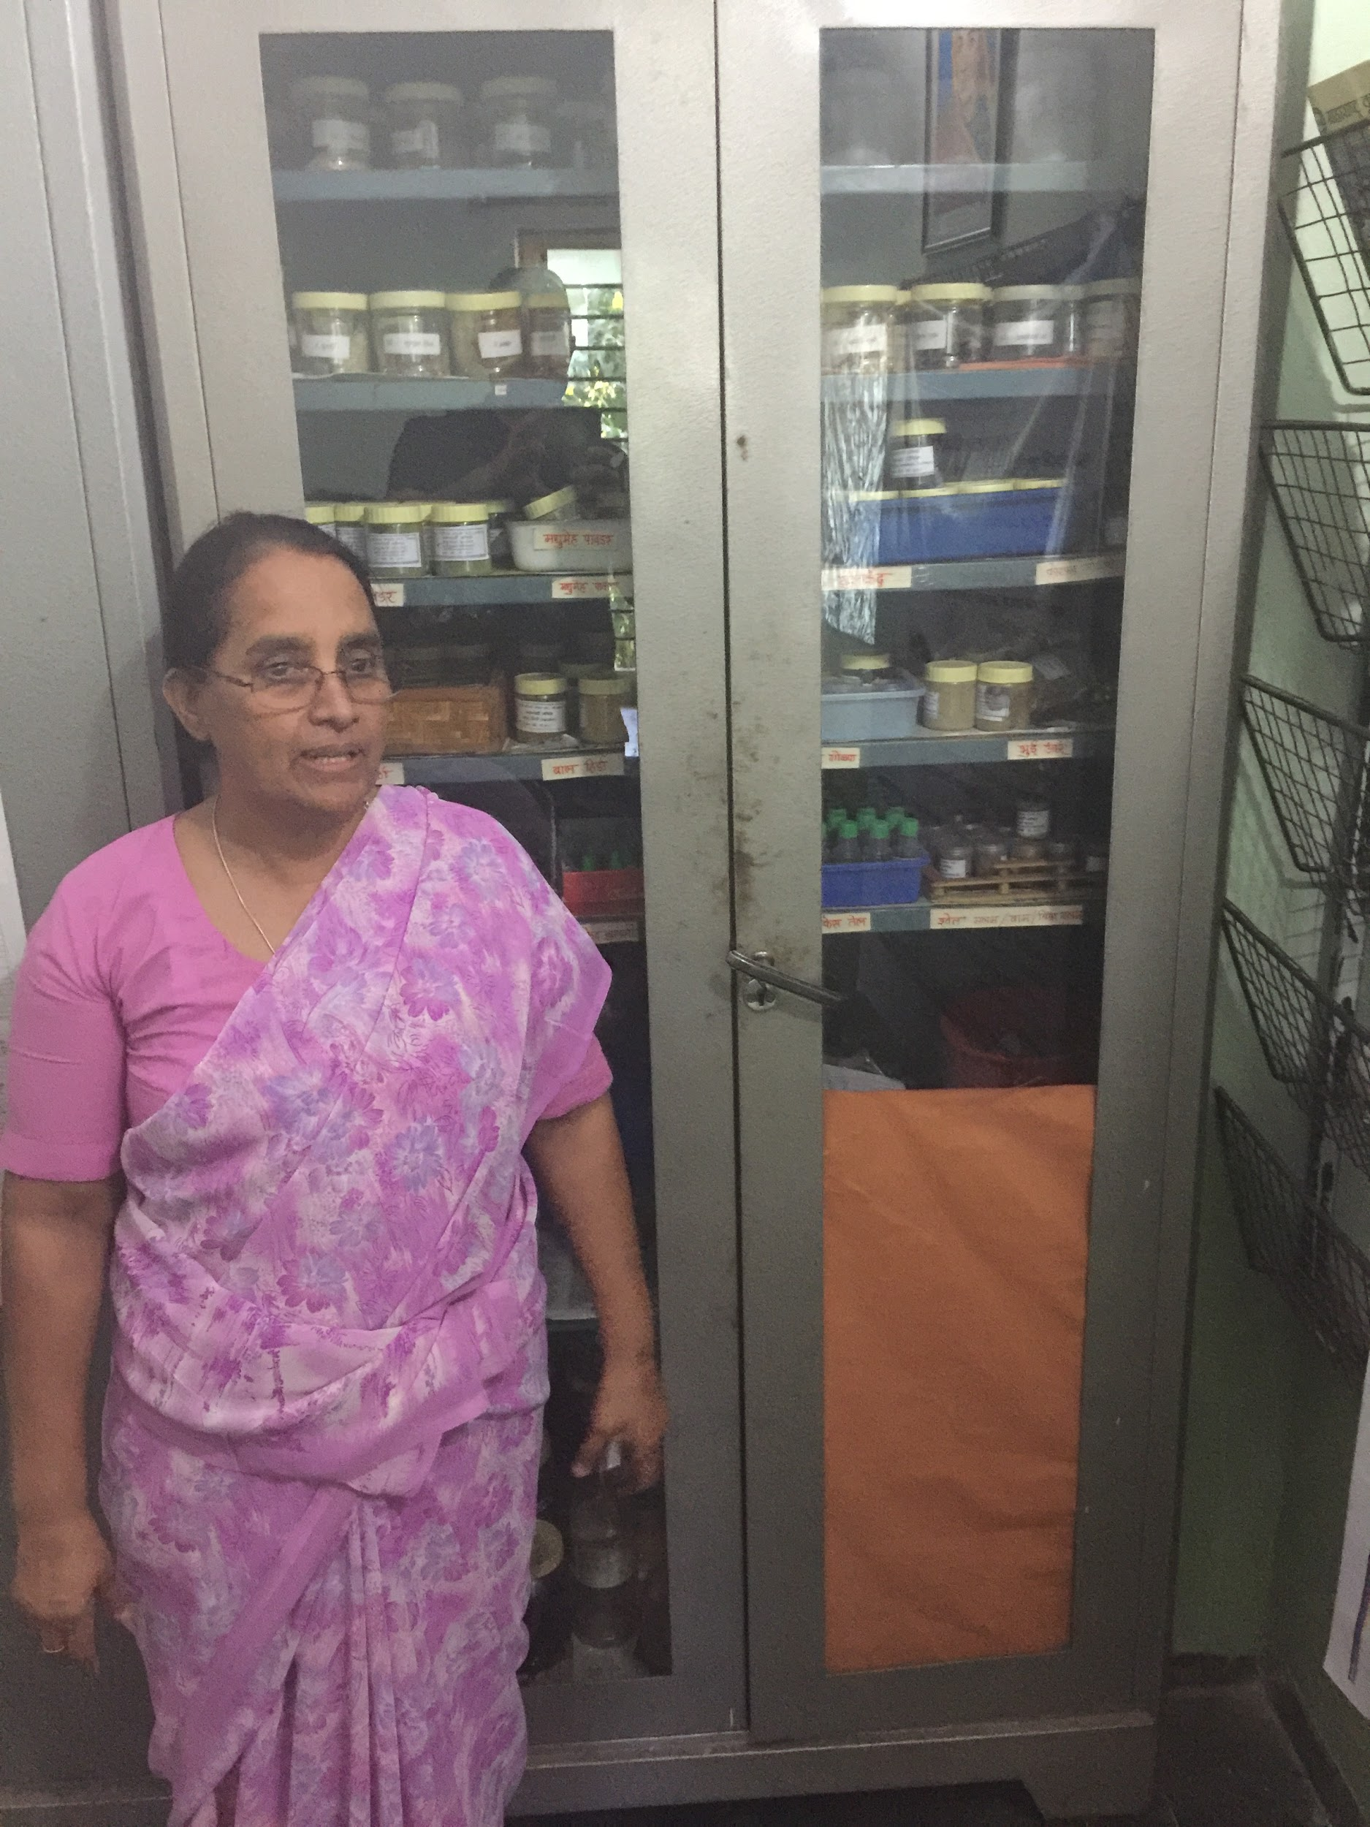

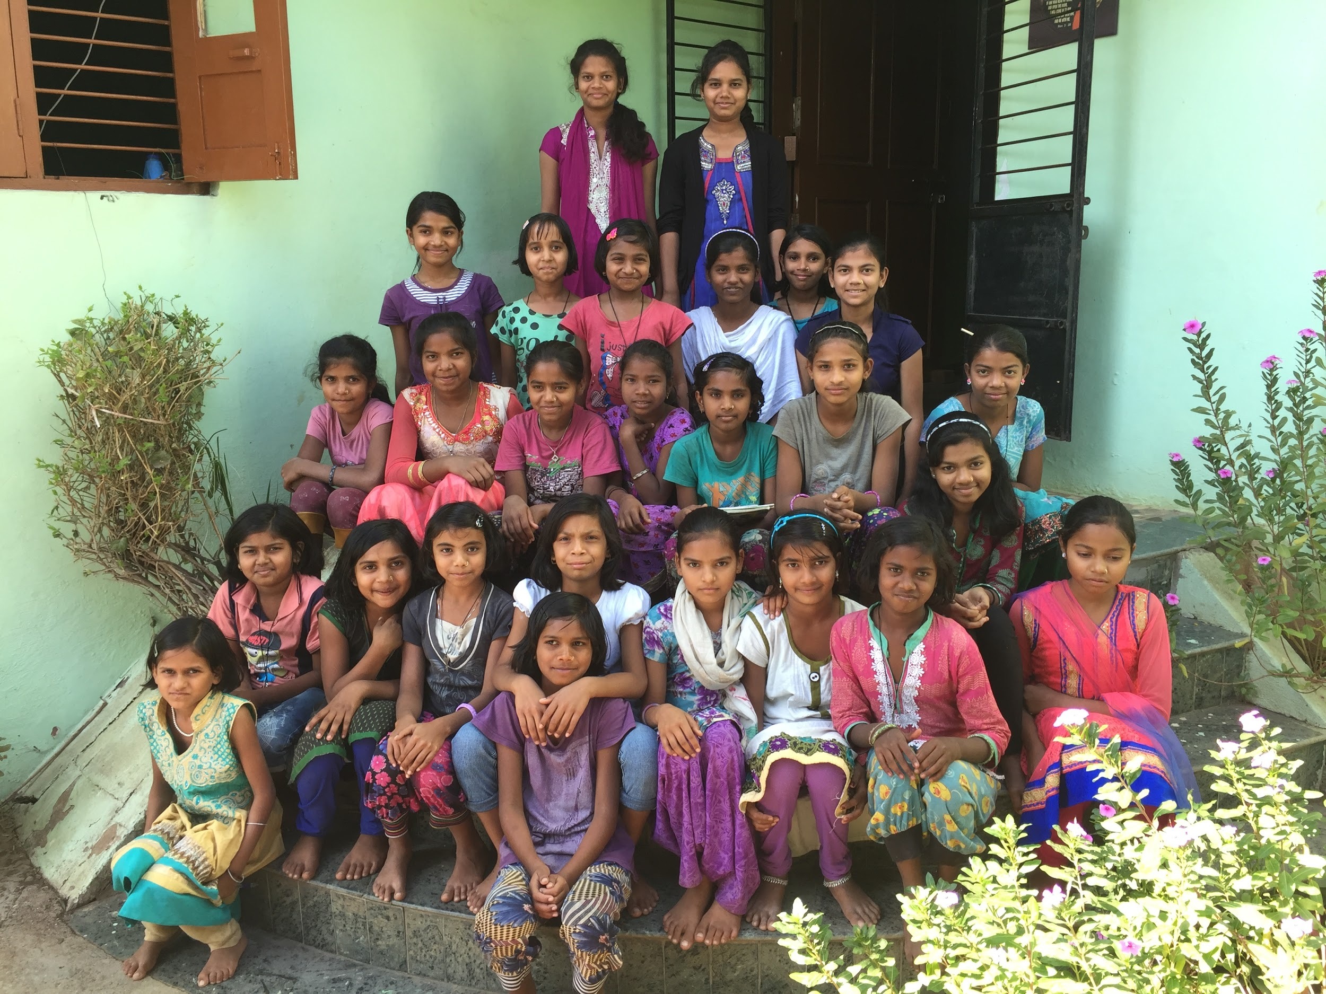

Additional Notes -

- Here are some of the activities available for the girls - Cycling, Skating, Computers for 5-12 standard.
- Total capacity is 75 Girls last year had 90 to manage and on top of that had to reject 20 based on deserving criteria.
- They grow Herbal medicines on campus. Train girls on how to prepare herbal medicine with the help of a Vaidya who visits the campus once a month. They prepare total 56 different types of herbal medicines. Also try to sale those medicines with the help of the Vaidya.
- They charge total Rs 3000/- per girl per year as fees.
- All Sanitary needs are provided by the hostel for the girls.
- Mobile phones are available for girls for Communication with parents. Each day a different group of girls have designated time to use and communicate with parents.
- Girls look out of each other as well as for any wrong doing by any girls. In one case reported by the girls one of the girls had to be sent back to her parents.
- Neighbors around the campus are really good and very supportive of the hostel and the cause.
- Sunday the girls have sewing classes.
- Sunday girls cook the food.
- Here is a sample schedule for the girls on a daily basis -
- 5:30am - get up and get ready followed by Yoga taught by two girls, cleaning, Breakfast, Gardening
- 8-10am Classes
- 10am get ready to eat
- 11am School
- 5-6:30pm Eat and play in campus
- 6:30-7:30pm Study with Senior Girls
- 7:30pm Dinner
- 8:30pm Young girls - time to sleep
- Older girls study till 10 pm
- 10pm Lights out for campus.

We then arrived at Jan seva accompanied by Father Jeevan.

Father Jeevan gave us a tour of the facility including offices, boys’ residence, kitchen and entertainment/study room.

The art projects, puzzles and stories written by the boys were very interesting.

We then had a chance to meet and have a chat session with the boys.

The boys also sang a welcome song for us.
We asked similar questions to the boys that we had asked to the girls.

Boys hostel building
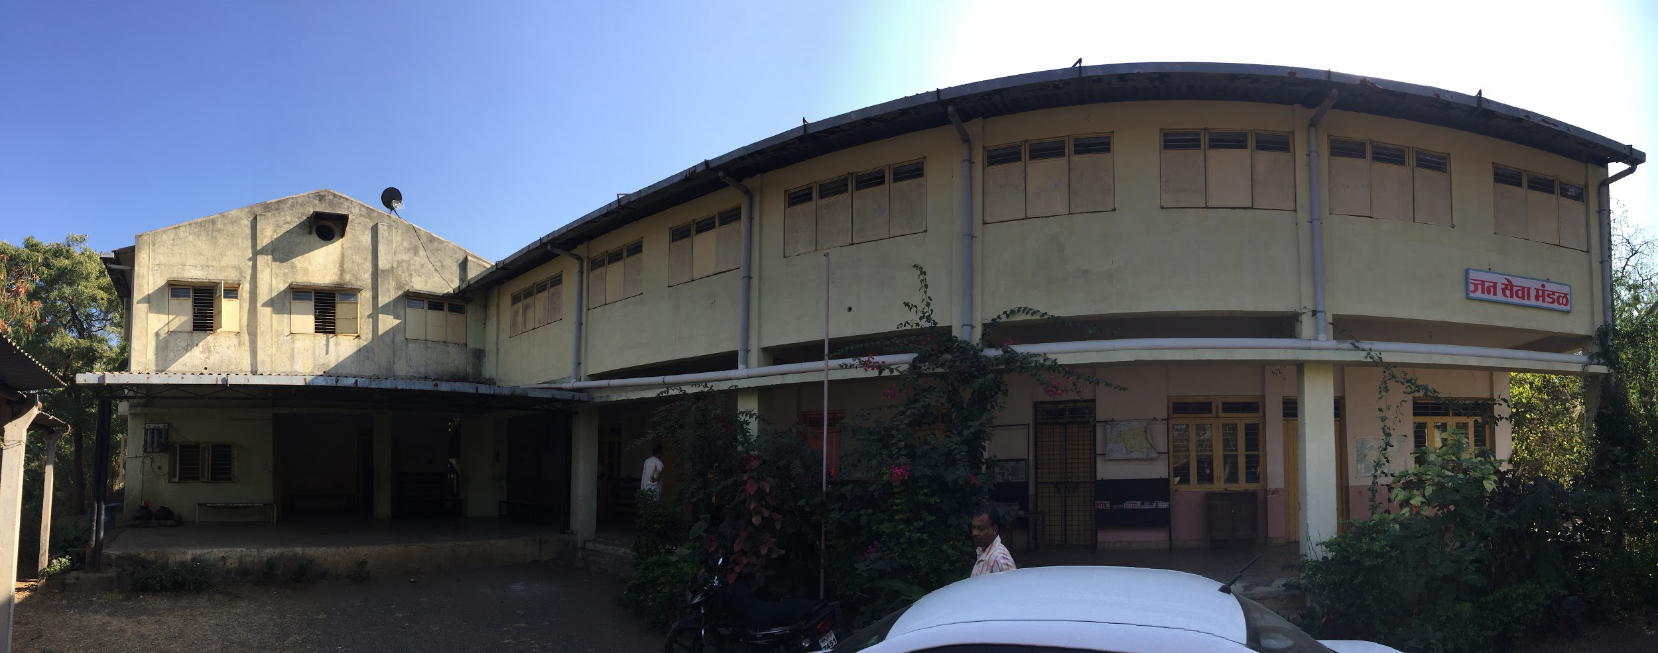

Boys hostel campus
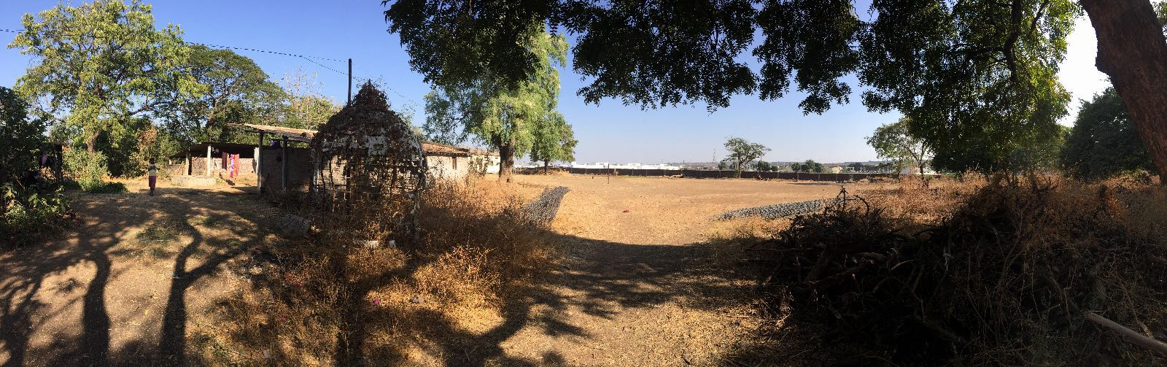

Kitchen with all firewood storage
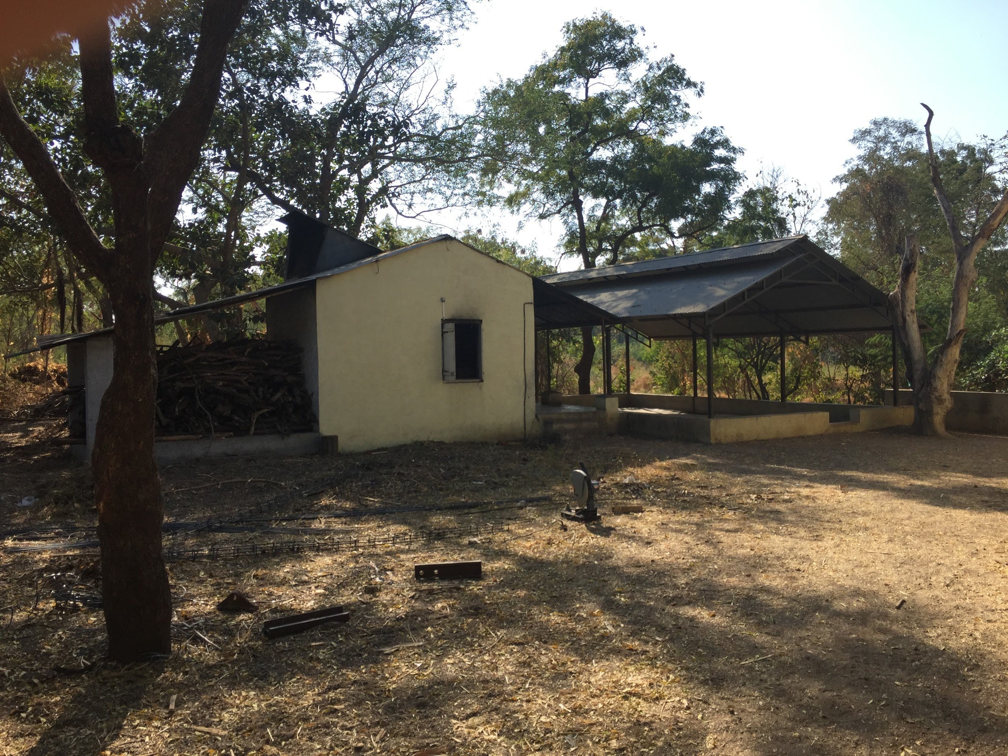

Inside of the kitchen
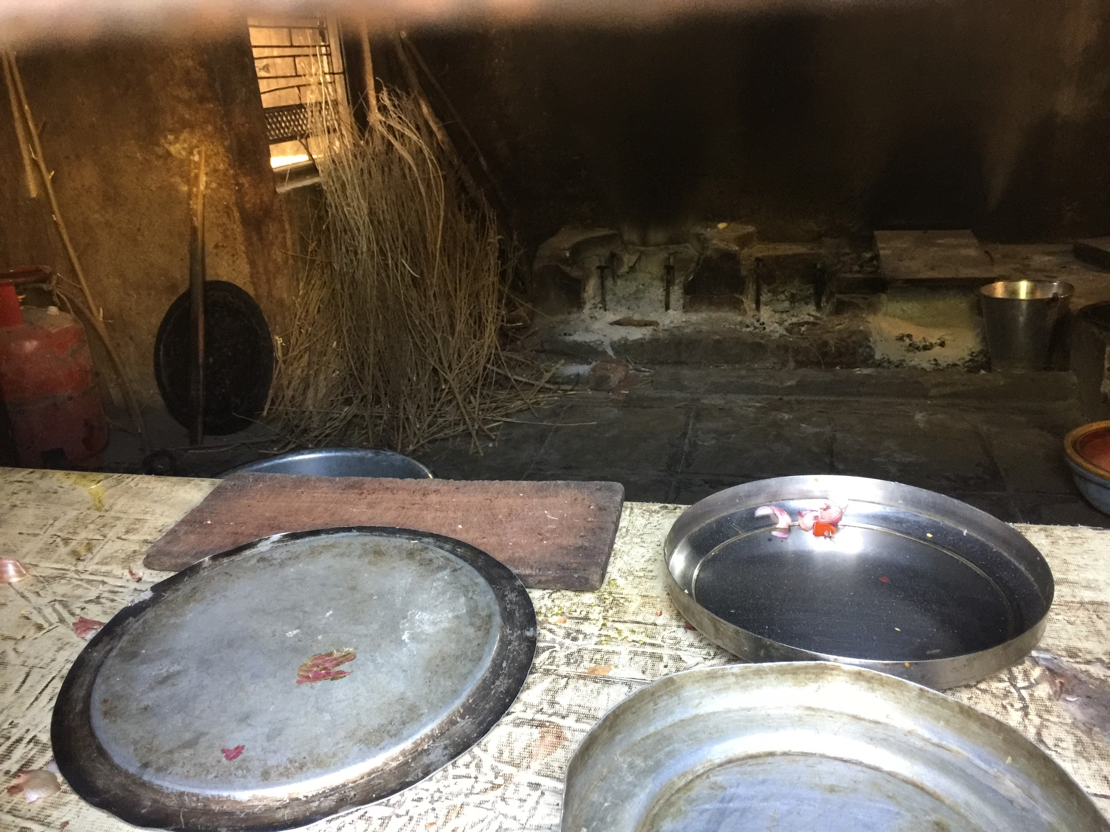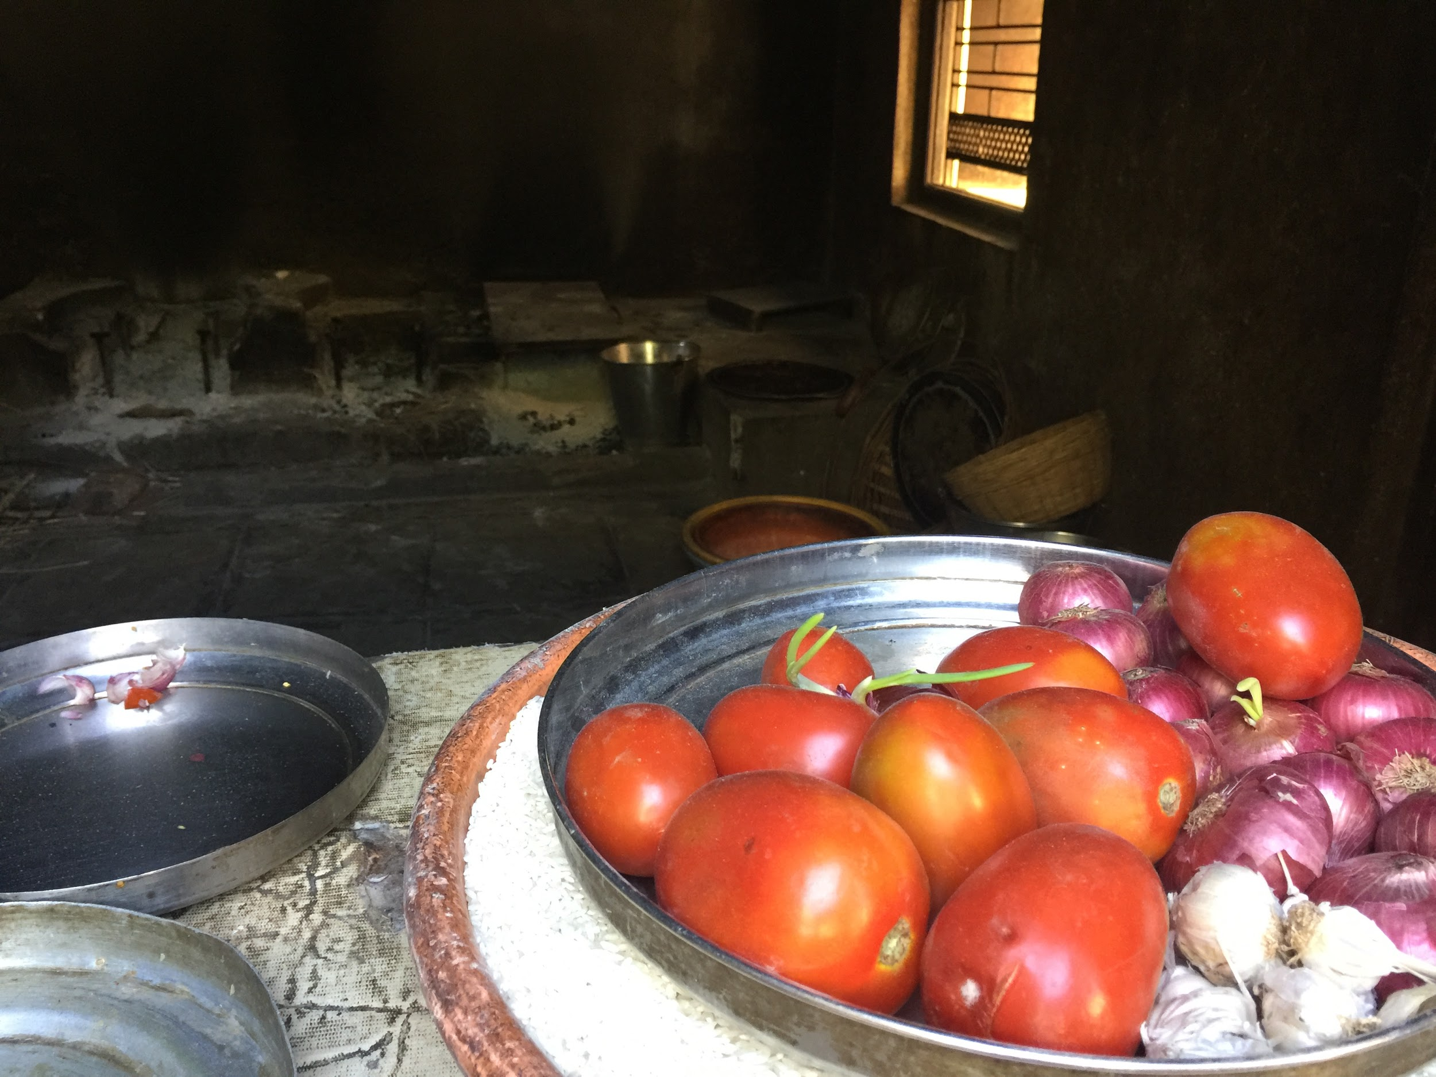

Computer room
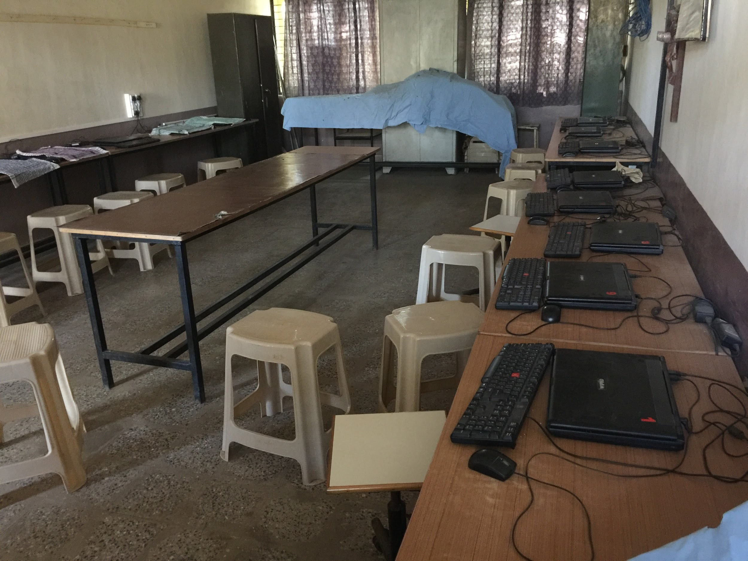

Class / activity room
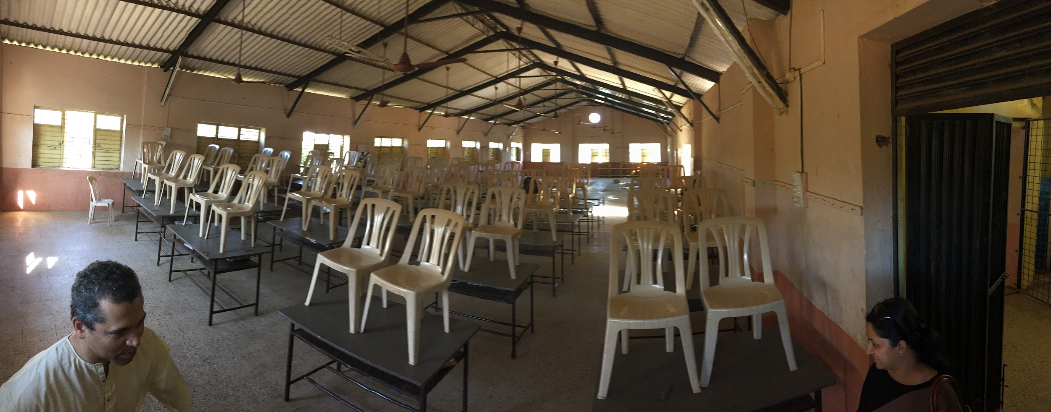

Jigsaw puzzles
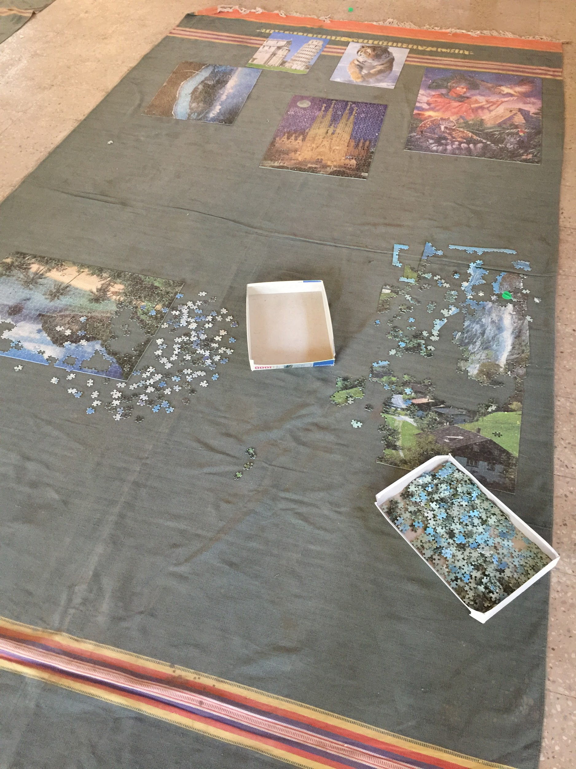

Lego blocks
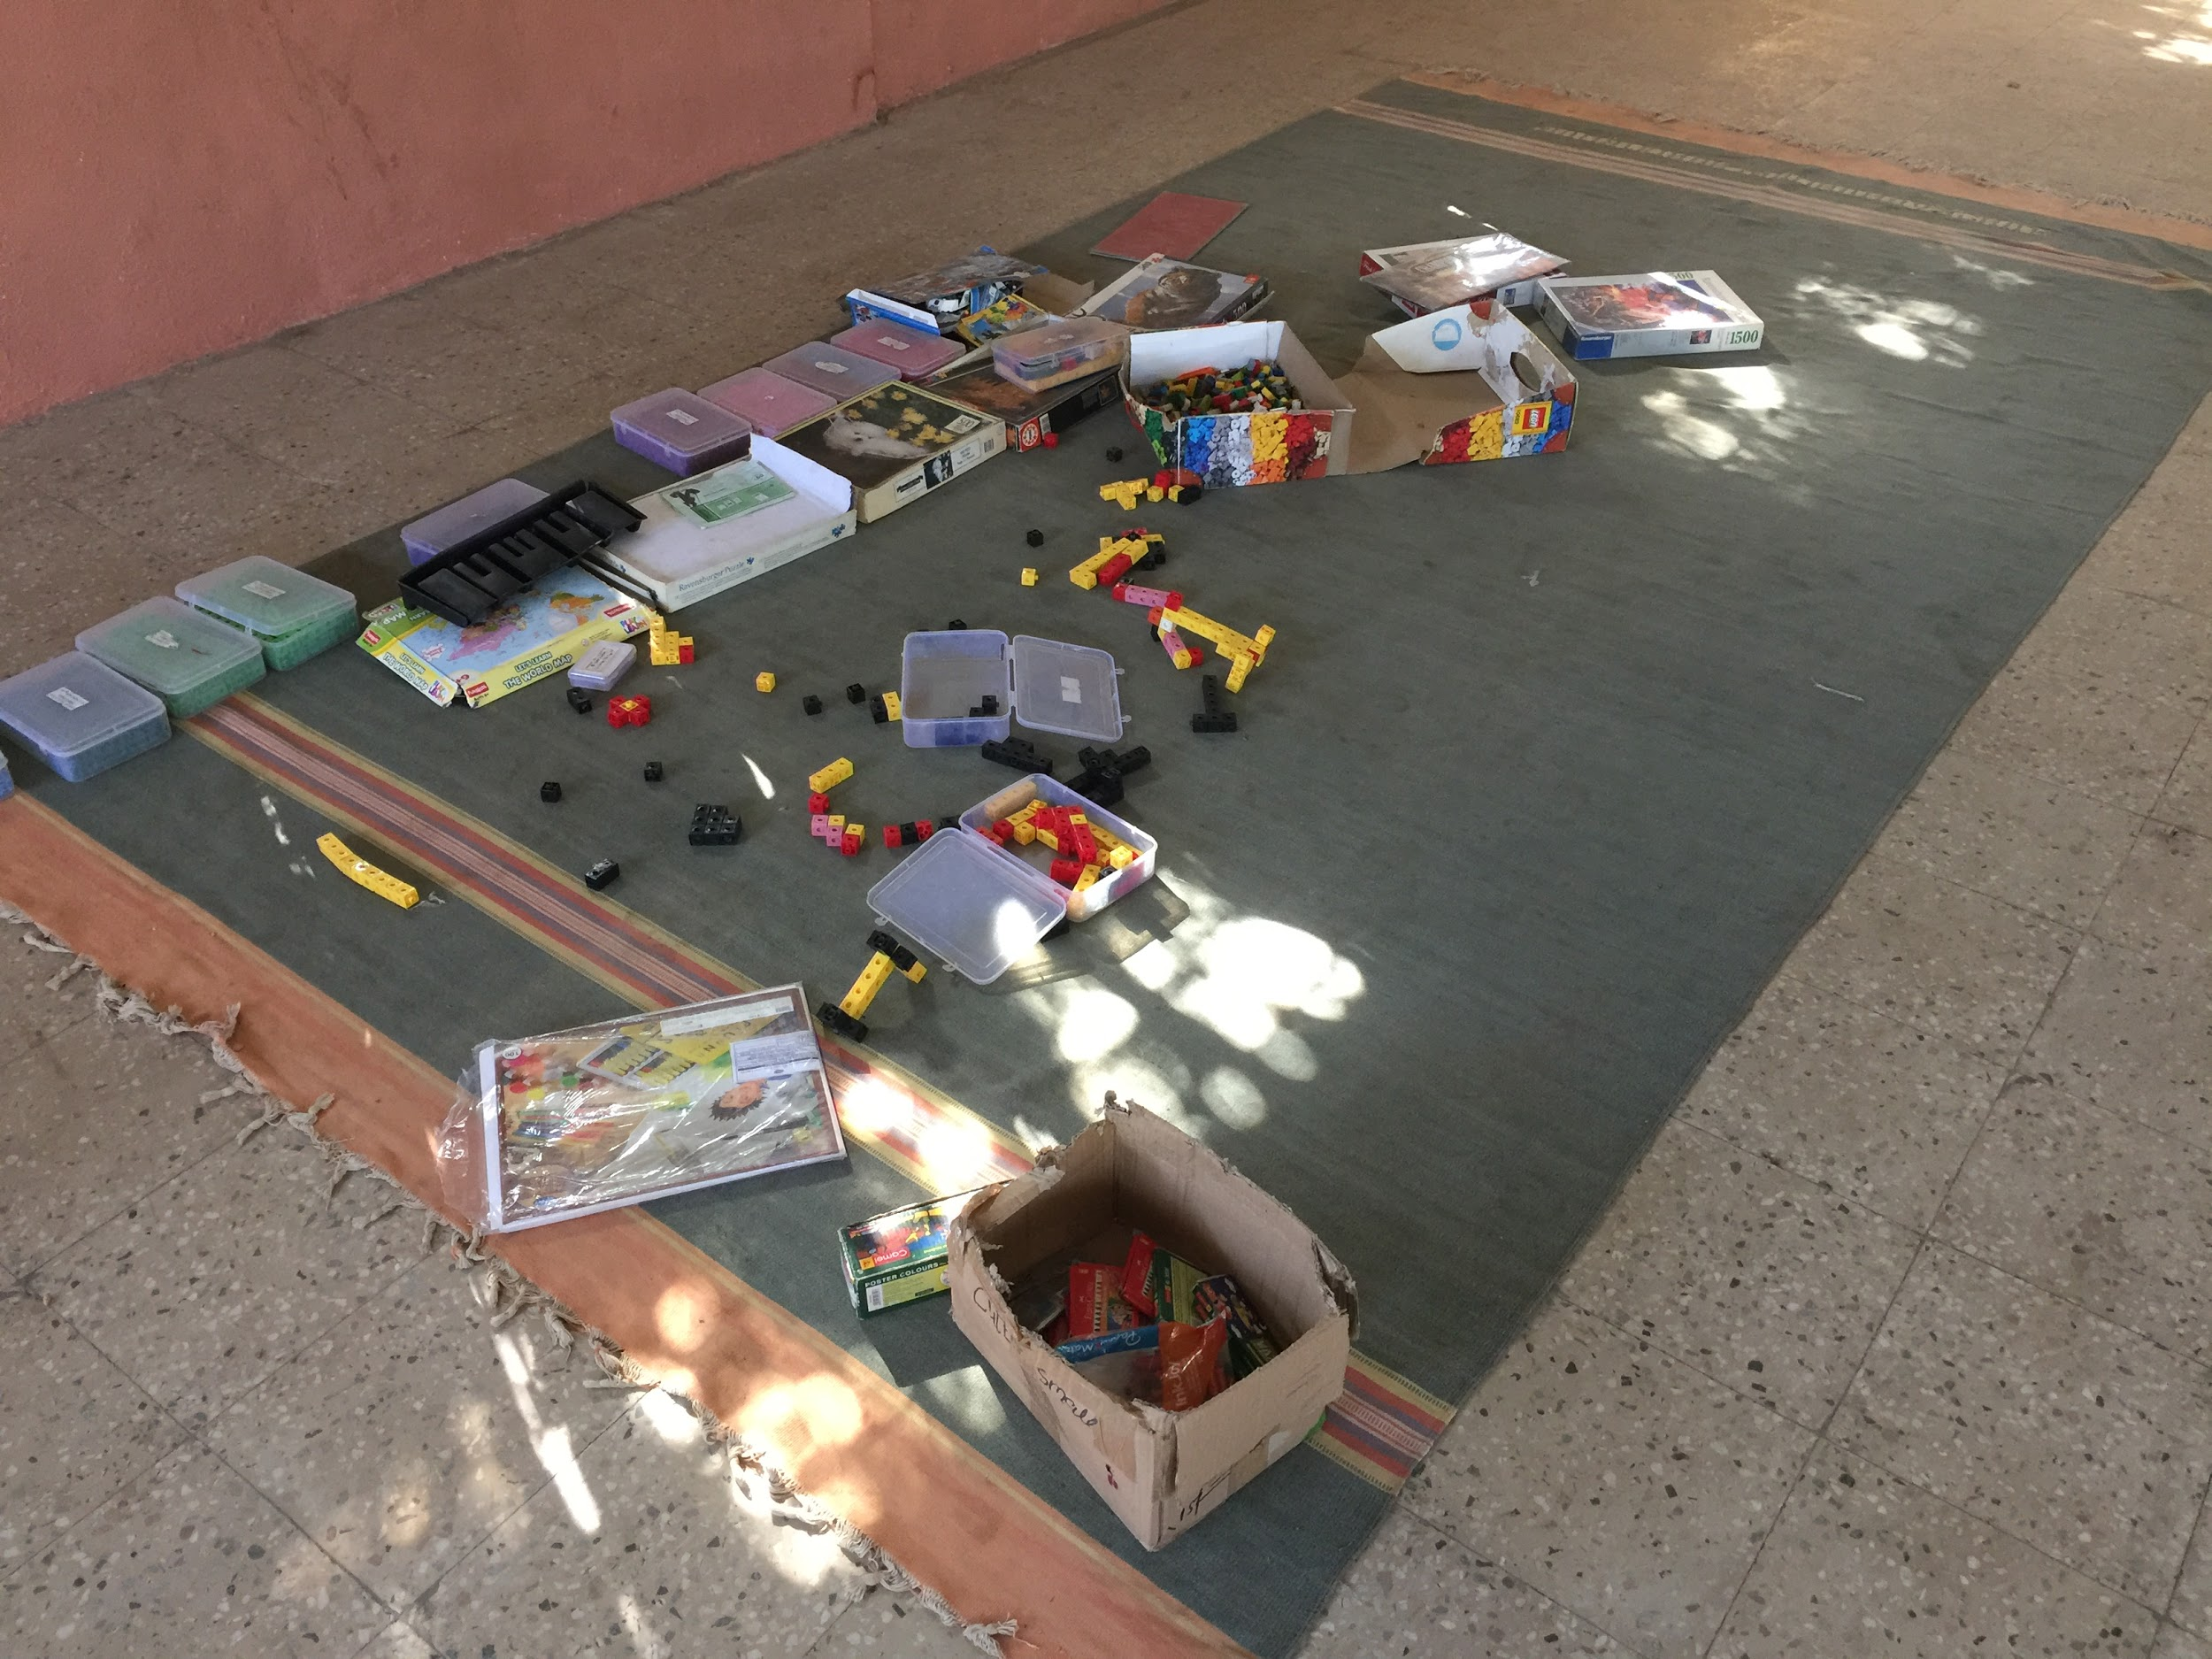

Books for reading
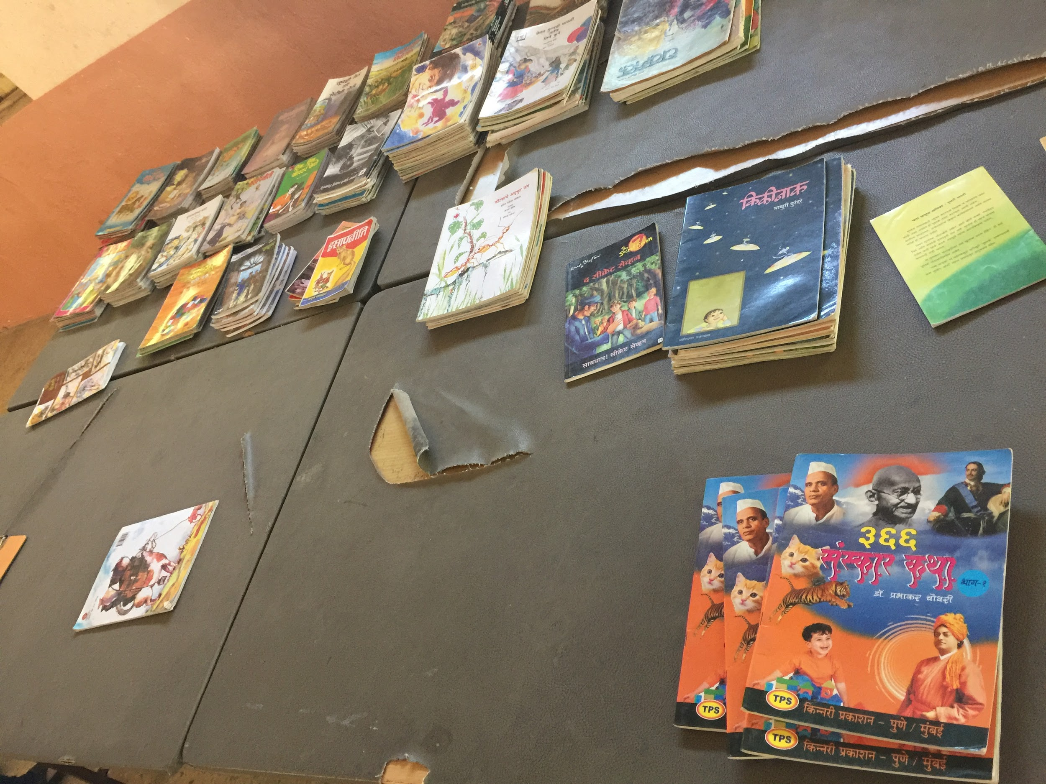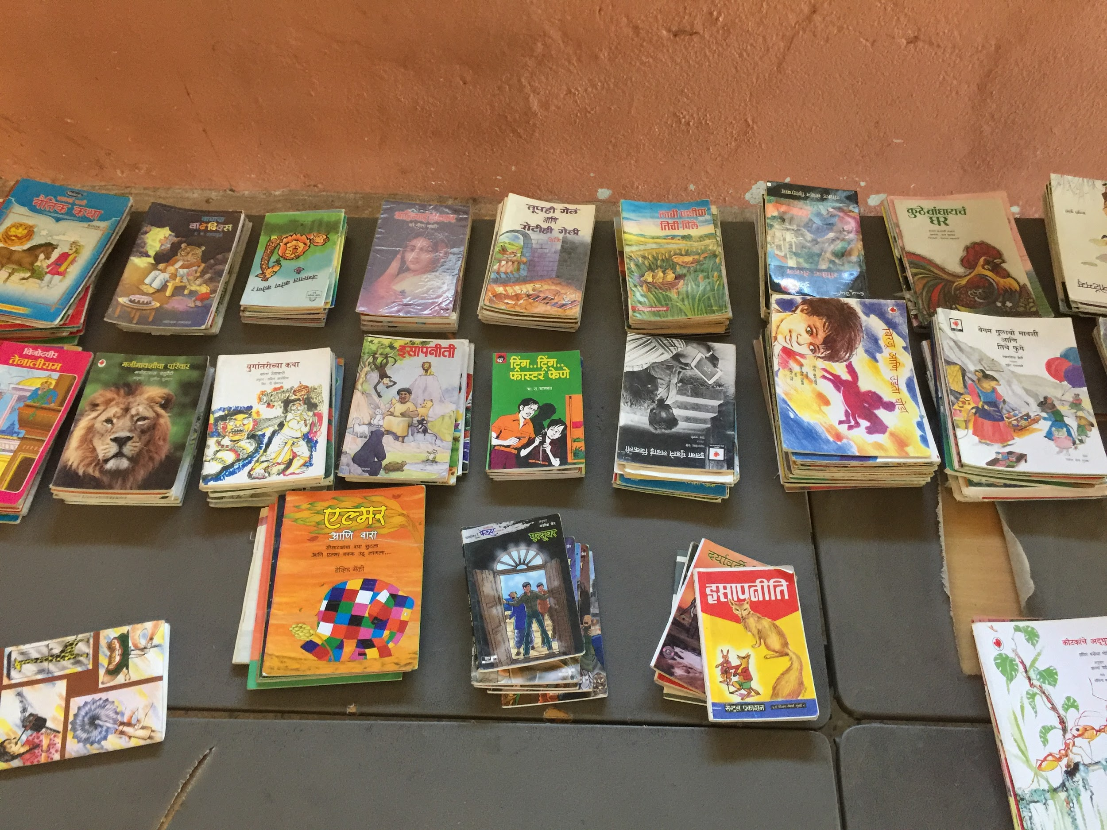

Skipping ropes
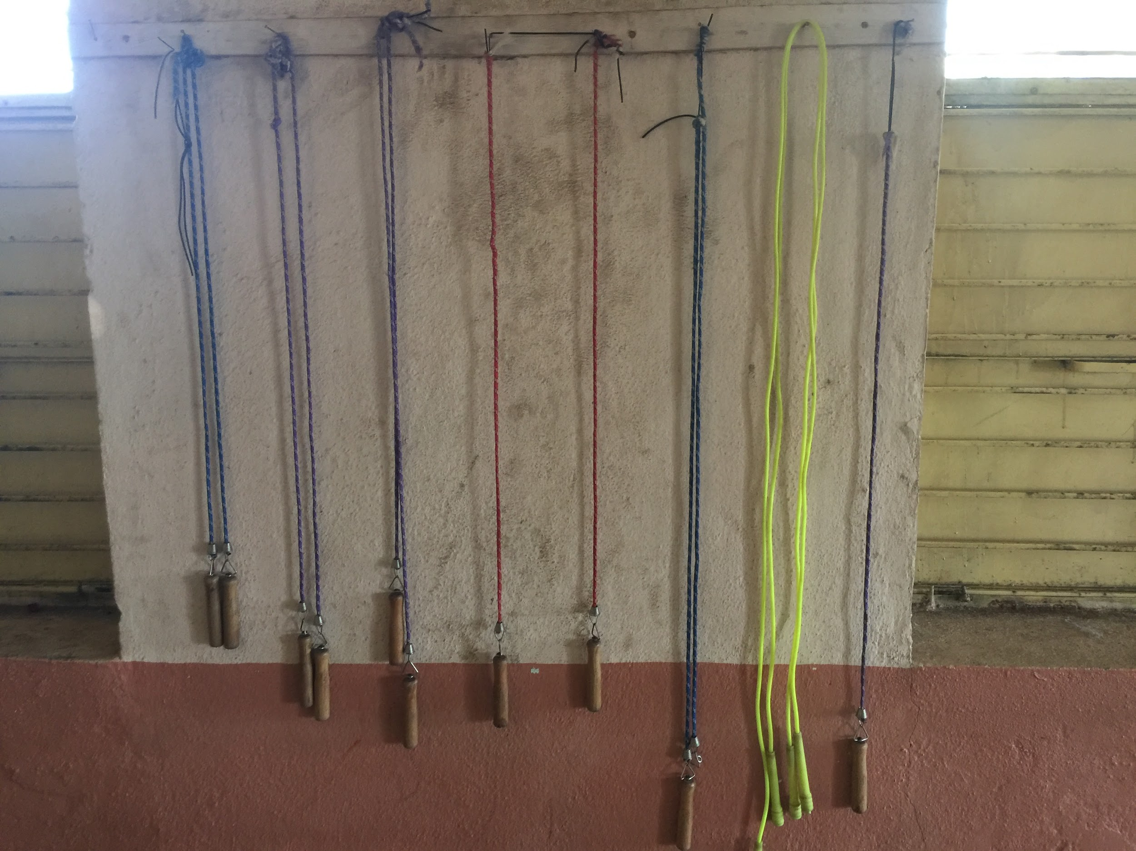

Pictorial depiction of a story by a student with this amazing drawing skills
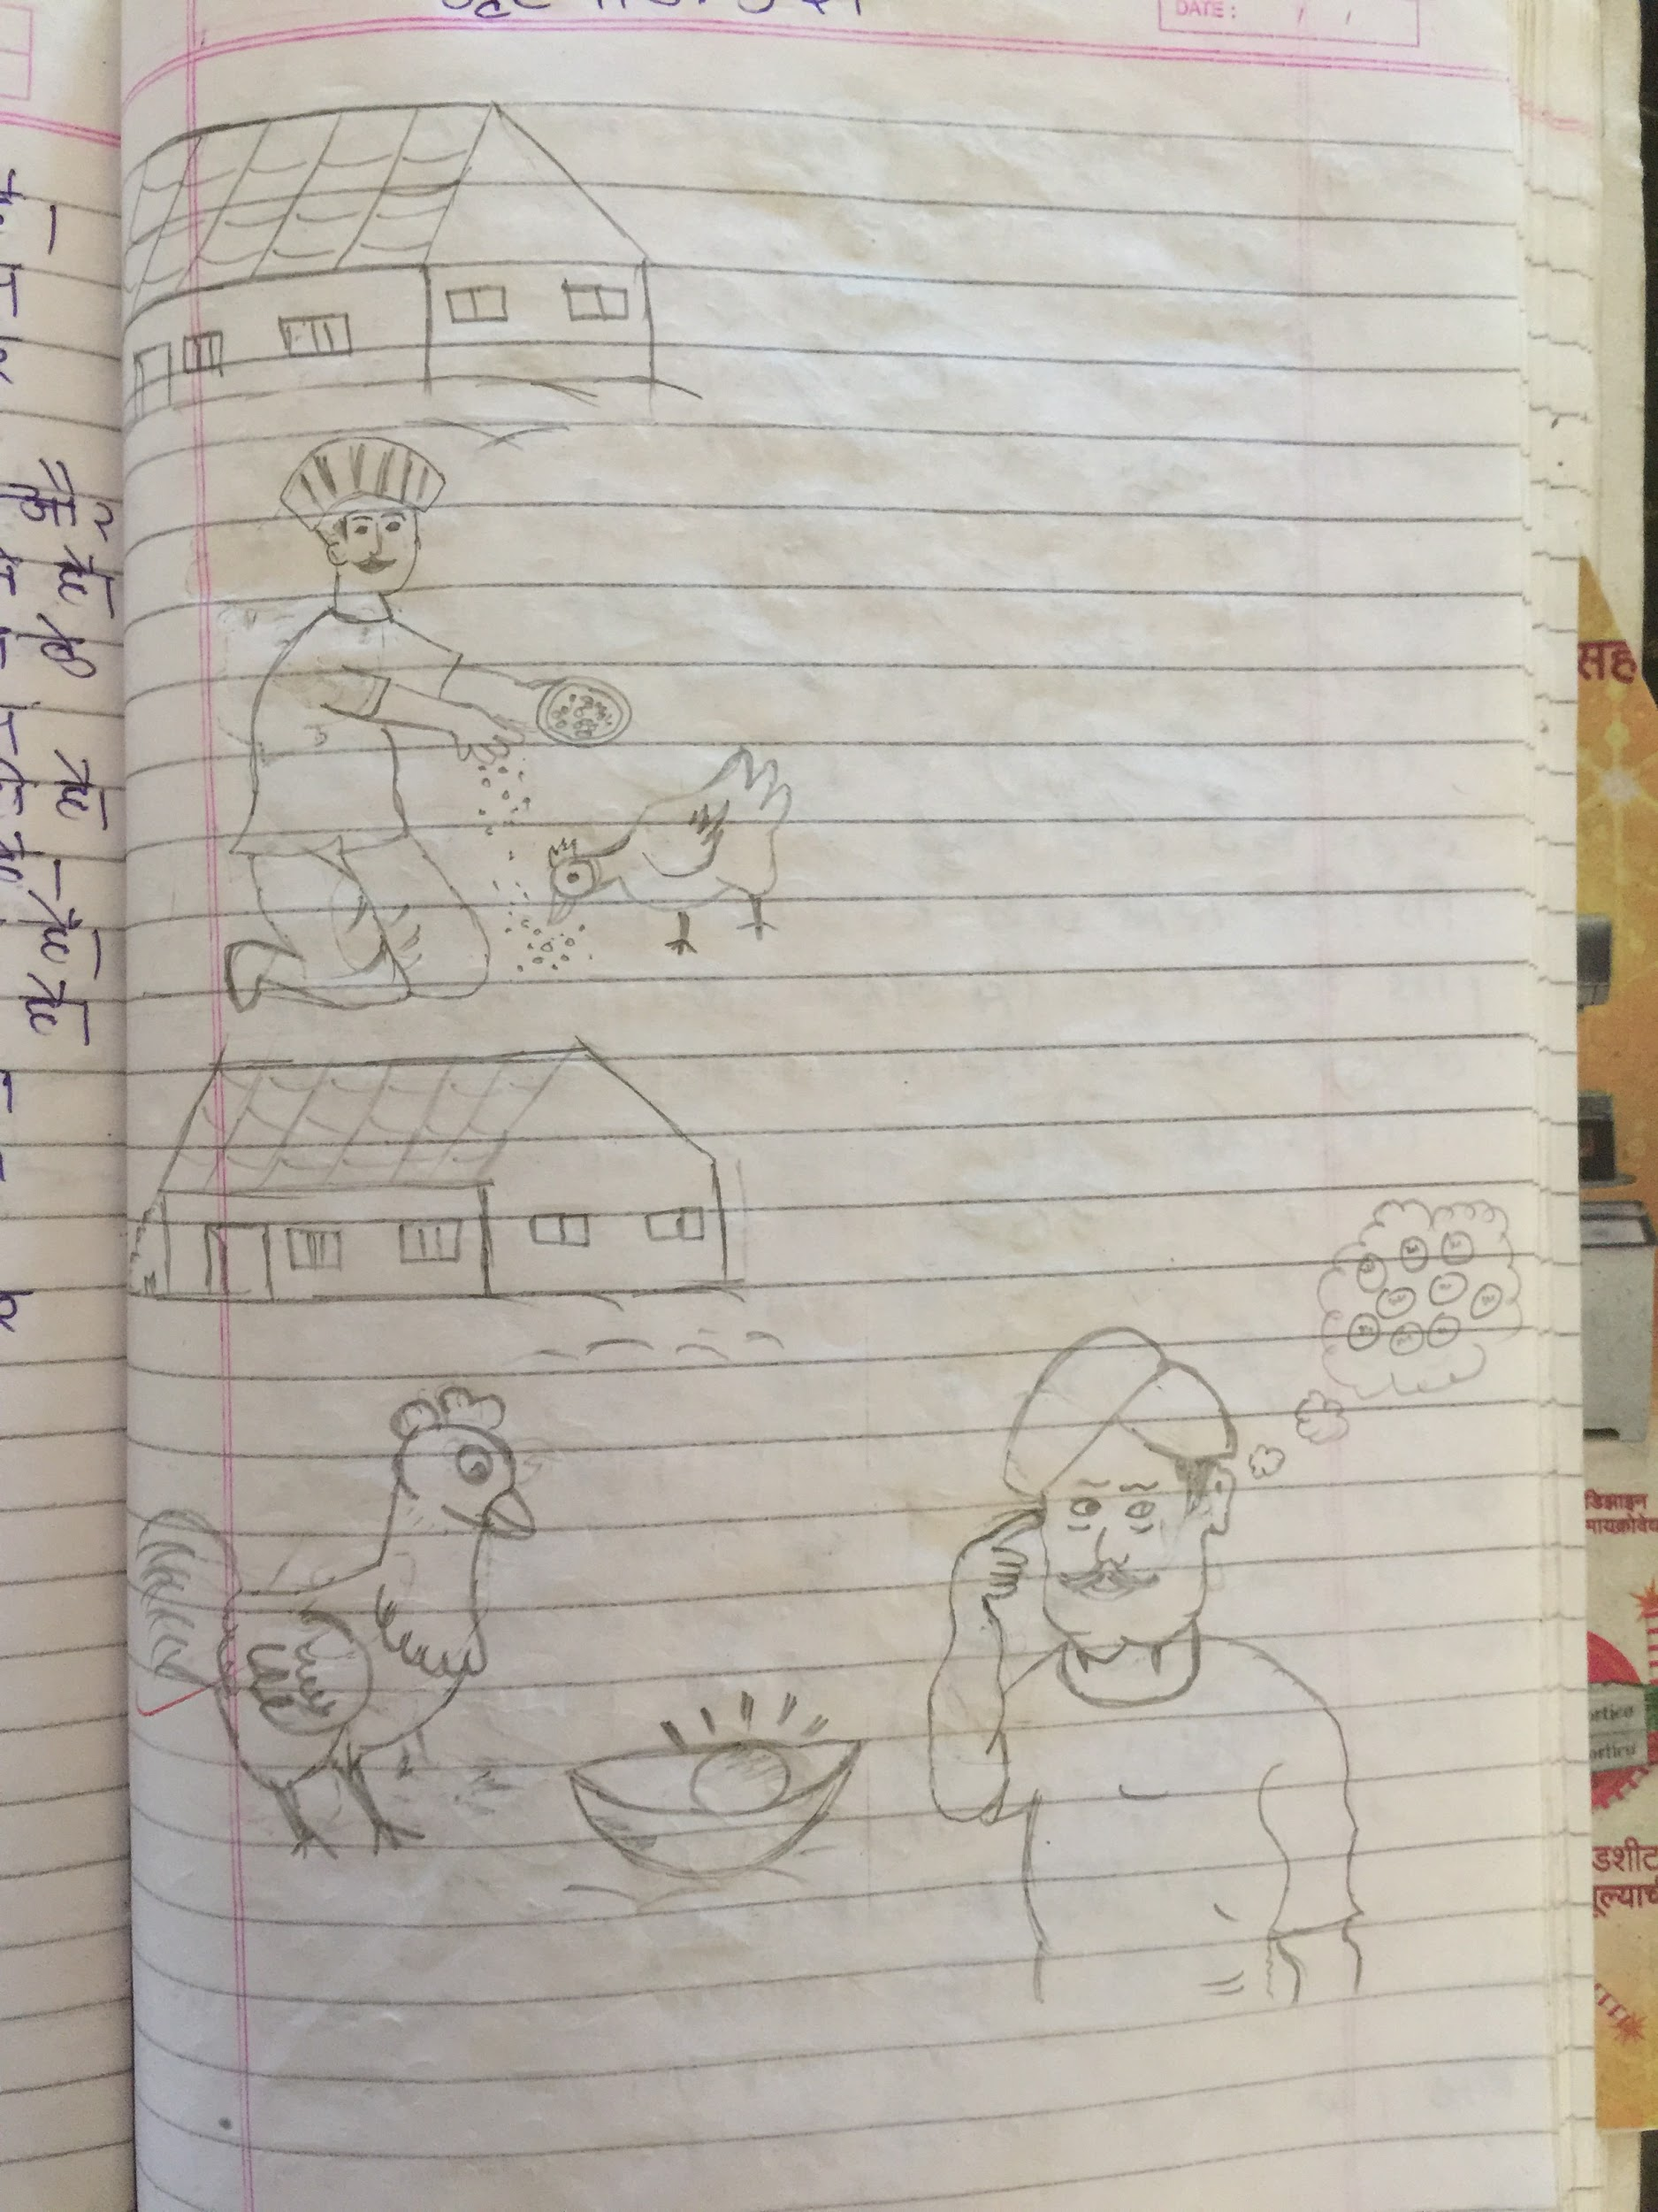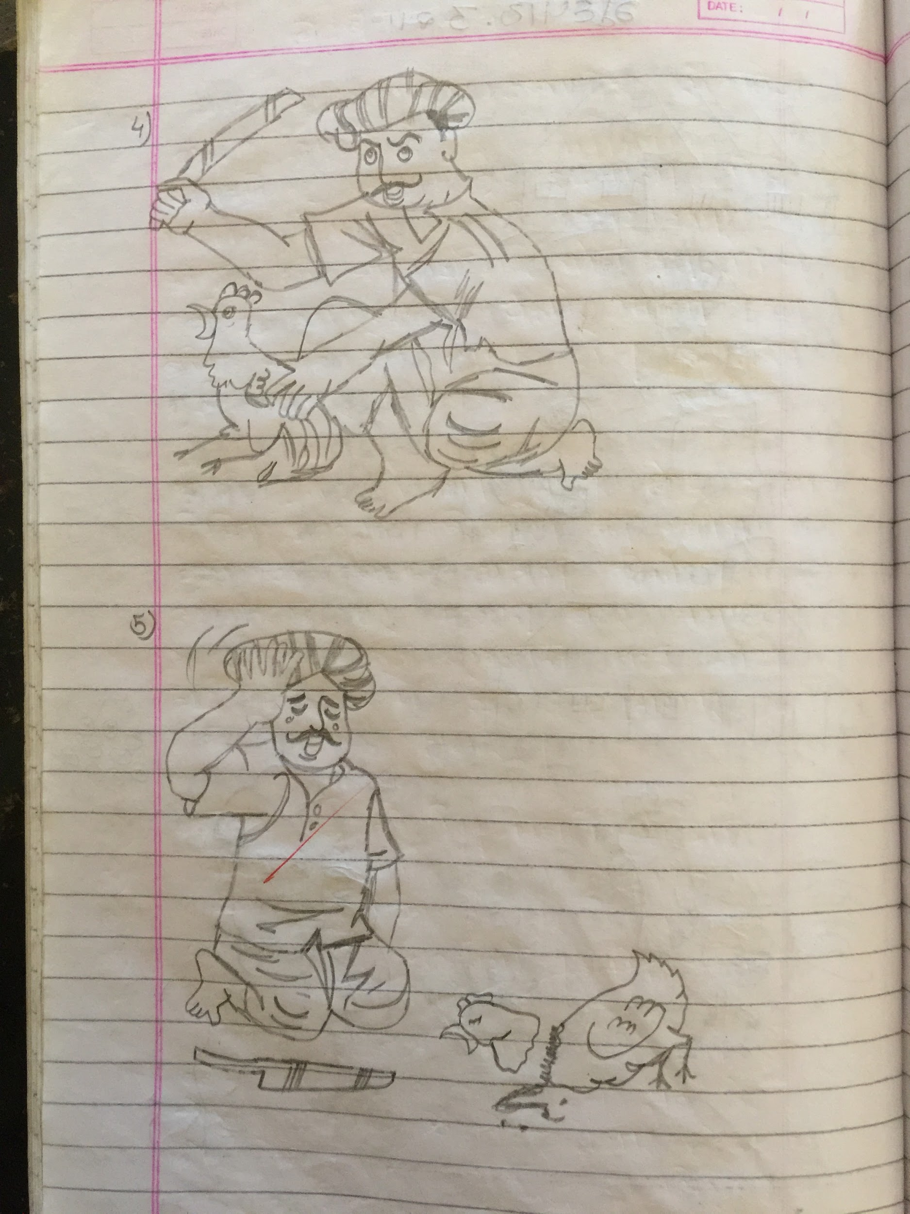

Beautiful handwriting by the same student
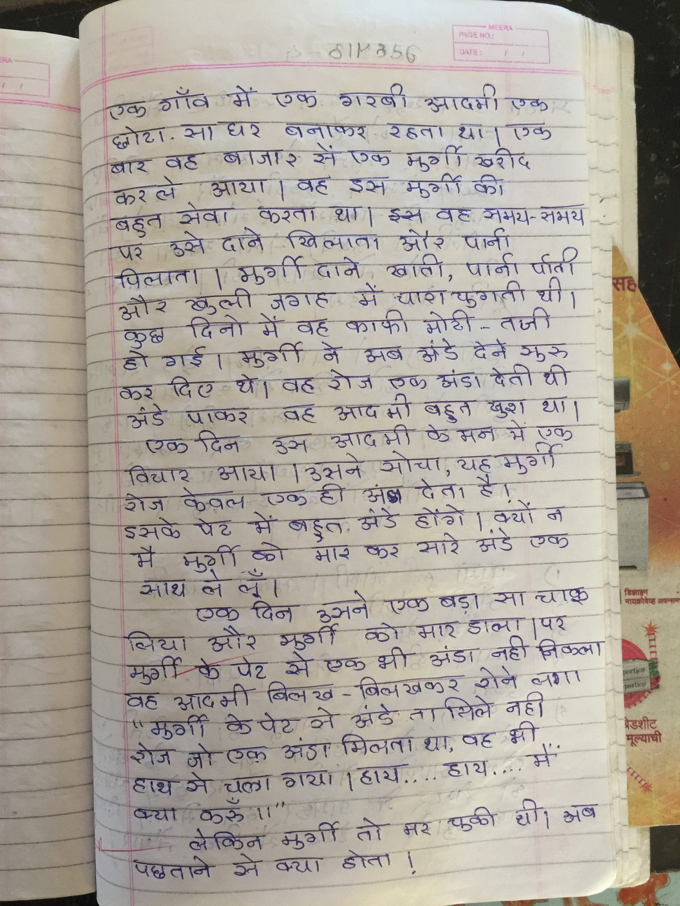

Gathering hall for entertainment with TV
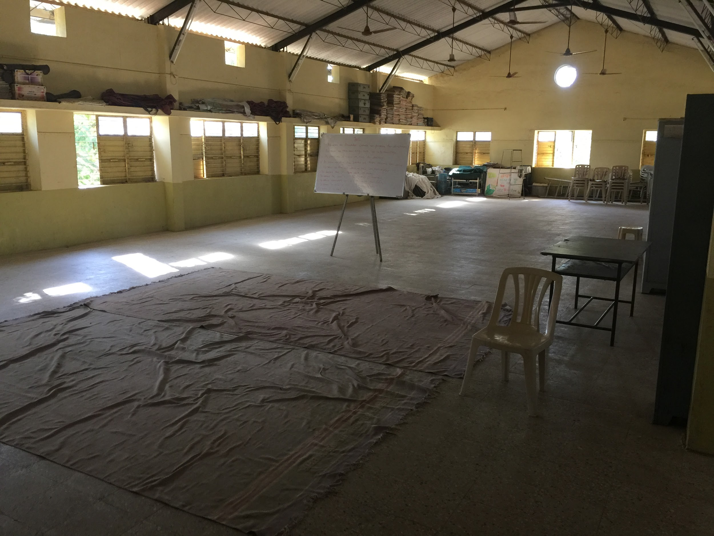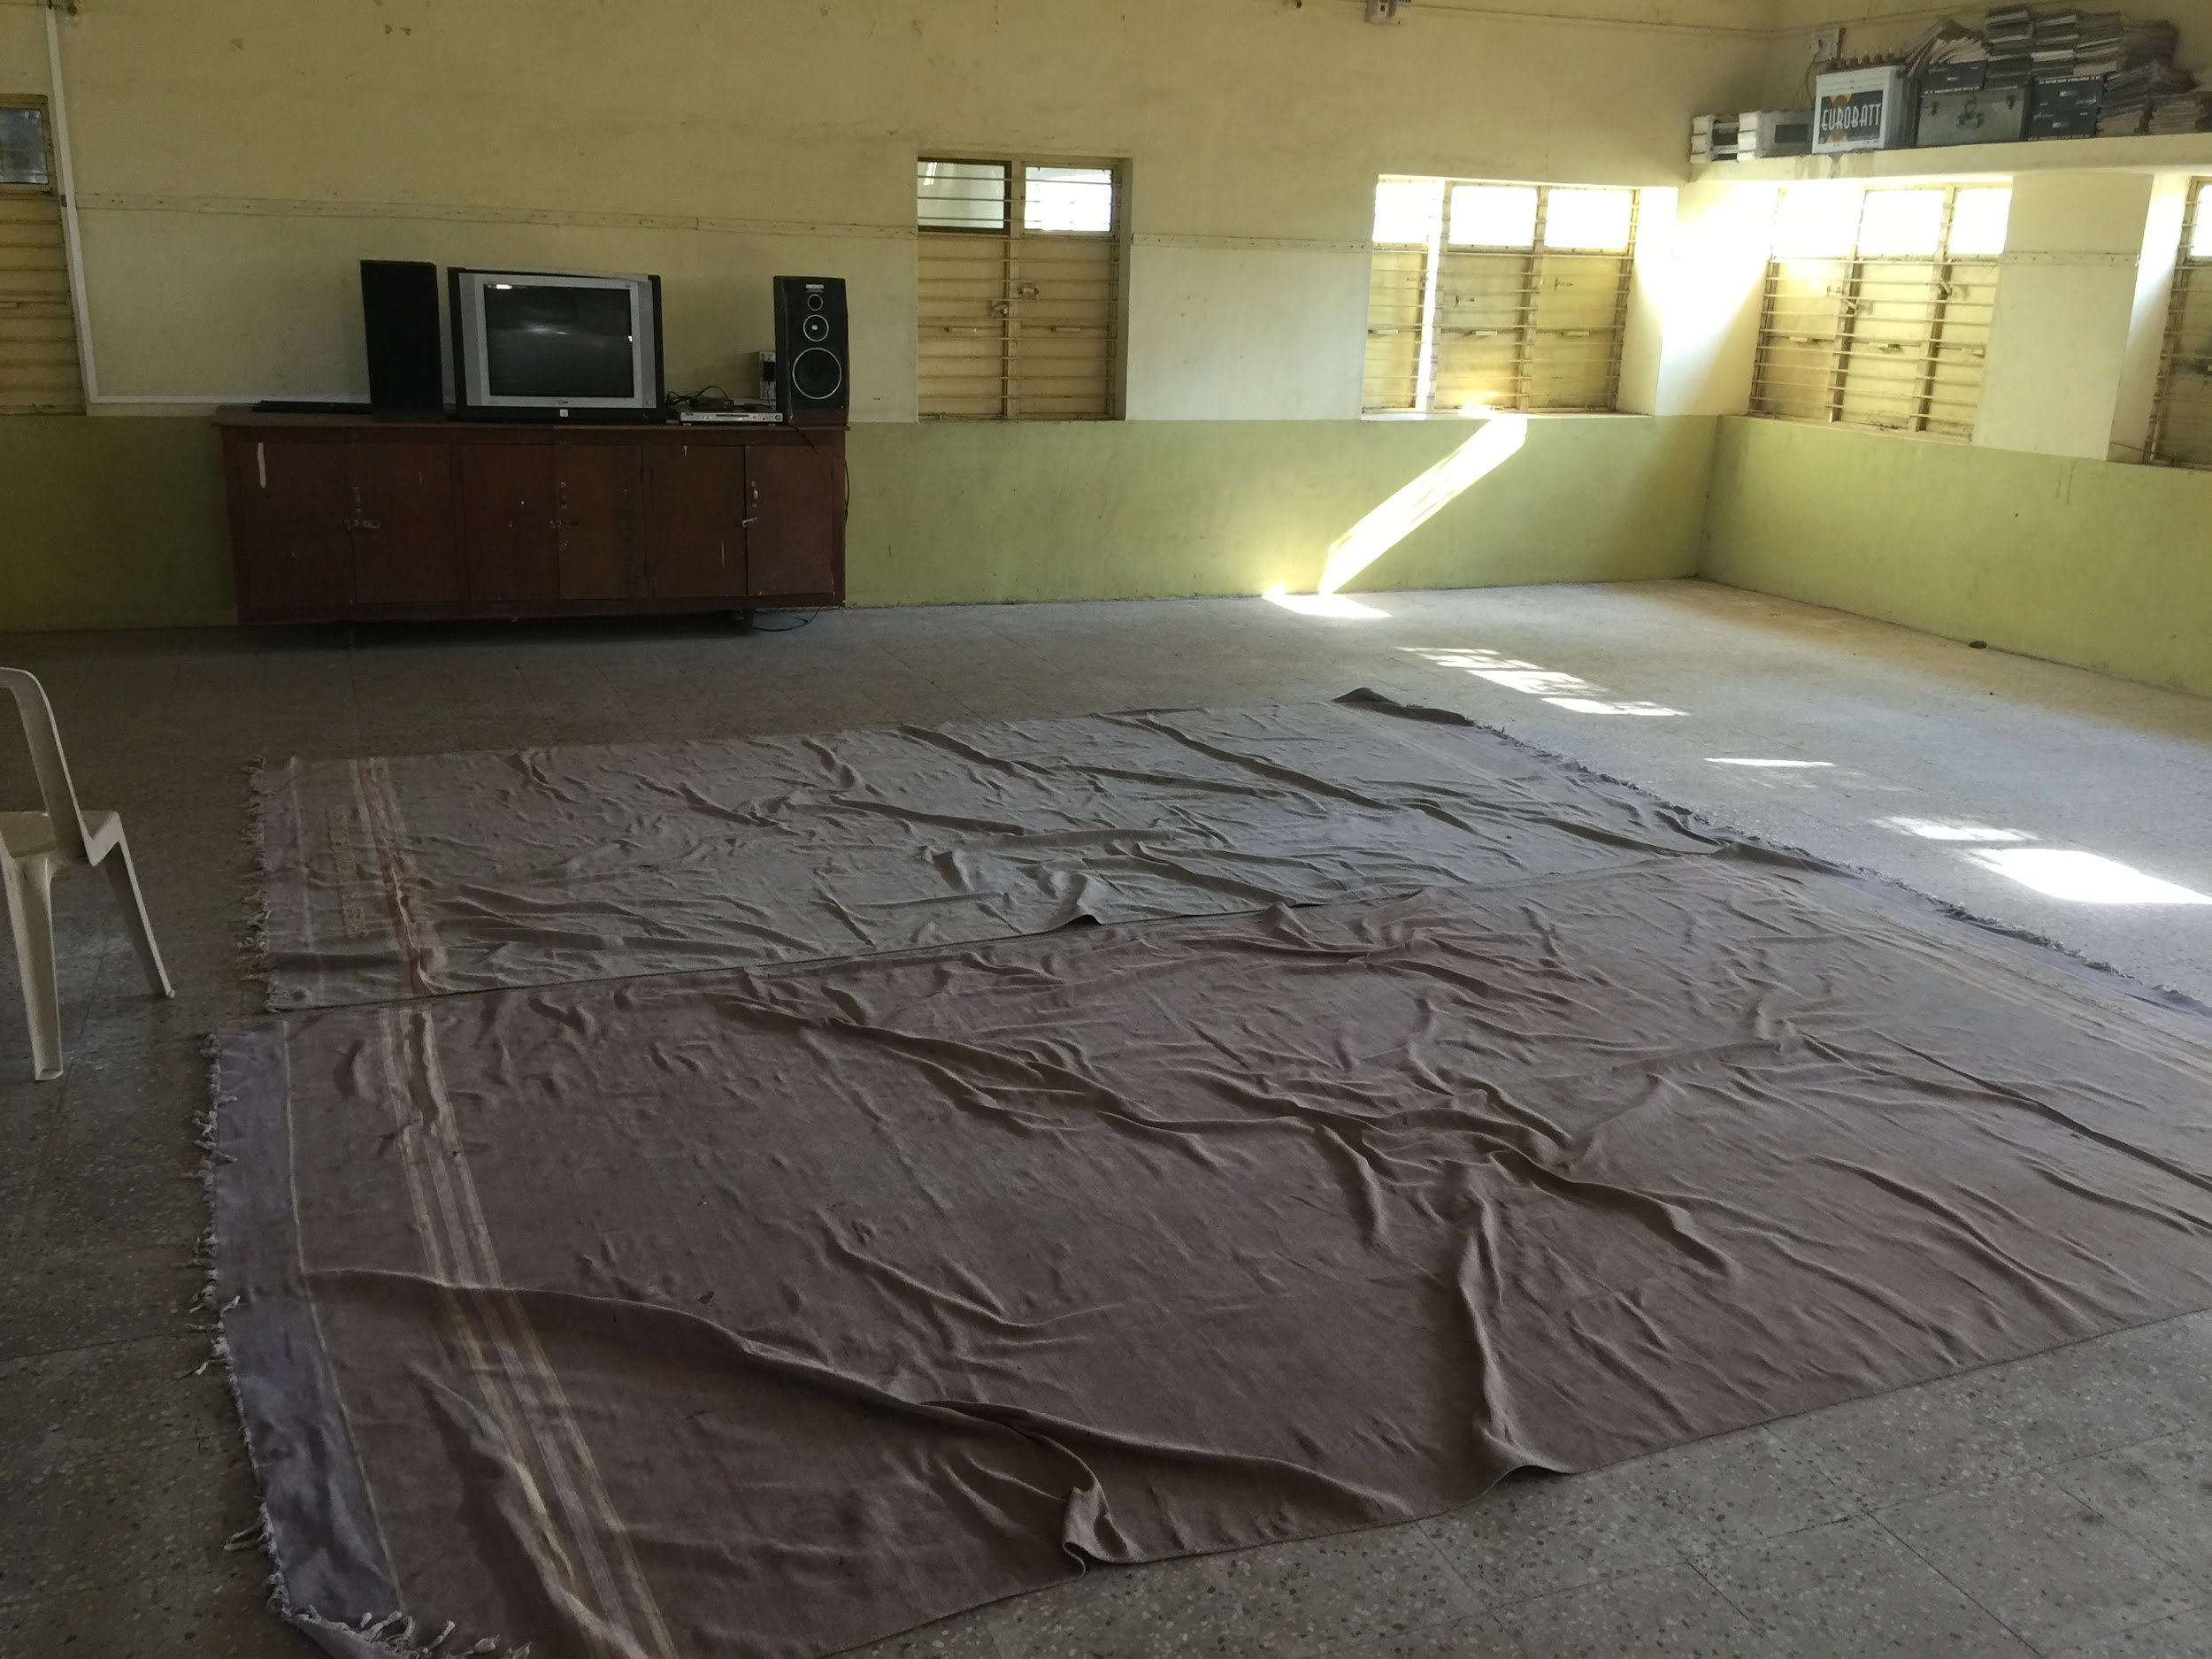

Meeting with students
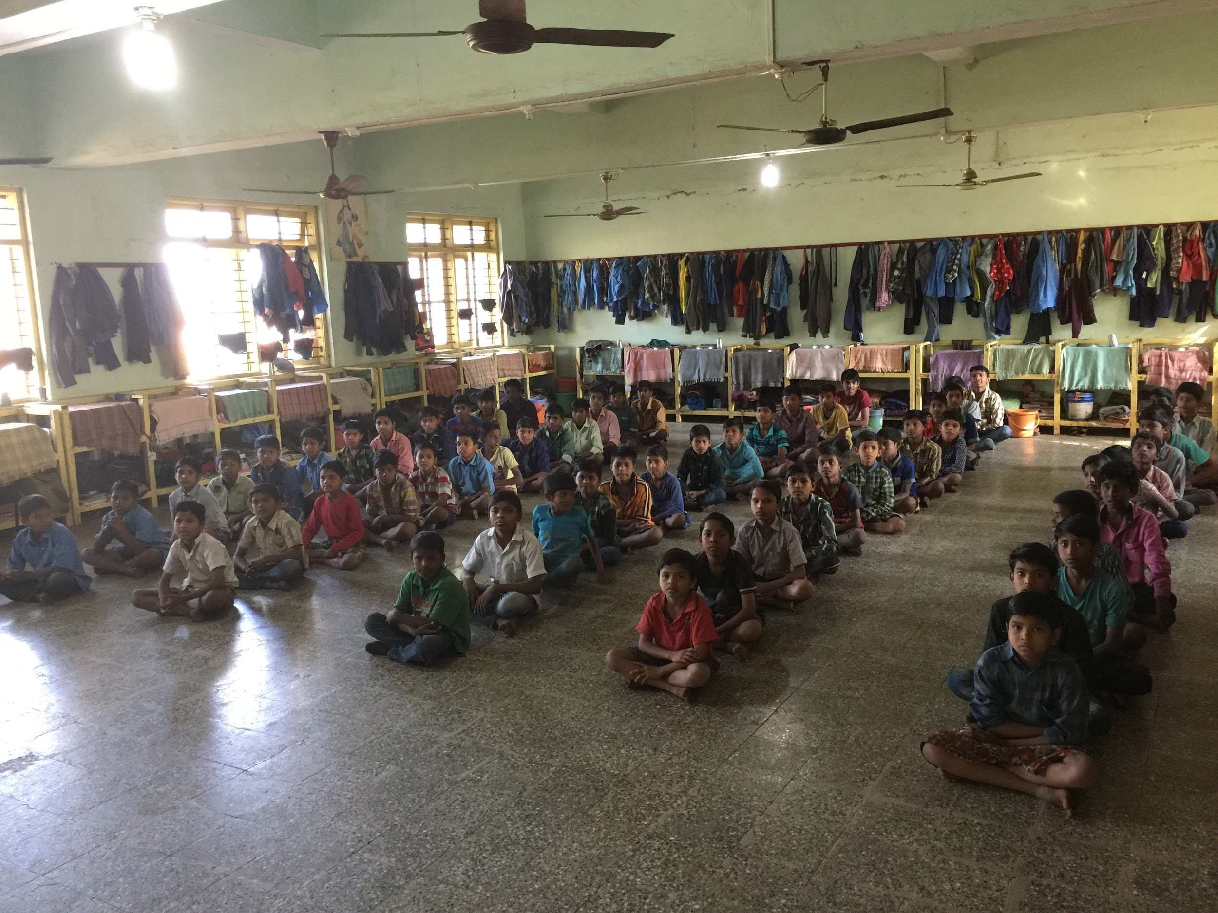

Rahul having a chat with boys at Jan seva -

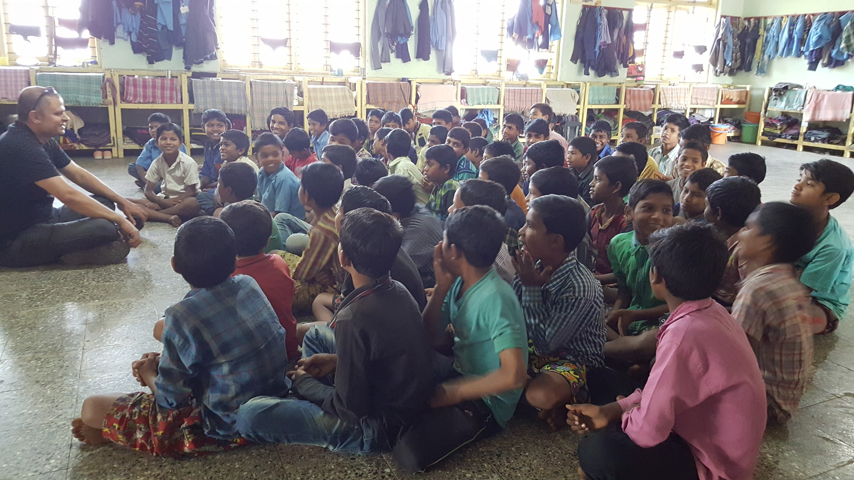

Rahul having conversation with with Father Jeevan and Father Adolf at Jan seva -
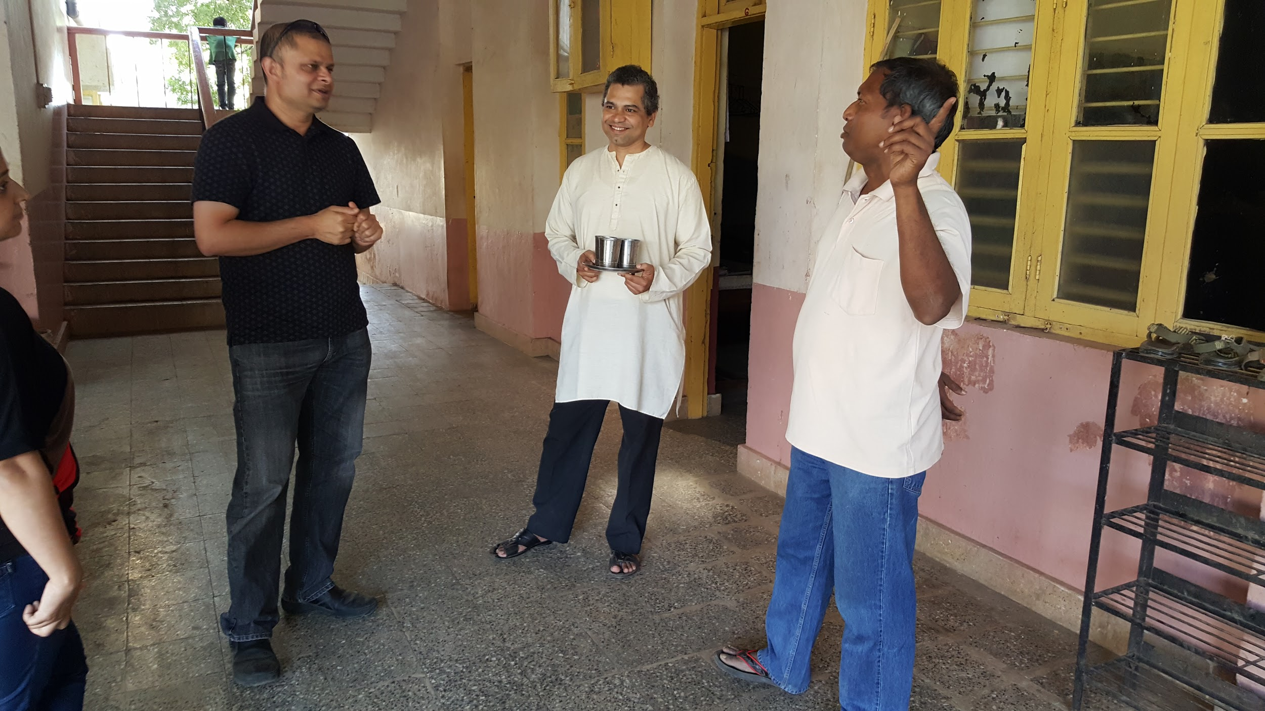

Conclusion -

1. we felt that both the facilities are well run by the in charge of the facilities.

2. We were very happy to see the children happy. The children are well cared for and get good guidance.

3. We were especially impressed by various programs, educational visits and guest presentations that girls at Jivan vidya are exposed to for personal development and enrichment.

Notes / suggestions for further improvements -

1.From our conversations with both the boys and the girls we felt that boys are eating meat, eggs and vegetables more frequently than the girls.

Martina Tai told us that the girls are a bit fussy and picky about eating vegetables.

However we strongly felt that the girls should be eating better and should be having more vegetables in their diet.

Perhaps there could be a presentation about nutrition made for the girls emphasizing the importance of eating more vegetables - and thereby encouraging them to get into habit of eating more vegetables.

It is also important for the girls to understand the nutrition knowledge as they will probably have significant impact on the diets of their families in future as well.

2. The boys at Jan seva are involved in farming practices. We will recommend that the girls at Jivan vidya also pick up the project of growing vegetables again and getting more encouraged to eat vegetables that they would grow.

